FDM 450 Certifier Top Task How to Guide

The FDM 450 Certifier role can complete any of these top tasks on Filers/reports within the 450 Certifier’s area of responsibility. Any 450 Certifier EC appointed can also complete these tasks (except for adding another EC).
Contents
(Click the hyperlinked topic to see a short summary and a link to a more
detailed explanation of the topic with step-by-step instructions)
Task | When
Add 450 Certifier EC | As needed
See my 450 Filer(s) | As needed
Add a 450 Filer | As needed
Assign an OGE 450 | As needed
Remove an Assigned, Not Started | Start checking in March annually
Inform/Remind my 450 Filer(s) to eFile | At beginning of filing season send Initial notice; later, NLT 2 weeks before 450 is due; repeat as needed
Record an Extension | NLT due date being extended
Review/eSign a 450 | As needed, generally within 30 days* after Filer eSigns
Remind Supervisor how to review in FDM | As needed, usually within 30 days after Filer eSigns
Oversee FDM 450 report processing | As needed, starting mid-March annually
See my Success Score | As needed
Update my FDM contact info | As needed
Edit an existing FDM org unit | As needed
Add new/replace departed users (other than Filer) for an existing FDM org unit | As needed
Remove a departed Filer | As needed
*OGE regulations require final certification within 60 days of report receipt when the reports do not require additional information or remedial action. (See OGE Program Management Advisory PA-11-04, http://www.oge.gov/DisplayTemplates/ModelSub.aspx?id=2147484468.)

450 Certifier/450 Certifier ECs resources:
- FDM 450 Certifier Quick Start introduces the most likely FDM features and resources 450 Certifier s/450 Certifier ECs need to successfully and efficiently use FDM 450.
- FDM 450 EC User Guide has the basics for the 450 Certifier/ethics counselor (EC) responsible for advising/assisting OGE 450 Filers and Supervisors as well as reviewing OGE 450s in FDM.
- Using FDM 450:
  - Slides: https://www.fdm.army.mil/PM_Reference_Docs/UsingFDM450.ppt
  - Narrated: https://www.fdm.army.mil/PM_Reference_Docs/450/UsingFDM450.html
- Using FDM Management Reports
- Slides: https://www.fdm.army.mil/PM_Reference_Docs/SLCStatus.ppt
- Narrated: https://www.fdm.army.mil/PM_Reference_Docs/SLCStatus/SLCStatus.html
Send suggestions for additions/changes to FDM Webmaster.

22 December 2011
FDM 450 Certifier Frequent Task How to Summary/Links
(Underlined text in left column links to more detailed explanation on that topic later in this document.)
In my 450 Certifier (or 450 Certifier EC) role I want to | where (FDM tab) | Suggestion; Reference/Resource  (Underlined text in this column links to online resources)
see my 450 Filer(s) so I know I have the right Filers to support | Admin | Filers | Check Show My Filers, click Retrieve Filers to display your list. If you do not see all your 450 Filers you support you may Add a Filer. If you are 450 Certifier EC, change to that role to see those 450 Filers.
assign a 450 so Filer knows which report to eFile | Admin | Filers | Assigning a report includes an option to Notify Filer to eFile.  Note: FDM automatically assigns an Annual report to all registered 450 Filers on the last duty day of the calendar year (unless the Filer has a New Entrant with an appointment date of 2 Nov – 31 Dec).  Filers see Assigned, Not Started reports on the My Reports | Reports Not Started tab as explained in the 450 Certifier Quick Start.  Tutorial Assign a Report  Assigning a Report  FDM User Guide, page 47
remove an Assigned, Not Started report assignment  since Filer does not need to file the assigned report | My Reviews | Review Reports – OrgUnit View Mode | Check Show My Filers Reports, enter the Filer’s name, click Search. Click on “Remove Assignment.”  Assigning a Report, page 2  FDM User Guide, page 52
record an extension on an Assigned, Not Started 450 or an existing 450 | My Reviews | Review Reports – OrgUnit View Mode | - The 450 Certifier and 450 Certifier EC roles may record an extension on an FDM 450 before certifying it.  - Report must be at least in Assigned, Not Started (see Assign a 450 to assign a report) or Draft status so that it has a “Review Status” screen.  - Find the report on the My Reviews | Review Reports tab, OrgUnit View Mode, View it, click on Review Status.  - Click on “View/Edit Due Date & Extensions” (on the right side, just to the left of the Common Questions) and follow the onscreen prompts.  Extensions  Tutorial Managing FDM Extensions  Managing Extensions  Also see Edit a report due date, FDM User Guide, page 50
monitor 450 processing & . . .
see who has not started an Assigned 450 | Management Reports | Disclosure | - Click on Option 3,”Filers with No Disclosures”  - Check the “Show My Filers” radio button  - Click “Generate Report”  Using FDM Management Reports & slides  Management Reports  Using FDM 450 & slides
see 450 report review progress details | Management Reports | Disclosure | - Click on Option 2, “Disclosure Report Detail”  - Check the “Show My Filers” radio button  - Click “Generate Report”  Using FDM Management Reports & slides  Management Reports  Using FDM 450 & slides
see a summary (numbers only) of report progress | Management Reports | Disclosure | - Click on Option 1, “Registered Filers Summary”  - Check the “Show My Filers” radio button  - Click “Generate Report”  Using FDM Management Reports & slides  Management Reports  Using FDM 450 & slides
see a report of overdue OGE 450s | Management Reports | Currently Overdue | - Start on the Management Reports | Currently Overdue tab  - Click “Generate Report”
In my 450 Certifier (or 450 Certifier EC) role I want to | where (FDM tab) | Suggestion; Reference/Resource  (Underlined text in this column links to online resources)
see possible 450 Certifier/450 Certifier EC actions on a 450:
View a 450 | My Reviews | Review Reports | Click on View for details  Tutorial Reviewing a 450  Reviewing a 450 Reference  Review suggestions  Review process  Review checklist
change a Supervisor on this 450 only (for a temporary Supervisor who will review this 450) | My Reviews | Review Reports – Review Status screen of the 450 | - Click “Show Report Review Chain Controls” action button  - Click “Change” in the row for the Supervisor  - Follow the on screen prompts  Edit the org unit on the Admin | Org Unit tab to replace a departed Supervisor. Managing Org Units and Roles, page 2
record that Supervisor reviewed outside FDM |  | - Click “Show Report Review Chain Controls” action button  - Click “Change” in the row for the Supervisor  - Follow the on screen prompts
bypass a Supervisor review to process 450 without an indication that Supervisor reviewed |  | - Click “Show Report Review Chain Controls” action button  - Click “Change” in the row for the Supervisor  - Follow the on screen prompts
Request Filer Amend |  | Request Filer Amend – starts the process to request Filer amend the report. Use when you decide Filer must personally provide additional information in the report.
End Initial Review |  | End Initial Review – allows recording that you have reviewed the report but are not ready to eSign and Complete. See 5 CFR 2634.605 for OGE’s 60-day review rule.
eSign |  | eSign – click to record your review
Print (or view/save) a 450 | View/Print tab (inside the report) | - Start on the My Reviews | Review Reports tab, Org Unit View Mode (recommended), find the 450 you want to print  - Click “View”  - Click the “View/Print” tab after FDM displays the Getting Started screen  - Click the “View/Print” action button
see key Administrative tasks:
update my FDM contact info to report changes to my FDM account | My Info | Contact Info | Key Features, page 3  Quick Reference on email settings to avoid spam filters
add an Ethics Counselor  to act for or instead of me as 450 Certifier on the same reports I could act on | My Info | My ECs | - Click “Add 450 Certifier EC”  - Enter name  - Click “Search”  - Click “Select”  - Click “Confirm”  Notes:  - FDM will email the person(s) you added as your 450 Certifier EC indicating (s)he now has FDM access in that role.  - Your 450 Certifier EC can do the same things in FDM that you can do.  - Remember to remove your 450 Certifier EC(s) before you leave or after they leave or no longer should use FDM in that role.
edit an existing FDM org unit to change/update an existing org unit name | Admin | Org Unit | - Search for the org unit name or click the down arrow until the org unit displays,  - Click “Edit” to open the Org Unit Edit screen.  FDM User Guide, page 26;

In my 450 Certifier (or 450 Certifier EC) role I want to | where (FDM tab) | Suggestion; Reference/Resource  (Underlined text in this column links to online resources)
add new/replace departed users (e.g., Supervisor; POC other than Filer) for an existing FDM org unit | Admin | Org Unit | - Search for the org unit name or click the down arrow until the org unit displays  - Click “Edit” to open the Org Unit Edit screen.  - Click “Change” or “Assign” for each role you want to change.  Note: FDM uses org unit hierarchy – roles are acting at subordinate levels until another user is assigned in that role. No need to assign to a role if the “acting” user is who you want to assign.  FDM User Guide, p 30
add an FDM 450 Filer | Admin | Filers | - Select Next Level Down until you reach the org unit for the Filer’s Supervisor  - Click the Add 450 Filer action button.  Note: Add the Filer who is also a Supervisor in the org unit where that user is assigned as Supervisor so the org unit 450 Certifier can see that Filer’s 450. FDM automatically looks next level up for the Supervisor on the Filer’s report  Caution: If FDM indicates the Filer was already registered in FDM you may see that the Filer has a 450 assigned in that other location. Follow the onscreen instructions before proceeding. Most of the time you can move the assigned report within your Agency, but not when the Filer is outside your agency at the time you are adding him/her.  Manage Filers, page 1
remove a Filer  because (s)he no longer files with my Agency | Admin | Filers | - Check the “Show My Filers” radio button & Search for the Filer’s name  - Check the check box to the left of the Filer’s name  - Click the “Remove 450 Filer Role” action button, Confirm.  Note: also remove Assigned, Not Started Reports  Manage Filers, page 3

- Assign a 450
- Start on the Admin | Filers tab in the 450 Certifier (or 450 Certifier EC) role, check the “Show My Filers” radio button:
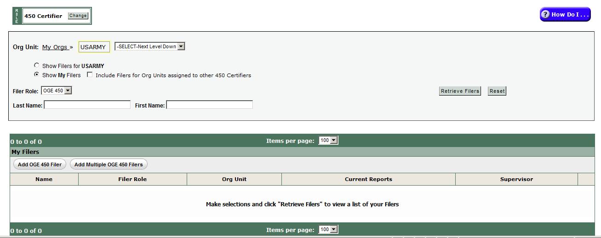

- Click the Retrieve Filers action button to display results in a table like this for all 450 Filers where you are in the report review chain as 450 Certifier (or 450 Certifier EC):
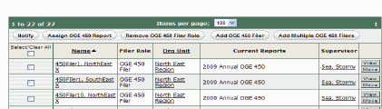
- Check the check box to the left of one or more Filers that you want to assign the same report type.
- Click the “Assign OGE 450 Report” action button and complete the choices for the report year, type, and due date.
- Click Save, Confirm
FDM will display an optional choice to Notify now or not. Decide and click Continue to proceed.
- See the Assign a Report Quick Reference, https://www.fdm.army.mil/documents/FDM_QRC_Assigning_A_Report_to_File.pdf.
- Remove an Assigned, Not Started report assignment
- Start on the My Reviews | Review Reports – OrgUnit View Mode; check “Show My Filers”
- Search for the Filer
- Click the “Remove Assignment” action button in the far right of the row with the Filer’s report that you want to unassign. This action means that the report will not be counted on the SLC Worksheet extract of information annually reported to OGE on the number and types of 450s.

Management Reports
Using FDM Management Reports & slides
Management Reports

- See who has not started an Assigned 450
- Start on the Management Reports tab
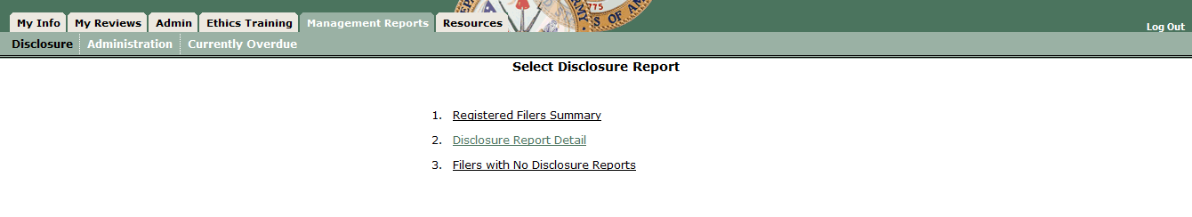
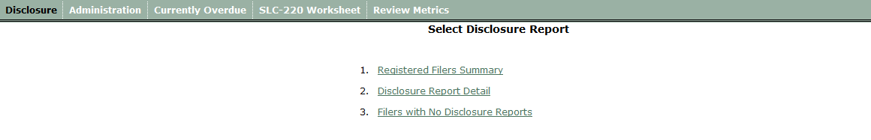

- Click on “Filers with No Disclosure Report” (Choice 3), then check the “Show My Filers” radio button.
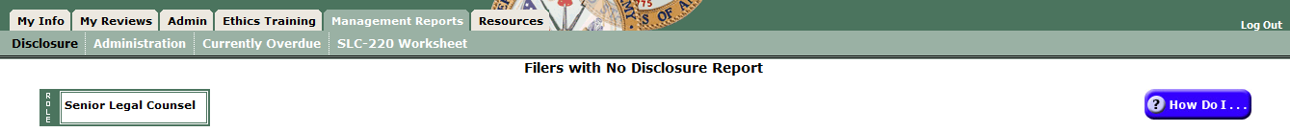
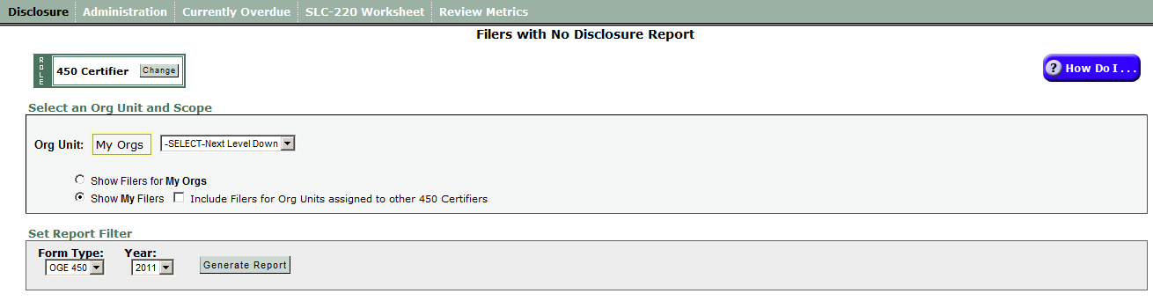

- Clicking “Generate Report” displays a Report Results screen like this:
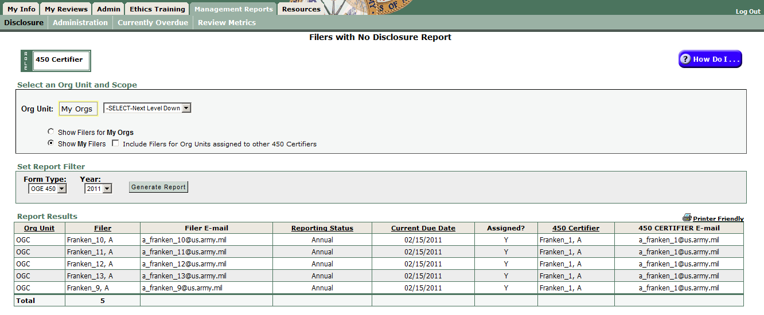
- Go to the My Reviews | Remind Filers tab to remind these Filers to eFile.
- See 450 review progress
- Start on the Management Reports | Disclosures tab
- Click on “Disclosure Report Detail”
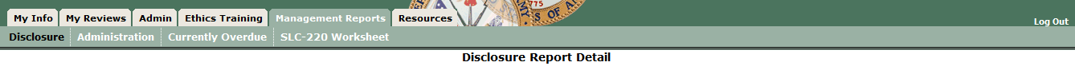
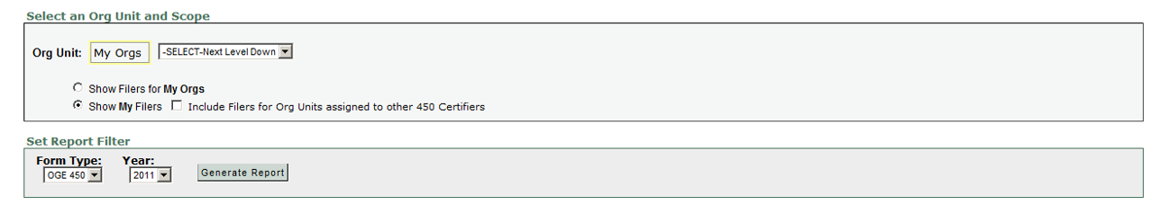

- Clicking “Generate Report” returns a Report Results screen showing your Filers and the status of their reports.

- See a summary (numbers only) of report progress
- Start on the Management Reports | Disclosures tab

- Click on Registered Filers Summary to open this screen:
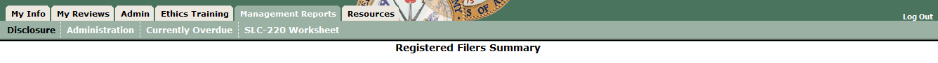
- Clicking “Generate Report” returns a Report Results screen showing the total number of Filers, the number not yet assigned a report, the number submitted, the number in draft, and the number assigned, not started. Use the Remind Filers feature to notify those who owe reports.
- View a 450
Reviewing a 450 tutorial: https://www.fdm.army.mil/documents/FDM_REVIEWING_AN_OGE_450_Report_For_Website/Reviewing_an_OGE_450_TOC.html
Quick Reference: QRC Reviewing an OGE 450: https://www.fdm.army.mil/documents/QRC_Reviewing_an_OGE450.pdf

450 Certifiers (or 450 Certifiers ECs) may View a 450 in several ways:
  - My Reviews | Review Reports tab – Worklist View Mode (default, most frequently used at the beginning of a filing season; displays those reports less than 30 days old ready for your action (Action Required) in a particular FDM role)
  - My Reviews | Review Reports tab – OrgUnit View Mode (will display all 450s in all Review Status – Assigned, Not Started; Draft; Under Review; used most frequently after mid-February)
  - My Reviews | Manage Exceptions (for reports over 30 days old, reports with Notes)

- Go to the default My Reviews | Review Reports – Worklist View Mode or click the “OrgUnit View Mode” action button (far right, near Common Questions display).
  - Worklist View Mode displays those reports ready for 450 Certifier action (Action = “Action Required” as the default).

Default landing screen: My Reviews | Review Reports – Worklist View Mode
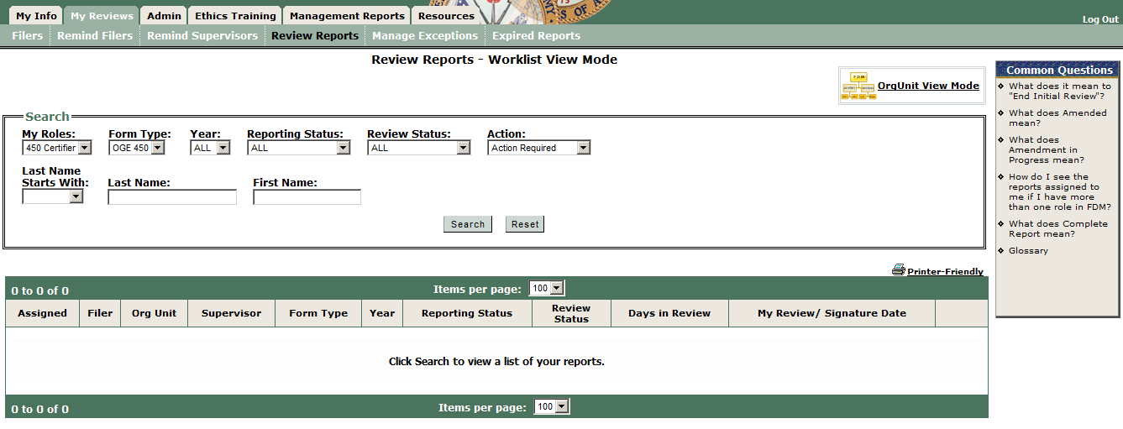

Note: this FDM 450 Certifier only has this role. If this user had more than one FDM role the My Roles drop down box would be different and user could pick a role.

Use the defaults and click Search or, to focus only on 450s ready for your action, set the Search filter settings as follows and click Search to load reports ready for your action.

My Role: 450 Certifier (450 Certifier EC)
Form Type: OGE 450
Year = ALL (or pick from drop down choices)
Reporting Status = All
Review Status = Under Review
Action = Action Required (default) to display only those reports already “Under Review” that you (or your 450 Certifier EC have not eSigned)

To see all 450s for Filers under your 450 Certifier authority, click “Reset” to restore the original Search settings and click Search.

  - Org Unit View Mode allows you to set multiple search filter combinations to see specific reports including those over 30 days since the Filer eSigned and still Under Review.
Click the “Org Unit View Mode” action button on the right side to display this screen: My Reviews | Review Reports – Org Unit View Mode
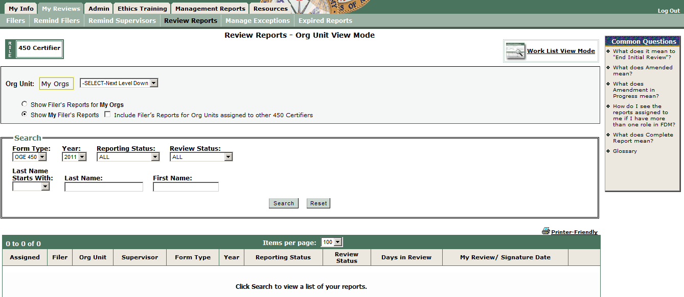
Suggestions:
- Use the “Org Unit View Mode” most of the time because it shows you more reports in different review status all at once.
- Almost always check the “Show My Filer’s Reports” radio button. (If you have subordinate FDM 450 Certifiers and you want to see the reports assigned to them check the check box to the left of the “Include Filer’s Reports for Org Units assigned to other 450 Certifiers.”)

- Set desired search filter settings or enter the Filer’s name, and click Search.
- Click the View action button in the row for the Filer’s report you want to open.
- Click View for a report in the table below the Search box to open that report. The Report Data row of tabs will display:

and the Report Progress Bar wizard (below) lets you click through or use Continue to advance through the report sections.

FDM 450 has a “Compare” view for Filers with more than one 450 in FDM:
Click “Compare” to open a view that highlights all changes a Filer made in this report as compared to the prior report. See page 2 of the Quick Reference: QRC Reviewing an OGE 450: https://www.fdm.army.mil/documents/QRC_Reviewing_an_OGE450.pdf

The Review Reports sub-menu displays sub-tabs (left to right):

- Report Data – main area used for preparing (or reviewing a report with FDM’s report wizard).
- Attachments – add/replace/view attachments associated with a report.
- Comments – area for recording Reviewer comments on a report.
- Flags – identifies missing or incomplete information that must be provided before the report is filed.
  - Red Flags - indicate a significant deficiency or missing information that may prevent the OGE 450 from being certified/approved until cleared.
  - Yellow Flags – indicate you may need additional information or clarification. For example, FDM “yellow flags” certain assets (i.e., 401(k), IRA) to remind all involved that the Filer may need to report the underlying holdings in the asset. Look at the asset information to decide if you need more information.
- Audit Trail – tracks all changes made to the report).
- View/Print – provides the user a view and print function for the report.
- Review Status – shows who has reviewed/approved a Filer’s report.
- Compare – highlights changes a Filer made from prior report when prepopulating the current one from the earlier one.
- Previous Reports – displays a Filer’s prior reports in FDM.
- Notes – an area for recording a temporary, Post-it type note as a memory jogger. Note: opening a Report Note temporarily moves the report to the Manage Exceptions area.
450 review suggestions:
- Many FDM 450 Certifiers/450 Certifier ECs click the Compare tab (when available), then Comments, Flags, Audit Trail, and Review Status tabs before reviewing the substantive content of a report. These help quickly identify missing or explanatory report information as well as display who else has reviewed the report (Review Status tab). Office of Government Ethics (OGE) financial disclosure report review guides are available on the FDM website Resources tab.
- The Reviewing an OGE 450, https://www.fdm.army.mil/documents/QRC_Reviewing_an_OGE450.pdf, illustrates how to navigate a 450 in FDM.
- Some 450 Certifiers prefer to print the report to review it. Go on the View/Print tab and click View/Print. Return to the wizard view to add any section/line item comments.
- Substantive review: Reviewers are checking the reported financial interests for completeness and to identify those financial interests that may conflict with the Filer’s official duties and that the report is administratively accurate and complete. Before signing off on the report the reviewer must take appropriate steps to resolve any apparent conflicts of interest.
- Generally 450 Certifiers or 450 Certifier ECs should be familiar with the OGE 450, instructions, conflict of interest statutes (18 USC §§ 201 – 209), the financial disclosure regulation (5 CFR Part 2634), the standards of conduct regulation (5 CFR Part 2635 and the Joint Ethics Regulation), and the agency lists of contractors.

- Reviewing an OGE 450
The purpose of the OGE Form 450, Confidential Financial Disclosure Report, is to help employees avoid conflicts between their official government duties and their private financial interests or affiliations. It also helps them avoid conflicts that result from the financial interests and affiliations of their spouses and dependent children. (See the 450ECUserGuide.doc, Appendix B, for information on certifying an FDM OGE 450.)

Agency review of the OGE Form 450 helps employees avoid conflicts of interests. It also protects the agency by giving the agency a chance to deal with conflicts of interest internally instead of publicly. The review also provides an in-depth, methodical review process to identify conflicts (or potential ones) that employees may overlook and to take appropriate preventive or corrective action.
- OGE 450 reviewers conduct two types of review:
- Technical review
- Conflict of interest analysis

Report Area | Conducting a technical review
General | The technical review is an initial determination to see if the filer provided complete information and properly completed the report. See 5 CFR § 2634.907, Report Contents. Often, a skilled paralegal will conduct the technical review using FDM’s flag system and checking the e450 display to ensure the information reported makes sense. Use this checklist as a guide when viewing the e450. Per 5 CFR § 2634.909, Procedures, penalties, and ethics agreements,(a) The provisions of subpart F govern the review of confidential disclosure reports. See 5 CFR § 2634.605.
Assets & Income | - Has the filer provided complete information?  - Has the filer reported underlying holdings (except diversified mutual funds) for investment clubs, private pension interests, investment life insurance, and retirement plans?  - If the filer reported a defined benefit plan, did the filer report the name of the employer providing the plan and identify it as a defined benefit plan?  - If the filer reported a defined contribution plan, did the filer report the reportable underlying assets of the plan (not diversified mutual funds)?  - Did the filer over-report items that should not be reported (e.g., diversified mutual funds)?  - When a previously reported asset no longer appears you may presume that it fell below the reportable threshold.  - Reference: 5 CFR § 2634.907(c)
Liabilities | - Did the filer report any liability that exceeded $10,000?  - Did the filer report the creditor’s name, city, and state?  - Did the filer over-report items that should not be reported (e.g., loans for automobiles, household furniture, or appliances (as long as the loan does not exceed the purchase price); loans from banks or other financial institutions on terms generally available to the public (e.g., mortgages); revolving charge accounts, student loans, loans from a spouse or to a parent, sibling, or child of filer, spouse, or dependent child(ren)? (Note: The new regulation does not require filers to report student loans, credit card debt, or loans from a financial institution or business entity that are granted on terms made available to the public.)  - When a previously reported liability/debt no longer appears you may presume that it was paid off or dropped below the $10,000 reportable threshold.  - Reference: 5 CFR § 2634.907(d)
Outside Positions | - Evaluate the completeness of each position reported (e.g., name, location of the organization, type or purpose of the organization, and specific position held)  - Verify that pertinent income-producing activities are also reported in the assets/income section of the report.  - Confirm that the filer is not over-reporting (e.g., did not report positions held by spouse or dependent child(ren); compensated or uncompensated positions held in any religious, social, fraternal, or political entity; positions solely of an honorary nature, positions filers hold as part of official duties, mere membership in an organization.  - Consider outside activity approval forms (if available)  - Reference: 5 CFR § 2634.907(e)
Agreements & Arrangements | - Evaluate the completeness of each entry (e.g., the name of the parties, the location, terms, and, if there is an arrangement for future employment, the date when the arrangement was made  - Confirm that pension plans and leaves of absence also appear in Part I and III, respectively.  - Confirm that the filer is not over reporting.  - Reference: 5 CFR § 2634.907(f)
Gifts & Travel Reimbursements | - Assess the completeness of each reported item (e.g., donor’s name, gift description, itinerary (i.e., purpose, date(s), and kinds of expenses when a travel-related gift).  - Assess the relationship between donor and filer  - Confirm the filer is not over-reporting (e.g., filer does not report anything less than $134, received from relatives, the US Government, DC, state, or local governments; bequests and other forms of inheritance; gifts and travel reimbursements given to filer’s agency in connection with filer’s official travel; gifts of hospitality (e.g., food, lodging, entertainment) at the donor’s residence or personal premises; anything received by filer’s spouse or dependent child totally independent of their relationship to filer.)  - Reference: 5 CFR § 2634.907(g)
*Developed from OGE training, Certifying Confidential Financial Disclosure Reports

- Conflict of Interest analysis:
Your conflict of interest analysis is to ensure that filers do not:
- Have interests that conflict with their official duties
- Have even an appearance of a conflict
- Receive income from sources that may be affected by actions Filers take in their official capacity

Note: Reviewers need to know a Filer’s duties to determine if there is a conflict of interest.

Use this checklist when checking a 450 for possible conflict of interests.
Here is a checklist* to use to review an OGE 450 for possible conflict of interests.
Report Area | Considerations to conduct a conflict of interest analysis
Admin – Filer’s position, grade | - What official duties does the filer perform?  - Does the filer deal with non-federal entities?
Assets & Income | Purpose of reviewing assets & income is to ensure that filers are not using their government jobs to affect the sources of their assets and income, and ultimately, their own financial interests.  - Are any of the reported interests in DoD contractors or are they on a DoD/Army prohibited holdings list?  - Do any of the reported financial interests raise a potential conflict with the filer’s official duties:  - Determine if the filer might take an official action that would result in a monetary gain or loss to himself or those whose financial interests are imputed to him  - Consider whether the filer’s official action may create an appearance of a conflict of interest  - Decide if the filer has a covered relationship that creates an appearance of a conflict of interest  - Reference: 5 CFR § 2634.907(c)
Liabilities | Purpose of reviewing liabilities is to ensure that filers do not receive gifts or special favors under the guise of a loan.  - Does filer have a loan with a prohibited source? If yes: ask about  - loan terms (e.g., same as available to general public or more favorable (if more favorable, inquire why) (Note: Special terms may not always raise ethical concerns. For example, there are instances where special terms reflect normal economic motives on the part of the lender, e.g., offering a lower rate to a customer with very large deposits or exceptional credit-worthiness.)) &  - filer relationship to creditor  - Reference: 5 CFR § 2634.907(d)
Outside Positions | Purpose of reviewing reported outside positions is to ensure that filers do not experience any conflicts of interest through such paid or unpaid positions with non-Federal organizations.  - Do any of filer’s official duties impact any of the organizations listed?  - What does filer do for the listed organization?  - Watch for situation where filer may attempt to represent the organization before the Government (18 USC §§ 203, & 205)  - Is filer an employee of the organization and does filer take Government action that affects the organization (18 USC § 208)  - Reference: 5 CFR § 2634.907(e)
Agreements & Arrangements | Agreements or arrangements with nongovernmental organizations create a financial tie between the employee and that organization. This may influence the way an employee performs his government job.  - Assess the terms of the agreement/arrangement – do they indicate any special treatment because of filer’s federal job?  - Could filer take an official action that could result in a monetary gain or loss to himself or the entity with which he has an agreement/ arrangement?  - Consider whether filer’s official action may create an appearance of a conflict of interest.  - Decide if filer has a covered relationship that creates an appearance of a conflict of interest.  - Reference: 5 CFR § 2634.907(f)
Gifts & Travel Reimbursements | Purpose of reviewing this section is to determine whether gifts are being given to influence the performance or non-performance of an official action and to ensure that filers are not using their public office for private gain.  - Consider the relationship between donor and filer  - What could donor and its affiliates gain from filer’s official performance of duties?  - Is the donor a prohibited source?  - How frequently does donor give gifts? Does a gift exception or exemption apply?  - Consider the gifts from outside sources subpart of the standards of conduct (5 CFR part 2635, subpart B (and in DoD, the Joint Ethics Regulation)) and any exceptions/exemptions. Some common outside source exceptions that meet the reporting threshold are awards and honorary degrees; gifts based on outside business or employment relationships, free attendance at certain widely attended gatherings.  - Reference: 5 CFR § 2634.907(g)
*Developed from OGE training, Certifying Confidential Financial Disclosure Reports

- Change a Supervisor on this 450 only
- View the report from the My Reviews | Review Reports – OrgUnit View Mode display.
- Click on the Review Status tab of the report.
- Click on Show Review Chain Controls:
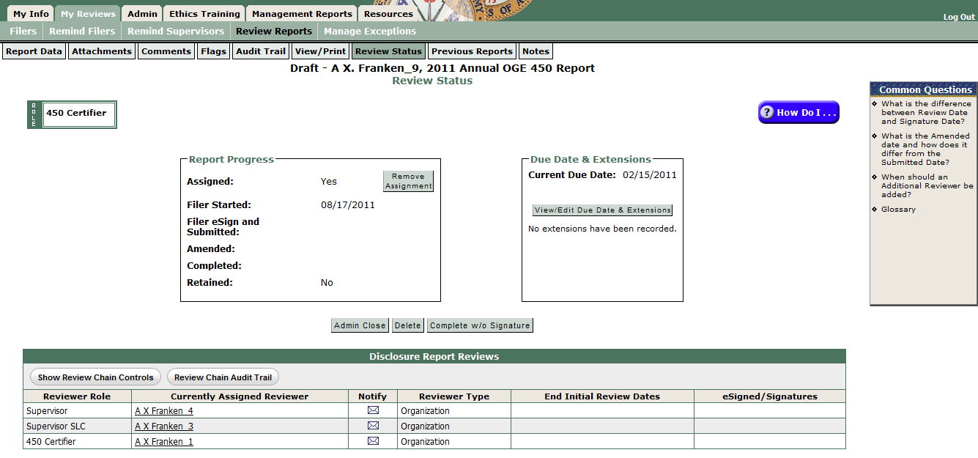

Notice the change in the Review Chain table:
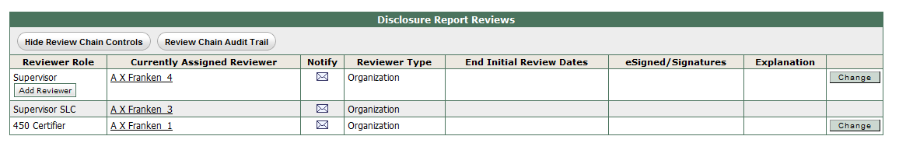

- Click “Change” in the row for the Supervisor to see this screen with several options:
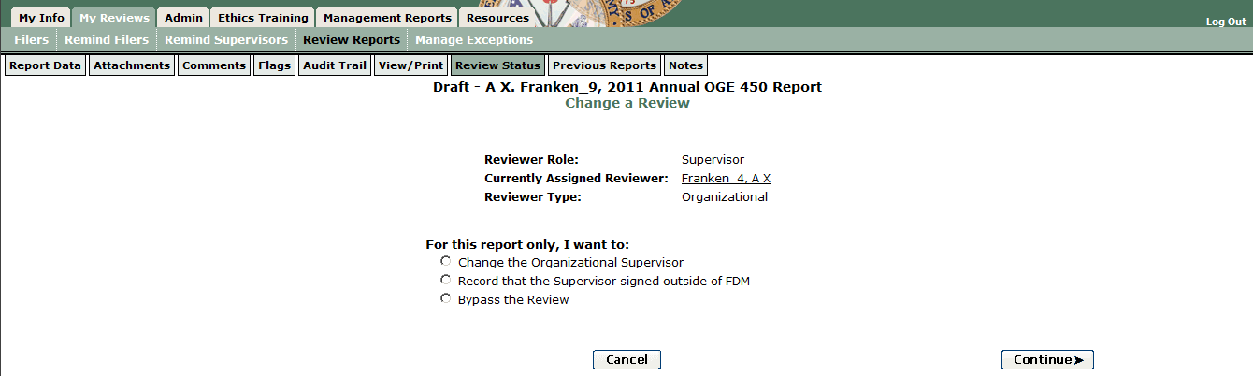
- Check the radio button to the left of “Change the Organizational Supervisor,” Click Continue, and follow the on screen prompts to change the Supervisor reviewer.
- Record that Supervisor reviewed outside FDM
- View the report from the My Reviews | Review Reports – OrgUnit View Mode display.
- Click on the Review Status tab of the report.
- Click on Show Review Chain Controls:

Notice the change in the Review Chain table:
- Click “Change” in the row for the Supervisor to see this screen with several options:

- Check the radio button to the left of “Record that the Supervisor signed outside of FDM,” Click Continue, and follow the on screen prompts to record the Supervisor’s review.
- Bypass a Supervisor review
- View the report from the My Reviews | Review Reports – Org Unit View Mode display.
- Click on the Review Status tab of the report.
- Click on Show Review Chain Controls:

Notice the change in the Review Chain table:
- Click “Change” in the row for the Supervisor to see this screen with several options:

- Check the radio button to the left of “Bypass the Review,” Click Continue, and follow the on screen prompts to bypass (skip) the Supervisor reviewer.
450 Certifier/450 Certifier EC action options
Report Status | 450 Certifier/450 Certifier EC Possible Actions on an FDM 450
Assigned, Not Started | Remove assignment or record an extension
Draft | Admin Close; Delete; Complete w/o Filer’s eSignature
Under Review | Admin Close, Delete; Request Filer Amend, eSign
Complete | View, Add supplemental Comments or Attachments

Report in Under Review status 450 Certifier /450 Certifier EC options:
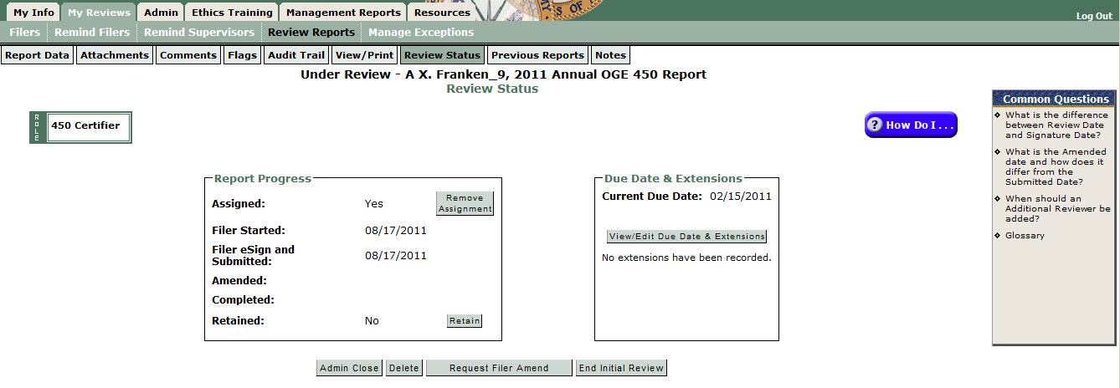

- Admin Close – Retains the report data for later use in Filer prepopulating another FDM 450.
- Delete – completely removes the report data from FDM.
- Request Filer Amend – starts the process to request Filer amend the report. Use when you decide Filer must personally provide additional information in the report.
- End Initial Review – allows recording that you have reviewed the report but are not ready to eSign and Complete. See 5 CFR 2634.605 for OGE’s 60-day review rule.
- eSign – appears when Supervisor has also eSigned the report; click to record your review of the report
- Add an Ethics Counselor
- Start on the My Info | My ECs tab. Click on “Add 450 Certifier EC” and the My Info | My ECs tab displays the My Ethics Counselors page (below).
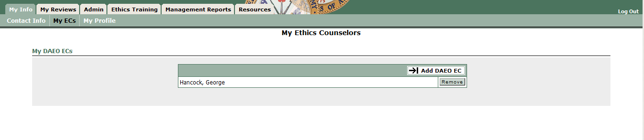

- Click on Add 450 Certifier EC. That opens the Add A New Ethics Counselor page (below) with the Search tool to find the EC to add:
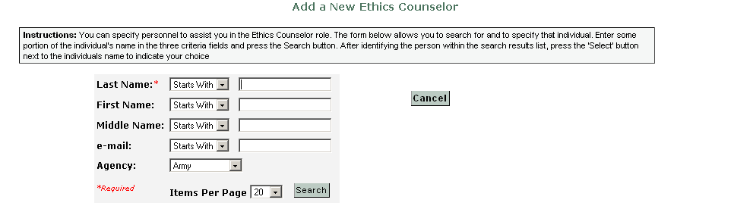
Tip: If you know the CAC-embedded email address (e.g., for Army personnel it is the AKO User Name) you may enter a few letters of the last name and then enter that in the email search box, then select Search.
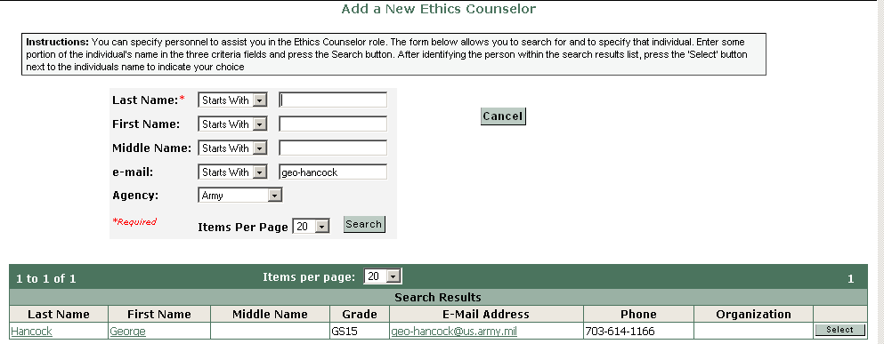

- The result will be a list of names (above), Select the right one and Confirm (below) to add the EC:
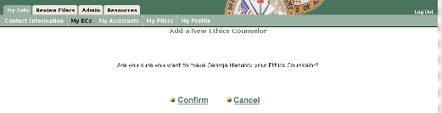
- The 450 Certifier EC can add new Org Units, register 450 Filers and Supervisors, record extensions, and see the 450 Certifier 's report list to monitor Filer progress and eSign a report for a 450 Certifier (when authorized).

- FDM will email the person you added that (s)he now has FDM access as your 450 Certifier EC.
- Remove a departed Filer
- Start on the Admin | Filer tab, check the “Show My Filers” radio button
- Enter the Filer’s name
- Click Search
- Check the check box to the left of the Filer’s name
- Click the “Remove 450 Filer Role” action button, Confirm

- Inform/Remind my Filer(s) to eFile in FDM
- The Annual 450 Filing season starts 1 January. FDM automatically assigns an “Annual” report to 450 Filers registered in FDM on the last duty day of the year (unless that Filer eFiled a New Entrant with an appointment date of 2 November or later). As you add Filers be sure to also assign the appropriate report and notify the Filer to eFile. See assign a 450.
- FDM’s My Reviews | Remind Filers tab gives you several options for reminding your 450 Filers:
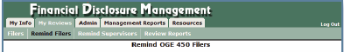
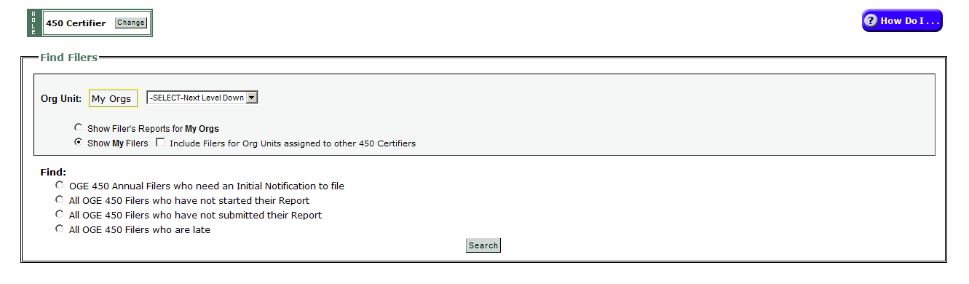
Be sure to check the “Show My Filers” radio button, then pick the Find option, and click Search. FDM will return a list of Filers to be reminded.
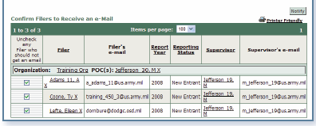
Click Notify to see the FDM email:
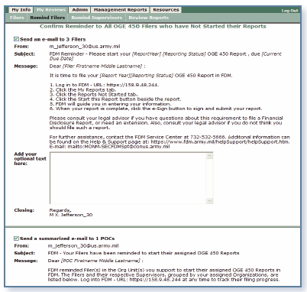
Note: the FDM POC role may also remind FDM 450 Filers to file.

- See the Remind Filers Quick Reference, https://www.fdm.army.mil/documents/QRC_Remind_Filers.pdf, for more details.

- Remind Supervisor to review/eSign in FDM
- FDM notifies the Filer’s Supervisor when the 450 Filer eSigns that the report is ready for Supervisor review.
- FDM includes a Remind Supervisor feature that 450 Certifiers, 450 Certifier ECs and Assistants, and POCs may use to remind Supervisors to review reports.
- Go on the My Reviews | Remind Supervisors tab:
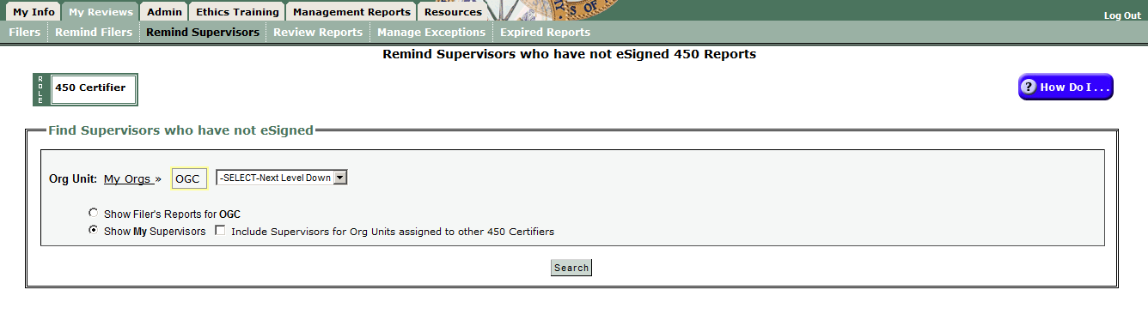
- Check the “Show My Supervisors” radio button. Click Search to see a table like this.
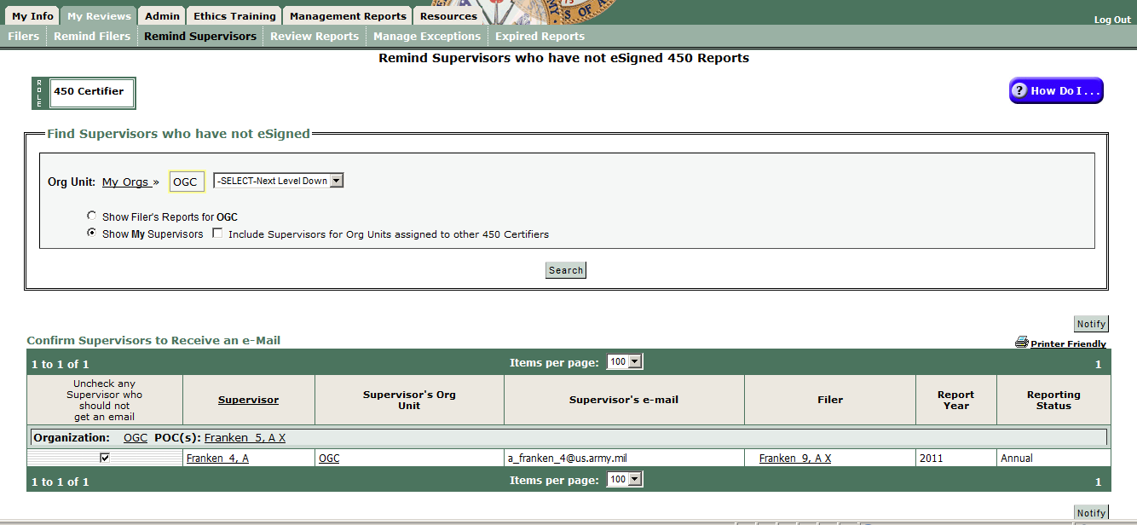
- Click Notify to open an email form like this:
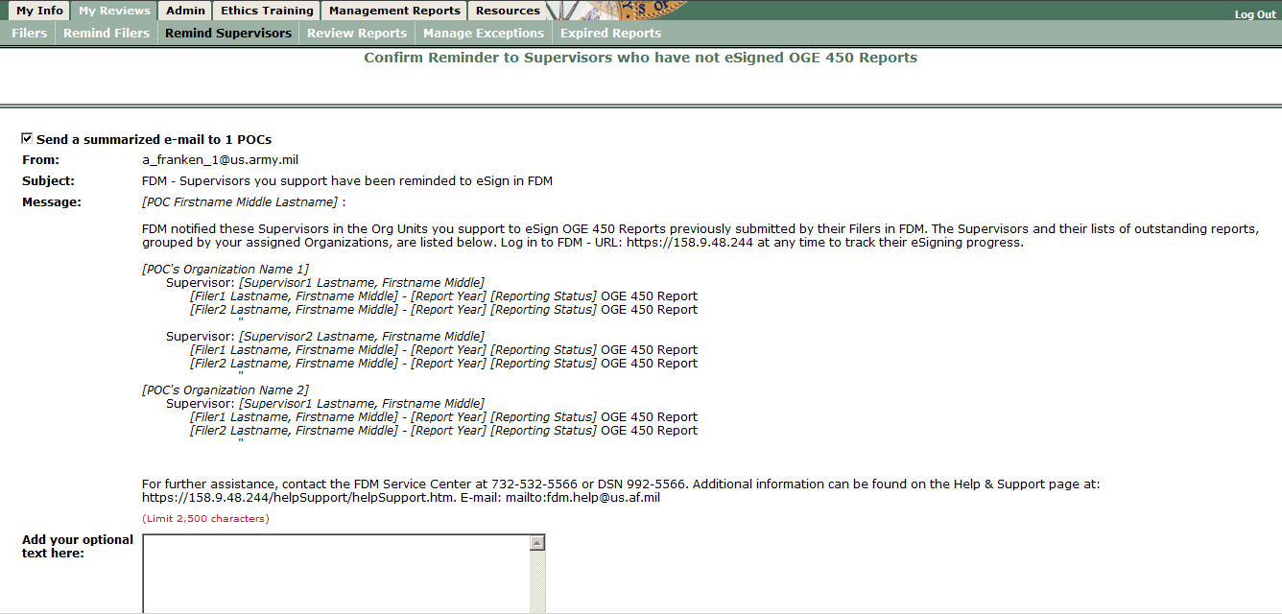
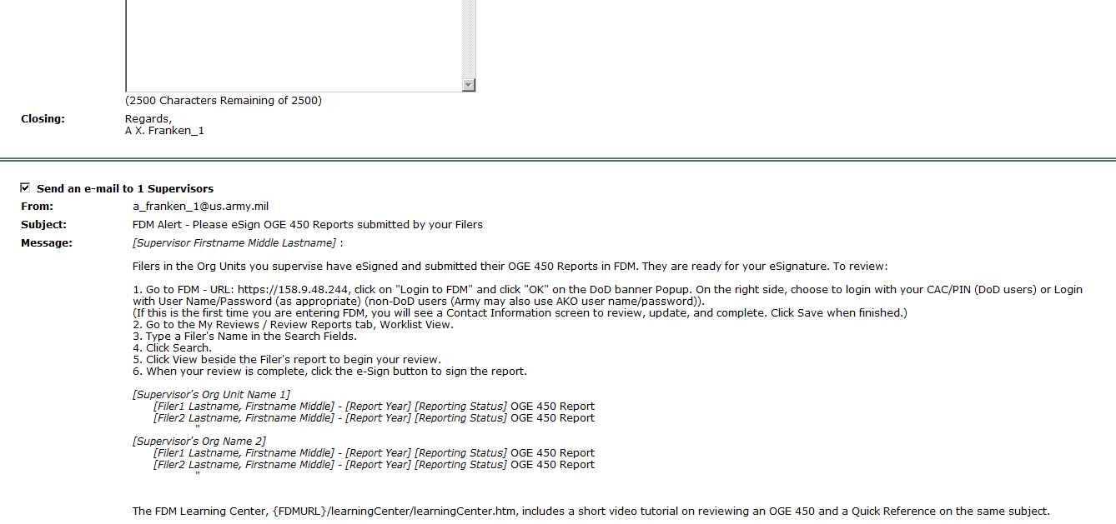
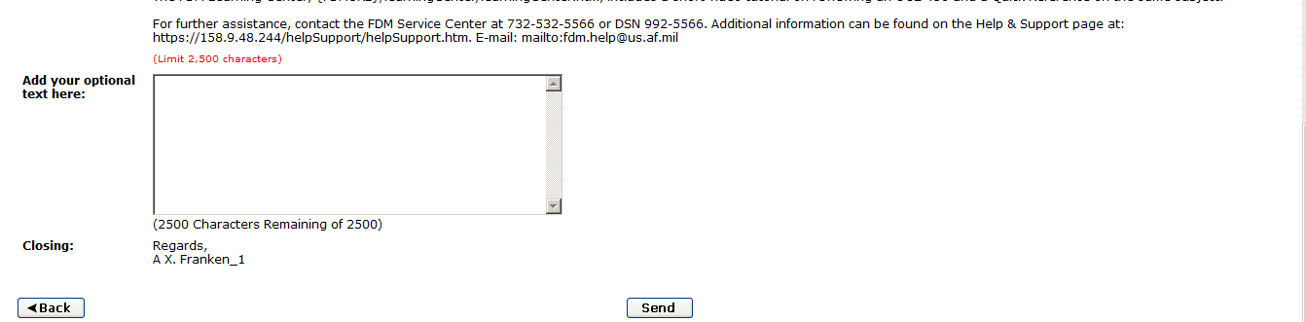
- Enter any optional text, click Send when finished. FDM will email the Supervisors shown.

FDM shows the summary result:
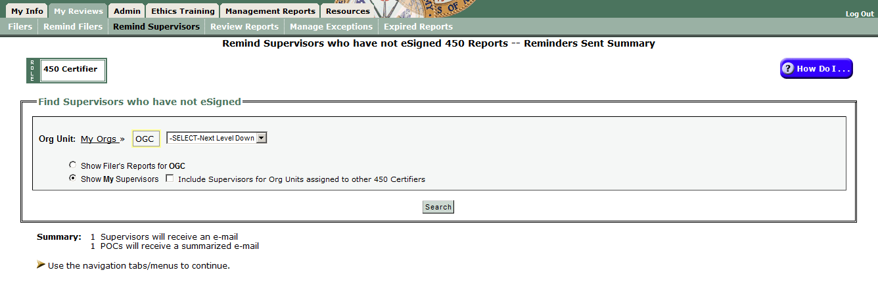

- Oversee FDM 450 Report Progress
- The Joint Ethics Regulation implements OGE regulations that indicate responsible Ethics Officials shall review reports within 60 days of filing (see 5 CFR 2634.605(a); Filer’s eSign date starts the 60-day review time clock). (See OGE Program Management Advisory PA-11-04, http://www.oge.gov/DisplayTemplates/ModelSub.aspx?id=2147484468.)
- FDM has several standard management reports to help you (and your supervisors) monitor FDM 450 report processing. A short narrated recording, Using FDM Management Reports, https://www.fdm.army.mil/PM_Reference_Docs/SLCStatus/SLCStatus.html, and slides: https://www.fdm.army.mil/PM_Reference_Docs/SLCStatus.ppt, explain how to use the FDM Management tools.
- Here are brief explanations of two available reports and suggestions for action. You may want to run these reports weekly beginning mid-March until all OGE 450s are Complete.
- Disclosure Report Details
- Start on the Management Reports | Disclosure tab.
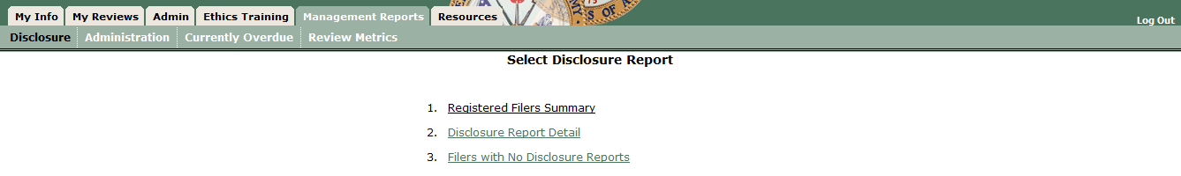
- Click on Disclosure Report Detail to see the screen below:
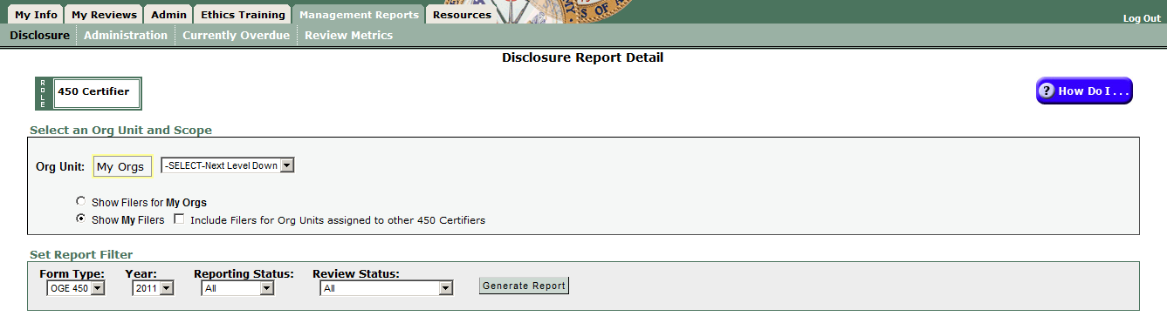
- Click “Generate Report” to see a report of the status/completion of reports:
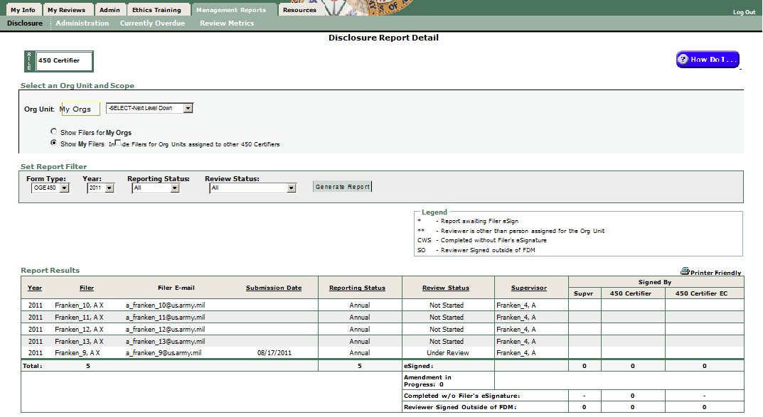

- Consult with your 450 Certifier EC to act on the unfinished reports, especially those that (s)he or the 450 Certifier Assistant has not indicated an initial review within 60 days from the Filer’s eSign. You may find the FDM450SITREP.doc (https://www.fdm.army.mil/PM_Reference_Docs/FDM450SITREP.doc) template a useful way to clean up Assigned, Not started reports near year end. See those reports on the Management Reports | Disclosure tab, Option 3, Filers with No Disclosures.
- See a report of overdue FDM 450s
- Start on the Management Reports | Currently Overdue:
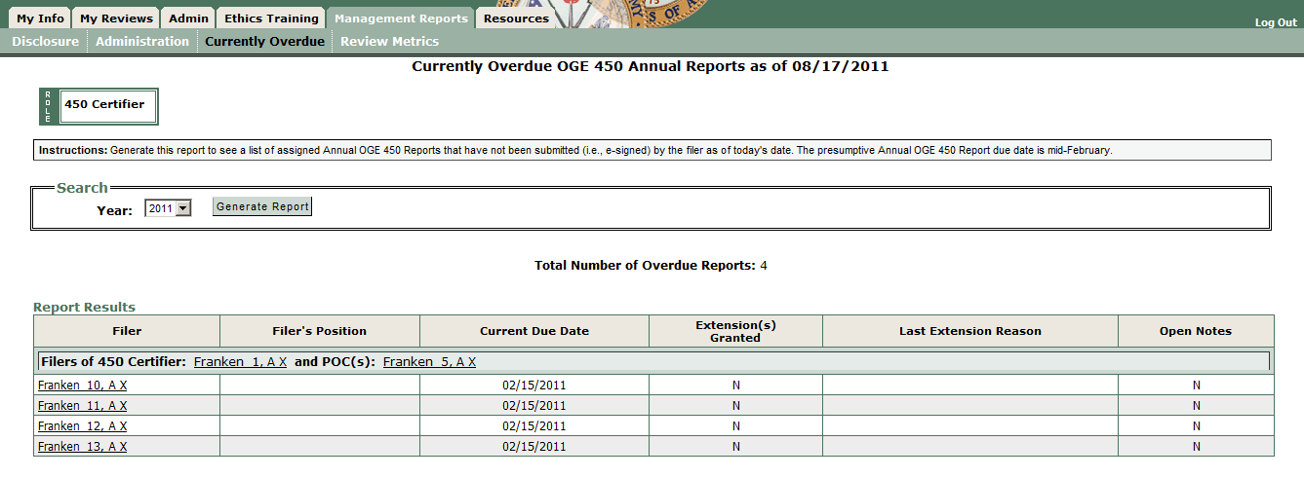
- Click “Generate Report” to see a Report Results screen that shows Filers assigned reports that are late (past the due date or extended due date):
Suggestion: Task your 450 Certifier EC or 450 Certifier Assistant to use the My Reviews | Remind Filers tab to notify 450 Filers who are late. They will have an option to include the Filer’s Supervisor on that notice.
- See My Success Score
FDM 450 now includes a score for 450 Certifiers to compare how they are doing with other agency 450 Certifiers on reviewing reports within 60 days of the Filer’s eSign date.
- Start on the Management Reports | Review Metrics tab:
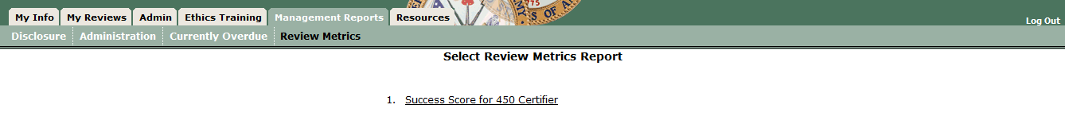
- Click “Success Score for 450 Certifier” to see this screen:
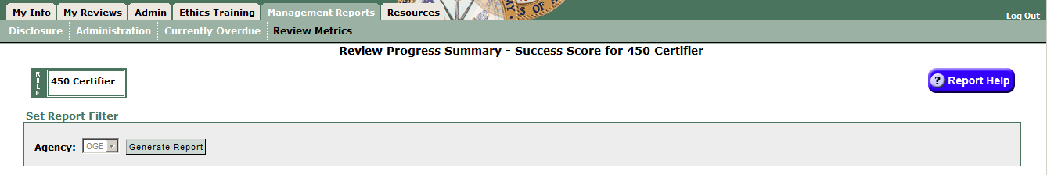
FDM will display a table like this one showing your score and the agency average.
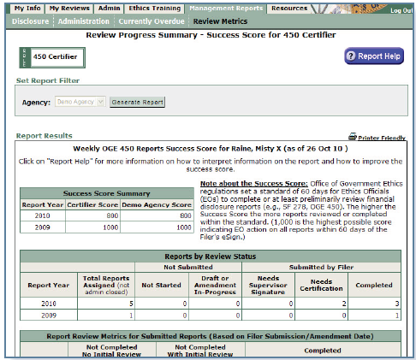
See the Review Progress Summary Quick Reference, https://www.fdm.army.mil/documents/QRC_Review_Progress_Summary.pdf, for more details on this.

