FDM Senior Legal Counsel (SLC) Top Task How to Guide

The FDM SLC role can complete any of these top tasks on Filers/reports within the SLC’s area of responsibility. Any SLC EC appointed can also complete these tasks (except for adding another EC).
Contents
(Click the hyperlinked topic to see a short summary and a link to a more
detailed explanation of the topic with step-by-step instructions)
Administrative/Maintenance Tasks | When
Update my FDM contact info | As needed
Add SLC EC | As needed
See my 278 Filer(s) | As needed
Add a 278 Filer | As needed
Inform/Remind my 278 Filer(s) to eFile | NLT 2 weeks before 278 is due; repeat as needed
Coordinate a Filer Assistant to draft Filer’s 278 | As needed
Remove a departed Filer | As needed
Edit an existing FDM org unit | As needed
Add new/replace departed users (other than Filer) for an existing FDM org unit | As needed
Report Processing Tasks
Record an Extension | NLT due date being extended
Review/eSign a 278 | As needed, generally within 30 days* after Filer eSigns
Advise Supervisor how to review in FDM | As needed, usually within 30 days after Filer eSigns
Overseeing Report Processing Tasks
Oversee FDM 450 report processing | As needed, starting mid-March annually
See overdue 450s | As needed, starting mid-March
Assign/change 450 Certifiers | As needed
*OGE regulations require final certification within 60 days of report receipt when the reports do not require additional information or remedial action. (See OGE Program Management Advisory PA-11-04, http://www.oge.gov/DisplayTemplates/ModelSub.aspx?id=2147484468.)



1 March 2012

Send suggestions for additions/changes to FDM Webmaster.
Other SLC/SLC EC tasks are explained in these resources:

- FDM 278 SLC Quick Start briefly introduces the most likely FDM features and resources SLCs/SLC ECs need to successfully and efficiently use FDM 278.
- FDM 278 SLC User Guide has the basics for the SLC/ethics counselor (EC) responsible for advising/assisting SF/OGE 278 Filers and Supervisors as well as reviewing SF/OGE 278s in FDM.
- FDM 278 SOP & Enclosures (on the FDM Resources tab, https://www.fdm.army.mil/helpSupport/resources.htm) is a customizable template for legal offices to adapt to use to electronically file (eFile) and manage the FDM 278, Public Financial Disclosure Report, process using FDM. It offers a review checklist, and other "get ready" type information and notices.)
- Using FDM 278:
  - Slides: https://www.fdm.army.mil/PM_Reference_Docs/UsingFDM278.ppt
  - Narrated: https://www.fdm.army.mil/PM_Reference_Docs/278/UsingFDM278.html
- Using FDM 450:
  - Slides: https://www.fdm.army.mil/PM_Reference_Docs/UsingFDM450.ppt
  - Narrated: https://www.fdm.army.mil/PM_Reference_Docs/450/UsingFDM450.html
- Using FDM Management Reports
- Slides: https://www.fdm.army.mil/PM_Reference_Docs/SLCStatus.ppt
- Narrated: https://www.fdm.army.mil/PM_Reference_Docs/SLCStatus/SLCStatus.html

FDM SLC Frequent Task How to Summary/Links
(Underlined text in left column links to more detailed explanation on that topic later in this document.)
In my SLC (or SLC EC) role I want to … | where (FDM tab) | Suggestion; Reference/Resource  (Underlined text in this column links to online resources)
see my 278 Filer(s) so I know I have the right Filers to support | Admin | Filers | Check Show My Filers, click Retrieve Filers to display your list. If you do not see all your 278 Filers you support you may Add a Filer.
assign a 278 so Filer knows which report to eFile | Admin | Filers | Assigning when registering a Filer includes an option to Notify Filer to eFile.  Note: FDM automatically assigns an Incumbent report to all registered 278 Filers on the last duty day of the calendar year.  Filers see Assigned, Not Started reports on the My Reports | Reports Not Started tab as explained in the 278 Filer Quick Start.  Tutorial Assign a Report  Assigning a Report  FDM User Guide, page 47
remove an Assigned, Not Started report assignment  since Filer does not need to file the assigned report | My Reviews | Review Reports – OrgUnit View Mode | Assigning a Report, page 2  FDM User Guide, page 52
record an extension on an Assigned, Not Started 278 or an existing 278 | My Reviews | Review Reports – OrgUnit View Mode | - The SLC, SLC EC, DAEO, and DAEO EC roles may record an extension on an FDM 278 before the DAEO completes it.  - Report must be at least in Assigned, Not Started (see Assign a 278 to assign a report) or Draft status so that it has a “Review Status” screen.  - Find the report on the My Reviews | Review Reports tab, View it, click on Review Status.  - Click on “View/Edit Due Date & Extensions” (on the right side, just to the left of the Common Questions) and follow the onscreen prompts.  Extensions  Tutorial Managing FDM Extensions  Managing Extensions  Also see Edit a report due date, FDM User Guide, page 50
monitor 278 processing & . . .
see who has not started an Assigned 278 | Management Reports | Disclosure | - Click on Option 3,”Filers with No Disclosures”  - Check the “Show My Filers” radio button  - Click “Generate Report”  Using FDM Management Reports & slides  Management Reports  Using FDM 278 & slides
see 278 report review progress details | Management Reports | Disclosure | - Click on Option 2, “Disclosure Report Detail”  - Check the “Show My Filers” radio button  - Click “Generate Report”  Using FDM Management Reports & slides  Management Reports  Using FDM 278 & slides
see a summary (numbers only) of report progress | Management Reports | Disclosure | - Click on Option 1, “Registered Filers Summary”  - Check the “Show My Filers” radio button  - Click “Generate Report”  Using FDM Management Reports & slides  Management Reports  Using FDM 278 & slides
see a report of overdue OGE 450s | Management Reports | Currently Overdue | - Start on the Management Reports | Currently Overdue tab  - Click “Generate Report”
In my SLC (or SLC EC) role I want to  because (or to) | where (FDM tab) | Suggestion; Reference/Resource  (Underlined text in this column links to online resources)
see possible SLC/SLC EC actions on a 278:
View a 278 | My Reviews | Review Reports | Click on View for details  Tutorial Reviewing a 278  Reviewing a 278 Reference  Review suggestions  Review process  Review checklist
change a Supervisor on this 278 only (for a temporary Supervisor who will review this 278) | My Reviews | Review Reports – Review Status screen of the 278 | - Click “Show Report Review Chain Controls” action button  - Click “Change” in the row for the Supervisor  - Follow the on screen prompts  Edit the org unit on the Admin | Org Unit tab to replace a departed Supervisor. Managing Org Units and Roles, page 2
record that Supervisor reviewed outside FDM |  | - Click “Show Report Review Chain Controls” action button  - Click “Change” in the row for the Supervisor  - Follow the on screen prompts
bypass a Supervisor review to process 278 without an indication that Supervisor reviewed |  | - Click “Show Report Review Chain Controls” action button  - Click “Change” in the row for the Supervisor  - Follow the on screen prompts
Request Filer Amend |  | Request Filer Amend – starts the process to request Filer amend the report. Use when you decide Filer must personally provide additional information in the report.
End Initial Review |  | End Initial Review – allows recording that you have reviewed the report but are not ready to eSign and Complete. See 5 CFR 2634.605 for OGE’s 60-day review rule.
eSign |  | eSign – click to record your review
Print (or view/save a pdf file of the) 278 | View/Print tab (inside the report) | - Start on the My Reviews | Review Reports tab, find the report you want to print  - Click “View”  - Click the “View/Print” tab after FDM displays the Getting Started screen  - Click the “View/Print” action button
see key Administrative tasks:
update my FDM contact info to report changes to my FDM account | My Info | Contact Info | Key Features, page 3  Quick Reference on email settings to avoid spam filters
add an Ethics Counselor  to act for or instead of me as SLC on the same reports I could act on | My Info | My ECs | - Click “Add SLC EC”  - Enter name  - Click “Search”  - Click “Select”  - Click “Confirm”  Notes:  - FDM will email the person(s) you added as your SLC EC indicating (s)he now has FDM access in that role.  - Your SLC EC can do the same things in FDM that you can do.  - Remember to remove your SLC EC(s) before you leave or after they leave or no longer should use FDM in that role.
edit an existing FDM org unit to change/update an existing org unit name | Admin | Org Unit | - Search for the org unit name or click the down arrow until the org unit displays,  - Click “Edit” to open the Org Unit Edit screen.  FDM User Guide, page 26;

In my SLC (or SLC EC) role I want to  because (or to) | where (FDM tab) | Suggestion; Reference/Resource  (Underlined text in this column links to online resources)
add new/replace departed users (e.g., Supervisor; other than Filer) for an existing FDM org unit | Admin | Org Unit | - Search for the org unit name or click the down arrow until the org unit displays  - Click “Edit” to open the Org Unit Edit screen.  - Click “Change” or “Assign” for each role you want to change.  Note: FDM uses org unit hierarchy – roles are acting at subordinate levels until another user is assigned in that role. No need to assign to a role if the “acting” user is who you want to assign.  FDM User Guide, p 30
add an FDM 278 Filer | Admin | Filers | - Select Next Level Down until you reach the org unit for the Filer’s Supervisor  - Click the Add 278 Filer action button.  Note: Add the Filer who is also a Supervisor in the org unit where that user is assigned as Supervisor so the org unit SLC can see that Filer’s 278. FDM automatically looks next level up for the Supervisor on the Filer’s report  Caution: If FDM indicates the Filer was already registered in FDM you may see that the Filer has a 278 assigned in that other location. Follow the onscreen instructions before proceeding. Most of the time you can move the assigned report within your Agency, but not when the Filer is outside your agency at the time you are adding him/her. Contact the FDM Webmaster in that case.  Manage Filers, page 1
Coordinate a Filer Assistant |  | Filer may add his/her own Filer assistant after login on the My Info | My Assistants tab.  Alternative: DAEO/DAEO EC on the Filer’s report and the FDM Webmaster may add Filer Assistant for Filer. Must provide the CAC-embedded email address for the Filer Assistant and Filer’s name with request.  Only the Filer can remove his/her Assistants. Does so on the My Info | My Assistants tab, clicks Remove by the name(s) being removed. Should review annually.
remove a Filer  because (s)he no longer files with my Agency | Admin | Filers | - Check the “Show My Filers” radio button & Search for the Filer’s name  - Check the check box to the left of the Filer’s name  - Click the “Remove 278 Filer Role” action button, Confirm.  Note: also remove Assigned, Not Started Reports  Manage Filers, page 3

- Assign a 278
- Start on the Admin | Filers tab:
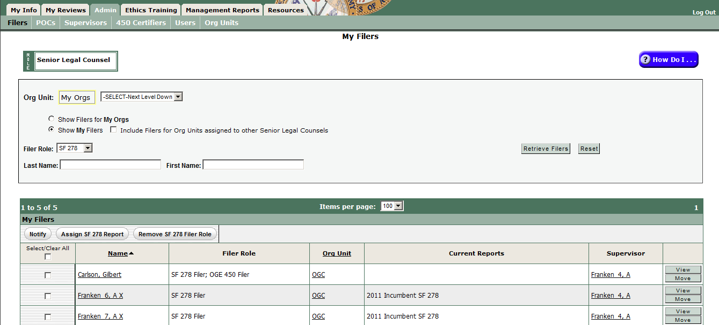
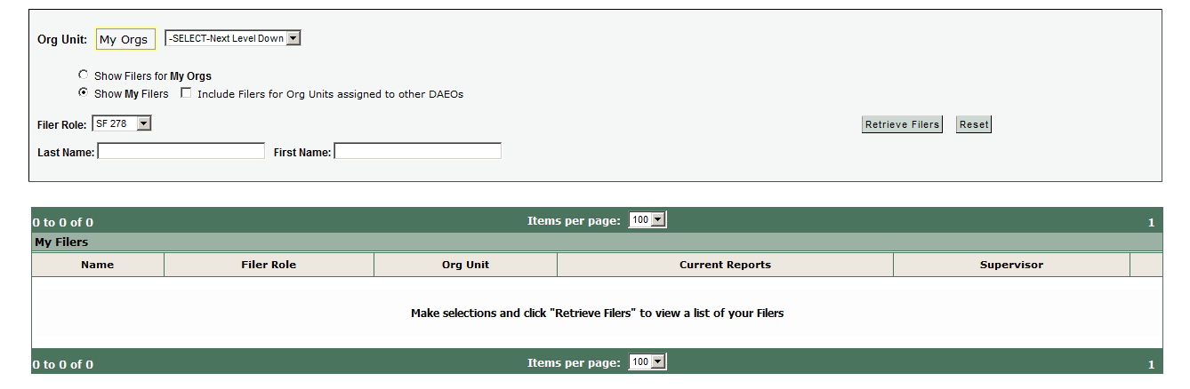

- Click the Retrieve Filers action button to display results in a table like this for all 278 Filers where you are in the report review chain as SLC:
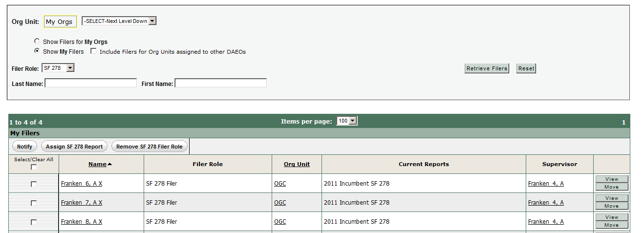
- Check the check box to the left of one or more Filers that you want to assign the same report type.
- Click the “Assign 278 Report” action button and complete the choices for the report year, type, and due date.
- Click Save, Confirm
FDM will display an optional choice to Notify now or not. Decide and click Continue to proceed.
- Remove an Assigned, Not Started report assignment
- Start on the My Reviews | Review Reports – OrgUnit View Mode; check “Show My Filers”
- Search for the Filer
- Click the “Remove Assignment” action button in the far right of the row with the Filer’s report that you want to unassign. This action means that the report will not be counted on the SLC Worksheet extract of information annually reported to OGE on the number and types of 278s.

Management Reports
Using FDM Management Reports & slides
Management Reports
Using FDM 278 & slides

- See who has not started an Assigned 278
- Start on the Management Reports tab
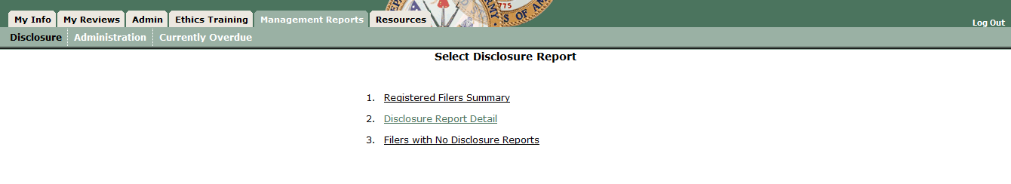
- Click on “Filers with No Disclosure Report” (Choice 3)
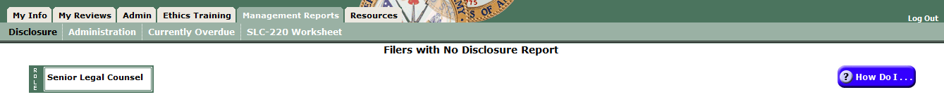
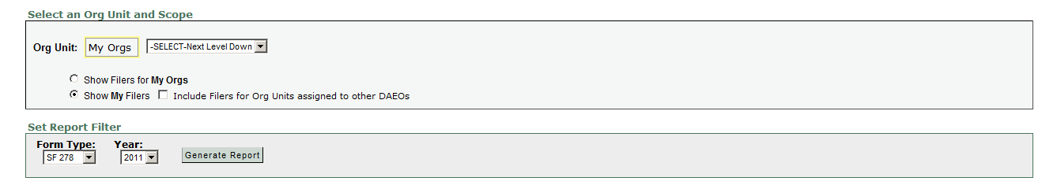

- Clicking “Generate Report” displays a Report Results screen like this:
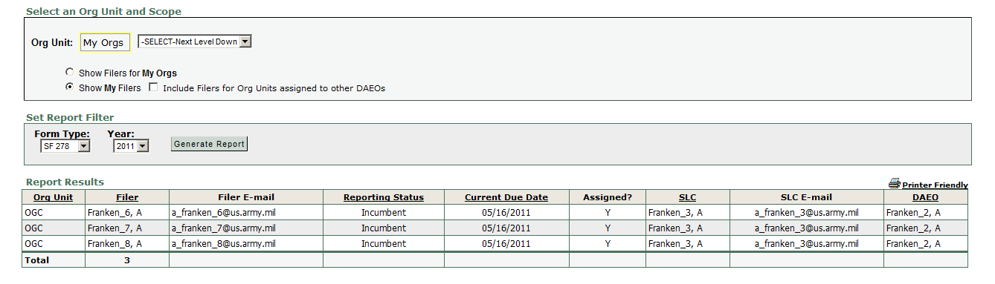
- See 278 review progress
- Start on the Management Reports | Disclosures tab
- Click on “Disclosure Report Detail”
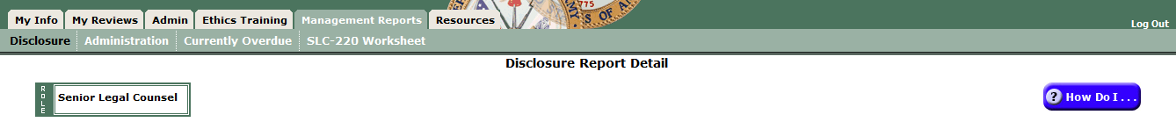
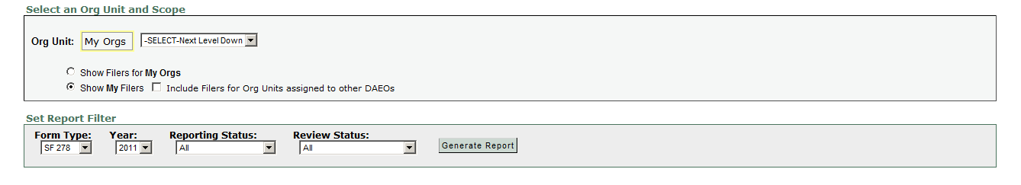

- Clicking “Generate Report” returns a Report Results screen like this:
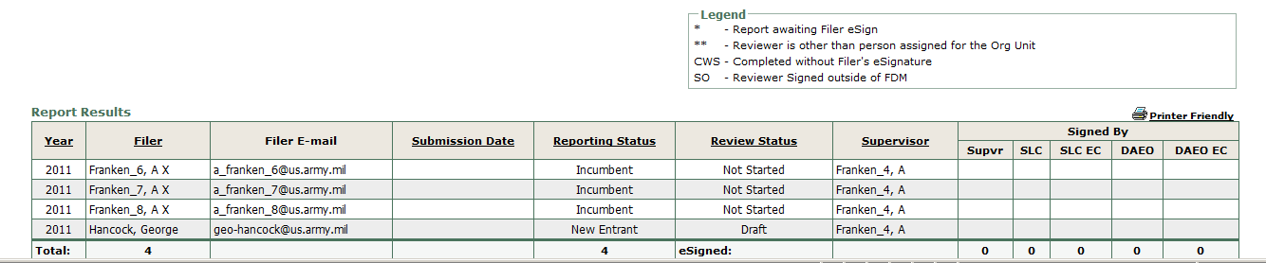
- See a summary (numbers only) of report progress
- Start on the Management Reports | Disclosures tab

- Click on Registered Filers Summary to open this screen:
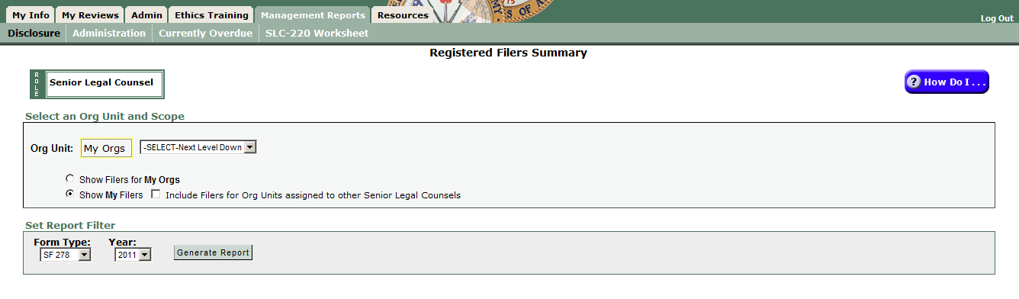
- Clicking “Generate Report” returns a Report Results screen like this:
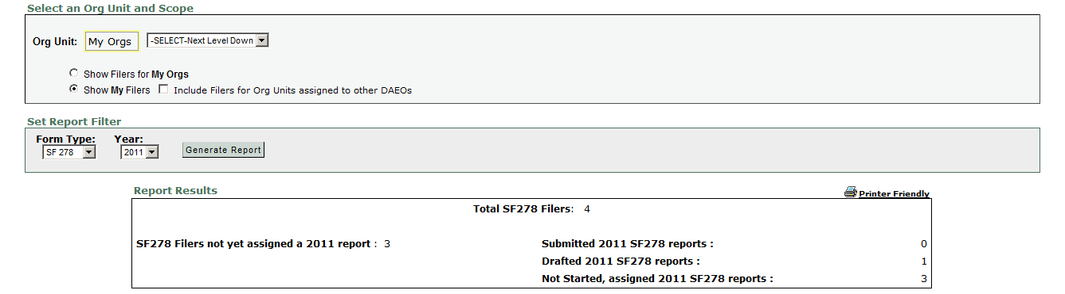

- View a 278
Reviewing a 278 tutorial: https://www.fdm.army.mil/documents/FDM_REVIEWING_A_SF_278_FOR_WEBSITE_53/Reviewing_an_SF_278_TOC.html
Quick Reference: QRC Reviewing a SF 278 https://www.fdm.army.mil/documents/QRC_Reviewing_SF_278.pdf

SLCs (or SLC ECs) may View a 278 in several ways:
  - My Reviews | Review Reports tab – Worklist View Mode (default, most frequently used; displays those reports less than 30 days old ready for your action in a particular FDM role)
  - My Reviews | Review Reports tab – OrgUnit View Mode (will display all 278s in all Review Status – Assigned, Not Started; Draft; Under Review )
  - My Reviews | Manage Exceptions (for reports over 30 days old, reports with Notes)

- Go to the default My Reviews | Review Reports – Worklist View Mode or click the “OrgUnit View Mode” action button (far right, near Common Questions display).
  - Worklist View Mode displays those reports ready for SLC action (Action = “Action Required” as the default).

Default landing screen: My Reviews | Review Reports – Worklist View Mode
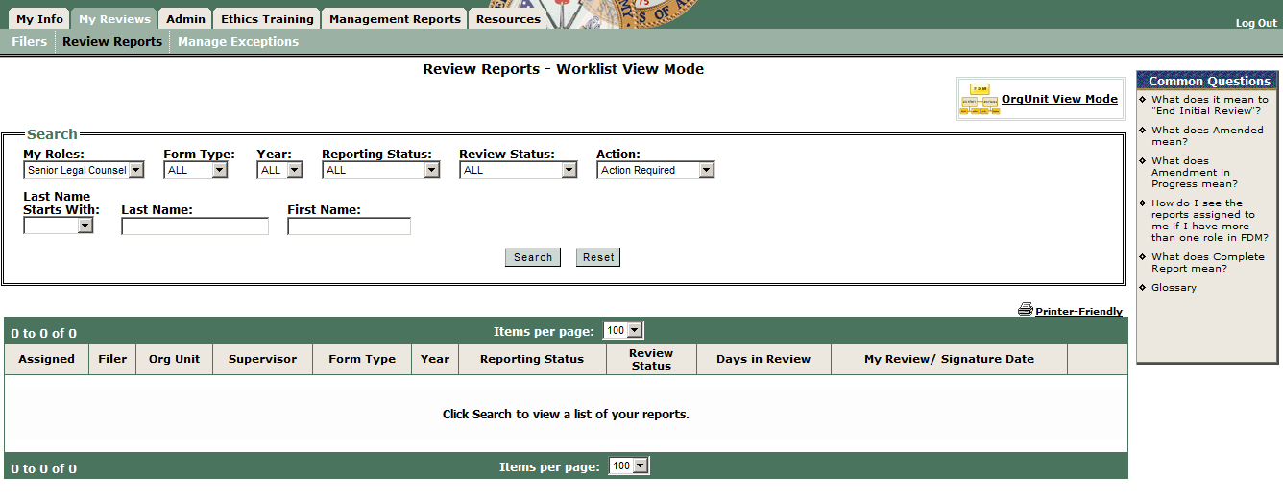

Note: this FDM SLC only has an SLC role. If this user had more than one FDM role the My Roles drop down box would be different and user should pick a role.

Use the defaults and click Search or, to focus only on 278s ready for your action, set the Search filter settings as follows and click Search to load reports ready for your action.

My Role: SLC (SLC EC)
Form Type: SF 278
Year = ALL (or pick from drop down choices)
Reporting Status = All
Review Status = Under Review
Action = Action Required (default) to display only those reports already “Under Review” that you (or your SLC EC have not eSigned)

To see all 278s for Filers under your SLC authority, click “Reset” to restore the original Search settings and click Search.

  - OrgUnit View Mode allows you to set multiple search filter combinations to see specific reports including those over 30 days since the Filer eSigned, those still Under Review and not yet “locked” in “Submitted to DAEO” status for final DAEO action.

Click the “OrgUnit View Mode” action button on the right side to display this screen: My Reviews | Review Reports – OrgUnit View Mode
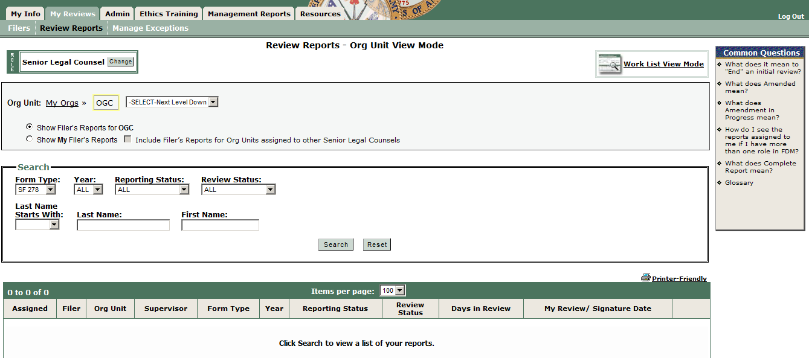
Note: this FDM SLC has other roles so there is a “Change” action button at the far side of the Role box right below the screen title.
Suggestions:
- Use the “Org Unit View Mode” most of the time because it lets you more easily, quickly see more reports in different review status all at once.
- Almost always check the “Show My Filer’s Reports” radio button. (If you have subordinate FDM SLCs and you want to see the reports assigned to them check the check box to the left of the “Include Filer’s Reports for Org Units assigned to other SLCs.”)

- Set desired search filter settings, enter the Filer’s name, and click Search.
- Click the View action button in the row for the Filer’s report you want to open.
- Click View for a report in the table below the Search box to open that report. The Report Data row of tabs will display:

and the Report Progress Bar wizard (below) lets you click through or use Continue to advance through the report sections.

FDM 278 has a “Compare” view for Filers with more than one 278 in FDM:
Click “Compare” to open a view that highlights all changes a Filer made in this report as compared to the prior report.

The Review Reports sub-menu displays sub-tabs (left to right):

- Report Data – main area used for preparing (or reviewing a report with FDM’s report wizard).
- Attachments – add/replace/view attachments associated with a report.
- Comments – area for recording Reviewer comments on a report.
- Flags – identifies missing or incomplete information that must be provided before the report is filed.
  - Red Flags - indicate a significant deficiency or missing information that may prevent the SF 278 from being certified/approved until cleared.
  - Yellow Flags – indicate you may need additional information or clarification. For example, FDM “yellow flags” certain assets (i.e., 401(k), IRA) to remind all involved that the Filer may need to report the underlying holdings in the asset. Look at the asset information to decide if you need more information.
- Audit Trail – tracks all changes made to the report).
- View/Print – provides the user a view and print function for the report.
- Review Status – shows who has reviewed/approved a Filer’s report.
- Compare – highlights changes a Filer made from prior report when prepopulating the current one from the earlier one.
- Previous Reports – displays a Filer’s prior reports in FDM.
- Notes – an area for recording a temporary, Post-it type note as a memory jogger. Note: opening a Report Note temporarily moves the report to the Manage Exceptions area.
278 review suggestions:
- Many FDM SLCs/SLC ECs click the Compare tab (when available), then Comments, Flags, Audit Trail, and Review Status tabs before reviewing the substantive content of a report. These help quickly identify missing or explanatory report information as well as display who else has reviewed the report (Review Status tab). Office of Government Ethics (OGE) financial disclosure report review guides are available on the FDM website Resources tab.
- The Reviewing a SF 278, https://www.fdm.army.mil/Documents/QRC_Reviewing_SF_278.pdf, illustrates how to navigate a 278 in FDM.
- Some SLCs prefer to print the report to review it. Go on the View/Print tab and click View/Print. Return to the wizard view to add any section/line item comments.
- Substantive review: Reviewers are checking the reported financial interests for completeness and to identify those financial interests that may conflict with the Filer’s official duties and that the report is administratively accurate and complete. Before signing off on the report the reviewer must take appropriate steps to resolve any apparent conflicts of interest.
- Generally SLCs or SLC ECs should be familiar with the SF 278, instructions, conflict of interest statutes (18 USC §§ 201 – 209), the financial disclosure regulation (5 CFR Part 2634), the standards of conduct regulation (5 CFR Part 2635 and the Joint Ethics Regulation), and the agency lists of contractors.

- Reviewing an SF 278
SF 278 reviewers conduct two types of review:
- Technical review
- Conflict of interest analysis

- Use this checklist as a guide when viewing a 278.
Report Area | Conducting a technical review*
General | The technical review is an initial determination to see if the Filer provided complete information and properly completed the report. See 5 CFR § 2634. Often, a skilled Army paralegal will conduct the technical review using FDM’s flag system and checking the 278 display to ensure the information reported makes sense. See 5 CFR § 2634.605, Review of reports.  Review presumptions: Accept reports at face value. When information is inconsistent from one year to the next, the reviewer may assume:  - New entry or lack of an entry is correct, if assets that normally would not require disclosure of transactions such as money marked funds, bank accounts, Treasury securities, or cash IRAs, appear or disappear  - Fluctuation in the market value of an asset, if the value category changes to the next category (up or down), without a reported transaction  - Non-reportable change in underlying assets, if mutual funds or limited partnerships earn different types of income  - Non-reportable intra-family transfer, if an asset’s identification as spouse’s, dependent child’s, or joint is different from last year’s designation  The Public Financial Disclosure: A Reviewer's Reference (2004), at pages 4-5, includes guidance on when to contact a Filer for additional information/clarification.
Assets & Income | - Has the filer provided complete information including a value range and type and range of income (unless no income or less than $201)?  - Has the filer reported underlying holdings for investment clubs, private pension interests, investment life insurance, and retirement plans?  - If the filer reported a defined benefit plan, did the filer report the name of the employer providing the plan and identify it as a defined benefit plan?  - If the filer reported a defined contribution plan, did the filer report the reportable underlying assets of the plan (not diversified mutual funds)?  - Did the filer over-report items that should not be reported (e.g., federal government salary, government retirement benefits)?  - When a previously reported asset no longer appears you may presume that it fell below the reportable threshold.  References: 5 CFR § 2634.301; also see Reviewer’s Reference, § 3.3
Transactions (New Entrant Filers do not report) | Review assumptions:  - Complete sale assumption. Asset is listed as sold on last year’s 278 and does not appear on the current year’s report. Assume the entire holding was sold only if the sale amount is no more than one category of value below the previous asset value.  - No reportable income assumption. Asset is listed as sold on Transactions and is not listed as an asset. Assume that the entire holding was sold if the sale amount is no more than one category of value below the previous asset value.  - Market fluctuation assumption. The purchase price differs from the value of the asset listed by one category (higher/lower). Assume market fluctuation explains the difference.  Consider these questions:  - Has the filer provided complete information on each transaction?  - Was Filer required to divest any interest? If so, was it accomplished timely? Was there a certificate of divestiture?  - Compare with changes in Assets between years. For example, compare this year’s assets list against last year’s to see if assets no longer listed are reported as transactions this year.  References: 5 CFR § 2634.303; also see Reviewer’s Reference, § 3.4
Gifts, Reimbursements & Travel Expenses | - Has the Filer adequately described the gift, the donor, and the value of the gift?  - Is the value over the reportable threshold ($305 in 2008)?  References: 5 CFR § 2634.304; also see Reviewer’s Reference, § 3.5
Liabilities | Review assumption: assume the filer paid the debt off or the loan value dropped below the $10,000 reporting limit when a liability in the $10,000 -$ 15,000 value category on last year’s report is not on this year’s report.  - Did the filer report any liability that exceeded $10,000?  - Did the filer report the creditor’s name, city, and state?  - Did the filer over-report items that should not be reported (e.g., loans for automobiles, household furniture, or appliances (as long as the loan does not exceed the purchase price); revolving charge accounts with a balance of less than $10,000 at the end of the reporting period; obligations arising from a divorce or permanent separation.)  - Is the reporting this year consistent with liabilities reported last year?  - If mortgage on rental property is reported check to see that the rental property is reported as an asset and if income is reported  Reference: 5 CFR § 2634.305; also see Reviewer’s Reference, § 3.6
Agreements & Arrangements | - Evaluate the completeness of each entry (e.g., the name of the parties, the location, terms, and, if there is an arrangement for future employment, the date when the arrangement was made  - Confirm that pension plans are also reported as assets. In addition, they may earn interest and/or reportable dividends even if the Filer is not receiving income now.  - Confirm that the filer is not over reporting.  Reference: 5 CFR § 2634.306; also see Reviewer’s Reference, § 3.7
Outside Positions | Time period covered:  - New Entrants must disclose outside positions held during the prior two calendar years up to date of filing.  - Incumbent/annual filers report for the prior calendar year.  - Evaluate the completeness of each position reported (e.g., name, location of the organization, type or purpose of the organization, and specific position held)  - Verify that pertinent income-producing activities are also reported in the assets/income section of the report.  - Confirm that the filer is not over-reporting (e.g., did not report positions held by spouse or dependent child(ren); compensated or uncompensated positions held in any religious, social, fraternal, or political entity; positions solely of an honorary nature, positions filers hold as part of official duties, mere membership in an organization).  - Did filer receive over $200 in income from any reported position? If so, is it reported as income?  - Consider outside activity approval forms (if available)  Reference: 5 CFR § 2634.307; also see Reviewer’s Reference, § 3.8
Compensation in Excess of $5,000 Paid by One Source  (New Entrant Filer reports) | - Evaluate the completeness of each item reported – is the name and address of the source provided? Is there a brief description of the duties the filer performed for that source?  Reference: 5 CFR § 2634.308(b)(6); also see Reviewer’s Reference, § 3.9
*Adapted from OGE Course Materials: Analyzing Public Financial Disclosure Reports Course

- Conflict of Interest analysis:
Your conflict of interest analysis is to ensure that filers do not:
- Have interests that conflict with their official duties
- Have even an appearance of a conflict
- Receive income from sources that may be affected by actions Filers take in their official capacity

Note: Reviewers need to know a Filer’s duties to determine if there is a conflict of interest.

Use this checklist when checking a 278 for possible conflict of interests. (Refer to appropriate sections of OGE’s Public Financial Disclosure: A Reviewer's Reference (2004) for more detail, as needed.)
Report Area | Considerations to conduct a conflict of interest analysis:
Admin – Filer’s position, grade | - What official duties does the filer perform?  - Does the filer deal with non-federal entities?
Assets & Income | When doing a conflict of interest analysis on assets and income sources, a wide variety of potential conflicts exist, including:  - 18 USC § 208, acts affecting a personal financial interest  - 5 CFR 2635.502, appearance issues in personal and business relationships  - 18 USC §§ 203, 205, representation issues  - 18 USC § 209, supplementation of salary issues, with potential for a continuing financial interest under 18 USC § 208  Consider these questions:  - Are any of the reported interests in DoD contractors or are they on a DoD/Army prohibited holdings list?  - Do any of the reported financial interests raise a potential conflict with the filer’s official duties:  - Determine if the filer might take an official action that would result in a monetary gain or loss to himself or those whose financial interests are imputed to him  - Consider whether the filer’s official action may create an appearance of a conflict of interest  - Decide if the filer has a covered relationship that creates an appearance of a conflict of interest
Transactions | The purpose of reviewing filer’s transactions is to verify filers reported activities as assets/income or divested (if directed) and used a certificate of divestiture  - Are any of the reported transactions interests in DoD contractors or are they on a DoD/Army prohibited holdings list?  - Do any of the transactions involve financial interests in prohibited sources?  - Did filer divest (if ordered)?
Gifts & Travel Reimbursements | - The relationship between donor and filer  - Was gift given because of filer’s official position?  - What could donor and its affiliates gain from filer’s official performance of duties?  - Is the donor a prohibited source?  - Consider bribery and supplementation of salary issues (18 USC § § 201, 209)  - How frequently does donor give gifts? Does a gift exception or exemption apply?
Liabilities | - Does filer have a loan with a prohibited source? If yes: ask about  - loan terms (e.g., same as available to general public or more favorable) &  - filer relationship to creditor  Notes:  - Loans between government employees could violate standards of conduct. Lenient loan terms more favorable than generally available could represent an unauthorized gift to a superior or gifts between employees.  - Special lower than common loan terms could reflect normal economic motives on the lender’s part (e.g., offering a lower rate to a customer with very large deposits or exceptional credit-worthiness).
Agreements & Arrangements | - What are the terms of the agreement/arrangement – do they indicate any special treatment because of filer’s federal job?  - Could filer take an official action that could result in a monetary gain or loss to himself or the entity with which he has an agreement/arrangement?  - Whether filer’s official action may create an appearance of a conflict of interest  - Whether filer has a covered relationship that creates an appearance of a conflict of interest
Outside Positions | - Do any of filer’s official duties impact any of the organizations listed?  - What does filer do for the listed organization?  - Watch for situation where filer may attempt to represent the organization before the Government (18 USC §§ 203, & 205)  - Is filer an employee of the organization and does filer take Government action that affects the organization (18 USC § 208)?  - Note: board memberships and similar officer positions have some control over the activities of an organization that could pose a conflict or appearance problem with filers’ official duties.
Compensation in Excess of $5,000 Paid by One Source | New entrant and nominee filers must report any source of compensation over $5,000 paid for their personal services during the preceding two calendar years and current calendar year up to date of filing.  - Did filer identify source?  - Did filer provide a brief description of the duties performed?  Special rules may apply allowing filer to report compensation without disclosing the client’s identity – see Reviewer’s Reference,
*Adapted from OGE Course Materials: Analyzing Public Financial Disclosure Reports Course

- Change a Supervisor on this 278 only
- View the report from the My Reviews | Review Reports – OrgUnit View Mode display.
- Click on the Review Status tab of the report.
- Click on Show Review Chain Controls:
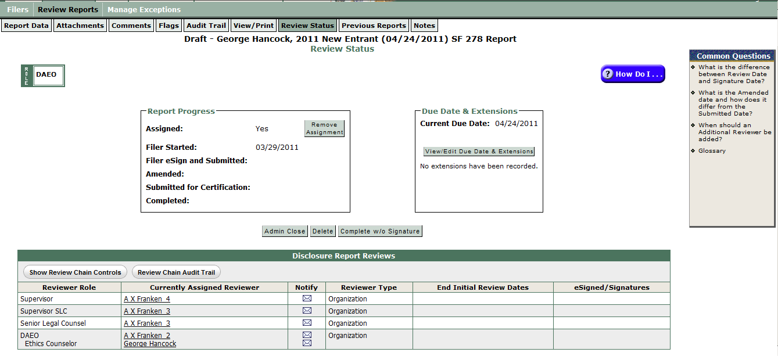

Notice the change in the Review Chain table:
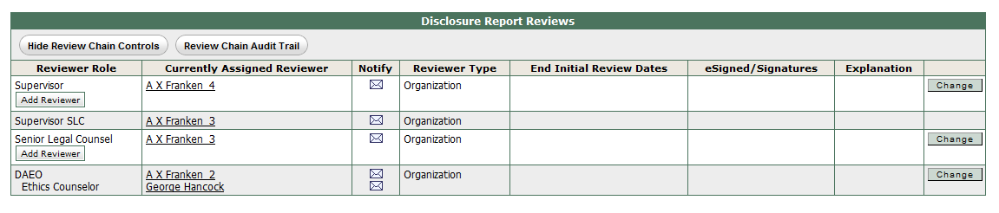

- Click “Change” in the row for the Supervisor to see this screen with several options:
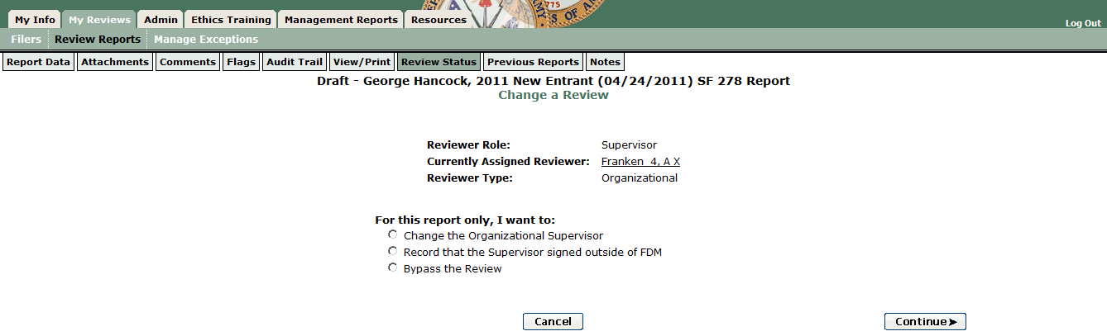
- Check the radio button to the left of “Change the Organizational Supervisor,” Click Continue, and follow the on screen prompts to change the Supervisor reviewer.
- Record that Supervisor reviewed outside FDM
- View the report from the My Reviews | Review Reports – OrgUnit View Mode display.
- Click on the Review Status tab of the report.
- Click on Show Review Chain Controls:

Notice the change in the Review Chain table:

- Click “Change” in the row for the Supervisor to see this screen with several options:
- Check the radio button to the left of “Record that the Supervisor signed outside of FDM,” Click Continue, and follow the on screen prompts to record the Supervisor’s review.
- Bypass a Supervisor review
- View the report from the My Reviews | Review Reports – OrgUnit View Mode display.
- Click on the Review Status tab of the report.
- Click on Show Review Chain Controls:
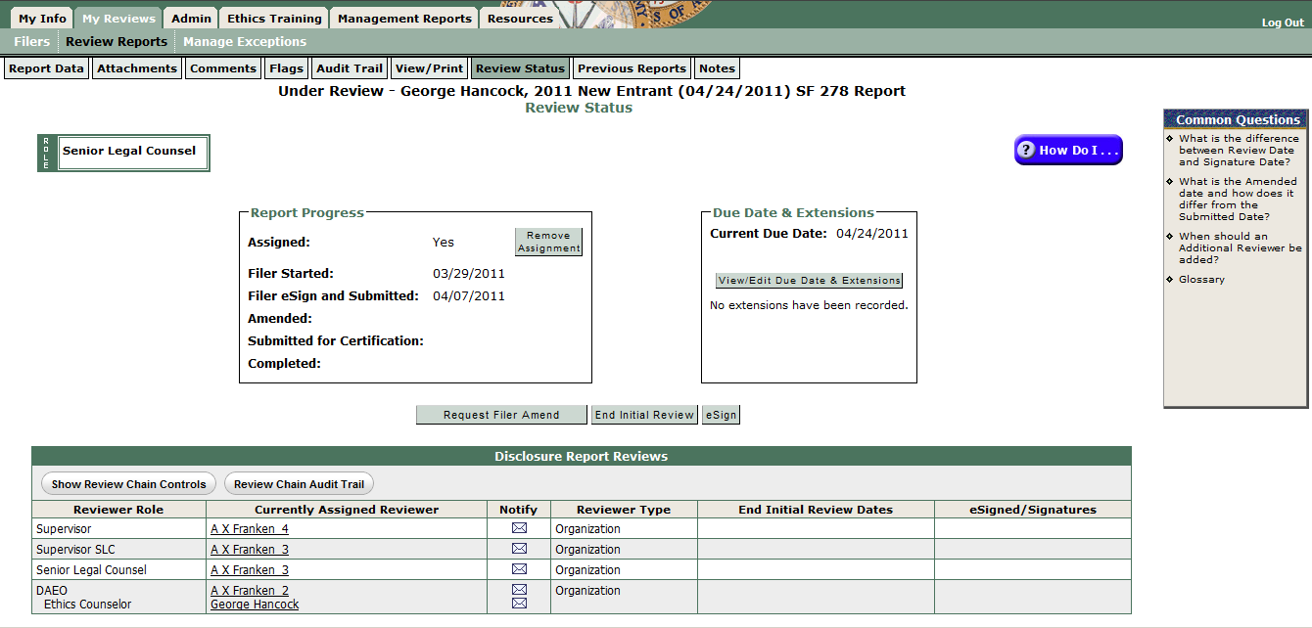

Notice the change in the Review Chain table:

- Click “Change” in the row for the Supervisor to see this screen with several options:
- Check the radio button to the left of “Bypass the Review,” Click Continue, and follow the on screen prompts to bypass (skip) the Supervisor reviewer.
SLC/SLC EC action options
Report Status | SLC/SLC EC Possible Actions on an FDM 278
Assigned, Not Started | Remove assignment or record an extension
Draft | Admin Close
Under Review | Admin Close, Request Filer Amend, eSign
Submitted to DAEO | View
Complete | View, Add supplemental Comments or Attachments

Note: The DAEO role can only complete a report that is in Submitted to DAEO review status. Beginning with Release 6.0.3 (March 30, 2011) FDM automatically advances an FDM 278 to Submit to DAEO status after both the Supervisor and SLC/SLC EC eSign the report so SLCs no longer need to click the Submit to DAEO action button.

Report in Under Review status SLC/SLC EC options:
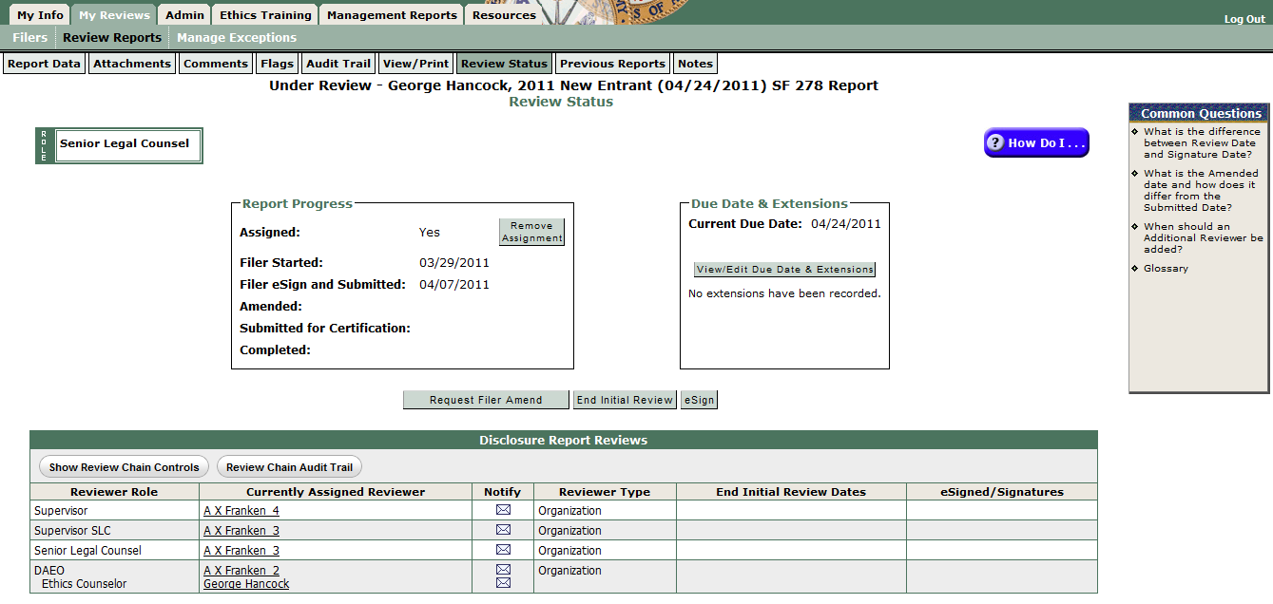

- Request Filer Amend – starts the process to request Filer amend the report. Use when you decide Filer must personally provide additional information in the report.
- End Initial Review – allows recording that you have reviewed the report but are not ready to eSign and Complete. See 5 CFR 2634.605 for OGE’s 60-day review rule.
- eSign – click to record your review of the report
- Add an Ethics Counselor
- Start on the My Info | My ECs tab:
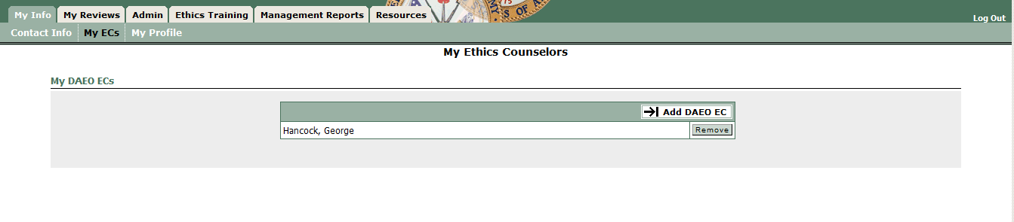

- Click on “Add SLC EC” and the My Info | My ECs tab displays the My Ethics Counselors page (below). Click on Add SLC EC. That opens the Add A New Ethics Counselor page (below) with the Search tool to find the EC to add:
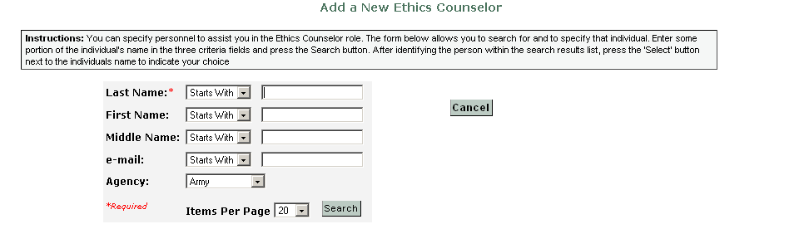
Tip: If you know the CAC-embedded email address (e.g., for Army personnel it is the AKO User Name) you may enter a few letters of the last name and then enter that in the email search box, then select Search.
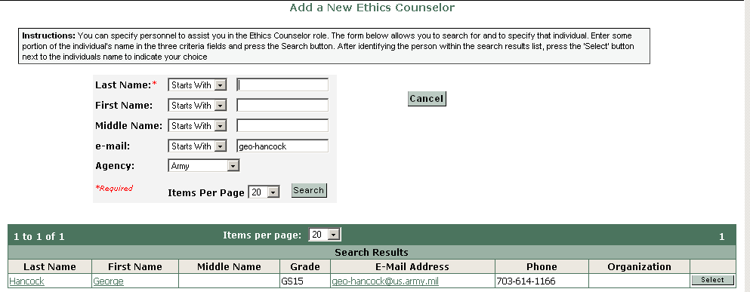

- The result will be a list of names, Select the right one and Confirm to add the EC:
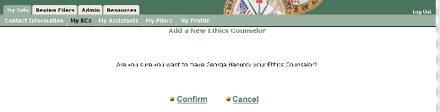
- The SLC EC can add new Org Units, register 278 Filers and Supervisors, record extensions, assign/replace 450 Certifiers, and see the SLC's report list to monitor Filer progress and eSign a report for an SLC (when authorized).

- FDM will email the person you added that (s)he now has FDM access as your SLC EC.
- Remove a departed Filer
- Start on the Admin | Filer tab, check the “Show My Filers” radio button
- Enter the Filer’s name
- Click Search
- Check the check box to the left of the Filer’s name
- Click the “Remove 278 Filer Role” action button, Confirm

- Inform/Remind my Filer(s) to eFile in FDM
- The annual Incumbent 278 Filing season starts 1 January. FDM automatically assigns an Incumbent report to 278 Filers registered in FDM on the last duty day of the year (unless that Filer eFiled a New Entrant with an appointment date of 2 November or later). If you add Filers the next year be sure to also assign the appropriate report. See assign a 278.
- Most 278 Filers don’t need to file until they have the information needed to complete their annual income tax return (usually mid-April). Mid-April is often the best time to notify your Filers to eFile their annual Incumbent report.
- Suggested email notice for your editing:

Subject: Your Incumbent SF 278, Public Financial Disclosure Report, is due 15 May 20xx

Content for your editing:

Again this year we are using FDM, https://www.fdm.army.mil, to eFile the 278. You are registered as a Public Financial Disclosure Report (OGE 278) Filer. You may login to FDM using either your CAC/PIN or AKO user name/password (as long as it is current with AKO). FDM login assistance: https://www.fdm.army.mil/faq3.html.

Upon first login annually FDM will display your Contact Info screen to review/update. When finished FDM will show you the My Reviews | Review Reports tab if you have a Supervisor role. Click on the My Reports tab to start the assigned Incumbent report.

FDM 278 Filer Quick Start, https://www.fdm.army.mil/documents/278FilerQuickStart.doc, to help orient you on FDM use and what & what not to report.

There were no reporting rule changes. FDM's Filer wizard will offer you the prepopulate option if you have previously eFiled in FDM when you start the report due in May covering calendar year 20xx-1. In FDM, the report is labeled as the 20xx report because it will be esigned in 20xx. The reporting period, however, is for Calendar Year (CY) 20xx-1.

Contact __________ if you have questions about what to report or need an extension.

FDM Help Desk: 732-720-6454 or DSN 848-8679 (8:00 a.m. - 5:00 p.m. Eastern time, M- F); email: usarmy.APG.cecom.mbx.FDMSpt@mail.mil

[Optional]
Retiring or departing before 15 May? File a Termination 278 instead of an Incumbent report. If going to another covered position within 30 days of leaving the Army you do not need to file with the Army.

Retiring or departing after 15 May and before 13 Aug? You may request an extension to file a combination annual and termination report, which covers all of 20__ and runs through your termination date. A combination report may not be filed later than August 13. If you choose to file a combination report, please let your Ethics Counselor know so that he/she may grant you an extension on your calendar year 20__ annual report.

Planning on working for a Defense Contractor after departing DoD? If so, the FY 2008 National Defense Authorization Act contains a provision that may apply to you. If you participated personally and substantially in an acquisition valued over $10,000,000, regardless of whether you are in an acquisition position, you are required to request a written opinion from an ethics counselor regarding the applicability of post-employment restrictions to activities that you may undertake on behalf of a DoD contractor-employer. Such contractors are prohibited from paying you during a two-year period following your departure from DoD unless you have either received the opinion or requested it at least 30 days prior to receiving compensation. We highly recommend that you consult your Ethics Counselor before seeking employment with anyone, and, to avoid problems with receiving future compensation, that you request the required guidance when you are considering future employment with a specific DoD contractor. Request an opinion at https://www.fdm.army.mil/AGEAR. Your Ethics Counselor may assist in determining whether you need to request an opinion.

Closing
Your Signature block

- Advise Supervisor how to review/eSign in FDM
- Filers sometimes notify their Supervisors concurrent with eSigning that the report is ready for Supervisor review. Some SLCs (and Supervisor SLCs) encourage the SLC to first review and then coordinate with the Supervisor SLC instead of the Supervisor directly.
- Here is suggested email content you could edit/send to your Filer’s Supervisor to review in FDM.

Subject: Reviewing Filers Name’s 278 in FDM

Content for editing:

Filer name’s 20__ Under Review 278 is ready for you to review and eSign in Financial Disclosure Management (FDM). Please review the 278 to check reported financial interests for completeness and identify any that may conflict with the Filer’s official duties. Please contact me if you have questions.

[I have reviewed this report and note the following: no apparent conflicts or ______________________.]

Please review this report by following these instructions:

- Go to FDM, https://www.fdm.army.mil, click on "Login to FDM" and click "OK" on the DoD banner Popup.
- On the right side, choose to login with your CAC/PIN (DoD users) or Login with User Name/Password (as appropriate) (non-DoD users (Army may also use AKO user name/password)).(If this is the first time you are entering FDM, you will see a Contact Information screen to review, update, and complete. Click Save when finished.)
- Click the Review Reports tab.
- Type Filer’s name in the Search fields.
- Click Search.
- Click View beside the Filer's report to begin the review.
- When finished go to Wrap Up or the Review Status screen of the report and click eSign to record your review.

References:
Supervisor review quick start: https://www.fdm.army.mil/documents/SupervisorReviewQuickStart.doc

Short narrated video, Reviewing a 278, https://www.fdm.army.mil/documents/FDM_REVIEWING_A_SF_278_FOR_WEBSITE_53/Reviewing_an_SF_278_TOC.html, on FDM mechanics.

Closing
Signature block

- Oversee FDM 450 Report Progress
- The Joint Ethics Regulation implements OGE regulations that indicate responsible Ethics Officials shall review reports within 60 days of filing (see 5 CFR 2634.605(a); date of eFiling in FDM starts the 60-day review time clock). (See OGE Program Management Advisory PA-11-04, http://www.oge.gov/DisplayTemplates/ModelSub.aspx?id=2147484468.)
- FDM has several standard management reports to help you monitor FDM 450 report processing. A short narrated recording, Using FDM Management Reports, https://www.fdm.army.mil/PM_Reference_Docs/SLCStatus/SLCStatus.html, and slides: https://www.fdm.army.mil/PM_Reference_Docs/SLCStatus.ppt, explain how to use the FDM Management tools.
- Here are brief explanations of two available reports and suggestions for SLC/SLC EC action. You may want to run these reports weekly beginning mid-March annually until all OGE 450s are Complete.
- Disclosure Report Details
- Start on the Management Reports | Disclosure tab.
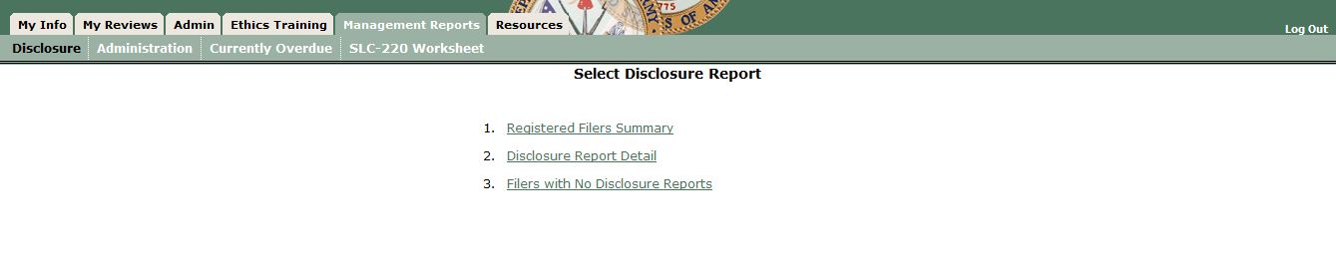
- Click on Disclosure Report Detail to see the screen below:
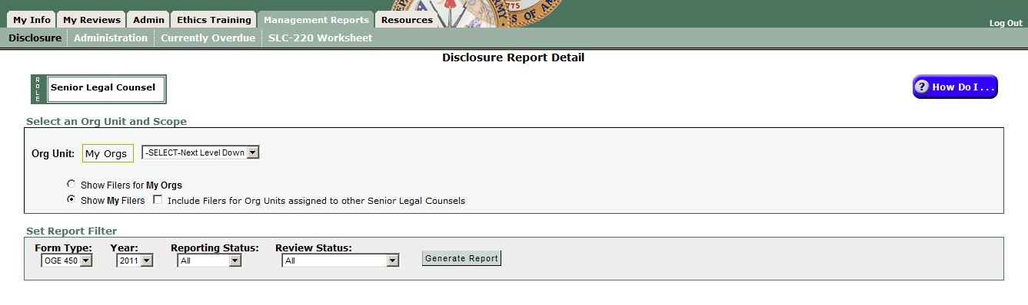
- Select Form Type = OGE 450, click “Generate Report” to see a report of the status/completion of reports:
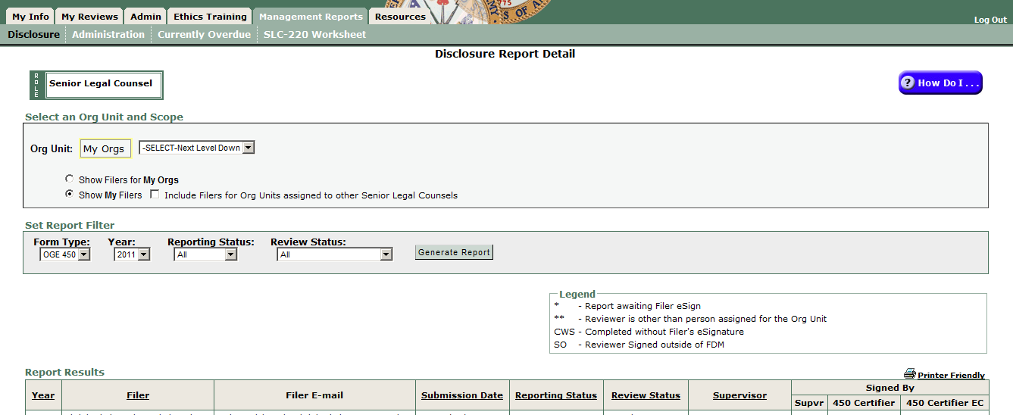
- Consult with your 450 Certifier to act on the unfinished reports, especially those that (s)he or the 450 Certifier Assistant has not indicated an initial review within 60 days from the Filer’s eSign.
- You may find the FDM450SITREP.doc (https://www.fdm.army.mil/PM_Reference_Docs/FDM450SITREP.doc) template a useful way to prompt the 450 Certifier to clean up Assigned, Not started reports near year end. See those reports on the Management Reports | Disclosure tab, Option 3, Filers with No Disclosures.

- See a report of overdue FDM 450s
- Start on the Management Reports | Currently Overdue:
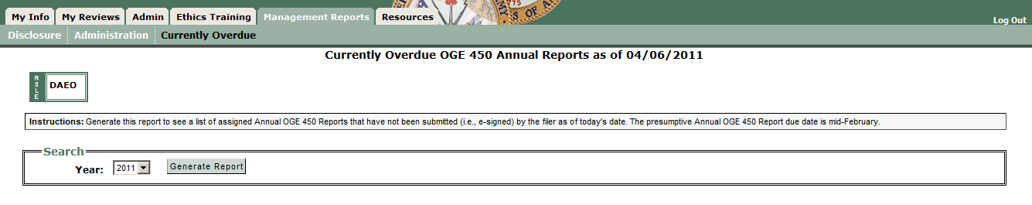
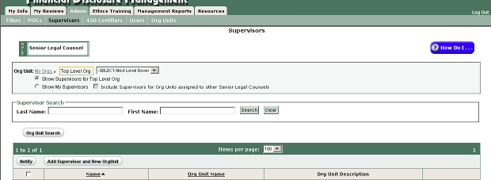

- Click “Generate Report” to see a Report Results screen that shows Filers assigned reports that are late (past the due date or extended due date):

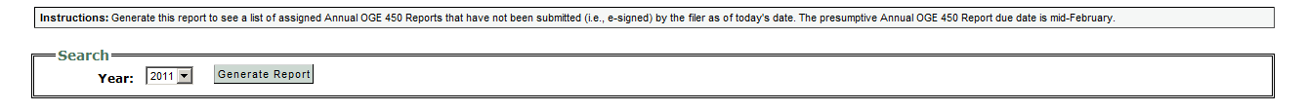

Suggestion: Task the 450 Certifier (EC) or 450 Certifier Assistant to use the My Reviews | Remind Filers tab to notify 450 Filers who are late. They will have an option to include the Filer’s Supervisor on that notice.

- Assign (or change) 450 Certifiers
- The SLC (or SLC EC) role may assign new or replace departed 450 Certifiers (those appointed Ethics Counselors delegated responsibility to review and certify OGE 450s).
- Start on the Admin | 450 Certifier tab
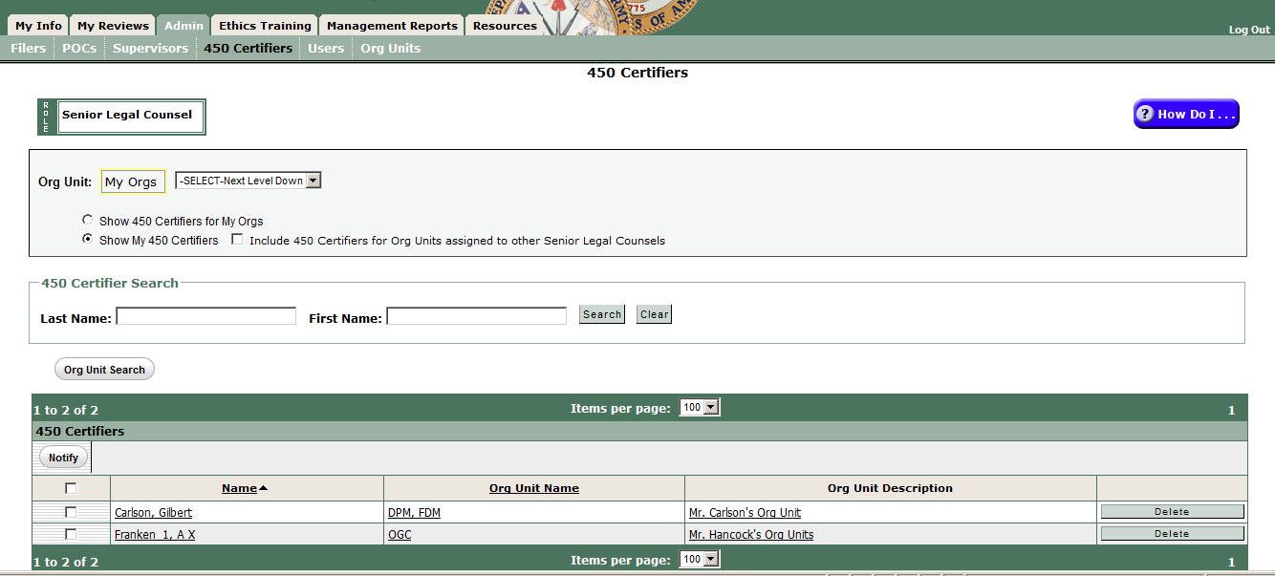
- Click the down arrow to the right of Select Next Level Down drop down list to reach the FDM org unit where you want to assign (or replace) the current 450 Certifier.
- In the table displayed at the bottom you will see a “Delete” action button if someone is already assigned or an “Assign” button to assign an EC. Click on the action button and follow the onscreen prompts to complete the action.

Alternative method:
- Start on the Admin | Org Unit tab.
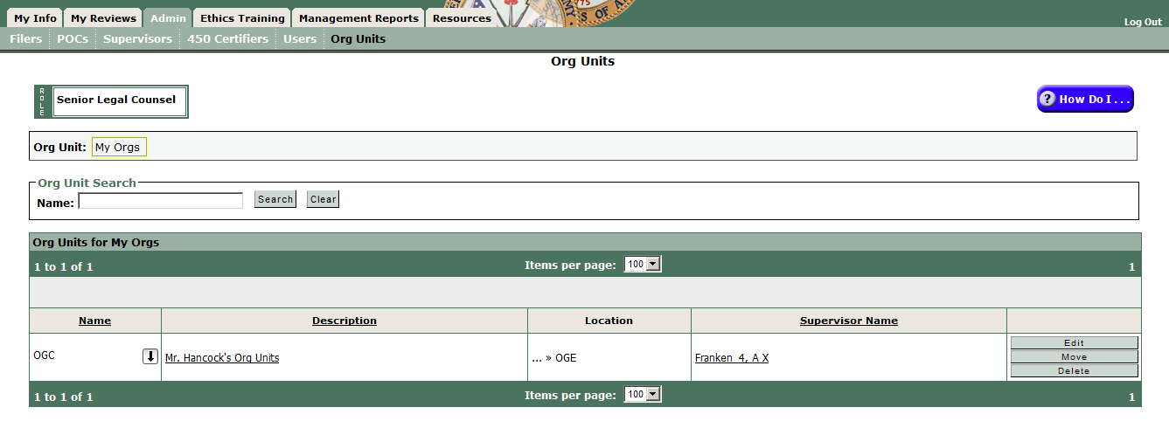
- Click the down arrow by the org unit name shown until you reach the org unit or search for the org unit
- Click Edit in the org unit name row to open the “Edit Org Unit – Name” screen (below):
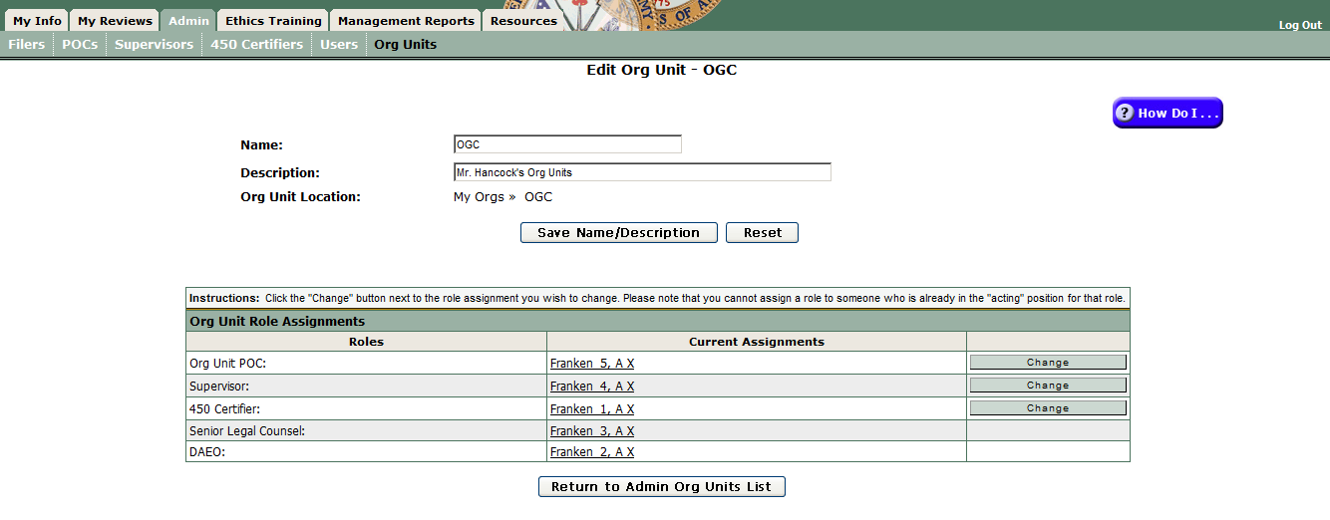

- Click Change in the 450 Certifier role row and follow the onscreen prompts to assign a successor 450 Certifier for that org unit (and all subordinate ones until someone else is assigned to that role).

