Legal Office Standing Operating Procedure (SOP) for Electronically Filing (Efiling) & Managing SF 278, Public Financial Disclosure Report

[Introduction.
This is a template for Deputy Designated Agency Ethics Officials/legal office use to electronically file (eFile) and manage the SF 278, Public Financial Disclosure Report. It sets forth one way to migrate from a paper-based filing and processing system to the Army’s secure online eFiling system, Financial Disclosure Management (FDM), https://www.fdm.army.mil. Army policy established eFiling using FDM as the normal way to process SF 278s beginning in 2005 for Army personnel with a Common Access Card (CAC) and/or registered on Army Knowledge Online (AKO). All Army SF 278 Filers should be registered in FDM upon appointment to a position that requires filing the SF 278 (e.g., promotion to brigadier general, Senior Executive Service). FDM limits access to individuals in the Filer’s report review chain or associated with a Filer.

In subsequent years of use FDM users will see improved report accuracy and efficiency in the report process and save time. Reviewers will also save time using FDM’s report comparison tool (available in 2008 for Filers with two reports in FDM.)

FDM supports the DoD transformation of enterprise management and a specific DoD priority: “Improve Effectiveness and Efficiency Across the Board.” FDM is currently being considered for DoD Enterprise-wide use and is in use in OSD, JCS, the Air Force, Navy, Air National Guard, DISA, the Office of Government Ethics, and the Department of Veterans Affairs, among others.

In this SOP template text in brackets [Office name] indicates suggestions for local substitution or deletion. Further local tailoring may be appropriate. Please send any comments or suggestions for improving this SOP to the FDM webmaster: FDMwebmaster2@hqda.army.mil.]

1. Purpose.
This SOP establishes [legal office installation / location] procedures for using Financial Disclosure Management (FDM) to electronically file, review, and process the SF 278, Public Financial Disclosure Report (PFDR) at [location] and for organizations the [SJA/legal office, location] supports.

2. References. [add others as appropriate, e.g., MACOM Ethics Regulation]

a. 5 C.F.R. 2634, Executive Branch Financial Disclosure, Qualified Trusts, and Certificates of Divestiture, http://www.usoge.gov/pages/laws_regs_fedreg_stats/oge_regs/5cfr2634.html.

b. OGE Frequently Asked Questions about the SF 278, http://www.usoge.gov/pages/financial_disclosure/sf_278_faqs_pg1.html. (Many are incorporated in to FDM’s Common Questions and display on the screen associated with a particular section of the PFDR.)
- c. OGE’s Public Financial Disclosure: A Reviewer's Reference (2004), a 367 page reference manual for reviewers of the PFDR. It contains an introduction to the PFDR system, the procedures and mechanics of review and conflict resolution, summaries of applicable ethics laws and regulations, sample SF 278 entries, model letters and documents related to the review process, and case studies. It is available on the FDM Resources page, https://www.fdm.army.mil/helpSupport/resources.htm.

d. DoD 5500.7-R, Joint Ethics Regulation (JER) 7-200 to 7-209, http://www.dod.mil/dodgc/defense_ethics/ethics_regulation/index.html, Enclosure 1.

e. Prevention of Violations of Post-Government Service Employment Restrictions, OSD 15517-04 (October 25, 2004) JER 8-400 (FDM implements this certification concurrent with a Filer eSigning the SF 278 so FDM 278 eFilers do not need to prepare separately.)

f. Army General Counsel Memorandum, Subj: Designation of Deputy Designated Ethics Officials (DAEOs) & Delegation of Authority UP JER, DOD 5500.7-R, January 03, 2007, http://www.hqda.army.mil/ogc/Delegation%20of%20Authority%20DAEOs.pdf, as amended by Designation of Deputy DAEOs & Delegation of Authority UP JER, DOD 5500.7-R, April 16, 2007, http://www.hqda.army.mil/ogc/Delegation%20April%202007.pdf.

g. Ethics Counselor Course materials on Financial Disclosures available online at http://www.hqda.army.mil/ogc/5ECC%20Main%20Page.htm.

h. DoD Contractors list (updated annually), available in DoD SOCO Ethics Library, http://www.dod.mil/dodgc/defense_ethics/resource_library/index.html.

i. OGC Memorandum, subject: Ethics Training, 3 August 2007, http://www.hqda.army.mil/ogc/eandf-OGC_memos.htm.

j. Useful Ethics-Related web sites (see Enclosure 2).

k. OGE DAEOgram DO-05-019, Documenting Ethics Advice, http://www.usoge.gov/pages/daeograms/dgr_files/2005/do05019.txt. (Consider FDM’s Comment and Attachment features when documenting ethics advice on specific financial disclosure reports.)

l. DAEOgram, DO-07-007, Clarification of the Scope of an Exception and an Exclusion to the Public Financial Disclosure Reporting Requirements, http://www.usoge.gov/pages/daeograms/dgr_files/2007/do07007.txt

m. DAEOgram, DO-06-011, Scope of Public Financial Disclosure Reporting Exception for Compensation from an Individual with Whom the Filer is in a Privileged Relationship, http://www.usoge.gov/pages/daeograms/dgr_files/2006/do06011.txt

n. FDM SLC 278 User Guide (updated in February annually), available on FDM Resources, https://www.fdm.army.mil/helpSupport/resources.htm.

o. FDM Glossary, https://www.fdm.army.mil/learningCenter/glossary.htm.

p. FDM 278 Common Questions & Answers, https://www.fdm.army.mil/helpSupport/commonQuestions278.htm.

r. The FDM Learning Center has tutorial "movies" on managing org units and
Filers: https://www.fdm.army.mil/learningCenter/tutorials.htm, Quick References, and the Release 4.1 User Guide, https://www.fdm.army.mil/learningCenter/documentation.htm.

3. General.

a. The OGE government-wide regulations in 5 C.F.R. Part 2634 provide the policy for the PFDR system. Public and confidential financial disclosure serves to prevent conflicts of interest and to identify potential conflicts, by providing for a systematic review of the financial interests of both current and prospective officers and employees. These reports assist agencies in administering their ethics programs and providing counseling to employees. Financial disclosure reports are not net worth statements. Financial disclosure systems seek only the information that the President, Congress, or OGE as the supervising ethics office for the executive branch has deemed relevant to the administration and application of the criminal conflict of interest laws, other statutes on ethical conduct or financial interests, and Executive orders or regulations on standards of ethical conduct. OGE approved FDM for electronic filing of SF 278s.

b. The Department of Defense (DoD) supplemented the regulation with the "Joint Ethics Regulation” (JER), DoD 5500.7-R. JER 7-200 et.seq. provide guidance for DoD SF 278 reports (see Enclosure 1).

c. The Designated Agency Ethics Official (DAEO) and appointed Deputies (DDAEOs) administer, oversee, and manage financial disclosure reporting for their area of responsibility. They must identify and inform new employees who have to file.

d. Ethics training.

(1) Deputy DAEOs are responsible for developing a written plan for annual ethics training (see references 2f and 2i, 5. C.F.R. 2638.706, and JER 11-302).

(2) SF 278 Filers must receive/complete annual ethics training each year. IAW reference 2i SF 278 Filers supported by [legal office installation / location] receive/complete annual ethics training [describe method(s)].

4. Responsibilities.

a. In April 2005, the Secretary of the Army approved and directed use of the Army’s online eFiling system, Financial Disclosure Management (FDM) (https://www.fdm.army.mil), as the method to process SF 278s.

b. The Army General Counsel designated several Deputy DAEOs including The Judge Advocate General, the Assistant Judge Advocate General, the Chief Counsel, US. Army Corps of Engineers, the Command Counsel, US Army Materiel Command, and Chief, Standards of Conduct Office (reference 2f). The designation included delegation of responsibility to oversee the financial disclosure reporting process and annual Ethics Training for the DDAEOs’ organization(s).

c. The [appropriate DDAEO, e.g., TJAG] appointed the [Staff Judge Advocate/other] as an Ethics Counselor with responsibility for [ regarding managing] SF 278s for Filers at [installation and/or supported organization location] (see Enclosure 3).

d. Filers are responsible for timely filing (i.e., within 30 days of promotion to general or confirmation as a Senior Executive Service employee, or annually by 15 May). Reports filed late may require payment of a $200 late fee unless appropriate authority approves a late fee waiver request.

e. Supervisors of SF 278 Filers review the report online in FDM normally within 30 days of eFiling. (A Quick Reference Card: Reviewing an SF 278 is in the FDM Learning Center | Documentation area, https://www.fdm.army.mil/learningCenter/documentation.htm).

f. Deputy DAEOs (DDAEOs) appoint senior legal advisors as FDM SLCs who are Ethics Counselors (ECs) to Filers and Supervisors.

(1) SLCs often appoint FDM SLC ECs to assist the SLC. When appointed and authorized SLC ECs should conduct an initial review (see para 7c(1) below) within 60 days of the filing date (see 5 CFR 2634.605). FDM flags identify report deficiencies (“red” for missing required information) or potential areas requiring additional information (“yellow” flags call a reviewer’s attention to items that may need closer attention and analysis).

(2) SLCs/SLC ECs may use FDM’s flagging system to check reported information quickly. Thereafter, SLCs/ECs should obtain answers to any questions and conduct the conflict of interest review. Once the Filer’s Supervisor has eSigned the report the SLC, SLC EC, or Supervisor may advance it to “Submit to DAEO” status for final action.

g. DDAEOs should eSign & Complete reports within 60 days of the Filer eSigning. Note: Reports submitted late with a late fee waiver request pending should not be completed until resolution of the waiver request. This allows attachment of that resolution to the report before the report is certified.

5. Timeline.

a. Incumbent (Annual) Reports. (Filing not required: Employees who start in a covered position between November 2nd and December 31st do not need to file an Incumbent report by May 15th the following year because they must work over 60 days in the reporting period (1 January – 31 December) before an annual report is required. The employee would need to file a timely New Entrant report – see 5.b, below.) These are [suggested] action dates for managing annual reports/Filers. [Revise as appropriate for your location.]

(1) NLT 31 January: Review list of existing SF 278 Filers for [the organization]. In FDM, view the My Info | My Filers to see all FDM-registered SF 278 Filers with whom you are associated. The FDM Admin | User search tool is available to discover if newly arrived generals or SES are registered in FDM in their prior organization. It may be necessary to administratively move a registered 278 Filer from the prior organization to the new one (if now under a different DDAEO). Register those that need to be added. (Go to FDM’s Learning Center | Documentation area, https://www.fdm.army.mil/learningCenter/documentation.htm, for Quick Reference Cards on step by step process.) The FDM Webmaster and Help Desk may assist as needed.

(2) NLT 15 February: Confirm all who should file Incumbent reports are properly registered in FDM under the appropriate DDAEO and the correct Supervisor is shown for each 278 Filer.

(3) NLT 15 March: Alert 278 Filers of need to file by 15 May. Include information on obtaining an extension. Note: SF 278 Filers serving in a combat zone (CZ) on 15 May are entitled to a CZ extension that lasts until 180 days after departure from the CZ. Using FDM, notify registered annual Filers of the requirement to file and the due date (15 May). FDM has a “Required Activity” feature (My Info | Required Activity tab) for grouping all Filers who need to file. Doing so enables the sending of an email to all Filers with the same required activity (i.e., file an Incumbent SF 278). More information on this capability is in the FDM Learning Center | Documentation, https://www.fdm.army.mil/learningCenter/documentation.htm. Mention how to request an extension if needed. See Enclosure 5 for a sample “notice to file” email.

(4) NLT 1 May: Monitor SF 278s being prepared/eSigned in FDM. Monitor Supervisor reviews; alert Supervisors to review those reports Filers have eSigned. (Enclosure 6 is sample text for an email to a Supervisor to review an SF 278).

(5) NLT 15 May: Receive and manage Filer requests for extensions. Subject to DDAEO guidance/authority, extensions may be granted for up to 60 days for good cause (e.g., extended TDY, pressing duty assignments, illness). (More information on recording an extension in FDM is in the FDM Learning Center | Documentation, https://www.fdm.army.mil/learningCenter/documentation.htm.) Currently, only the DDAEO or DDAEO EC may adjust the report due date on the My Info | Required Activity tab for the particular Filer. The DDAEO may record an approved extension until certifying the report (Review Status tab of the report).

(6) 16 May: Send first late notice to delinquent Filers (Enclosure 7 is a sample). Late filing may incur a $200 late fee. SF 278 Filers who are late may request a late fee waiver (Enclosure 8). See 5 CFR 2634.704.

(7) NLT 60 days after eFiling: complete preliminary technical review (see para 7c(1) below) of the SF 278 for possible conflict of interests. (Enclosure 9 is a review checklist.)

b. New Entrant (NE) Reports. Register the new entrant Filer in FDM as soon as known. The DDAEOs’ FDM POCs or the FDM Webmaster may do this provided the report review chain is known.

(1) NE must file within 30 days of assuming position (e.g., promotion to Brigadier General (not frocked) or appointment to Senior Executive Service status), unless an extension is granted.

(2) Supervisors and Ethic Counselors review within 60 days from the date of filing (Filer eSigns in FDM).

(3) Send reminder “requirement to file” notice 10 days after NE assumed duties (if NE has not eFiled).

(4) Send second reminder notice 20 days after NE assumed duty with courtesy copy to the supervisor (if necessary).

(5) Follow up with Supervisor weekly until the delinquent employee files (if necessary).

(6) Late filing may incur a $200 late fee. SF 278 Filers who are late may request a late fee waiver for extraordinary reasons from the appropriate DDAEO (Enclosure 8).

c. Termination Reports. An SF 278 Filer who retires or leaves a position that required filing an SF 278 must file a Termination report within 30 days (unless going to another position that requires filing an SF 278). In FDM the report may be drafted anytime, but eSigned/submitted no earlier than the last day of employment. Army Termination 278 Filers may use their AKO user name/password to access FDM and eSign their report after surrendering their Common Access Card.

d. Combined Incumbent (Annual) and Termination Reports. Reporting individuals who anticipate leaving a covered position on or within 90 days after the May 15 annual deadline may file a combined Incumbent (annual)/Termination report if they request and receive an extension of the annual filing deadline. An official leaving before May 15 who has not yet filed an annual SF 278, however, would file a Termination SF 278, not a combined report. Note: This termination report will cover a period slightly longer than one year, including both the previous year and the current year up to the date of termination.

6. Using FDM to Manage SF 278s.

a. The My Info | My Filers and Review Filers tabs are an excellent way to manage SF 278 Filers and track report completion. In addition, the My Info | Required Activity tab will assist in preparing reporting statistics. Except for New Entrant SF 278 Filers, most Army SF 278 Filers have used FDM before the current filing season. Some FDM updating may be required if the 278 Filer PCS’d since last filing or a new SLC or Supervisor is now associated with the Filer. The FDM Learning Center has information on making changes. In addition, the FDM Help Desk and FDM Webmaster can assist. Please include the name of the Supervisor with such a registration request.

b. The DDAEO FDM POCs (i.e., FDM Webmaster, OTJAG, USACE, USAMC) all monitor promotions to Brigadier General and confirmation as Senior Executive Service so as to update FDM with New Entrant 278 Filers. Sometimes, however, a new SF 278 Filer is first identified upon arrival at the unit of assignment. The senior legal advisor may ask the DDAEO FDM POC or FDM Webmaster to register that new SF 278 Filer.

c. FDM Release 4.1 introduced an Organizational Unit (“Org Unit”) tool to hierarchically group and organize Filers by Supervisor for visibility to the respective, responsible DDAEO. There were over 1,000 “Supervisors” already using FDM when Release 4.1 went live in November 2007. To keep those Filers grouped together by their reviewing Supervisor, FDM named that grouping using this naming convention:

Org Unit Supervisor’s Last Name (e.g., OrgUnit Hancock, G).

SLCs may change the Org Unit name to one based on the Supervisor’s title or position or use the office symbol. This is especially important where the former Supervisor departed and a new one will review reports of the employees who remained in that organization (and are still grouped in FDM under the named OrgUnit). The FDM Learning Center also has a short video tutorial, Managing FDM Org Units, and a Quick Reference Card, QRC Managing Org Units. Enclosure 10, Understanding & Using FDM Organization Units, discusses the administrative set up. Since most Army SF 278 Filers are already registered in FDM, org unit name editing may be all that is required. The FDM Help Desk or FDM Webmaster can assist as desired. Note: Termination Filers are transferred to a special grouping with other Termination report Filers upon DDAEO completion of the Termination report.

Caution: In FDM on the Admin | Org Units tab, SLCs and SLC ECs may move the entire org unit and all filers in it and subordinate org units to a different FDM location. Before doing so confirm that all Filers should in fact move as well. Sometimes only a change to the Supervisor is needed while the org unit remains unchanged. Change a Supervisor of an existing org unit on the Admin | Supervisor tab by selecting next level down until reaching the Supervisor to be deleted. Delete, then Assign the successor Supervisor.

7. Reviewing SF 278 Reports.

a. Purposes:

(1) Assist employees to avoid conflicts of interest and protect the agency by giving agency representatives a chance to deal with conflicts of interest internally instead of publicly.

(2) Certification of reports. Agency review entails a technical review, a conflict of interest analysis of reported financial interests compared to the employee’s duties, and if necessary a recommendation of remedies to resolve a conflict, and certification or approval of the report.

b. Preparing to review an SF 278. Generally SLCs or SLC ECs should be familiar with the SF 278, instructions, the references in paragraph 2, conflict of interest statutes (18 USC §§ 201 – 209), the financial disclosure regulation (5 CFR Part 2634), the standards of conduct regulation (5 CFR Part 2635 and the Joint Ethics Regulation), and the agency lists of contractors. Also see Enclosure 9.

c. Review (see JER 7-206b).

(1) Technical Review – Ensure the Filer has completed the report accurately and completely. FDM includes flags to help Filers provide complete information. ECs review the report to ensure required information is complete and the Filer timely filed (eSigned on or before the due date).

(2) Conflict of Interest Analysis – This analysis is the basis for determining that the Filer is complying with the conflict of interest statutes and standards of conduct. See Enclosure 9 for issues corresponding to different areas of the report.

(a) Conflict of Interest Statutes Summary Chart:

18 USC §§ | An employee must not . . .
201 | Seek, receive, or agree to accept anything of value for himself or others in return for: being influenced in an official act; being influenced to aid in the commission of a fraud on the US; or being induced to do or omit any act in violation of his official duties
203 | Seek or accept compensation for representing another before a federal department, agency, or court in matters where the US is a party or has a substantial interest; or receive money for anyone else’s representation
205 | Prosecute or assist in the prosecution of claims against the US; or represent another before a Federal department, agency, or court in matters where the US is a party or has a substantial interest, whether or not the employee is compensated
207 | Engage in certain representations, communications, aid, advisements, or appearances, with or without compensation, on behalf of persons or entities other that the US after leaving the government or certain high-level positions
208 | Participate personally and substantially in an official capacity in any particular matter that would have a direct and predictable effect on his own or his imputed financial interests
209 | Receive any salary or contribution to or supplementation of salary from any source other than the US as compensation for services as a government employee

(b) 18 USC § 208 Implementing Regulation, 5 CFR Part 2640

Subpart | Brief Summary
A – General Provisions | Describes the statutory prohibition of § 208(a), its purpose, scope and interpretation, and defines key terms used throughout part 2640
B – Exemptions | Describes the financial interests OGE considers too remote or too inconsequential to affect the integrity of the services of the employees to whom the prohibition applies. Includes mutual funds, unit investment trusts, employee benefit plans, securities, and a variety of miscellaneous exemptions, and specific conditions that must be met for these exemptions to apply.
C – Waivers | Provides guidance to agencies on the factors to consider when issuing individual waivers under § 208(b)(1) or (b)(3).

(c) 5 CFR Part 2635, Standards of Conduct, and the Joint Ethics Regulation

Subpart | An employee must not . . .
A – General Provisions | Place private gain above loyalty to the Constitution, laws, and ethical principles. Nor, violate the 14 general principles of ethical conduct.
B – Gifts from Outside Sources | Solicit or accept any gift given by a prohibited source or given because of his official position, unless the item is excluded from the definition of a gift or falls within one of the exceptions in this subpart.
C – Gifts between Employees | Give, donate to, or solicit contributions for a gift to an official superior nor accept a gift from an employee who receives less pay, unless the item is excluded from the definition of a gift or falls within one of the exceptions in this subpart.
D- Conflicting Financial Interests | Participate personally and substantially in any particular government matter that will affect his own financial interest or those of certain other persons. Or, acquire or continue to hold financial interests specifically prohibited by his agency.
E – Impartiality in Performing Official Duties | Act on a matter if a reasonable person who knew the circumstances of the situation could legitimately question impartiality.
F – Seeking Other Employment | Participate personally and substantially in any particular government matter that will affect the financial interests of a person with whom he is seeking, negotiating for, or has any arrangement concerning prospective employment.
G – Misuse of Position | Use his government time, authority, information, and resources for: his own private gain; the endorsement of any product, service or enterprise; or the personal benefit of others. Nor may a supervisor use a subordinate’s time in this manner.
H – Outside Activities | Engage in outside employment or any outside activity that conflicts with his government job. Or, fail to adhere to restrictions: on outside earned income; service as an expert witness; compensation for teaching, speaking, or writing; and fundraising.

(3) Compare the prior report (for Incumbent/Termination Filers).

(4) Verify that the Supervisor reviewed the report (required UP JER 7-206a) (not required for Termination reports).

(5) Accept the report at face value unless there is a patent omission or ambiguity or you have independent knowledge of matters outside the report (see JER 7-206b(2)). See enclosure 9 for a summary of reportable information.

(a) If additional information is required, notify the reporting individual of the additional information required and the date by which it must be submitted. Annotate the additional information in a comment to the report in FDM.

(b) If a substantial amount of information is missing or the Filer made significant errors requiring correction, ask the Filer to “amend” the report in FDM and add or correct the information. Remember, the SF 278 is subject to release upon request.

(6) Check the report type (determines which parts of the report are required (e.g., new entrants do not report gifts or transactions) and affects the period the report covers) and Filer’s duty position to determine the Filer’s official duties and whether the Filer deals with non-federal entities. The Chart - SF 278 Schedules, available on FDM Resources, shows the different parts (Schedules) a Filer must complete for different time periods depending upon the type of report (e.g., New Entrant, Incumbent) filed.

(7) Compare reported assets to the most current version of the DoD Contractor List (reference 2h). Review any list(s) of prohibited sources to determine potential conflicts of interest between official duties and the assets in question.

(8) If the employee reports or has assets of a non-Federal entity that does or seeks to do business with DoD, but that interest does not violate or appear to violate applicable conflict of interest rules, then consider a Memorandum of Caution to the employee (see JER 7-306(f) and Enclosure 11 for an example).

(9) If the EC thinks a violation of law or regulation exists, notify the employee in writing of the preliminary determination and afford the employee an opportunity to respond (see JER 7-206b(5)). If, after considering the input from the employee, the EC still thinks there is a violation of law or regulation, the EC must notify the employee in writing of the determination, allow the employee an opportunity for personal consultation, determine what remedial action should be taken (see (10) Remedies, below), and notify the employee in writing of the remedial action required, with a date of required compliance (normally 90 days from date of notification of required action). Notify the Supervisor of the employee of the required remedial action and suspense date. (The most common type of remedial action is a disqualification statement or recusal.)

(10) Remedies: If a conflict of interest is identified recommend one or more remedies to resolve it:

(a) Recusal – the employee does not participate in the matter

(b) Waiver – 18 USC § 208 – permitted in government matters that would otherwise conflict with an employee’s financial interests, when certain conditions are met:

- (b)(1) waiver for circumstances where the employee’s interests are not so substantial as to be deemed likely to affect the integrity of the employee’s services to the government (see 5 CFR § 2640.301).
- (b)(3) waiver for circumstances where the need for the Federal advisory committee member’s services outweighs the potential for a conflict of interest created by the financial interest involved (see 5 CFR § 2640.302).

(c) Divestiture – the employee sells the financial interest(s). (Note: requires coordination with OGE. OGE has a new format, http://www.usoge.gov/pages/forms_pubs_otherdocs/forms_pubs_other.html, scroll down to “Other Ethics Documents” | “Miscellaneous Ethics Documents.”

(d) Reassignment – the employee avoids particular assignments, such as working on a particular contract, or transfers to a different section or subject area.

(e) Resignation – the employee gives up his position in an outside organization or leaves his government position.

(f) Gift resolution – the employee may choose one of the following options: return the gift, pay the market value, donate the gift to charity, destroy it, or share the gift within the office if it is perishable.

(11) When the report is complete and without conflicts, eSign and date the report. The EC should indicate compliance with any remedial measure(s) by adding a comment to the report. If the Filer’s Supervisor has also eSigned then advance the report to “Submit to DAEO” status (on the Review Filers tab, list of reports, or Review status tab in a report) so the appropriate DDAEO may eSign & Complete the report.

8. Enclosures.

a. Enclosure 1: JER PFDR Extract

b. Enclosure 2: Useful Ethics-Related Web Sites

c. Enclosure 3: DDAEO Ethics Counselor Appointment

d. Enclosure 4: SJA Ethics Counselor Appointment
e. Enclosure 5: Sample email content: “Notice to File Your SF 278”

f. Enclosure 6: Sample email to Supervisor, subj: [Filer Name] SF 278 Ready for Review Online

g. Enclosure 7: Sample email to Filer - Report is Late (1st notice)

h. Enclosure 8: Sample email to Filer - Report is “Over 30 Days” Late (Late Fee Waver)

i. Enclosure 9: Reviewing an SF 278
j. Enclosure 10: Understanding & Using FDM Organization Units
k. Enclosure 11: Cautionary Notice to Filer with Financial Interests in DoD Contractors

l. Enclosure 12: Sample Notice of Disqualification
m. Enclosure 13: Public Financial Disclosure Report System, Extract from OGE, Tips on Preparing for an Ethics Program Review (and for Administering a Well-Run Program)
n. Enclosure 14: List of Select OGE Opinions – Financial Disclosures

[other enclosures]

9. POC: Point of Contact for this SOP is [?].

[DDAEO/SJA/GC Approving Official]
Enclosure 1
Joint Ethics Regulation Public Financial Disclosure Provisions

JER 7-200 PFDR (JER available at http://www.dod.mil/dodgc/defense_ethics/ethics_regulation/index.html)
SECTION 2. PUBLIC FINANCIAL DISCLOSURE REPORT (SF-278)

7-200. Individuals Required to File

a. Covered Positions. For purposes of this section, the following individuals are in "covered positions" and are required by the Ethics in Government Act of 1978, Pub. L. 95-521 (reference (b)) to file an SF 278, Appendix C of this Regulation, with their DoD Component DAEO or designee as set out in subsection 7-205 of this Regulation, below:

(1) Civilian Presidential appointees;

(2) Regular military officers whose pay grade is 0-7, or above, and Reserve officers whose pay grade is 0-7, or above, and who have served on active duty more than 60 days during a calendar year;

(3) Members of the Senior Executive Service;

(4) Other civilian DoD employees, including special Government employees, whose positions are classified above GS/GM-15 prescribed by 5 U.S.C. 5332 (reference (c)) or civilian DoD employees under other pay systems whose rate of basic pay is fixed at or above 120% of the minimum rate of basic pay for a GS/GM-15;

(5) DoD employees in the excepted service in positions that are of a confidential or policy-making character unless they have been excluded by the Director, OGE. See subsection 7-200.d. of this Regulation, below;

(6) Individuals serving by appointment under the Intergovernmental Personnel Act, from State or local governments, institutions of higher education or other eligible organizations. See 5 U.S.C. 3371-3376 (reference (c));

(7) Civilian individuals who are detailed to positions described in subsection 7-200.a.(3) through 7-200.a.(5) of this Regulation, above;

(8) DoD Component DAEOs.

b. Waiver. An individual otherwise required to file an SF 278, Appendix C of this Regulation, but who now is expected to perform the duties of a covered position for less than 130 days in a calendar year, may request a waiver of any or all reporting requirements from the Director, OGE, in accordance with 5 C.F.R. 2634 (reference (a)) in subsection 7-100 of this Regulation, above.

c. Exception. An individual who is nominated to or assumes a covered position is not required to file an SF 278, Appendix C of this Regulation, if the Secretary concerned or the DoD Component DAEO determines that the individual is not reasonably expected to perform the duties of the position for more than 60 days in a calendar year. If such individual performs the duties of the position for more than 60 days in a calendar year, an SF 278, Appendix C of this Regulation, shall be filed within 15 days after the 61st day of duty.

d. Exclusion. The Director, OGE, may exclude an individual who is in a covered position under subsection 7-200.a.(5) of this Regulation, above, from the requirement to file an SF 278, Appendix C of this Regulation, in accordance with 5 C.F.R. 2634.203 (reference (a)) in subsection 7-100 of this Regulation, above.

7-201. Information on Covered Positions. The directors of DoD Component personnel offices are responsible for providing the following information to their DoD Component DAEOs or designees:

a. The name, position, grade, organization and entrance-on-duty or termination date of each individual assigned to the DoD Component who is required to file a new entrant or termination SF 278, Appendix C of this Regulation, immediately upon the appointment of the individual to a position requiring filing, or upon receipt of an SF 52, "Request for Personnel Action," August 1988, Appendix C of this Regulation, requesting approval of the retirement, resignation, or removal of the individual from such a position;

b. By January 10 of each year, the name, position, grade, and organization of each individual assigned to the DoD Component who is required to file an annual SF 278, Appendix C of this Regulation.

7-202. Notification of Requirement to File. Each DoD Component DAEO or designee shall provide appropriate notices and instructions to all reporting individuals to ensure the timely preparation of the reports and submission to supervisors and Ethics Counselors for review and filing. The SF 278, Appendix C of this Regulation, may be accessed through the internet at http:\\web1.whs.osd.mil\diorhome.htm.

7-203. Time of Filing

a. Nomination Reports

(1) Any time after public announcement but within five days after transmittal by the President to the Senate of the nomination of an individual to a civilian DoD position that requires the advice and consent of the Senate, the DoD Component DAEO shall ensure the nominee's SF 278, Appendix C of this Regulation, is filed with appropriate authorities.

(2) The report shall contain the information prescribed in the "Instructions for Completing SF 278" attached to the SF 278, Appendix C of this Regulation. These reports shall be certified by the DoD Component DAEO, and processed as prescribed by OGE regulation, 5 C.F.R. 2634 (reference (a)) in subsection 7-100 of this Regulation, above.

(3) Unless otherwise required by the Senate, nomination reports are not required of individuals nominated to positions as military officers. Such individuals must file new entrant reports as prescribed below.

b. New Entrant Reports

(1) Within 30 days of assuming a covered position, a reporting individual shall submit an SF 278, Appendix C of this Regulation.

(2) The report shall contain the information prescribed for new entrant reports in the "Instructions for Completing SF 278" attached to the SF 278, Appendix C of this Regulation.

(3) No new entrant report is necessary if the reporting individual has, within 30 days prior to assuming a new position, left another covered position for which the reporting individual filed an SF 278, Appendix C of this Regulation.

(4) Reserve military officers shall file a new entrant report within 30 days after the 61st day of serving on active duty during any calendar year (see 10 U.S.C. 101(d)(1) and 32 U.S.C. 101(12) (references (b) and (c))) for the first time in the grade of 0-7.

c. Annual Reports. Any time after January 1 but not later than May 15, a reporting individual who served in a covered position for more than 60 days during the preceding calendar year shall file an annual SF 278, Appendix C of this Regulation. For Reserve military officers, only service pursuant to orders issued under title 10, United States Code, is counted.

d. Termination Reports. Not sooner than 15 days before but not later than 30 days after termination from a covered position, a reporting individual shall submit an SF 278, Appendix C of this Regulation. A termination report is not required of a reporting individual who, within 30 days of such termination, assumes another covered position. A termination report is not required of a Reserve military officer in the grade of O-7 or above who did not serve more than 60 days on active duty during the calendar year in which the military officer is transferred to the Retired Reserve.

e. Extension of Filing Deadlines. The DoD Component DAEO, in the case of civilian Presidential appointees, and the DoD Component DAEO or designee in other cases, may grant, for good cause, a filing extension up to 45 days. All requests for extensions shall be provided, in writing, by the reporting individual to the DoD Component DAEO or designee. The request shall contain a clear statement of the reasons for the request and shall be submitted in advance of the original filing deadline. Requests for additional time beyond the initial 45 day extension shall be forwarded by the appropriate DoD Component DAEO or designee with his comments to the Director, OGE, who may grant an additional 45 days extension. The reporting individual shall notify his supervisor of any extension granted.
f. Combined Annual and Termination Reports. Reporting individuals who anticipate terminating their DoD employment before June 30 may request an extension from the appropriate DoD Component DAEO or designee of up to 45 days in order to file one consolidated annual and termination report. Combined annual and termination reports must be filed within 30 days after termination of employment or service but not later than July 15.
g. Late Filing Fee
(1) Any reporting individual who is required to file an SF 278, Appendix C of this Regulation, and does so more than 30 days after the date the report is required to be filed, or, if an extension is granted, more than 30 days after the last day of the filing extension period, shall be subject to a $200 late filing fee. See 5 C.F.R. 2634 (reference (a)) in subsection 7-100., above. For the purpose of determining if the fee should be imposed, the report shall be deemed filed when it is delivered to the first reviewing official. That individual shall note the date of receipt on the report and should forward the report through the chain of submission to the DoD Component DAEO, or designee, within 30 days of receipt. If the forwarding of the report will be delayed, the Ethics Counselor must send a written explanation within 30 days of receipt of the SF 278.
(2) The fee shall be collected by the DoD Component DAEO or designee for deposit with the U.S. Treasury. If the reporting individual fails to remit the $200 fee within 90 days, the fee shall be subject to DoD Component debt collection procedures.
(3) If extraordinary circumstances existed that caused the late submission of the report, a request for a waiver of the fee may be submitted by the reporting individual with supporting documentation to the DoD Component DAEO or designee. The DoD Component DAEO or designee shall review the request and forward it with a recommendation for approval or denial to OGE. OGE will grant or deny the waiver.
7-204. Content of Report
a. Instructions for completing the SF 278, Appendix C of this Regulation, are attached to the form. See detailed instructions at 5 C.F.R. 2634.301 through 2634.408 (reference (a)) in subsection 7-100 of this Regulation, above, for additional guidance or contact the local Ethics Counselor.
b. A complete report is required even if no changes have occurred since the last submission.

c. Termination reports shall contain information covering the preceding calendar year, if an annual report was not filed for that year, and that portion of the present calendar year up to the date of termination from the covered position.

d. A reporting individual shall request required information known only to another person to be submitted by that person to appropriate reviewing authorities. Such a submission may be made with a request for confidentiality which shall be honored by DoD reviewing authorities when appropriate even if it limits disclosure to the reporting individual.

7-205. Chain of Submission. A reporting individual shall submit his SF 278, Appendix C of this Regulation, as follows:

a. A civilian Presidential appointee shall file directly with his DoD Component DAEO or designee;

b. Any other reporting individual shall submit his SF 278, Appendix C of this Regulation, through his supervisor and through his Ethics Counselor to the DoD Component DAEO or designee. In some cases, the Ethics Counselor and the DoD Component DAEO or designee are the same person;

(1) A military officer serving in a DoD Component or in the Central Intelligence Agency shall submit his report through his supervisor directly with the DAEOs or designees of those agencies;

(2) A military officer serving in OSD or for the Chairman of the Joint Chiefs of Staff and Joint Staff, shall submit his report, through his supervisor, to the GC, DoD, as the DoD Component DAEO;

(3) A military officer serving in a joint, Unified, Specified or Combined Commands, other than a Commander in Chief, shall file through his supervisor directly with his DoD Component DAEO or designee. A Commander in Chief of such command shall file with the Legal Advisor to the Chairman of the Joint Chiefs of Staff.

c. A reporting individual who has more than one immediate supervisor shall submit his report through both supervisors prior to submitting it to the DoD Component DAEO or designee. Such a reporting individual may submit a copy of his report to one supervisor and the original to the other in order to expedite processing;

d. Reporting individuals on detail to other Executive or Legislative Branch Agencies shall follow the filing requirements and procedures of those agencies.

7-206. Review

a. Initial Supervisor Review. Upon receipt of an SF 278, Appendix C of this Regulation, the supervisor of the reporting individual shall review the report to determine if any of the reported financial interests reveal a conflict of interest with the reporting individual's current and future official duties. See 5 C.F.R. 2634.605(b) (reference (a)) in subsection 7-100 of this Regulation, above. The supervisor shall supplement the report with any required information or data, including comments on the existence of actual or apparent conflicts of interest, and forward the report with all attachments to the Ethics Counselor. If any review reveals a conflict or apparent conflict, the supervisor shall ensure that the matter is resolved in accordance with subsection 7-206.b.(7) of this Regulation, below. No supervisory review is required for termination reports or reports filed by Presidential appointees confirmed by the Senate.

b. Ethics Counselor Review

(1) When applicable, the Ethics Counselor shall review each report to determine that:

(a) Each item is completed; and

(b) No interest or position disclosed on the report violates or appears to violate:

1 Any applicable provision of Chapter 11 of title 18, United States Code (reference (d));

2 Pub. L. 95-521 (reference (b)), and implementing regulations;

3 E.O. 12674 (reference (e)), in subsection 12-100 of this Regulation and implementing regulations; or

4 Any other related laws or regulations applicable to DoD employees.

(2) The reports are to be taken at "face value" unless there is a patent omission or ambiguity or the official has independent knowledge of matters outside the report. However, to ensure that there are no omissions, the previous report of each reporting individual, if applicable, shall be compared to the current submission. The Ethics Counselor shall submit termination reports directly to the DoD Component DAEO, or designee.
(3) If the Ethics Counselor believes that additional information is required, the reporting individual shall be notified of the additional information required and the date by which it must be submitted. The reporting individual shall submit the required information directly to the Ethics Counselor.
(a) When the Ethics Counselor amends or revises a report based on additional information obtained from the reporting individual, he shall initial the amendment or revision and make a note of the source of the information in the comment section of the report. For example, if the Ethics Counselor adds to a report that a certain fund is an excepted investment fund based on a telephone conversation with the reporting individual, he shall number and initial the change on Schedule A and add a notation in the comment section of the report, such as "1. per telecon with Mr. Doe on June 16, 1992" and initial the comment.
(b) When a substantial amount of information is missing from the report, it shall be returned to the supervisor for evaluation in accordance with the standards set forth in subsection 7-206.b.(1) of this Regulation, above, with instructions to return it to the Ethics Counselor with any additional comments or supplementary information.
(4) If the Ethics Counselor agrees with the supervisor's evaluation that no item violates, or appears to violate, applicable laws or regulations, then:
(a) The Ethics Counselor shall annotate the report or attach an endorsement stating that no conflicts of interest under applicable laws or regulations exist, and forward it to the appropriate DoD Component DAEO or designee; and
(b) If there are financial interests in non-Federal entities doing or seeking business with DoD reported on the SF 278, the Ethics Counselor may issue a memorandum of caution to the reporting individual and forward a copy of the memorandum with the SF 278 to the appropriate DoD Component DAEO or designee.
(5) If the Ethics Counselor disagrees with the supervisor's evaluation, and concludes that the report does not comply with applicable laws and regulations, he shall do the following:
(a) Notify the reporting individual in writing of the preliminary determination;
(b) Afford the reporting individual a reasonable opportunity for an oral or written response; and
(c) Determine, after considering any response, whether or not the reporting individual is in compliance with applicable laws and regulations. If the Ethics Counselor concludes that the report does fulfill the requirements, he shall annotate the report or attach an endorsement stating that no conflicts of interest under applicable laws or
regulations exist and dispose of the report in accordance with subsection 7-206.b.(4) of this Regulation, above. If the Ethics Counselor determines that it does not, he shall:

1 Notify the reporting individual of the conclusion;

2 Afford the reporting individual an opportunity for personal consultation, if practicable;

3 Determine what remedial action should be taken to bring the reporting individual into compliance;

4 Notify the reporting individual, in writing, of the remedial action required, indicating a date by which that action must be taken; and

5 Ensure that the supervisor of the reporting individual is notified of the required remedial action and date by which that action must be taken.

(6) Except in unusual situations, which must be documented fully to the satisfaction of the Ethics Counselor, remedial action shall be completed within three months from the date the reporting individual was notified that the action is required.

(7) Remedial steps, in accordance with 5 C.F.R. 2634.605 et seq. (reference (a)) in subsection 7-100 of this Regulation, above, may include the following measures:

(a) Divestiture:

1 Any reporting individual or the spouse, minor or dependent child of a reporting individual, may be issued a Certificate of Divestiture by the Director, OGE, upon a determination that such divestiture is reasonably necessary to comply with 18 U.S.C. 208 (reference (d)), or any other Federal Government conflict of interest statute, regulation, rule, or Executive Order, or pursuant to the request of the Senate as a condition of confirmation;

2 If obtained before the sale, the Certificate of Divestiture allows for the non-recognition of capital gains that result upon the sale of property to comply with conflict of interest requirements if the property is rolled over into property permitted by OGE. See 5 C.F.R. 2634.1001 (reference (a)) in subsection 7-100 of this Regulation, above;

3 The following items must be submitted to the Director, OGE, by the DoD Component DAEO:

(i) A copy of the written request from the reporting individual to the DoD Component DAEO to seek certification in the case of the property to be divested;

(ii) A copy of the latest SF 278 or SF 450, Appendix C of this Regulation;

(iii) A detailed description of the specific property for which divestiture is contemplated;

(iv) A complete statement by the DoD Component DAEO or designee of the facts and circumstances relevant to the requirement for divestiture and an explanation of the rules that apply to the requirement for divestiture;

(v) An analysis and recommendation as to whether the certificate should be granted.

4 The Director, OGE, will issue a Certificate of Divestiture when divestiture is a condition for Senate confirmation or is reasonably necessary to comply with conflict of interest requirements.

(b) Disqualification in accordance with subsection 2-204 of this Regulation;

(c) Limitation of duties;

(d) Transfer or reassignment;

(e) Resignation;

(f) Exemption under 18 U.S.C. 208(b)(1) or (b)(3) (reference (d));

(g) Establishment of a qualified blind trust.

(8) When the Ethics Counselor determines that a reporting individual has complied fully with the remedial measures, a notation to that effect shall be made in the comment section of the SF 278, Appendix C of this Regulation. The Ethics Counselor shall then follow the procedures set forth in subsection 7-206.b.(4) of this Regulation, above.

(9) If steps ensuring compliance with applicable laws and regulations are not taken by the date established, the Ethics Counselor shall report the matter to the Agency Designee for appropriate action, with an information copy to the DoD Component DAEO.

c. DoD Component DAEO Review

(1) The DoD Component DAEO or designee shall review the report in accordance with the standards set forth in subsections 7-206.b.(1) and 7-206.b.(2) of this Regulation, above.

(2) Additional information required by the DoD Component DAEO or designee shall be collected in accordance with subsection 7-206.b.(3) of this Regulation, above.

(3) The DoD Component DAEO or designee shall notify the reporting individual of any necessary remedial action in accordance with procedures set forth in subsection 7-206.b.(5) of this Regulation, above.

(4) When the DoD Component DAEO or designee determines that no item violates, or appears to violate, any applicable law or regulation, or when the DoD Component DAEO or designee determines that a reporting individual has complied fully with the remedial measures, the DoD Component DAEO or designee shall sign and date the report.

(5) If steps ensuring compliance with applicable laws or regulations are not taken by the date established, the DoD Component DAEO or designee shall report the matter to the Head of the DoD Component for remedial action, with an information copy to the Director, OGE.

(6) If the DoD Component DAEO or designee concludes that no item violates, or appears to violate, any applicable law or regulation, but that there are financial interests in non-Federal entities doing or seeking business with DoD, then the DoD Component DAEO or designee may issue a memorandum of caution to the reporting individual.

(7) All reports shall be reviewed within 60 days after the date of filing. The DoD Component DAEO or designee shall record the date of the review and ensure that all reports are reviewed within the 60 day period. After review, the DoD Component DAEO or designee may proceed to obtain additional information, seek remedial action, or sign and date the report.

d. Special Reviewing Requirements of O-9 and O-10 Flag and General Officer Nominees

(1) As part of the process for approving nominees for appointment to O-9 and O-10 Flag or General officer positions, the Secretaries of the Military Departments shall ensure that the nominee has a current SF 278, Appendix C of this Regulation, on file and that the report has been reviewed by the appropriate DoD Component DAEO or designee in relation to the position for which he is being considered.

(2) Secretaries of Military Departments shall cause a review of all relevant systems of records maintained by their departments, including investigative files, to determine if there is any evidence that the nominee has violated the rules or standards of conduct.

(3) Each nomination forwarded to the Secretary of Defense shall be accompanied by a certification by the Secretary of the Military Department concerned that the required review has been conducted and has or has not disclosed a violation of the rules or standards of conduct.

7-207. Disposition

a. Designation of Certifying Official. Only the Head of the DoD Component or the DoD Component DAEO may certify nomination reports required to be filed by a reporting individual who is nominated by the President to a position requiring the advice and consent of the Senate. For all other reports, the DoD Component DAEO may delegate this responsibility to other officials within the DoD Component.

b. Disposition. The SF 278, Appendix C of this Regulation, and a complete record of all action taken thereon shall be retained for a period of six years by the DoD Component DAEO or designee, and a copy of the report shall be forwarded to OGE, when required. For filers who are military members in joint, unified or combined commands, the original SF 278, Appendix C of this Regulation, shall be fowarded for retention to the DAEO or designee of the Military Department concerned. After the six-year period, the report shall be destroyed, unless needed in an ongoing investigation. In the case of a reporting individual who filed a report as a nominee and was not subsequently confirmed by the Senate, the report shall be destroyed one year after the reporting individual is no longer under consideration by the Senate.

7-208. Public Availability of Reports. SF 278s, Appendix C of this Regulation, must be made available for public inspection 30 days after the reports are filed unless otherwise exempted under law. OGE Form 201, "Request to Inspect or Receive Copies of SF 278, Financial Disclosure Report," Appendix C of this Regulation, shall be filed by a requestor before inspecting an SF 278, Appendix C of this Regulation.

7-209. Penalties

a. Action within a DoD Component. The Head of the DoD Component may take appropriate action, including adverse action, in accordance with applicable laws or regulations, against any reporting individual who fails to file an SF 278, Appendix C of this Regulation, or who falsifies or fails to report required information.
b. Action by the U.S. Attorney General. The U.S. Attorney General may bring a civil action in the U.S. District Court against any individual who knowingly and willfully falsifies or fails to file or report information required to be reported. The court may assess a civil penalty. Knowing and willful falsification of information required to be filed may also result in criminal prosecution under 18 U.S.C. 1001 (reference (d)), leading to a fine or imprisonment of not more than five years, or both.

c. Misuse of Reports

(1) The U.S. Attorney General may bring a civil action against an individual who obtains or uses an SF 278, Appendix C of this Regulation, filed under Pub. L. 95-521 (reference (b)), for the following reasons:

(a) Any unlawful purpose;

(b) Any commercial purpose other than by news and communications media for dissemination to the general public;

(c) Determining or establishing the credit rating of any individual;

(d) Directly or indirectly, for the solicitation of money for any political, charitable or other purpose.

(2) The court in which the action is brought may assess a penalty against a person in any amount, not to exceed $10,000. This shall be in addition to any other remedy available under statutory or common law.

Enclosure 2

Useful Ethics Websites
Office of Government Ethics (OGE) web site: http://www.oge.gov
The Ethics News and Information e-mail list service is OGE's primary medium for communicating with the ethics community. OGE uses the list to provide timely information to ethics officials about changes in ethics regulations, statutes, interpretations, guidance etc., as well as upcoming events such as the conference and ethics training.
http://listserv.access.gpo.gov/scripts/wa.exe?SUBED1=oge-ethicsinfo-l&A=1 to eScribe:
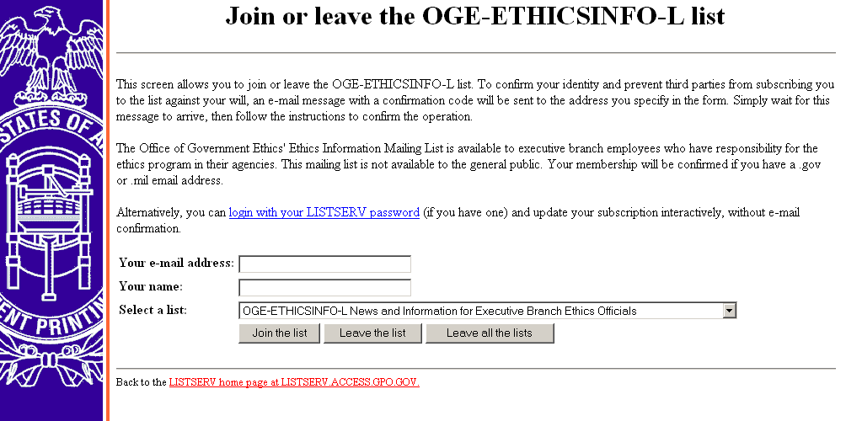
DoD SOCO Advisories: http://www.defenselink.mil/dodgc/defense_ethics/
SOCO Advisory, similar to OGE’s list serve letter. Subscribe as shown below:
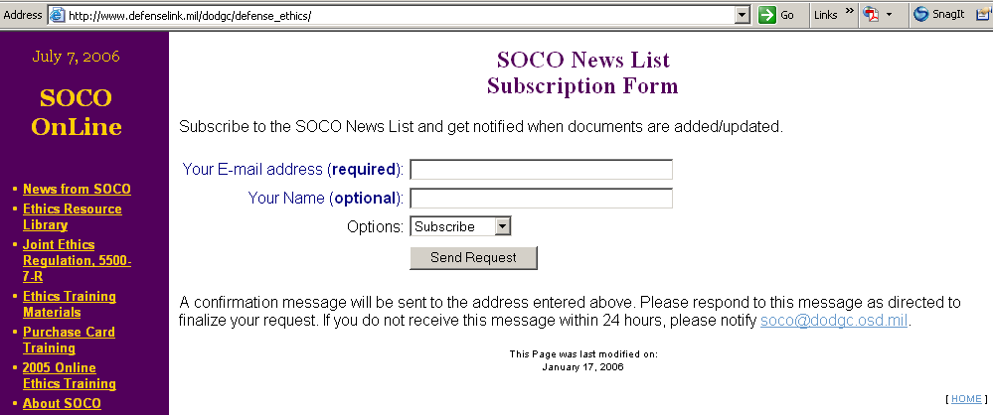

Army General Counsel Ethics & Fiscal site: http://www.hqda.army.mil/ogc/eandf.htm

Army SOCO site: https://www.jagcnet.army.mil/soco

Air Force Ethics site http://afmcethics.wpafb.af.mil/
AF ethics email service: email mark.stone@wpafb.af.mil and ask to be added to his email list AF Ethics Materials – eMails (see example below)

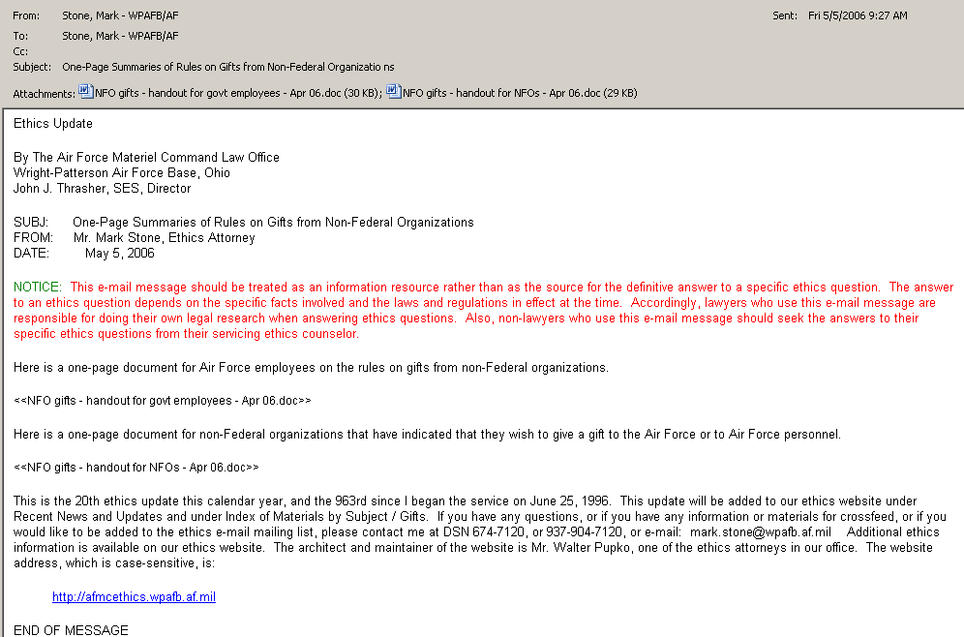

Interagency Ethics Council (IEC) site: http://www.iecjournal.org/iec/ Visit http://www.iecjournal.org/iec/2008/01/mailing-list-to.html to sign up for automatic email updates on various ethics topics.

Financial Interest Websites

Some Financial Disclosure Report reviewers use one or more of these web sites for researching financial interests. This list is informational only and not intended as an endorsement of these sites.

(tip: use "quotation" marks around names or phrases in site search tools)

Sources for researching individual companies:
- Altavista – http://www.altavista.com
- Ask Jeeves – http://www.ask.com
- Dog Pile – http://www.dogpile.com
- Google – http://www.google.com
- Hoovers – http://www.hoovers.com
- Yahoo – http://www.yahoo.com
- Wikipedia – http://www.wikipedia.org
- [individual company web pages]

Sources for researching mutual funds:
- Business.com – http://www.business.com
- Google finance – http://finance.google.com/finance
- Lipper – http://www.lipperweb.com
- Morningstar – http://www.momingstar.com
- Motley Fool – http://www.fool.com
- NASDAQ – http://www.nasdaq.com
- New York Stock Exchange – http://www.nyse.com
- TIAA-CREF – http://www.tiaa-cref.org/
- Yahoo Finance – http://finance.yahoo.com

Government sources:
- SEC (generally) – http://www.sec.gov
- EDGAR (SEC) – http://www.sec.gov/edgar.shtml
- IRS – http://www.irs.gov

529 – Education Savings Plans: 401 kid advisors inc - https://401kid.com/

Searching a Filer’s name for outside positions:
- Altavista – http://www.altavista.com
- Ask Jeeves – http://www.ask.com
- Dog Pile – http://www.dogpile.com
- Google – http://www.google.com
- Yahoo – http://www.yahoo.com
- Wikipedia – http://www.wikipedia.org

Information about individual company retirement packages: see individual company web pages

Telephone calls: a call to a fund manager may yield information about the fund's exact name or the fund's holdings (such a call may also be useful to confirm the existence of a listed fund)

Source: distributed at the National Office of Government Ethics Conference, Orlando, Florida, March 2007.
Enclosure 3

Insert DDAEO EC Designation/Delegation here.

Enclosure 4

Insert local SJA Appointment of EC here.

Enclosure 5

Sample email content*: “Notice to File Your SF 278”
Note: Do not use special characters, such as <, >, =, &, :, or quotes in FDM notices.

You are registered in FDM, https://www.fdm.army.mil, as an SF 278 Filer. Your 2008 SF 278 Incumbent report is due 05/15/2008. Please consult your legal advisor or me, [name, email, phone] if you have questions about this requirement to file a Financial Disclosure Report, or need an extension. Also, consult your DAEO and/or legal advisor if you do not think you should file such a report.

Very Respectfully,
Your signature block

*FDM My Info | Required Activities, Notify will open this email form for your editing.

Optional additions:

You may login with your Common Access Card (CAC)/PIN or your AKO user name/password. You may have to first visit AKO, https://www.us.army.mil, to reset it if you haven't in the last 150 days.

FDM is fairly simple to use, much like TurboTax if you have efiled your income taxes. Upon first login you will see a Contact Info screen that reflects information pulled from AKO. Please complete the missing information, save and then go to the My Reports tab to add/create your report. A report wizard will present questions for you to answer and guide you through the report preparation.

You may appoint a Filer Assistant to draft your report for you. You may do that, or if you send me the name(s) of your Assistant(s) and I will register them for you. Your Assistant must also have a CAC or an AKO user name.

FYI: Here is a link to a short, Quick Reference, on filing an SF 278 in FDM that shows screen shots: https://fdm-preview.army.mil/Documents/QRC_Filing_A_SF278.pdf.

An Incumbent SF 278 Filer Quick Start is attached (see FDM 278 User Guide, Appendix I)

An information chart, https://www.fdm.army.mil/documents/278_Schedules_Applicable_Reporting_Periods_Value.pdf, shows the different parts (Schedules) a Filer must complete for different time periods depending upon the type of report (e.g., New Entrant, Annual) filed. The reportable amount threshold is listed for each schedule.

Please contact _____ or me if you have any questions or need assistance.

FDM Help Desk: (732) 532-5566, DSN 992-5566. This office is staffed from 7:00 AM to 5:00 PM Eastern Time. Voice mail available other times.

Finally, if you encounter any difficulties with FDM please email me so I may investigate.

Enclosure 6

Sample Review Notice to Supervisor
Note: Do not use special characters such as <, >, =, &, :, or quotes in FDM notices.

Subject: [Filer name] SF 278 Ready for Review Online

Content:

FDM shows that [Filer name] has an SF 278 that you have not reviewed.

To do so, please login to FDM, https://www.fdm.army.mil/FDM, go to the Review Filers tab. Use these settings to see/search for the report:

Role: Supervisor

Use these Search filter settings (or Review Status: Under Review):
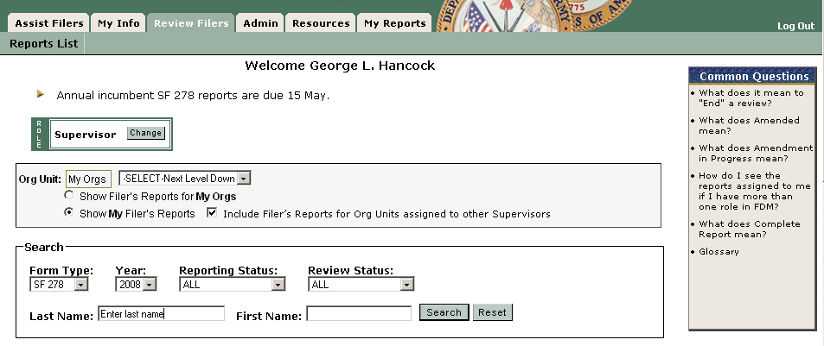
In the Search box, use the Last Name and First Name fields, the Search to find the specific 2008 report to review.

The FDM Learning Center, https://www.fdm.army.mil/learningCenter/documentation.htm, includes a Quick Reference, Reviewing an SF 278, that you may find helpful.

[Consider adding

Guidance to Supervisors Reviewing SF 278,

Public Financial Disclosure Report

1. The Public Financial Disclosure Report (SF 278) is used to ensure that employees comply with conflict of interest laws and regulations. As a supervisor, you are required to review, sign, and date each report employees you supervise submit.

2. These reports contain sensitive personal and financial information that you must safeguard from inappropriate disclosure. Suggestions:

- Do not leave the reports where they might be seen by others.
- Do not send the reports through internal mail in unsealed envelopes.
- Do not use the information in the reports for any purpose other than ensuring that your employees' work assignments are not in conflict with their financial interests.

3. When reviewing the report you are seeking to determine that the reported financial interests do not conflict with the Filer’s government duties.

4. Review the financial interests reported in the report. When looking at corporations, consider corporate subsidiaries. For example, corporate subsidiaries of Lockheed Corp. are Loral Intl., Inc. and Martin Marietta Diversified Technologies, Inc., and a corporate subsidiary of Boeing Co. is McDonnell Douglas.

5. If there is no relationship between reported interests and your employee's work, you should sign and date the report.

6. If there is a conflict between a reported interest and the employee's duties, the employee must furnish you a written, signed disqualification statement. A new disqualification statement must be filed each year. Sign the disqualification statement, keep a copy for yourself, and attach a scan of the signed original to the report in FDM. Make sure the employee is not given any work assignments involving that company or any of its subsidiaries, affiliates, or joint ventures.

7. If, in your opinion, there is a potential for a conflict of interest because the employee might be assigned work involving a company in which he or she has reported an interest, but no actual conflict exists at the time of your review, sign and date the report. You should caution the employee not to accept an assignment involving the company and make sure no work involving that company is given to the employee.

8. For additional assistance consult your legal advisor. ]

Enclosure 7

Sample first late notice to delinquent Filer

Subject: Late SF 278

1. Your Incumbent SF 278 is late. Please login to FDM, https://www.fdm.army.mil, to complete your report today.

2. Your report was due 15 May [or later date if prior extension expired].

3. A $200 late filing fee is payable to the U.S. Treasury, if you file your report more than thirty days after the later of the report due date ([date]) [or the expiration of any extension [date]].

Enclosure 8

Sample “over 30 day” late notice to delinquent Filer

Subject: Late SF 278

1. Your Incumbent SF 278 is over 30 days late. Please login to FDM, https://www.fdm.army.mil, to complete your report today.

2. Your report was due 15 May [or later date if prior extension expired].

3. A $200 late filing fee is payable to the U.S. Treasury, if you file your report more than thirty days after the later of the report due date ([date]) [or the expiration of any extension [date]].

4. If extraordinary circumstances caused your late filing you may request a waiver in writing of the late filing fee. Explain the extraordinary circumstances and submit to [DDAEO].
Enclosure 9

Reviewing an SF 278

SF 278 reviewers conduct two types of review:
- Technical review
- Conflict of interest analysis

The purpose of a technical review is to ensure that:
- All required details are disclosed for each entry, and
- The none box is marked if nothing is reported on a schedule.

The purpose of a conflict of interest analysis is to ensure that filers do not:
- Have interests that conflict with their official duties
- Have even an appearance of a conflict
- Receive income from sources that may be affected by actions filers take in their official capacity

Resources (FDM Resources tab, https://www.fdm.army.mil/helpSupport/resources.htm):
- SF 278 Instructions.
- Public Financial Disclosure: A Reviewer's Reference (2004), a 367 page reference manual for reviewers of the Standard Form 278 which contains an introduction to the public financial disclosure system, the procedures and mechanics of review and conflict resolution, summaries of applicable ethics laws and regulations, sample SF 278 entries, model letters and documents related to the review process, and case studies.
- Comparing entries from last year’s report with the current one.
- Cross-checking information reported in one schedule with information in another schedule.
- FDM SF 278 Filers attach a copy of their position description

SF 278 Schedules to Complete by Report Type*

SF 278 | Incumbent (Annual) | New Entrant/  Nominee | Termination
Assets & Income (Schedule A) | X | X | X
Schedule B
- Transactions | X |  | X
- Gifts, Reimbursements, and Travel Expenses | X |  | X
Schedule C
- Liabilities | X | X | X
- Agreements or Arrangements | X | X | X
Schedule D
- Positions Held Outside US Government | X | X | X
- Compensation in Excess of $5,000 Paid by One Source | X | X
*Source: OGE Course, Analyzing Public Financial Disclosure Reports

Chart, SF 278 Schedules & Applicable Reporting Periods, https://www.fdm.army.mil/documents/278_Schedules_Applicable_Reporting_Periods_Value.pdf
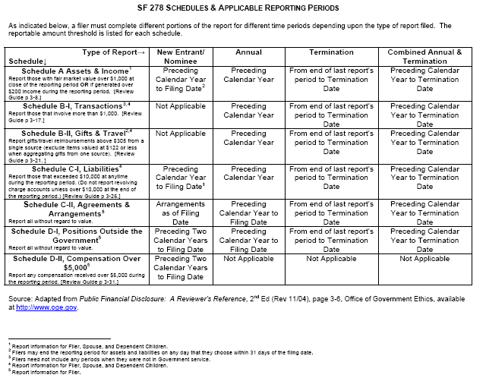
Information to Provide*

SF 278 | Filer | Spouse | Dependent Child(ren)
Assets & Income (Schedule A) | X | X | x
Schedule B
- Transactions | X | X | X
- Gifts, Reimbursements, and Travel Expenses | X | X | X
Schedule C
- Liabilities | X | X | X
- Agreements or Arrangements | X
Schedule D
- Positions Held Outside US Government | X
- Compensation in Excess of $5,000 Paid by One Source | X
*Source: OGE Course, Analyzing Public Financial Disclosure Reports

Use this checklist as a guide when viewing the SF 278.
Report Area | Conducting a technical review*
General | The technical review is an initial determination to see if the Filer provided complete information and properly completed the report. See 5 CFR § 2634. Often, a skilled Army paralegal will conduct the technical review using FDM’s flag system and checking the 278 display to ensure the information reported makes sense. See 5 CFR § 2634.605, Review of reports.  Review presumptions: Accept reports at face value. When information is inconsistent from one year to the next, the reviewer may assume:  - New entry or lack of an entry is correct, if assets that normally would not require disclosure of transactions such as money marked funds, bank accounts, Treasury securities, or cash IRAs, appear or disappear  - Fluctuation in the market value of an asset, if the value category changes to the next category (up or down), without a reported transaction  - Non-reportable change in underlying assets, if mutual funds or limited partnerships earn different types of income  - Non-reportable intra-family transfer, if an asset’s identification as spouse’s, dependent child’s, or joint is different from last year’s designation  The Public Financial Disclosure: A Reviewer's Reference (2004), at pages 4-5, includes guidance on when to contact a Filer for additional information/clarification.
Assets & Income | - Has the filer provided complete information including a value range and type and range of income (unless no income or less than $201)?  - Has the filer reported underlying holdings for investment clubs, private pension interests, investment life insurance, and retirement plans?  - If the filer reported a defined benefit plan, did the filer report the name of the employer providing the plan and identify it as a defined benefit plan?  - If the filer reported a defined contribution plan, did the filer report the reportable underlying assets of the plan (not diversified mutual funds)?  - Did the filer over-report items that should not be reported (e.g., federal government salary, government retirement benefits)?  - When a previously reported asset no longer appears you may presume that it fell below the reportable threshold.  References: 5 CFR § 2634.301; also see Reviewer’s Reference, § 3.3
Transactions (New Entrants do not report) | Review assumptions:  - Complete sale assumption. Asset is listed as sold on last year’s 278 and does not appear on the current year’s report. Assume the entire holding was sold only if the sale amount is no more than one category of value below the previous asset value.  - No reportable income assumption. Asset is listed as sold on Transactions and is not listed as an asset. Assume that the entire holding was sold if the sale amount is no more than one category of value below the previous asset value.  - Market fluctuation assumption. The purchase price differs from the value of the asset listed by one category (higher/lower). Assume market fluctuation explains the difference.  Consider these questions:  - Has the filer provided complete information on each transaction?  - Was Filer required to divest any interest? If so, was it accomplished timely? Was there a certificate of divestiture?  - Compare with changes in Assets between years. For example, compare this year’s assets list against last year’s to see if assets no longer listed are reported as transactions this year.  References: 5 CFR § 2634.303; also see Reviewer’s Reference, § 3.4
Gifts, Reimbursements & Travel Expenses | - Has the Filer adequately described the gift, the donor, and the value of the gift?  - Is the value over the reportable threshold ($305 in 2008)?  References: 5 CFR § 2634.304; also see Reviewer’s Reference, § 3.5
Liabilities | Review assumption: assume the filer paid the debt off or the loan value dropped below the $10,000 reporting limit when a liability in the $10,000 -$ 15,000 value category on last year’s report is not on this year’s report.  - Did the filer report any liability that exceeded $10,000?  - Did the filer report the creditor’s name, city, and state?  - Did the filer over-report items that should not be reported (e.g., loans for automobiles, household furniture, or appliances (as long as the loan does not exceed the purchase price); revolving charge accounts with a balance of less than $10,000 at the end of the reporting period; obligations arising from a divorce or permanent separation.)  - Is the reporting this year consistent with liabilities reported last year?  - If mortgage on rental property is reported check to see that the rental property is reported as an asset and if income is reported  Reference: 5 CFR § 2634.305; also see Reviewer’s Reference, § 3.6
Agreements & Arrangements | - Evaluate the completeness of each entry (e.g., the name of the parties, the location, terms, and, if there is an arrangement for future employment, the date when the arrangement was made  - Confirm that pension plans are also reported as assets. In addition, they may earn interest and/or reportable dividends even if the Filer is not receiving income now.  - Confirm that the filer is not over reporting.  Reference: 5 CFR § 2634.306; also see Reviewer’s Reference, § 3.7
Outside Positions | Time period covered:  - New Entrants must disclose outside positions held during the prior two calendar years up to date of filing.  - Incumbent/annual filers report for the prior calendar year.  - Evaluate the completeness of each position reported (e.g., name, location of the organization, type or purpose of the organization, and specific position held)  - Verify that pertinent income-producing activities are also reported in the assets/income section of the report.  - Confirm that the filer is not over-reporting (e.g., did not report positions held by spouse or dependent child(ren); compensated or uncompensated positions held in any religious, social, fraternal, or political entity; positions solely of an honorary nature, positions filers hold as part of official duties, mere membership in an organization).  - Did filer receive over $200 in income from any reported position? If so, is it reported as income?  - Consider outside activity approval forms (if available)  Reference: 5 CFR § 2634.307; also see Reviewer’s Reference, § 3.8
Compensation in Excess of $5,000 Paid by One Source  (New Entrant Filer reports) | - Evaluate the completeness of each item reported – is the name and address of the source provided? Is there a brief description of the duties the filer performed for that source?  Reference: 5 CFR § 2634.308(b)(6); also see Reviewer’s Reference, § 3.9
*Adapted from OGE Course Materials: Analyzing Public Financial Disclosure Reports Course

Conflict of Interest Analysis*

The purpose of a conflict of interest analysis is to ensure that filers do not:
- Have interests that conflict with their official duties
- Have even an appearance of a conflict
- Receive income from sources that may be affected by actions Filers take in their official capacity

Note: Reviewers need to know a Filer’s duties to determine if there is a conflict of interest.

Use this checklist when checking an SF 278 for possible conflict of interests. (Refer to appropriate sections of Reference 2c, OGE’s Public Financial Disclosure: A Reviewer’s Reference (2004) for more detail, as needed.)
Report Area | Considerations to conduct a conflict of interest analysis:
Admin – Filer’s position, grade | - What official duties does the filer perform?  - Does the filer deal with non-federal entities?
Assets & Income | When doing a conflict of interest analysis on assets and income sources, a wide variety of potential conflicts exist, including:  - 18 USC § 208, acts affecting a personal financial interest  - 5 CFR 2635.502, appearance issues in personal and business relationships  - 18 USC §§ 203, 205, representation issues  - 18 USC § 209, supplementation of salary issues, with potential for a continuing financial interest under 18 USC § 208  Consider these questions:  - Are any of the reported interests in DoD contractors or are they on a DoD/Army prohibited holdings list?  - Do any of the reported financial interests raise a potential conflict with the filer’s official duties:  - Determine if the filer might take an official action that would result in a monetary gain or loss to himself or those whose financial interests are imputed to him  - Consider whether the filer’s official action may create an appearance of a conflict of interest  - Decide if the filer has a covered relationship that creates an appearance of a conflict of interest
Transactions | The purpose of reviewing filer’s transactions is to verify filers reported activities as assets/income or divested (if directed) and used a certificate of divestiture  - Are any of the reported transactions interests in DoD contractors or are they on a DoD/Army prohibited holdings list?  - Do any of the transactions involve financial interests in prohibited sources?  - Did filer divest (if ordered)?
Gifts & Travel Reimbursements | - The relationship between donor and filer  - Was gift given because of filer’s official position?  - What could donor and its affiliates gain from filer’s official performance of duties?  - Is the donor a prohibited source?  - Consider bribery and supplementation of salary issues (18 USC § § 201, 209)  - How frequently does donor give gifts? Does a gift exception or exemption apply?
Liabilities | - Does filer have a loan with a prohibited source? If yes: ask about  - loan terms (e.g., same as available to general public or more favorable) &  - filer relationship to creditor  Notes:  - Loans between government employees could violate standards of conduct. Lenient loan terms more favorable than generally available could represent an unauthorized gift to a superior or gifts between employees.  - Special lower than common loan terms could reflect normal economic motives on the lender’s part (e.g., offering a lower rate to a customer with very large deposits or exceptional credit-worthiness).
Agreements & Arrangements | - What are the terms of the agreement/arrangement – do they indicate any special treatment because of filer’s federal job?  - Could filer take an official action that could result in a monetary gain or loss to himself or the entity with which he has an agreement/arrangement?  - Whether filer’s official action may create an appearance of a conflict of interest  - Whether filer has a covered relationship that creates an appearance of a conflict of interest
Outside Positions | - Do any of filer’s official duties impact any of the organizations listed?  - What does filer do for the listed organization?  - Watch for situation where filer may attempt to represent the organization before the Government (18 USC §§ 203, & 205)  - Is filer an employee of the organization and does filer take Government action that affects the organization (18 USC § 208)?  - Note: board memberships and similar officer positions have some control over the activities of an organization that could pose a conflict or appearance problem with filers’ official duties.
Compensation in Excess of $5,000 Paid by One Source | New entrant and nominee filers must report any source of compensation over $5,000 paid for their personal services during the preceding two calendar years and current calendar year up to date of filing.  - Did filer identify source?  - Did filer provide a brief description of the duties performed?  Special rules may apply allowing filer to report compensation without disclosing the client’s identity – see Reviewer’s Reference,
*Adapted from OGE Course Materials: Analyzing Public Financial Disclosure Reports Course

Enclosure 10
Understanding & Using FDM Organization Units (“Org Unit”)

Introduction. In the Army several Deputy Designated Agency Ethics Officials (DDAEOs) are responsible for the financial disclosure reporting program and process for specific areas generally along command lines. (See Army General Counsel Memorandum, Subj: Designation of Deputy Designated Ethics Officials (DAEOs) & Delegation of Authority UP JER, DOD 5500.7-R, January 03, 2007 http://www.hqda.army.mil/ogc/Delegation%20of%20Authority%20DAEOs.pdf.)

FDM Release 4.1 introduced an Organizational Unit (“Org Unit”) tool to hierarchically group Filers by supervisor for visibility to the respective, responsible DDAEO. There were over 1,000 “Supervisors” already using FDM when Release 4.1 came on line in early November 2007. To keep those Filers grouped together by the reviewing Supervisor, FDM used an Org Unit name using this naming convention: Org Unit Supervisor’s Last Name (e.g., OrgUnit Hancock, G). SLCs/SLC ECs may change the Org Unit name to a name based on the Supervisor’s title or position or use the office symbol (Admin | Org Unit). This is especially important where the former supervisor departed and a new one will review FDRs of the employees who remained in that organization (and are still grouped in FDM under the named OrgUnit).

1. An FDM “Org Unit” contains a group of one or more financial disclosure report (FDR) Filers for a particular supervisor. Each reviewing Supervisor has at least one Org Unit. Within an organization, one or more other Org Units are created and added to link each reviewing Supervisor to all his or her FDR Filers. Senior Legal Counsels (SLCs) and Ethics Counselors (ECs) may create these Org Units and register the Filers in them. SLCs and ECs may delegate this to organizational points of contact (POCs) to spread the level of effort and share the administration at all levels.

2. The FDM website, https://www.fdm.army.mil, has Quick References in the Learning Center (https://www.fdm.army.mil/learningCenter/documentation.htm), including tutorial videos (https://www.fdm.army.mil/learningCenter/tutorials.htm) on creating and managing Org Units and adding Filers to those units.

3. The first step is to login to FDM and go to the My Info | My Filers tab to see all SF 278 Filers registered in organizations where you are the SLC (or SLC EC). Set your role to SLC (SLC EC) and in the Org Units, Select Next Level Down or use the second radio button “Show My Filers” to see all 278 Filers where you are the named SLC (SLC EC). You may check the “Include . . .” box to see all SF 278 Filers in the chosen org unit and all subordinate org units (even where you are not the SLC).

4. Edit the name of an existing Org Unit or add a new Org Unit on the Admin | Org Unit tab. There, you will find a “My Orgs” display showing existing organizations with which you have an association in FDM. Most SLCs will start with an organization corresponding to the supported SF 278 Filer (e.g., CG of the organization) and may see other Org Units where there is an SLC relationship. SLCs and ECs may Edit the org unit name (20 character maximum) and org unit description (up to 100 characters). You may add a new Org Unit and assign a POC to register and manage Filers for that organization online in FDM.

Practical tip: it is better to use Admin | Supervisor tab to add a new Supervisor for a new org unit and the org unit together.

The FDM Help Desk or FDM Webmaster will add Supervisors and new org units for you upon request.

5. Updating an Org Unit by renaming and/or assigning a new Supervisor for the group of Filers in that organization takes several steps. In many cases, the FDM supervisor for the Filer is still the same. In that case, renaming the org unit is straightforward. If the supervisor moved to a different organization and a new one will do the FDR reviews the tasks are to rename the OrgUnit, delete the former Supervisor, and assign the new Supervisor to it.

Step 1: After logging in to FDM, go to Admin | Org Units to see your top level (My Orgs box in the Breadcrumb trail). As an SLC you are likely to see an Org Unit for your CG or an SES 278 Filer.

Step 2: Check which role you want to use (e.g., SLC or SLC EC).

Step 3: Look in the Location column for any Org Units listed at your level. These are Org Units. The screen shows TRADOC as the level for this SLC. The breadcrumb trail is:

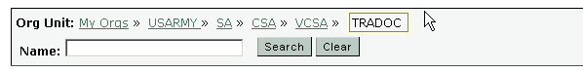
The TRADOC SLC (or SLC EC) would see My Orgs >> TRADOC (without the “>>USARMY >>SA >>CSA >>VCSA”).

There are 13 Org Units listed in the TRADOC Org Unit.
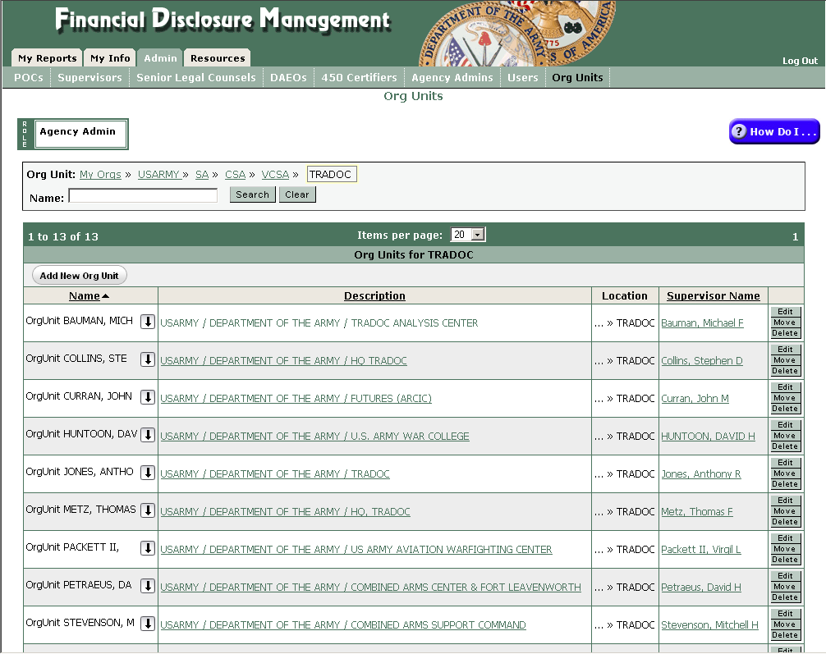

Step 4: Click on the Org Unit Description (Description column underlined) and inspect the profile information in the popup window (for Org Unit Bauman, Mich). The description field notes that it is the TRADOC Analysis Center and lists the default or assigned person(s) in the appropriate roles.

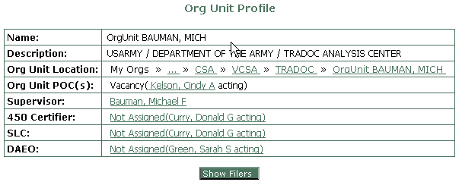
Verify that the selected Org Unit really is part of TRADOC. An organization chart or wiring diagram is particularly helpful. You may want to contact the FDM Help Desk ((732) 532-5566, DSN 992-5566) about moving the Org Unit elsewhere.

Clicking on the Show Filers button, we see by the below screen that there is only one Filer in this Org Unit, Michael Bauman.

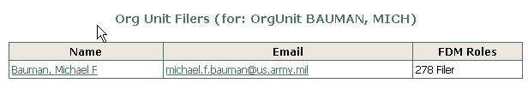
If the Filer is still in the same title/position, this Org Unit can be renamed by clicking Edit (far right column) and providing a new name and description on the edit screen that appears.
For this example you might use “TAC” for the name and “TRADOC Analysis Center” in the description field.

If the Supervisor has changed title/position then before “moving” the Org Unit to another organization, use the down arrow in the Name column to see any subordinate Org Units linked to OrgUnit Bauman, Mich. If there are then you may not want to move the OrgUnit Bauman, Mich, but you may want to assign a new Supervisor and move the Filer, Bauman, to a different organization.

The basic process is:
Review the parent Org Unit;
Determine if there are subordinate Org Units or filers in the parent Org Unit;
If no sub Org Units rename the Org Unit to title/position;
If sub Org units are displayed, rename sub org units to title/position
Search for and locate new parent org unit;
Move newly renamed org unit to new parent org unit;
Rename old parent of moved org unit(s) to current title/position;
Move newly renamed org unit to new parent org unit if needed.

A flow chart for the process is provided below.

Continuing with our example, pretend Michael Bauman moved from the TRADOC Analysis Center and is now working at HQs, AMC. If Org Unit Bauman, Mich had additional Org Units (Filers) you should rename Org Unit Bauman, Mich, leaving it in TRADOC. You could rename the Org Unit as “TAC” (TRADOC Analysis Center). Renaming doesn’t move any subordinate Filers, instead, all subordinate Filers remain grouped in that org unit. Next you would assign the new supervisor to that org unit (Do so on the Admin | Supervisors tab, display OrgUnit TAC; delete the current Supervisor creating a vacancy, then assign new Supervisor).

If the Org Unit Bauman had no subordinate Org Units (and only one Filer, Bauman) then you might use the “move” option on the Admin | Org Units tab to transfer Org Unit Bauman to his new org, AMC. (Note: if Org Unit Bauman, Mich has any Filers other than Bauman, “moving” the Org Unit Bauman, Mich would automatically move those Filers too. That would mean that they would then be in AMC.

6. Summary. FDM Release 4.1 introduced an Organizational Unit (“Org Unit”) tool to “group” Filers by supervisor and provide visibility to the responsible DDAEO.

Generally FDM will have an Org Unit for each supervisor who will review one or more FDRs.

Remember to browse the FDM website Learning Center (https://www.fdm.army.mil/learningCenter/documentation.htm), including tutorial movies (https://www.fdm.army.mil/learningCenter/tutorials.htm), on creating and managing Org Units and adding Filers to those units.

Enclosure 11

Cautionary Notice to Filer with Financial Interests in DoD Contractors

Ethics Counselors may further tailor as appropriate and email to SF 278 Filer. Consider attaching with Filer’s reply in FDM to the Filer’s report by saving the email as a .txt file or copying into an MS Word document.

Subject: SF 278 – Potential Conflict of Interest - Precaution

This email is to put you on notice of potential conflicts of financial interest in accordance with the Standards of Ethical Conduct for Employees of the Executive Branch. A financial conflict arises when you are asked to take personal and substantial action in a particular matter that will have a direct and predictable effect on your or your family members' (spouse, dependant child) financial interest. A review of your SF 278 reveals that you have a potential conflict of financial interest with the following entity, which does business with the Department of Defense: [Name of Contractors]. [Additionally, you should review your duties to ensure that there is no conflict of interest with your spouse’s employment.]

If you are required to take official action with regard to these entities, you must inform your supervisor. At that time, you and your supervisor, with assistance from this office, will work towards a solution to remove the conflict of financial interest. Possible solutions include:

1. Disqualifying yourself from personal and substantial participation in the particular matter. Disqualification should be written and inform your supervisor of your disqualification. I have included for your use the disqualification memorandum format. If you decide to use this format, I ask that you provide a copy to your supervisor and a copy to [local legal office contact], who may be reached at [phone number] or [email].

2. Asking for reassignment of duties that do not involve personal and substantial participation in the matter.

3. Divesting yourself of the financial interest, in which case you can receive a Certificate of Divestiture (CD) from the Office of Government Ethics to defer capital gains taxes. We would require further information to determine whether this is a viable option in your case. Warning: The procedure to obtain a CD is very complex. You must hold the stock until you receive the certificate. You cannot receive a CD if you sell the stock first.

4. Seeking an individual waiver under 18 U.S.C. §208(b)(1) issued by the Office of Government Ethics via the Office of General Counsel. The factors considered in granting the waiver include the type of interest creating the conflict, the identity of the persons holding the financial interest, the dollar value of the interest and its relationship to the entire value of the person's assets, the nature and the importance of the employee's role in the particular matter, the need for the employees services in the matter, and whether adjustments can be made in the employee's duties minimizing their impact in the particular matter.

If you have no duties that would impact either [ ] or your spouse’s employment, please let me know and I will make an appropriate annotation in your file. If you have duties that conflict with either [ ] or your spouse’s employment, please let me know and we can discuss how to resolve the conflict. I may be reached at [phone number].
Regards,
[sender’s information]
Enclosure 12

Sample Format For Conflicting Financial Interests Disqualification Memo

MEMORANDUM FOR SEE DISTIBUTION

SUBJECT: Notice of Disqualification

Title 18, United States Code, Section 208 (18 U.S.C. § 208) requires me to disqualify myself from participation in any particular matter that will have a direct and predictable effect on the financial interests of a person or organization with whom I have a financial interest. I have a financial interest in the following:

[List all financial interests. These may include financial assets, such as stocks in DoD contractors; spouse’s employment; or organizations in which you are a member.]

Accordingly, I am disqualified from participating in any official matter that will have a direct and predictable effect on the financial interests on this organization. This means that I cannot act directly or through others in deciding, approving, or disapproving such official matters; nor may I recommend, investigate, advise or otherwise contribute to or influence such official matters.

Any official matter that will conflict with the above-listed financial interest must be handled without my knowledge or participation. If such official matter would otherwise have required my personal decision, approval or disapproval, the matter should be referred to [Name of Individual].

Signature Block

DISTRIBUTION

Name of Immediate Supervisor
Name of Person Signing the Memo
[Local Ethics Counselor]

Sample Format for Spousal Employment Disqualification Memo

MEMORANDUM FOR SEE DISTRIBUTION

SUBJECT: Disqualification

Title 18, United States Code, Section 208 (18 U.S.C. § 208) requires me to disqualify myself from participation in any particular matter that will have a direct and predictable effect on the financial interests of a person or organization with whom I have a financial interest. I hereby give notice that my spouse, [Name], [is an employee with] [has a consulting arrangement with] [Name of Corporation(s) or other entities in which he or she has a financial arrangement]. Accordingly, I have a financial interest in these entities.

Pursuant to law (18 U.S.C. Section 208) and the "Standards of Ethical Conduct" (5 C.F.R. Sections 2635.402(c), .502(a) and .604), I am disqualified from participating in any official matter that will have a direct and predictable effect on the financial interests of the above-listed organization. This means that I cannot act directly or through others in deciding, approving, or disapproving such official matters; nor may I recommend, investigate, advise or otherwise contribute to or influence such official matters.

Accordingly, any official matter that will conflict with the above-listed financial interest(s) must be handled without my knowledge or participation. If such official matter would otherwise have required my personal decision, approval or disapproval, the matter should be referred to [name of person who should handle issues].

Signature Block

DISTRIBUTION:
Supervisor
Name of Person Signing the Memo
[SLC/SLC-EC]

Enclosure 13
Public Financial Disclosure Report System
Extract from OGE
Tips on Preparing for an Ethics Program Review
(and for Administering a Well-Run Program)

From: http://www.usoge.gov/pages/forms_pubs_otherdocs/fpo_files/prd_mats/prdreviewtips.html

Public System | □ Are the procedures for administering the Public report system documented? | ► Provide procedures.
Public System | □ Is it time to refresh your annual/termination filer notification memorandum? (i.e., Are filers advised to use FDM 278?) | ► Provide notification memo.
Public System | □ Are listings of filers current? | ► Provide listings.
Public System | □ Identify public filers by type (i.e., Presidential appointees confirmed by the Senate, Schedule C, non-career SES, regular SES). | ► dentify by-type on listing.
Public System | □ Were any SF 278 filers granted an extension or $200 late filing fee waivers? | ► Provide documentation
Public System | □ Are the public reports organized? (In addition, are the reports signed and dated in accordance with regulatory requirements? | ► Provide access to last two years of certified SF 278s.
Public System | □ What mechanisms are in place to identify those who enter or leave public filing positions to ensure that the required reports are filed within 30 days?
Public System | □ Is it time to refresh your new entrant notification memorandum? | ► Provide new entrant notification memo.
Public System | References:  □ 5 CFR Part 2634 (available at www.usoge.gov).  □ Public Financial Disclosure: A Reviewer’s Reference  □ Joint Ethics Regulation 7-200 et seq.

Enclosure 14
List Select OGE Opinions – Financial Disclosures

The OGE web site, http://www.usoge.gov/pages/advisory_opinions/advisory_opins.html, has opinions issued by OGE's Office of General Counsel and Legal Policy in response to questions received about the conflict of interest laws and regulations, the standards of conduct, and financial disclosure requirements in the executive branch. The table below is a compilation of select opinions between 1999 and 2006 related to financial disclosures.

OGE index of advisory opinions 1990 – 2006: http://www.usoge.gov/pages/advisory_opinions/advop_files/indices/90_06index.pdf.

5 CFR § | Topic | Opinion(s)
Part 2640, OGE Opinions on the Interpretation, Exemption, & Waiver Guidance Concerning 18 USC § 208
.102(a) | Definition: Diversified | 00x8; 03x2
.102(a) Note | A mutual fund is diversified for purposes of this part if . . . | 00x8
.102(l) | Definition: Particular matter involving specific parties | 00x1; 06x9
.102(m) | Definition: Particular matter of general applicability | 00x1; 06x9
.103(a)(1) | Particular matter | 97x2; 00x4; 05x1; 06x8; 06x9
.103(a)(2) | Personal and substantial participation | 99x11; 99x14(1)
.103(b) | Disqualifying financial interests | 97x5
.201(a) | Diversified mutual funds and unit investment trusts | 00x8; 03x2
.201(b) | Sector mutual funds | 00x8
.201(c) | Employee benefit plans | 99x6
.202 | Exemptions for interests in securities | 99x9
.202(a) | De minimis exemption for matters involving parties | 00x8
.202(a)(2) | The aggregate market value of the holdings of the employee, his spouse, and is minor children in the securities of all entities does not exceed $15,000 | 00x8
.202(b) | De minimis exemption for matters affecting nonparties | 00x8; 06x10
.301(b)(2) | The identity of the person whose financial interest is involved, and if the interest is not the employee’s, the relationship of that person to the employer | 04x13

5 CFR § |  | Topic |  | Opinion(s)
Part 2635, Subpart D; OGE Opinions on Conflicting Financial Interests
.402 | Disqualifying financial interests |  | 94x10(2); 95x8; 96x10; 06x9
.402(b)(1) | Definition: Direct and predictable effect |  | 95x5
.402(b)(2) | Definition: Imputed interests |  | 06x1; 06x7; 06x13
.402(b)(3) | Definition: Particular matter |  | 95x5; 97x2; 06x8
.402(b)(4) | Definition: Personal and substantial |  | 92x25; 95x5; 06x7
.402(c) | Disqualification |  | 98x11; 99x8
.402(c)(1) | Notification |  | 99x8
.402(c)(2) | Documentation |  | 99x8
.402(d)(1) | Regulatory exemptions |  | 93x12
.403 | Prohibited financial interests |  | 06x7
.403(a) | Agency regulation prohibiting certain financial interests |  | 96x10; 99x5;
.403(b) | Agency determination of substantial conflict |  | 96x10; 99x5; 06x7
.403(d) | Reasonable period to divest or terminate |  | 99x5

5 CFR § | Topic |  | Opinion(s)
Part 2635, Subpart E; OGE Opinions on Impartiality in Performing Official Duties
.502 | Personal and business relationships | 93x25; 94x10(1); 94x14; 95x8; 97x2; 97x8; 98x14; 99x8; 01x5; 04x4; 04x5; 06x1; 06x7
.502(a) | Consideration of appearances by the employee | 92x27; 93x25; 94x10(1); 94x10(2); 95x1; 95x5; 97x8; 98x11; 06x7
.502(b)(1) | Definition: covered relationship | 93x25; 00x4
.502(b)(1)(iv) | Definition: person employee served within the last year | 95x5
.502(b)(1)(v) | Definition: organization in which employee is an active participant | 94x10(2); 95x8; 06x1
.502(c) | Determination of agency designee | 97x8; 00x4
.502(d) | Authorization by agency designee | 95x5; 97x2; 97x8; 01x5; 06x1; 06x7
.502(e) | Disqualification | 99x8
.503 | Extraordinary payments from former employers | 04x5; 06x7

