Financial Disclosure Management (FDM) 450
(Revised for Release 6.0.5)

FDM 450 User Guide
for Senior Legal Counsel (SLC),
Ethics Counselors (ECs), 450 Certifiers, SLC Assistants,
Filers, Filer Assistants,
& Supervisors
(v.1)

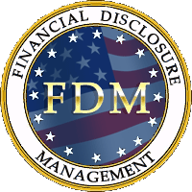

Secure, Professional Financial Disclosure Reporting

December 2011

Table of Contents

1.0 FDM 450 Overview 4
1.1 Introduction 4
1.2 Getting Help with FDM 5
1.3 Usage Conventions 6
1.4 User Comments & Feedback 6

2.0 Navigating FDM 7
2.1 Website 7
2.2 Inside FDM 7
2.2.1 FDM 450 User Roles 7
2.2.2 FDM 450 Certifier Tabs 8
2.2.3 Filer Tabs 8
2.2.4 Supervisor Tabs 8
2.2.5 My Info Tab 9
2.2.6 My Reviews Tab 9
2.2.7 Admin Tab 9
2.2.8 Resources Tab 10
2.2.9 Report Navigation 10
2.2.10 Administrative Action Buttons & Notify Feature 11
2.2.11 Save & Quit 12

3.0 FDM Technology 13
3.1 General 13
3.2 Minimum System Requirements: 13
3.3 Printing 13
3.4 System Maintenance Outages 13
3.5 Improve FDM Speed 13

4.0 Senior Legal Counsel (SLC)/Legal Advisors/450 Certifier 14
4.1 Introduction 14
4.2 Registration 14
4.2.1 Unregistered SLCs 14
4.2.2 Unregistered 450 Certifiers 14
4.3 Login 14
4.4 Registering/Replacing other FDM users 14
4.4.1 Registering/Replacing a 450 Certifier 15
4.4.2 Registering/Replacing a 450 Certifier Ethics Counselor (EC) 16
4.4.3 Registering/Replacing an Org Unit Point of Contact (POC) 16
4.4.4 Registering a Filer & Assigning an OGE 450 17
4.4.4.1 Registering 450 Filers 18
4.4.4.2 Assign Report to File 19
4.4.5 Registering/Replacing a Supervisor 20
4.5 Notify OGE 450 Filers 20
4.5.1 Remind Filers to file 20
4.5.2 Remind Filers who have not started 20
4.6 Report Extensions 21
4.7 Reviewing an OGE 450 Report in FDM 21
4.7.1 End Initial Review 23
4.7.2 Request Filer Amend 24
4.7.3 Notes 24
4.7.4 Admin Close Reports 26
4.7.5 Delete Reports 26
4.7.8 Review Chain Controls 26
4.8 Manage Exceptions (Watch List) 27
4.9 Certifying an OGE 450 28
4.10 Electronically signing (eSigning) a reviewed report 28
4.11 Management Reports 28
4.12 Supplemental Items 29

5.0 Filers 30
5.1 Registration & Filer Notification 30
5.2 Filer Login 30
5.3 Adding a Filer’s Assistant 31
5.4 Starting a New 450 32
5.5 Wrap Up & eSign 34
5.6 Amending a report 34
5.7 Log Out 34

6.0 Supervisors 35
6.1 Introduction 35
6.2 Registration 35
6.3 Login 35
6.4 Reviewing a report 35
6.4.1 Report Wizard View 36
6.4.2 View/Print Review 36
6.5 Electronically signing (eSigning) a reviewed report 36
6.7 eSigning an amended report 38
6.8 Log Out 38

Appendices
Appendix A – Sample Email Content: Electronically Filing Your Annual OGE 450. .. . 39
Appendix B – Certifying an OGE 450, Confidential Financial Disclosure Report. . . . 41
Appendix C – Summary Chart: OGE 450 Contents & Report Type. . . . . . . . . . . . . . 54
Appendix D – 450 Certifier Quick Start . . . . . . . . . . . . . . . . . . . . . . . . . . . . . . . . . . . . 56
Appendix E – POC Quick Start . . . . . . . . . . . . . . . . . . . . . . . . . . . . . . . . . . . . . . . . . 56
Appendix F – How To Report Selected Assets, Liabilities, and More in FDM 450 . . . 56
Appendix G – OGE Job Aid: Confidential Financial Disclosure . . . . . . . . . . . . . . . . . . 56

1.0 FDM 450 Overview

1.1 Introduction
FDM helps Filers securely, accurately prepare and electronically file a Financial Disclosure Report (either the Office of Government Ethics (OGE) Form 278, Public Financial Disclosure Report, or the OGE Form 450, Confidential Financial Disclosure Report). FDM is a secure, online application accessed at https://www.fdm.army.mil that simplifies financial disclosure report preparation and review saving time and eliminating common errors.

- In January 2009 the Deputy Secretary of Defense designated Army as Executive Agent to fund and operate FDM for DoD-wide use. OSD, JCS, the Air Force, Navy, Air National Guard, DISA, the Office of Government Ethics (OGE), and the Department of Veterans Affairs, among others, use FDM. In September 2011, OGE awarded the Army an Excellence & Innovation award for FDM.

Key FDM 450 Resources for Ethics Officials:
- 450 Certifier Quick Start: https://www.fdm.army.mil/documents/450CertifierQuickStart.doc
- 450 Certifier Frequent Task How to Guide: https://www.fdm.army.mil/PM_Reference_Docs/450CertifierFDMTasks.doc
- Using FDM 450 slides/recorded presentation:
- Slides: https://www.fdm.army.mil/PM_Reference_Docs/UsingFDM450.ppt
- Narrated: https://www.fdm.army.mil/PM_Reference_Docs/450/UsingFDM450.html
- FDM Key Features for Legal Reviewers: https://www.fdm.army.mil/documents/QRC_Key_Features_%20For_Legal_Reviewers.pdf

FDM 450 Numerology:
- Over 98,000 FDM 450 Filers successfully eFiled in 2011.
- OGE approved FDM 450 for Army-wide use beginning in 2008. The Army General Counsel, our Designated Agency Ethics Official (DAEO), directed Army-wide use of FDM 450 for all Army OGE 450 reports due on/after 1 January 2009.

Agencies transitioning to use FDM may consider using the FDM 450 Standing Operating Procedure (SOP), a customizable template for legal offices to adapt to electronically file (eFile) and manage their supported OGE Form 450 Filers. The SOP is on the FDM Resources page, https://www.fdm.army.mil/helpSupport/resources.htm, together with other FDM 450 resources. The SOP has one way to migrate from a paper-based filing and processing system to FDM 450. It includes references related to filing and substantively reviewing the OGE Form 450.

The FDM Learning Center, https://www.fdm.army.mil/learningCenter/learningCenter.htm, includes short video tutorials (https://www.fdm.army.mil/learningCenter/tutorials.htm) (e.g., Filing an OGE 450), and topical Quick Reference Cards (QRCs) (https://www.fdm.army.mil/learningCenter/documentation.htm) that are often less than six pages of screen shots and step-by-step instructions to explain select FDM features or functions including:

Filing an OGE 450 | Managing Org Units
Managing My Filers (including how to add Filers) | Granting Extensions
Managing Filer Activities | Reviewing an OGE 450

This guide is intended primarily for legal community users. It briefly explains major FDM features that Filers, Supervisors, and legal advisors/staff use to prepare and electronically file and manage the OGE 450. It is best viewed online as it contains hyperlinks to assist easy movement to different topics. It is divided into these sections:

Navigating FDM – briefly explains how to navigate the FDM website and inside FDM to prepare and review financial disclosure reports.

FDM Technology – identifies the minimum system requirements users need to successfully use FDM.

Senior Legal Counsel (SLC)/Legal Advisors/450 Certifiers – explains the basic information that SLCs (and legal staff) need to know to efficiently use FDM. In FDM the term “Senior Legal Counsel” indicates the senior legal advisor at a command, installation, organization, or other high level official responsible for Ethics at that location. In FDM, the Staff Judge Advocate (SJA) and General Counsel are FDM “SLCs” for an organization. They may appoint Ethics Counselors (ECs) (FDM role = 450 Certifier) on their staff to review OGE 450 financial disclosure reports (FDRs). SLCs and 450 Certifiers may similarly appoint ECs in FDM who are also authorized to act on OGE 450s in FDM 450 in place of the appointing person.

Filers – explains the basic information that Filers (and Filers’ Assistants) need to know to efficiently use FDM. These topics are covered:
Registration
Login
Adding an assistant
Starting a new report
Electronically signing (eSigning) a report
Amending a report

Supervisors/Report Reviewers – explains the basic information that Supervisors need to know to efficiently use FDM. These topics are covered:
Registration
Login
Reviewing a report
Electronically signing (eSigning) a report
eSigning an amended report

1.2 Getting Help with FDM
FDM is simple to use, much like TurboTax for electronic income tax filing. FDM uses a “Report Wizard” with Common Questions and Answers and on-screen report preparation instructions that guide a Filer through the report preparation and electronic filing process. SLCs and 450 Certifiers should find this Guide covers most information needed to use and explain FDM.

Consult your local Information Technology (IT) Help Desk for technology related matters. For example, a user who experiences computer problems reading the Common Access Card (CAC) or does not have the minimum system requirements for using FDM should contact the local IT Help Desk. See the FDM Technology section.

Here are a few suggestions for best FDM use.

a. When changing screens in FDM watch the upper right corner of your Internet Explorer Window for the “flying Windows flag icon” or the status bar at the bottom of the screen for an indication
that FDM is accomplishing your action. If both “stop” completely you may need to click on the action again. At times FDM may appear to stall or go slower than you expect. Avoid double clicking whenever possible.

b. Check the FDM Learning Center | Tutorials tab, https://www.fdm.army.mil/learningCenter/tutorials.htm, for short videos on specific subjects. Each will self-play or use the Playback controls:
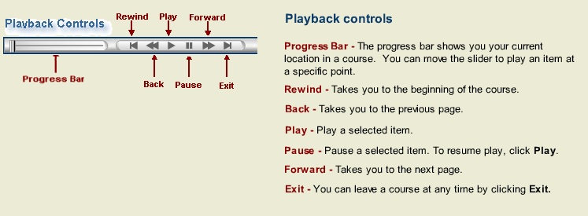
c. FDM includes a  symbol. Click it for more information on a particular task.

d. FDM’s Glossary: https://www.fdm.army.mil/learningCenter/glossary.htm.

e. FDM Help Desk: 732-720-6454 or DSN 848-8679. This office is staffed from 7:00 AM to 5:00 PM Eastern Time. Voice mail available for other times. The email is: MONM-SECFDMSpt@conus.army.mil.

f. Contact the FDM Webmaster by email at FDMWebmaster2@conus.army.mil or by phone at 703.696.5512. Send comments or suggestions for improvements to the FDM Webmaster.

g. Read the 450 Certifier Quick Start: https://www.fdm.army.mil/documents/450CertifierQuickStart.doc

h. Scan the FDM Resources tab, https://www.fdm.army.mil/helpSupport/resources.htm, for useful information (e.g., FDM 450 Examples, https://www.fdm.army.mil/PM_Reference_Docs/FDM450Examples.doc).

1.3 Usage Conventions
In this guide, bold, italicized text indicates the FDM user should click on that item (e.g., Continue) or type that information in FDM in the area indicated.

Bolded or highlighted FDM location navigation tabs (e.g., My Info, My Reviews) indicate where an FDM user is at a particular time. FDM page or screen names are bolded and underlined.

1.4 User Comments & Feedback
Send comments or feedback on this Guide or about FDM to the FDM Webmaster, email address: FDMWebmaster2@conus.army.mil.

Return to Table of Contents

2.0 Navigating FDM
FDM users start at the FDM website, https://www.fdm.army.mil, to login. The site contains general information on FDM, including the current system status (Important Information area) and system requirements (see Help & Support). Login assistance, https://www.fdm.army.mil/documents/QRC_Logging_In_to_FDM.pdf.

2.1 Website
Notice the “Information for . . . “ area along the left side. View role-specific information in that area. For more information about the FDM website, https://www.fdm.army.mil, take the narrated tour at https://www.fdm.army.mil/PM_Reference_Docs/GCFDMIntro/GCIntro.html.

2.2 Inside FDM
FDM functions are always accessible through a tab menu at the top of each page. It provides a visual cue to a user’s location in FDM. Users may select tabs at any time to change location. The tab and sub-menu item (if any) corresponding to the user’s location are always highlighted or bolded. The FDM User Guide is an overview of the basic FDM functions.

2.2.1 FDM 450 User Roles
FDM is role-based. Only individuals registered with one or more roles may access FDM. Here is a list of FDM 450 roles:

Filer – user registered to submit a financial disclosure report (FDR) (i.e., OGE 278, OGE 450).

Supervisor – DoD user assigned to review a FDR as required under the Joint Ethics Regulations. Non-DoD agencies using FDM often assign a paralegal in the FDM “Supervisor” role (especially for the FDM 450s) to do the initial, technical screening of the OGE 450.

450 Certifier – FDM user who “signs off” on the OGE 450 at an organization. May appoint one or more 450 Certifier EC(s) to also certify OGE 450s (does so on the My Info | My ECs tab).

450 Certifier EC – an Ethics Counselor the organization “450 Certifier” appointed to also “sign off” on OGE 450s for a particular organization (and subordinate organizations). The appointed 450 Certifier EC sees the same OGE 450s that the 450 Certifier sees.

450 Certifier Assistant – an FDM user the 450 Certifier appoints to assist in managing OGE 450s as well as managing OGE 450 Filers and Supervisors. The 450 Certifier Assistant is often a paralegal in the office working with the 450 Certifier. In many organizations the 450 Certifier Assistant uses FDM to manage the organization’s Filers and Supervisors as well as manage the OGE 450 FDR process.

SLC – an FDM user who is the senior or primary legal advisor to the senior OGE 278 Filer of an organization. The FDM SLC assigns the organization’s primary 450 Certifier on the Admin | 450 Certifier tab.

SLC EC – an FDM user the SLC appoints to assist the SLC in managing and reviewing OGE 278s (see the FDM 278 EC User Guide).

Org Unit POC – an FDM user who is empowered in FDM to register, delete, and manage OGE 450 Filers and Supervisors. One or more Org Unit POCs may be assigned to each FDM org unit.

Org Unit – the FDM construct that connects one or more Filers to a particular Supervisor and ethics counselor. This graphic depicts that relationship of the FDM user roles:

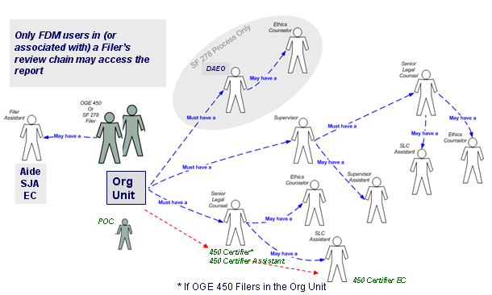

See the Quick Reference Card (QRC) Managing FDM Roles, https://www.fdm.army.mil/documents/FDM_QRC_Managing_FDM_Roles.pdf.

2.2.2 FDM 450 Certifier Tabs
The top tier menu for a 450 Certifier has these five tabs: My Info, My Reviews, Admin, Ethics Training, Management Reports, and Resources:
The My Reviews tab is the main FDM workspace for legal personnel, including the 450 Certifier (the role for SLC-appointed Ethics Counselors responsible for approving and certifying the OGE 450 in FDM). The Admin tab is where much of the administrative work is accomplished. It includes tabs for adding and managing Filers, POCs, Supervisors, SLCs, 450 Certifiers, and Org Units. Optionally use the Ethics Training tab to identify and notify Filers who need or record who received Ethics Training. A tutorial, https://www.fdm.army.mil/documents/FDM_ETHICS_TRAINING_FOR_WEBSITE/Ethics_Training_TOC.html, and a Quick Reference, https://www.fdm.army.mil/documents/QRC_Manage_Ethics_Training.pdf, explain the Ethics Training feature.

2.2.3 Filer Tabs
The top tier main menu for Filers has three tabs: My Reports, My Info, & Resources
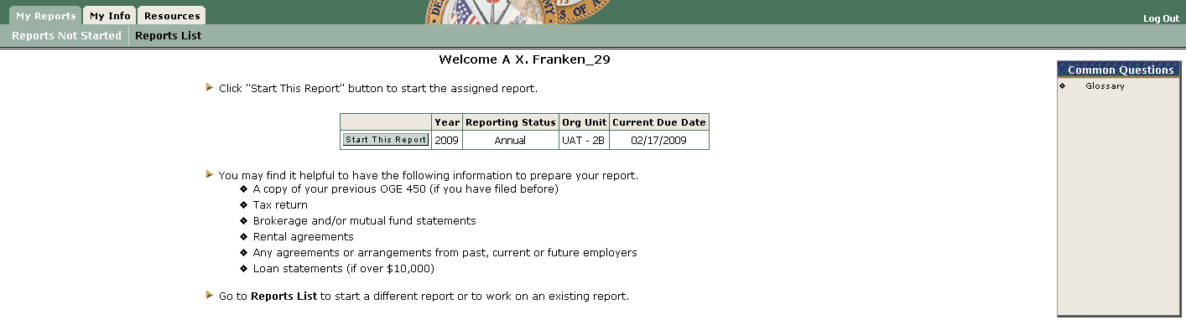
The My Reports tab is the Filer’s main FDM workspace. Here the Filer will begin a new report or edit/view any previous report prepared in FDM. OGE 450 Filers with an Assigned report will see a “Reports Not Started” tab.

2.2.4 Supervisor Tabs
The top tier menu for Supervisors is the same as for the 450 Certifier unless the Supervisor is also an FDM Filer. If so, it includes a My Reports tab to the left of My Info for the Supervisor’s FDR(s).

2.2.5 My Info Tab
FDM uses the My Info tab to capture user contact information. All users see the Contact Info screen the first time entering FDM.
Once the Contact Info is completed and saved that user gets other role-based tabs. The My Info tab is where a 450 Certifier appoints and manages assistants who will help with FDR reviews. (An SLC assigns the organization 450 Certifier on the Admin | 450 Certifier tab.)

2.2.6 My Reviews Tab
Legal personnel and Supervisors have a My Reviews | Review Reports tab, Worklist View that displays a list of the Filer(s) and FDR(s) depending on the selected filter settings. See the QRC Reviewing an OGE 450 in the FDM Learning Center | Documentation. A video tutorial, Reviewing an OGE 450, is available. My Reviews | Manage Exceptions and My Reviews | Review Reports, Org Unit View Mode, are other ways to display reports. My Reviews | Manage Exceptions displays those reports that are over 30 days old or have had an eNote opened. My Reviews | Review Reports, Org Unit View Mode displays all or specific reports, even those awaiting Supervisor signature so that the 450 Certifier (or 450 Certifier EC or Assistant) may screen the OGE 450 once the Filer has eSigned and “End Initial Review” even before the Supervisor reviews.

2.2.7 Admin Tab
The Admin tab is where SLCs, 450 Certifiers (including assigned 450 Certifier ECs and Assistants), and Org Unit Points of Contact (POC) group filers in “Org Units” associated with a specific supervisor. Recall that the Joint Ethics Regulation (JER) requires DoD supervisors review the FDR. The Org Unit is how FDM organizes filers for the responsible reviewing supervisor.

On the Admin | Org Unit tab, SLCs, 450 Certifiers (including assigned 450 Certifier ECs and Assistants), and Org Unit POCs may update select roles for a particular Org Unit by selecting Edit for the Org Unit to display a screen similar to this one:
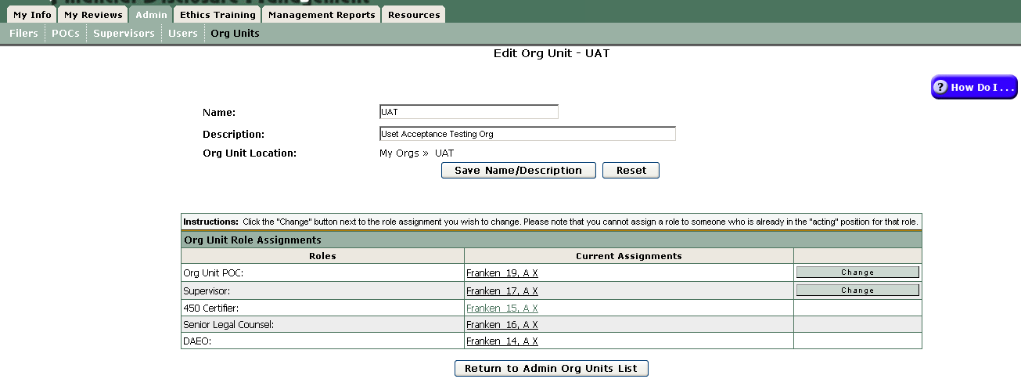
Click the “Change” action button to replace the current name in a particular role.

Finally, the Users sub-tab is search tool for any FDM user showing a user’s FDM role(s) (and Org Unit location if a Filer):
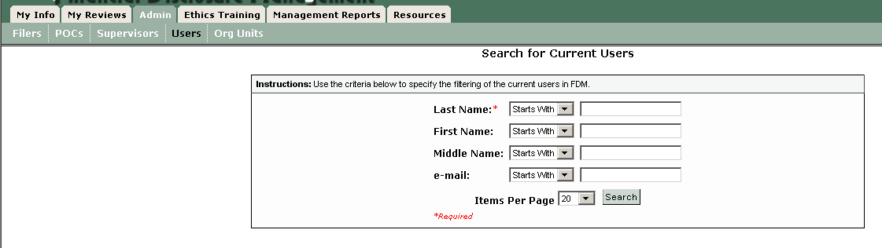

2.2.8 Resources Tab
A Resources tab links to the FDM web site Resources collection.

2.2.9 Report Navigation
Inside an OGE 450 FDR, on the My Reviews | Review Reports - Report Data page are Progress Bar buttons to move through the different report sections.
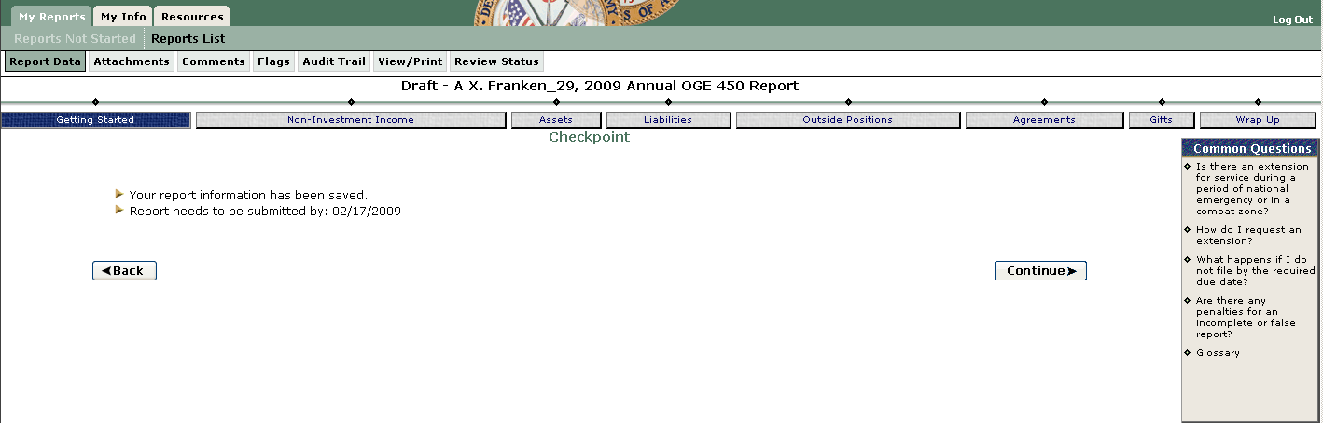

For the New Entrant OGE 450 the progress bar buttons are Getting Started, Non-Investment Income, Assets, Liabilities, Outside Positions, Agreements, and eSign (formerly labeled Wrap Up).

For the Annual OGE 450, the progress bar buttons are Getting Started, Non-Investment Income, Assets, Liabilities, Outside Positions, Agreements, Gifts, and eSign (formerly labeled Wrap Up).

Most FDM report pages display a page title, tabs, tab menu items, report completion instructions, Common Questions (links open with answer in a separate window), and navigation buttons as shown here.

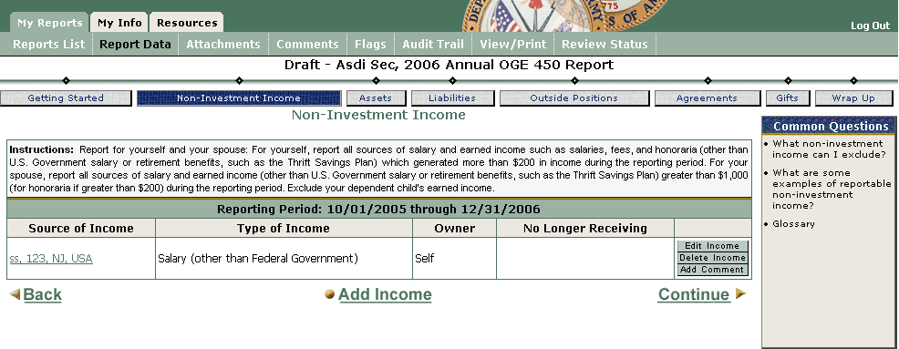
Tabs
Click to display the first page for the tab and any tab menu items
Tab Menu Items
Click to display
Instructions
Provide directions on how to enter data
Log Out
Click to exit FDM
Back, Add, Continue
Click to navigate inside a report
Common Questions
Click to display
Page Title
Report Data | Non-Investment Income

Progress Bar
Use to move to different report section

2.2.10 Administrative Action Buttons & Notify Feature
FDM includes action buttons on Admin screens that allow select users to Add that role and another Org Unit or Delete the currently assigned in a role and Assign a successor. FDM now has a “converged” Admin | Org Units screen:

Select users may change one or more roles for an Org Unit on the Admin | Org Unit screen by clicking the “Change” action button for the role(s).

The Notify action button will open an email form to email all the checked/selected names from the list at the bottom. The Notify feature remains available on the role-based Admin tab.

Caution: Be sure to review your content, especially if you created your notice in MS Word and copied/pasted it to FDM since MS Word special characters (e.g., “, #, “) may not display correctly.

2.2.11 Save & Quit
FDM saves information entered when a user selects Save. FDM users who Log Out will find the previous information available upon return. Filers may stop and resume a report as many times as desired.

Return to Table of Contents

3.0 FDM Technology

3.1 General
FDM uses Army-wide standard computer settings (known as the Army Gold Master). In the unlikely event you encounter technology difficulties (e.g., your Common Access Card (CAC) does not work or FDM does not open an Adobe file) please check the FDM web site, http://www.fdm.army.mil, Help & Support page, for information that your local IT Help Desk may need to check your computer settings.

3.2 Minimum System Requirements:
- Operating System: Windows 2000 Pro (Service Pack (SP) 2) or XP Pro (SP1 or SP2)
- Browser: Internet Explorer (IE) 6.0 (128 bit encryption)
- Adobe Acrobat Reader 6.0 (or 7.0 IE plug-in)
- JRE: Microsoft JVM or Sun JRE 1.5 or greater
- CAC reader & any of this middleware:
  - Activcard 3.0
  - Litronic Inc. Netsign CAC 4.2
Consult the the Desktop Readiness Checklist, https://www.fdm.army.mil/helpSupport/knowledgeCenter.htm#Checklist, for the latest information.

3.3 Printing
FDM relies on the user’s own computer printer settings to print. Users may need to check/adjust printer settings starting at the Internet Explorer File button, selecting Print to open the printer options.

3.4 System Maintenance Outages
Defense Information Systems Agency (DISA) began hosting FDM in late 2007. DISA regularly does system maintenance on Sunday evenings that may cause FDM to be temporarily unavailable. The FDM home page, https://www.fdm.army.mil, will usually reflect planned outages several days before they are scheduled. If a user is unable to access FDM please report that to the FDM Help Desk, MONM-SECFDMSpt@conus.army.mil. It is staffed Monday – Friday 8:00 – 5:00 p.m. Eastern or phone: DSN 848-8679.

3.5 Improve FDM Speed
Improve your computer’s operation by clearing your web browser cache or temporary internet files. To clear the cache:
- Open Internet Explorer.
- Click Tools (for Internet Explorer 5.0 and later).
- Click Internet Options, and then click the General tab.
- On the General tab, in the Temporary Internet Files section, click the Delete Files button. This will delete all the files that are currently stored in your cache.
- In the Delete Files dialog box, click to select the Delete all offline content check box.
- Click OK, and then click OK again.
- Click Delete Cookies in the Internet Properties dialog box.
- Click OK.

Return to Table of Contents

4.0 Senior Legal Counsel (SLC)/Legal Advisors/450 Certifier

4.1 Introduction
Senior Legal Counsel (SLCs), their Ethics Counselors (ECs) or Assistants, and 450 Certifiers (or their ECs) may perform many FDM functions including adding Filers and their Supervisor, and adding organization Points of Contact (POC) to assist with managing Filers and Supervisors in FDM. The SLC role does not act on OGE 450s. Instead, the 450 Certifier role (and any 450 Certifier ECs appointed) act on OGE 450s in FDM. This section explains selected features for SLCs, SLC ECs, SLC Assistants, 450 Certifiers, 450 Certifier ECs, and 450 Certifier Assistants.

4.2 Registration

4.2.1 Unregistered SLCs
Unregistered SLCs needing FDM access should contact the agency FDM DAEO or the FDM Webmaster, FDMWebmaster2@conus.army.mil.

4.2.2 Unregistered 450 Certifiers
Unregistered 450 Certifiers needing FDM access should contact the local SLC, their FDM DAEO or the FDM Webmaster, FDMWebmaster2@conus.army.mil.

4.3 Login
Registered users click Login on https://www.fdm.army.mil. Then select the Common Access Card (CAC) and Personal Identification Number (PIN). Army users may also use the Army Knowledge Online (AKO) user name and password. Non-DoD agencies use their local user name and password for access once they are registered in FDM. Login instructions: https://www.fdm.army.mil/documents/QRC_Logging_In_to_FDM.pdf.

The first time any new user logs in to FDM the Contact Information page displays for review and completion.
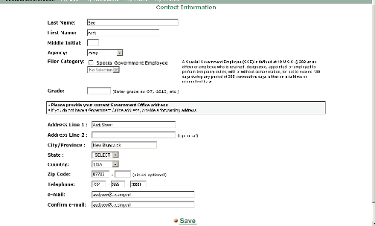
Add any missing information and select Save.

4.4 Registering/Replacing other FDM users
SLCs may register new FDM users – Filers, Supervisors, 450 Certifiers (a special FDM role for approving in FDM the OGE 450), SLC Ethics Counselors (SLC ECs), SLC Assistants, and organization POCs.

4.4.1 Registering/Replacing a 450 Certifier
Many SLCs appoint an Ethics Counselor to certify the OGE 450s. SLCs may appoint a primary 450 Certifier for each organization unit of OGE 450 Filers on the Admin | 450 Certifier tab.
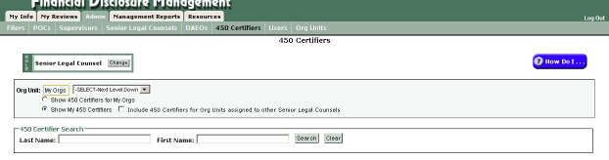
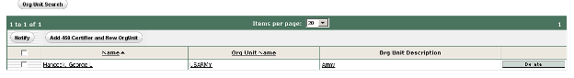

The Admin | 450 Certifier tab displays the 450 Certifiers page and the Org Unit location. A table at the bottom of the screen will display the currently assigned 450 Certifier for the particular org unit. Click on Delete to remove the currently assigned. When Assign appears click it to search for and assign another 450 Certifier. Select Next Level Down to assign a 450 Certifier below the currently displayed org unit.

Note: FDM uses a hierarchy construct. Once an SLC, POC, or 450 Certifier (or any admin role) is filled at a particular level that person may act in that role for all subordinate organizations/levels, even if another person is assigned to that role for a particular subordinate organization. FDM does not permit assigning a user in a role at a subordinate organization when that user is assigned at a higher level (Select Next Level Down) and FDM simply shows “Vacancy, . . . acting” at the subordinate levels. That way, when the person vacates that role and a successor is assigned that carries through as well, saving time on replacing at each subordinate level.

Search Tip: For the fastest, most accurate search, use the CAC-embedded email address (e.g., for Army personnel it is the AKO User Name). Or, enter a few letters of the last name and then enter the start of the email address in the email search box, select Search.
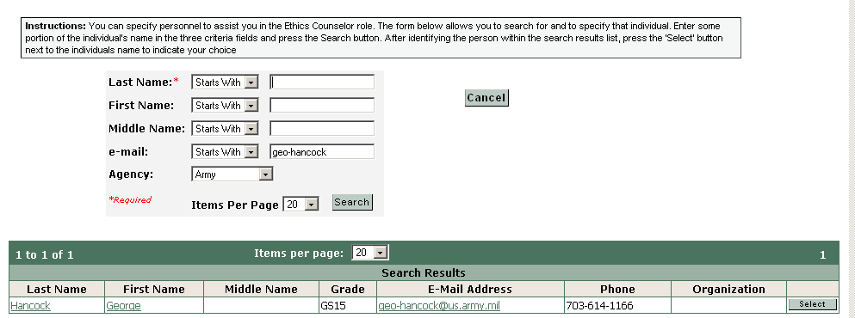

The result will be a list of names, Select the right one and Confirm to add the EC:


4.4.2 Registering/Replacing a 450 Certifier Ethics Counselor (EC)
Some 450 Certifiers have other ECs who assist them review and approve FDM 450s. FDM allows the 450 Certifier to appoint 450 Certifier ECs (on the My Info | My ECs tab) who will see the same FDM 450s that the primary 450 Certifier sees. The 450 Certifier EC and the 450 Certifier may act interchangeably on the OGE 450s for the organization.
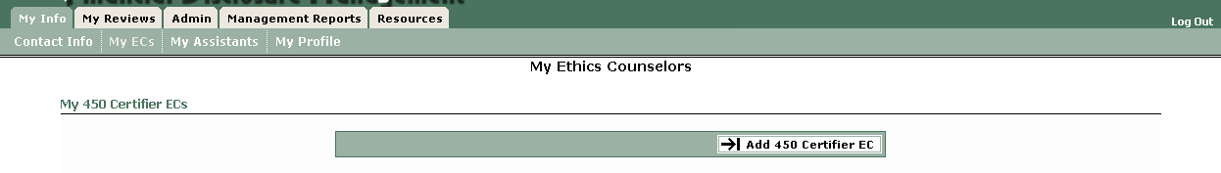
450 Certifiers may also appoint Assistants to screen and monitor reports in FDM. To add an Assistant, use the My Info | My Assistants page and click on Add Assistant:
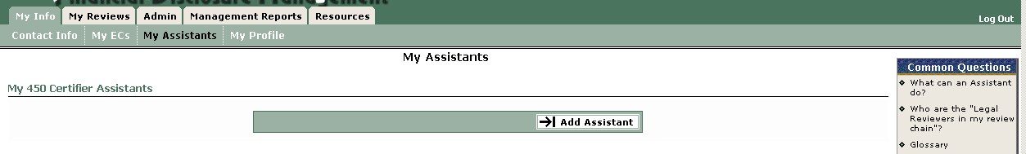

The Add a 450 Certifier Assistant page (below) appears where you use the standard FDM search tool:
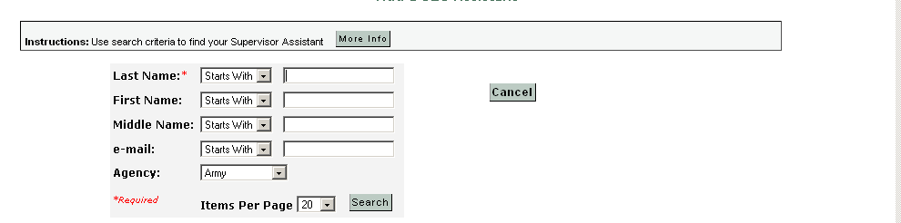
Select the correct name and Confirm to finish the Add 450 Certifier Assistant.

The 450 Certifier Assistant can register report Filers and Supervisors, preliminarily screen reports, open a Note (to indicate a troublesome area or missing information), Remind Filers, Remind Supervisors, and see the 450 Certifier's report list to monitor Filer progress. A 450 Certifier Assistant cannot eSign a report for a 450 Certifier, but can “End Initial Review” to record a technical review of an FDM 450.

4.4.3 Registering/Replacing an Org Unit Point of Contact (POC)
Many organizations appoint an administrative person who identifies OGE 450 Filers for the organization, often reminds them to file, collects their reports, and delivers them to the Filer’s Supervisor, and eventually to the legal office for certification. In some cases, a legal office paralegal coordinates with the organization POCs to administer the OGE 450 filing process. FDM has the Org Unit POC role to handle these tasks on line.
- FDM 450 Certifiers, 450 Certifier ECs, and 450 Certifier Assistants (often a legal office paralegal) may Assign POCs to org units in FDM.
- Each FDM Org Unit may have one or more POCs.
- Assign (or Add another) POC on the Admin | POCs tab if you will have POCs assist in administering FDM Filers and Supervisors. You may want to scan the FDM POC Quick Start on the FDM Resource page: https://www.fdm.army.mil/helpSupport/resources.htm and the resources included in it in orienting/training your POCs.

4.4.4 Registering a Filer & Assigning an OGE 450
The Admin | Filers tab displays any OGE 450 Filers already registered in FDM for the particular organization shown. A short video tutorial, Managing FDM Filers, and a Quick Reference Card (QRC), QRC My Filers, are available to explain the filer registration process. Other videos and QRCs are available on these topics: Managing FDM Org Units and Managing FDM Roles.

In the Army several Deputy Designated Agency Ethics Officials (DDAEOs) are responsible for the financial disclosure reporting program and process for specific areas generally along command lines.

FDM uses an Organizational Unit (“Org Unit”) tool to group and organize Filers by supervisor for visibility to the respective, responsible DDAEO. 450 Certifiers, 450 Certifier ECs, 450 Certifier Assistants, org unit POCs may Edit the Org Unit name to one based on the Supervisor’s title or position or use the office symbol (Admin | Org Unit tab). This is especially important where the former Supervisor departed and a new one will review reports of the employees who remained in that organization (and are still grouped in FDM under the named Org Unit). See Enclosure 11 to the FDM 450 SOP for more on Org Units.

Before you add a Filer you need an Org Unit for the Filer. Add one on the Admin | Org Units tab:
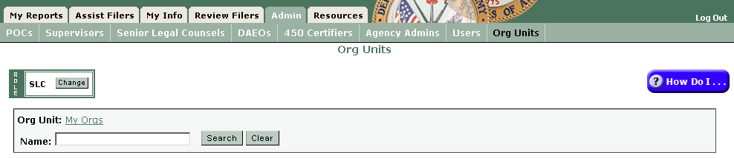
The SLC (or 450 Certifier) sees a “Role” (SLC/450 Certifier) and an opportunity to change (if the SLC has other FDM roles). Below the Role display is an “Org Unit: My Orgs” “breadcrumb trail” display showing existing organizations with which you have an association in FDM. Most 450 Certifiers will start with an organization corresponding to the supported OGE 278 Filer (e.g., CG of the organization) and may see other Org Units where there is a similar relationship. SLCs, ECs, and 450 Certifiers may add a new Org Unit. See the video on adding org units, https://www.fdm.army.mil/Documents/FDM_Org_Units_for_Website/Managing_FDM_Org_Units.html, or the Quick Reference, https://www.fdm.army.mil/Documents/FDM_QRC_Managing_Org_Units.pdf.

After the new Org Unit is added, the 450 Certifier/Certifier EC/Certifier Assistant may assign a Supervisor and a POC, to register and manage Filers for that organization in FDM. See the Quick Reference, Managing FDM Roles, https://www.fdm.army.mil/Documents/FDM_QRC_Managing_FDM_Roles.pdf or the video tutorial on assigning a Supervisor, Managing FDM Roles, https://www.fdm.army.mil/Documents/Managing_FDM_Roles_for_Website/FDM_Adding_a_New_RCP_and_OU.htm.
FDM includes a  symbol. Click it for more information on the particular task.

An SLC (or SLC EC, 450 Certifier, 450 Certifier EC, 450 Certifier Assistant, POC) adds Filers to particular Org Units on the Admin | Filers tab. See the Quick Reference, My Filers, (FDM Learning Center | Documentation) for specific instructions or watch the short video tutorial, Managing FDM Filers (FDM Learning Center | Tutorials). FDM also supports adding multiple OGE 450 filers (up to 25 at one time) – see chapter 4 of the video tutorial, Managing FDM Filers.

Note: FDM uses a hierarchy construct. Once an SLC, POC, or 450 Certifier (or any role) is filled at a particular level that person may act in that role for all subordinate organizations/levels, even if another person is assigned to that role for a particular organization. It is not necessary to assign a person in a role at the higher level to the same role at the subordinate level. FDM shows “Vacancy, . . . acting” at the subordinate levels. That way, when the person vacates that role and a successor is assigned that carries through as well, saving time on replacing at each subordinate level.

Note: Be sure to Delete/Assign Successor supervisors for org units on the Admin | Supervisor tab or on the Admin | Org Unit tab when editing the Org Unit information.

4.4.4.1 Registering 450 Filers
A short video tutorial, Managing FDM Filers, and a Quick Reference Card (QRC), QRC My Filers, are available to explain the filer registration process.

Start on the Admin | Filers tab:
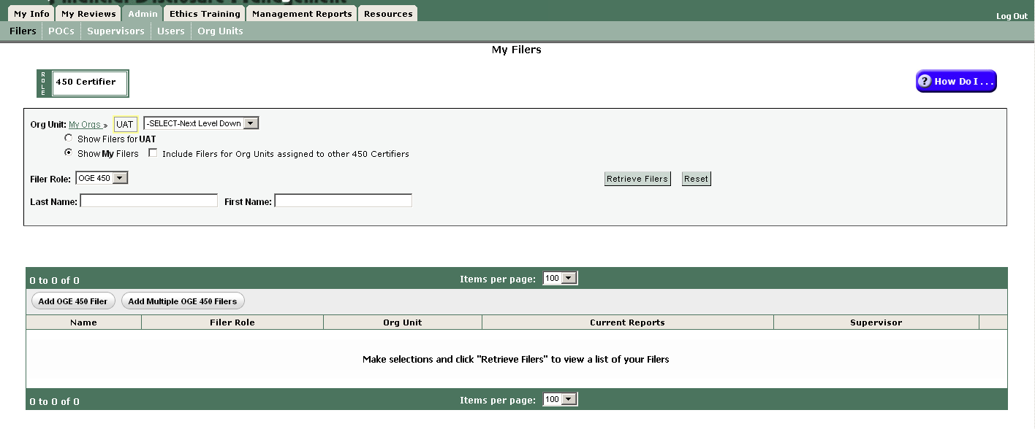

Select “Show My Filers” and click “Retrieve Filers” to display a list of current FDM 450 filers where you are the 450 Certifier.

Use Select Next Level Down to reach the particular org unit for the Filers you are registering.
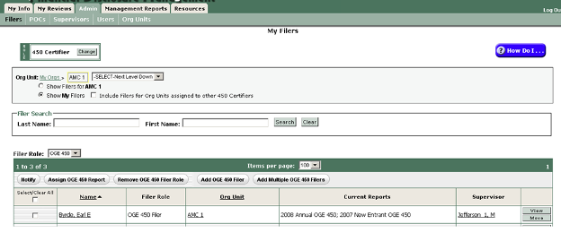

Notice that you may Add OGE 450 Filer (one at a time) or Add Multiple OGE 450 Filers (up to 25 at once). By using the 450 Tracking Spreadsheet (FDM Resources tab) you may block copy/paste the email addresses of the 450 Filers you want to add together in the same org unit.

Note: if a 450 Filer has another FDM role you must add that person as an OGE 450 Filer individually, using Add OGE 450 Filer. This is an FDM safeguard to ensure a single person is not added as a Filer in more than one org unit.

When adding an OGE 450 Filer individually, FDM will indicate if the selected individual is already registered in another FDM organization. If so, you will be prompted to move any assigned report when completing the registration. See the QRC My Filers, https://www.fdm.army.mil/documents/FDM_QRC_My_Filers.pdf. In most cases move the assigned report so that it is counted in the correct org unit for statistical purposes (on the annual agency report to OGE (due 1 February of the following calendar year)).

Note: Some OGE 450 Filers are also Supervisors of other Filers. In some cases the Filer/Supervisor is registered as a Filer in the same organization that they supervise to preserve certification by the correct OGE 450 Certifier. This technique is appropriate where the 450 Certifier at the next level up (the FDM org unit for the Supervisor of the Filer/Supervisor) differs from the 450 Certifier assigned to review the Filer’s report. FDM will automatically look to the Supervisor at the next level up to “supervise review” the Filer/Supervisor’s report.

4.4.4.2 Assign Report to File
FDM includes an Assign Report tool to assign Filers the requirement to file and a “Remind Filers” tool to notify Filers to file using FDM. The Quick Reference Card (QRC) Assigning a Report, https://www.fdm.army.mil/documents/FDM_QRC_Assigning_A_Report_to_File.pdf, explains assigning OGE 450s and notifying Filers. Assign reports on the Admin | Filers tab.

Note: assigning the report will help quickly identify delinquent/non filers, notify them of their lateness (My Reviews | Remind Filers tab), and compile a report for higher headquarters. An additional benefit is the ability to quickly obtain the Filer numbers for the annual Office of Government Ethics questionnaire.

For the Army: We initialize FDM 450 annually, automatically assigning the Annual OGE 450 report due mid-February to all FDM registered OGE 450 Filers who did not have an “appointment date” as a New Entrant OGE 450 Filer in the last 60 days of the calendar year or who were not assigned a New Entrant report in FDM 450 in the last 60 days of the calendar year. FDM does not auto assign an Annual to a Special Government Employee (SGE) who filed last year. The SGE files a New Entrant report annually and that must be assigned individually.

Filer’s Reports Not Started: Filers assigned a report in FDM 450 will land on the My Reports | Reports Not Started tab to start.

Earlier Assigned, Not Started Reports: FDM 450 Certifiers, 450 Certifier ECs, Certifier Assistants should login to FDM and go to the My Reviews | Review Reports – Manage Exceptions tab to see any assigned, but unstarted 2010 or 2011 OGE 450s for their Filers. When Filers land on the My Reports | Reports Not Started tab they will see the Year 2012 report (due in Feb 2012, covering Calendar Year 2011) and any earlier year not started reports. If the earlier assigned not started reports covering earlier years are not required, remove that assigned report to avoid confusing the Filer.

The old Assigned, Not Started reports will appear on the My Reviews | Review Reports – Manage Exceptions tab:
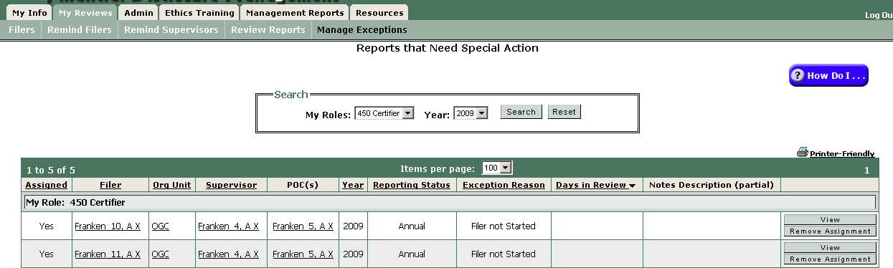
Click on the “Remove Assignment” button to remove the earlier year assigned report(s).

Manage Exceptions is also discussed in 4.9.

New Entrant OGE 450 Filers: when you register a new employee Assign the New Entrant Report as you complete the Filer registration. FDM will display an “Assign Report” action button to accomplish that.

Note about FDM email notices: FDM will email notify up to 100 Filers at a time, however, some local commands limit the number of “email addresses” in a single email to 20 – 30. If you don’t know your local activity limits, consider notifying only 20 at one time. Initially, Army users are registered using their Army Knowledge Online (AKO) email address. If those users do not check or auto forward their AKO email then the FDM-generated email to that email address may not be delivered. FDM users may edit their email address on the My Info | Contact Info screen. Only the FDM user may change his/her email address shown in FDM.

4.4.5 Registering/Replacing a Supervisor
See the short video, Managing FDM Roles, or the QRC, QRC Managing FDM Roles for information about adding a new Supervisor or deleting and replacing a departed one.

4.5 Notify OGE 450 Filers
FDM includes a Remind Filers feature that 450 Certifiers, 450 Certifier ECs, 450 Certifier Assistants, and organization POCs may use to email notify OGE 450 Filers to file. In the Army, select OGE 450 Filers registered by 31 Dec are automatically assigned the Annual OGE 450 Report (due mid-February 2012) as applicable. The auto assignment does not include OGE 450 Filers who filed a New Entrant in the last 60 days of the year as they will not have served in a covered position for over 60 days. They will owe an Annual OGE 450 in 2013 if they remain in the covered position over 60 days in calendar year 2012 and are in a covered position in February 2013 when the disclosure covering CY2012 is due.

Appendix A is a sample instruction template, Filing Your Annual OGE 450, that you may tailor and email to your 450 Filers.

4.5.1 Remind Filers to file
In January, the 450 Certifier, 450 Certifier EC, 450 Certifier Assistant, or organization POC should use the My Reviews | Remind Filers tool to initially email notify the OGE 450 Filers to do their Annual report.

The Remind Filers tool includes standard content and allows you to add additional content.

4.5.2 Remind Filers who have not started
Late in January or early February the 450 Certifier, 450 Certifier EC, 450 Certifier Assistant, or organization POC, may return to the My Reviews | Remind Filers feature and select “All OGE 450 Filers who have not started their Report” to identify those OGE 450 Filers previously notified, but who have not yet started as of the date this feature is used.
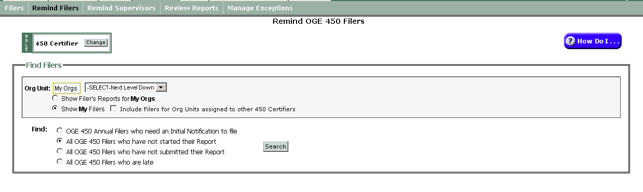
As you see, FDM’s My Reviews | Remind Filers feature includes two other group notification options:
- All OGE 450 Filers who have not submitted their Report
- All OGE 450 Filers who are late

Use these to identify Filers who started, but didn’t eSign (submit) by the date when you ran the feature, or after the due date, identify those Filers who are late (i.e., have not submitted by the mid-February due date or the extension deadline has passed).

4.6 Report Extensions
Many SJAs (FDM SLCs) delegate to the local Ethics Counselor (EC or FDM 450 Certifier) the authority to approve an extension to file for OGE 450 Filers. See Extensions for general information. Visit the FDM Learning Center, https://www.fdm.army.mil/learningCenter/tutorials.htm, for a short video tutorial on Managing FDM Extensions, and a Quick Reference Card, QRC Granting Extensions. FDM has a tool to record extensions granted for the OGE 450 Filer as shown in the items in the FDM Learning Center.

Note: OGE 450 Filers may have up to 90 days after leaving a combat zone (CZ) to file as part of an OGE 450 "optional" extension for service during national emergency, including CZ. See Extensions. FDM 450 Certifiers should check whether the SLC has delegated or withheld the authority to grant extensions.

4.7 Reviewing an OGE 450 Report in FDM
The FDM 450 Certifier role reviews and completes OGE 450s for the organization(s) where the 450 Certifier has that role. See Appendix B for a substantive review checklist. To review reports start on the My Reviews | Review Reports – Worklist View mode. Be sure to set your Role to 450 Certifier, and Action to Action Required, then click Search to see OGE 450s ready for your review:
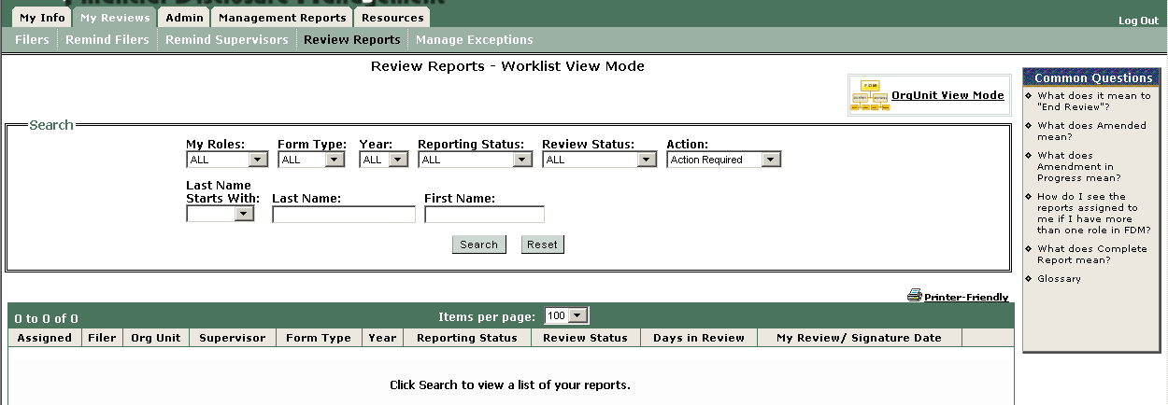
The table at the bottom will display all OGE 450s where the Filer and Supervisor already have eSigned that report. This table also allows you to order the reports by earliest submitted to most recent submitted (click on the Days in Review column). This helps reviewers meet the OGE 60-day review rule (see 5 C.F.R § 2634.605(b), http://edocket.access.gpo.gov/cfr_2008/janqtr/5cfr2634.605.htm).

- 450 Certifiers and 450 Certifier ECs & Assistants may review reports once a Filer has eSigned (even before the Supervisor has eSigned) and use the “End Initial Review” feature to record the review was completed within 60 days of submission, especially on those reports you will not complete within 60 days. To do so start on the My Reviews | Review Reports – Org Unit View Mode, show all reports Under Review.

On the My Reviews | Review Reports – Worklist View mode page, is a list of Filer(s) with any reports filtered using the filter search settings. FDM 450 Certifiers will have the View, eSign, End Initial Review, and either Assign or Remove Assignment.

You may want to “Remove Assignment” and remove the Filer’s role if the Filer need not file. The Assign/Remove Assignment feature affects whether a report is counted in the FDM statistics for the annual agency report to OGE (due annually covering the preceding calendar year). Assigned reports count toward the Filers Required to File category of the annual ethics report. Note: Certification converts an unassigned report to Assigned status.

Selecting View opens the report and displays a Report Progress Bar (below) that lets you Continue to advance through the report sections.
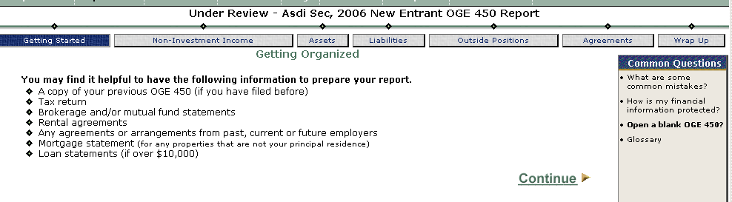

Notice that the Review Reports Report Data sub-menu may contain up to ten tabs that appear when appropriate for the particular Filer’s report:
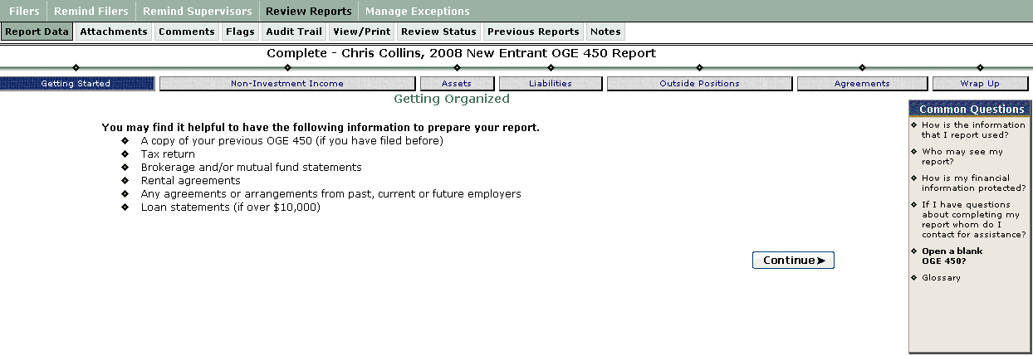
- Report Data – main area used for reviewing a report with FDM’s report wizard.
- Attachments – add/replace/view attachments associated with a report.
- Comments – area for recording Reviewer comments on a report.
- Flags – identifies missing or incomplete information that must be provided before the report is certified.
- Audit Trail – tracks key change events.
- View/Print – provides the user a view and print function for the report. This displays the FDM e450, a single scrollable web page of the Filer’s reported information.
- Review Status – shows who has reviewed/approved a Filer’s report.
- Compare – when the Filer has two or more OGE 450s in FDM and the Filer “prepopulated” the most recent one from an earlier one, this tab shows the FDM report comparison, highlighting for the reviewer all changes the Filer made in the last report submitted in FDM.
- Previous Reports – a list of any prior reports for that Filer.
- Notes – an area for recording a temporary, Post-it type note as a memory jogger. Note: opening a Report Note temporarily moves the report to the Manage Exceptions area.
Most 450 Certifiers check the Compare tab (available when a Filer has at least two reports in FDM), Comments, Flags, Audit Trail, View/Print, and Review Status tabs when reviewing a report. These help quickly identify missing or explanatory report information as well as display who else has reviewed the report (Review Status tab).

4.7.1 End Initial Review
The End Initial Review feature helps Ethics Officials demonstrate compliance with OGE’s 60-day report review rule. See Joint Ethics Regulation 7-206c(7) (Department of Defense reviewers); 5 C.F.R. § 2634.605 Review of reports (OGE 450s).
End Initial Review confirms that you reviewed but are not ready to eSign this report (e.g., perhaps you want the Filer to provide more information or amend the report). End Initial Review is an optional feature that is unnecessary when the reviewer eSigns the report within 60 days after the Filer eFiles. Ethics Officials (e.g., Ethics Counselors and Assistants) should use this feature to comply with the Office of Government Ethics' 60-day review requirement for those reports that they are not ready to certify Complete within 60 days after the Filer eFiles. One Ethics Official assigned to review the report should End Initial Review within 60 days after the Filer eFiles if the report will not be certified "Complete" until over 60 days after the Filer eFiled. If the filer amends the report after you recorded your initial review, review the report again and either "End Initial Review" or eSign and Complete it.

4.7.2 Request Filer Amend
450 Certifiers and their ECs may request a filer amend a report on the Report’s Review Status screen. FDM adds a report comment to the report when you request Filer amend. You can also add this comment as a Note to the report. Request Filer Amend opens an e-mail you send to the Filer through you e-mail application. Once you click Request Filer Amend, view the report on the Manage Exceptions or My Reviews | Review Reports – Org Unit View Mode page.

4.7.3 Notes
FDM offers 450 Certifiers, 450 Certifier ECs, and 450 Certifier Assistants Notes, an online, electronic “post-it” type, memory jogger area to record a reason why the report is not yet ready for certification. Sometimes a report is not quite ready for certification during the initial or first review. Reviewers who printed or reviewed a printed OGE 450 often annotated a comment or added a “Post-It” note for later reference. Certifiers may use FDM’s Notes feature instead. Certifier ECs and Assistants also may see its content and add to it.

- See the Using Notes Quick Reference: https://www.fdm.army.mil/documents/FDM_QRC_Manage_Exceptions.pdf.

For those reports that cannot be completed within 60 days of the report’s submission (Filer’s eSign date) opening a Note could indicate that the technical screening occurred within the OGE 60-day review rule. (See 5 C.F.R § 2634.605(b), http://edocket.access.gpo.gov/cfr_2008/janqtr/5cfr2634.605.htm.)

A 450 Certifier can add a report Note at any time during the report review process. The content of the Note is only visible to the 450 Certifier, 450 Certifier EC, and 450 Certifier Assistant. The Note is automatically closed when the report is certified.

Using Notes should help most 450 Certifiers, 450 Certifier ECs, and 450 Certifier Assistants eliminate the need to create a separate record or print out of a list of reports with annotations on why the report was not immediately certified, whether emails were sent to the Filer for more information, or similar memory jogging notes.

Click the Notes tab, then Start/Add More Notes to start recording the note.
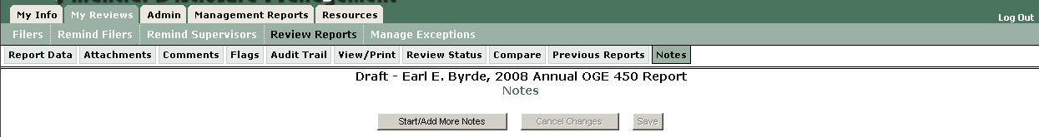
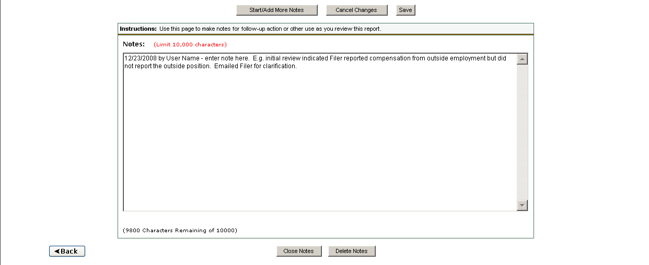

Once a Note is added, FDM temporarily shifts the report from the 450 Certifier’s My Reviews | Review Reports – Worklist view to the Manage Exceptions (Watch list) tab. Reports with Notes will remain on the Manage Exceptions list until the report Note is Closed or Deleted or the OGE 450 is certified as Complete. Supervisors will still see the report on their My Reviews | Worklist and can still review and eSign reports that have report Notes.

The Close Notes button feature (at the bottom) “closes” the note and returns the report to Worklist.
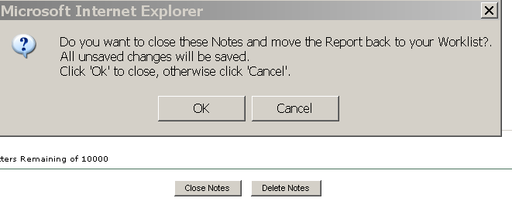
Caution: Notes are temporary. They do not replace Comments intended to stay with a report after it is certified complete. Notes are temporary, memory-jogging type items to help you process the report or explain why the report is not quite ready for certification at a given point in time. You may also add a Note as a Report Comment. Doing so will enable the Filer and Supervisor on that report to see the Comment.

4.7.4 Admin Close Reports
Once a Filer eSigns a report in FDM the Filer may not delete it. If the Supervisor or 450 Certifier determines the report is unnecessary or the Filer has departed the agency or otherwise will not complete the report the 450 Certifier may “Admin Close” or delete it by first viewing the report and then on the Review Status screen clicking “Admin Close” or “Delete.” Admin Close keeps the report data in FDM in the condition at that time. A Filer may use the Admin Closed report to prepopulate another report.
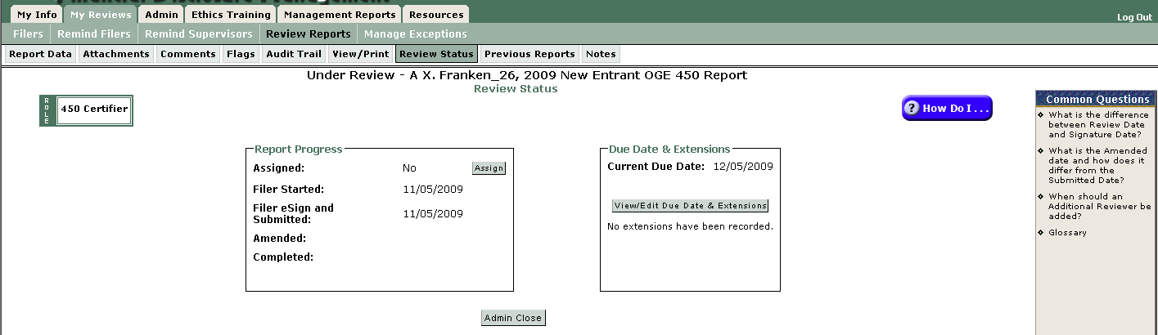
See the Admin Close Quick Reference, https://www.fdm.army.mil/documents/QRC_Administratively_Close_Report.pdf.

4.7.5 Delete Reports
FDM 450 Certifiers may delete any unnecessary report until it is “Completed.” Delete is permanent and removes all report data on the deleted report. A Deleted report cannot be restored. The Delete feature helps you remove abandoned Draft reports left in FDM after a Filer was deleted, as well as incomplete reports that will never be completed (e.g., perhaps because the Filer left the organization), and those reports that are "Admin Closed. Use Delete to remove the report data for those reports that expire 6 years after the Filer eSigns.

4.7.8 Review Chain Controls
FDM 450 Certifiers, Certifier ECs, and Assistants may add an additional reviewer on a particular OGE 450 or a change an assigned reviewer on a particular Filer’s specific OGE 450 via “Review Chain Controls” on the Review Status page.
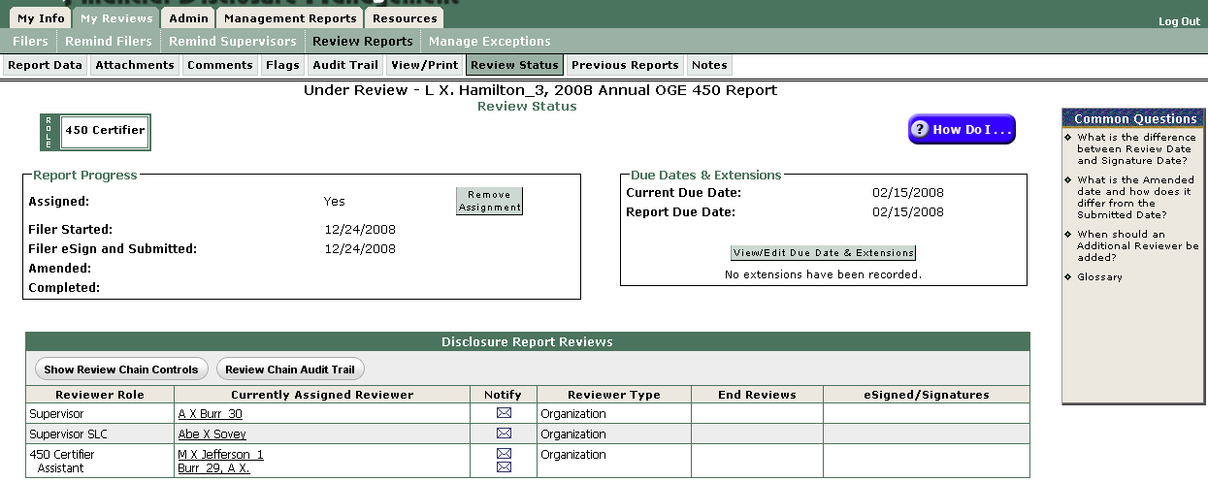

Click on Show Review Chain Controls to see the possible options:
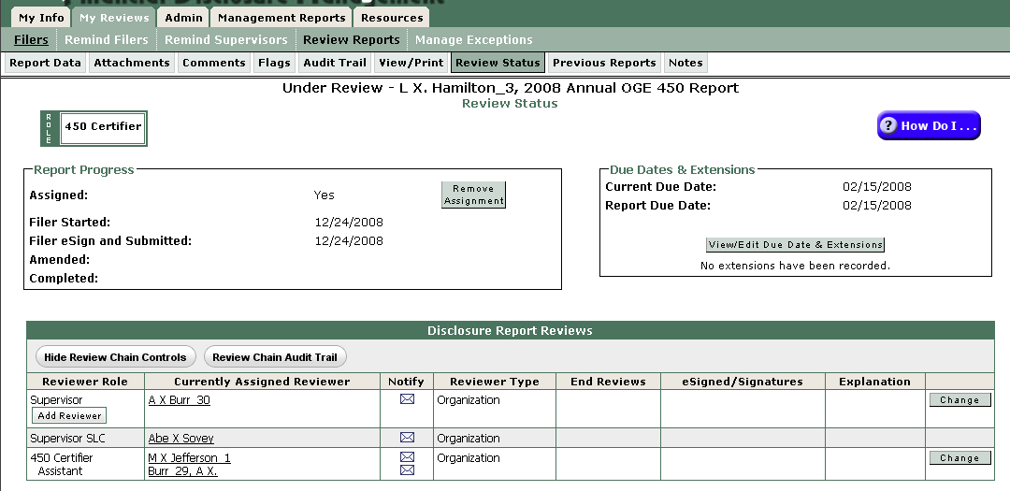
Use Change (far right) to replace the currently assigned reviewer. Use Add Reviewer to add another user who may see the report contents.

On screen instructions and prompts guide the user through completion of the addition or change.

4.8 Manage Exceptions (Watch List)
This temporary hold area helps 450 Certifiers track (or watch) Filer and Supervisor Reviewer compliance and manage reports that require any special action(s) or more information in one convenient location without cluttering the normal My Reviews | Review Reports – Worklist view of reports ready for approval. Reports remain in the Manage Exceptions list until the report issue is resolved (e.g., the Note is closed or the FDR is certified “Complete”).

Reports display on the Manage Exceptions list if:
- Open Notes - The Report has existing Notes that are not “Closed” or a National Emergency/Combat Zone extension has been recorded for the report.
- Late - The Filer has not submitted the report in FDM by the report’s due date.
- Late Supervisor - More than 30 days have passed since the Filer has submitted (or re-submitted (if amended) their report in FDM) and the Supervisor has not eSigned.
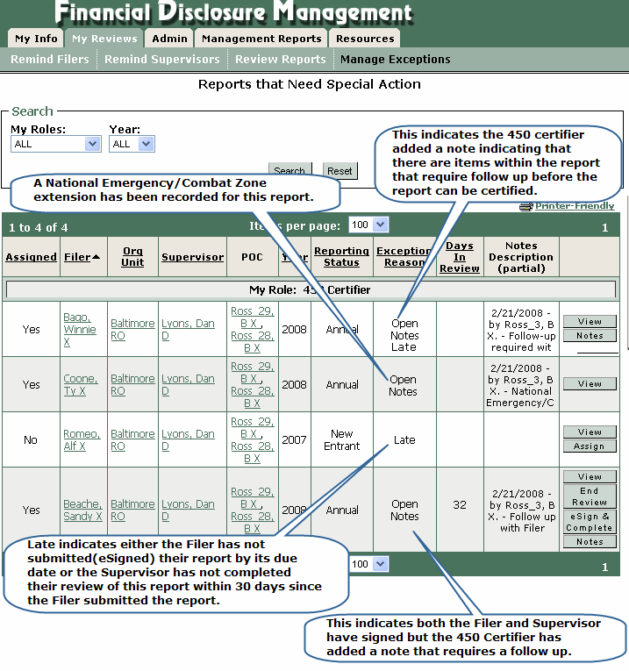

4.9 Certifying an OGE 450
Reviewers are checking the reported financial interests for completeness and to identify those financial interests that may conflict with the Filer’s official duties and that the report is administratively accurate and complete. Before signing off on the report the reviewer must take appropriate steps to resolve any apparent conflicts of interest.

The in-depth, systematic agency review of financial disclosure reports is called the certification process. It entails:
- A technical review (is the report completed accurately)
- A conflict of interest analysis (focal point of the certification process; your analysis whether a filer is/is not complying with the conflict of interest statutes, standards of conduct, and any agency-specific laws and regulations.)
- Recommending remedies to resolve a conflict, if one is found on the report, and
- A certifying signature by the responsible approving authority.

See Appendix B for a substantive checklist for certifying an OGE 450.

4.10 Electronically signing (eSigning) a reviewed report
See the QRC, QRC Reviewing an OGE 450, for details on eSigning a report. (Note: a short video tutorial, Reviewing an OGE 450, is available in the FDM Learning Center | Tutorials.)

Most 450 Certifiers (or 450 Certifier ECs) who have used FDM 450 before prefer to use Compare to quickly see changes in a Filer’s last report as compared with the Filer’s earlier report. At the bottom of Compare is an eSign button to start the eSign process.

Report Compare is only available when a Filer has at least two OGE 450s in FDM and the last report was “prepopulated” from the earlier one.

When finished Log Out or use the other tabs to move to a different FDM location.

4.11 Management Reports
FDM offers several pre-defined reports (Management Reports tab) for monitoring report progress. A narrated presentation, https://www.fdm.army.mil/PM_Reference_Docs/SLCStatus/SLCStatus.html, explains how to use these tools to identify report status and notify FDM users of required actions.



For example, use the Disclosure Report Detail (2 above) to see a total number of all OGE 450s submitted in any status (e.g., Draft, Under Review, Complete) for a particular organization. These filter settings will show all a particular 450 Certifier’s Filers’ reports for the year shown in any reporting status (i.e., New Entrant or Annual) and in any Review Status (i.e., Draft, Under Review, Complete).

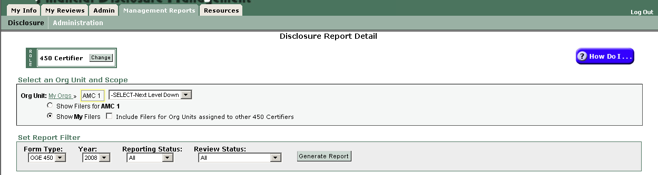
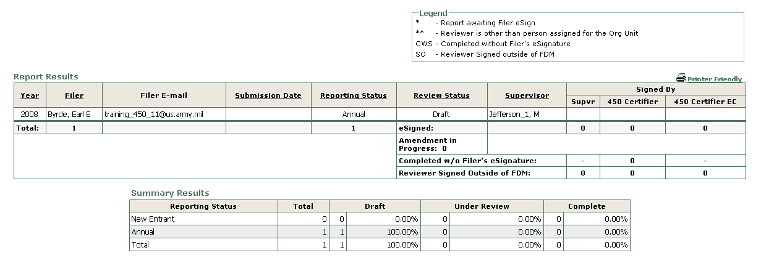

See the QRC, Management Reports,
https://www.fdm.army.mil/documents/QRC_FDM_Management_Reports.pdf, for more.

4.12 Supplemental Items
Once an OGE 450 report is “Complete” you may not change it. Occasionally, a Filer or Reviewer discovers additional information that should be stored with the report for future reference. FDM allows this via “Supplemental Items.”

Report Reviewers, Filers, and Filer Assistants may add supplemental information to a report using the Comment and/or Attachments tabs inside a completed report. First, find the report on the My Reviews | Review Reports, Org Unit View Mode, Completed reports. Next View the report and go to the Comments or Attachments tab to add a supplemental comment or attachment.

Adding supplemental information to a completed report does not remove any of the report signatures or change the report’s status in FDM.

Return to Table of Contents

5.0 Filers

5.1 Registration & Filer Notification
Certain FDM users (e.g., an agency legal advisor (a Senior Legal Counsel (SLC), SLC Ethics Counselor, 450 Certifier), a Point of Contact (POC) or administrator, or supervisor) may register a Filer. Filers may ask their FDM-registered legal staff, Supervisor, or organization FDM point of contact (POC) to register them. They may need to provide the email address on their Common Access Card (CAC) and the name(s) of the legal advisor and supervisor to the agency FDM POC.

Appendix A is a sample instruction template, Filing Your Annual OGE 450, that you may tailor and email to your 450 Filers.

5.2 Filer Login
Filers login to FDM by selecting Login at the FDM web site, https://www.fdm.army.mil.

The FDM Login page displays with the DoD User Notice pop up. Click OK to proceed to login.
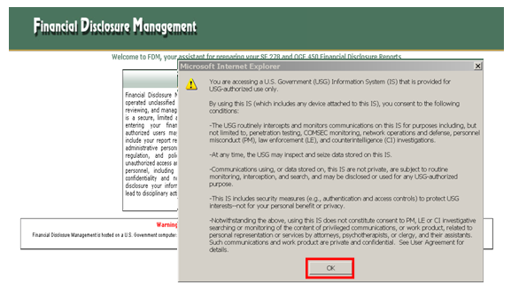
DoD users may use their CAC/PIN (or, an Army Knowledge Online (AKO) account User Name and password). Non-DoD agency users select their agency and use their local agency user name and password. Login information: https://www.fdm.army.mil/documents/QRC_Logging_In_to_FDM.pdf.

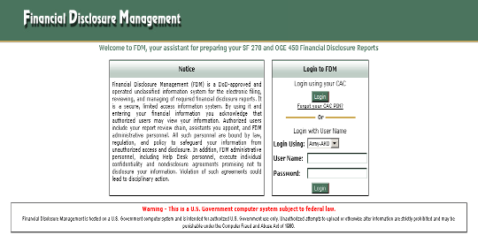
The first time a user logs in FDM prompts the user to update contact information on the My Info Contact Information page:
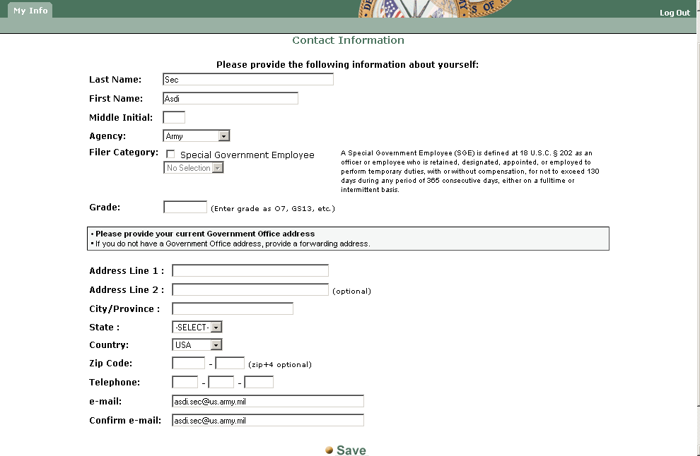
Review the information, update as necessary, and click on Save to proceed. Special Government Employees (SGEs) must use the drop down box to indicate the type of SGE category.

5.3 Adding a Filer’s Assistant
Some Filers take advantage of an FDM feature that allows the Filer to appoint one or more Filer Assistants to draft the report for the Filer. Assistants may create, view, edit, and delete reports in Draft state and only view other reports. Assistants may not submit a report nor make any changes after a Filer has submitted (eSigned) a report. Only Filers may amend reports (those a Filer has eSigned).

A Filer adds an Assistant on the My Info| My Assistant tab to open the My Assistants page:

See the QRC, QRC Managing Assistants, for screen shots on the process.

5.4 Starting a New 450
Filers new to FDM should find the short video tutorial, Filing an OGE 450 Report, the Quick Reference Card, QRC Filing an OGE450, and/or the Filer Quick Start, https://www.fdm.army.mil/450FilerQuickStart.doc quick and easy ways to see how to start a report.

The top tier main menu for Filers has these three tabs: My Reports, My Info, & Resources
The My Reports tab is the Filer’s main FDM workspace where the Filer will begin a new report or edit/view any previous report prepared in FDM.

After logging in to FDM (and saving the Contact Info screen the very first time you login to FDM), you will land on the My Reports page to start a report. If the person registering you as an OGE 450 Filer assigned you a specific report, you will see a My Reports | Reports Not Started screen.

Click Start this Report to start the assigned report.

After starting a report, FDM opens the Report Wizard and displays the Getting Started screen shown below that identifies information helpful in preparing a report:

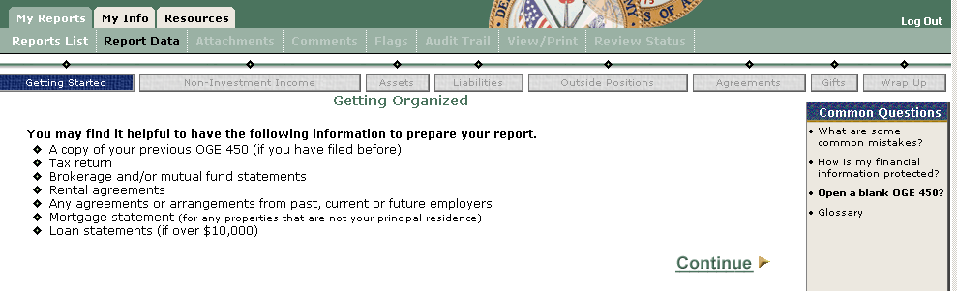
Select Continue to proceed through the Getting Started portion of the Report Data progress bar.

Special Government Employees (SGEs) indicate their status on the Special Government Employee page:
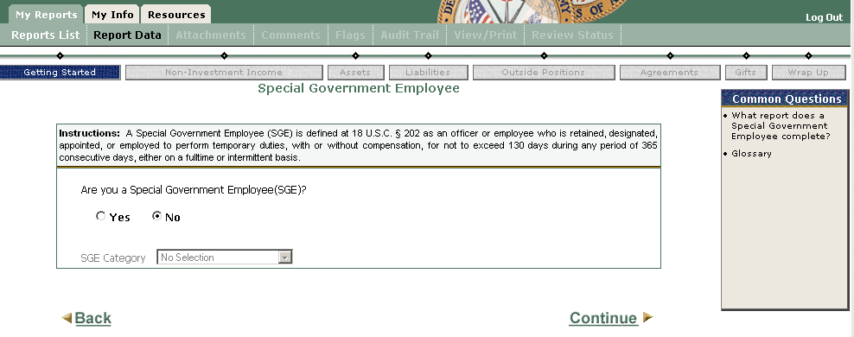
SGEs indicate their SGE Category:
- Advisory Committee Member
- Expert/Consultant
- Board Member
- Commissioner
- Other

Filers who have an earlier report in FDM will see a prompt (below) to use information in a Filer’s prior FDM report to “prepopulate” a new report:
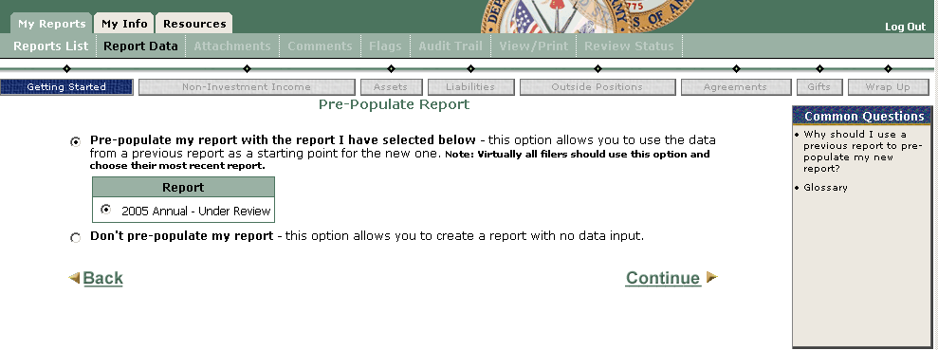
A Checkpoint page (below) displays cautioning Filers to review the old information that was carried forward and indicates that the annual OGE 450 is due not later than February 15:
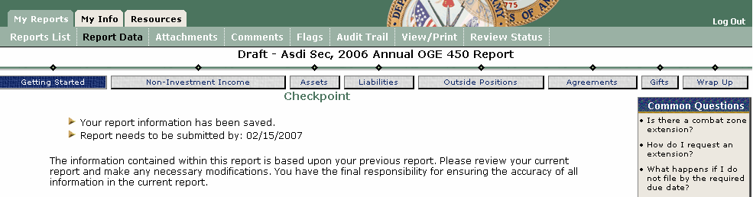

From here the Filer uses Continue to proceed through the Report Wizard answering the questions appropriately for the Filer’s situation.

See FDM 450 Examples, https://www.fdm.army.mil/PM_Reference_Docs/FDM450Examples.doc, for information on reporting selected assets in FDM 450.

Inside the report, Filers will find these navigational tools to assist report preparation:
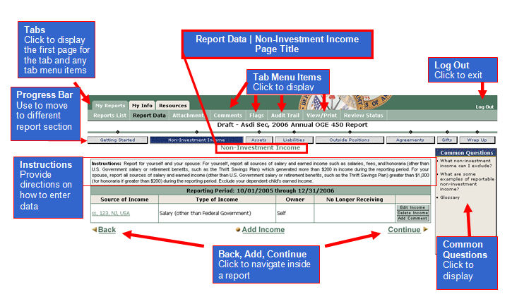

The My Reports sub-menu may contain up to eight items that appear when needed:
- Reports List - shows Filer’s previous report(s) (if any). This is where you can begin a new report and edit/view all previously prepared reports.
- Report Data – main area used for preparing a report.
- Attachments – add/replace/view attachments associated with a report.
- Comments – area for recording Reviewer comments on a report.
- Flags – identifies missing or incomplete information that must be provided before the report is filed.
- Audit Trail – tracks all changes made to the report).
- View/Print – provides the user a view and print function for the report.
- Review Status – shows who has reviewed/approved a Filer’s report.
The Common Questions (along the right side of most Report Wizard screens) provide additional information tailored to the Filer’s location in FDM.

5.5 Wrap Up & eSign
Filers ready to electronically sign and submit the OGE 450 do so in the Wrap Up section by clicking the eSign button. They may first want to check the Quick Reference, QRC Filing an OGE450¸(in the FDM Learning Center | Documentation), or the video tutorial, Filing an OGE 450 Report, (in the FDM Learning Center | Tutorials).

5.6 Amending a report
When necessary, a Filer may amend a report (before it is certified complete) by starting on the My Reports | Reports List page. There will be an “Amend” option in the far right column of any report that may be amended:
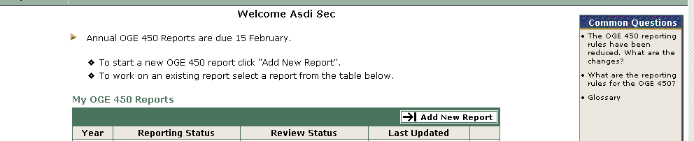

Filers use the Report Data page navigation buttons to go to the specific reports section(s) to amend:
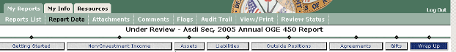

Note: Filers must complete the Wrap Up eSign process again after amending a report before a reviewer may act on that report. Only a Filer may amend a report.

5.7 Log Out

OGE 450 Filers may exit FDM using Log Out (upper right). Return to Table of Contents

6.0 Supervisors

6.1 Introduction
DoD Supervisors use FDM to review the Filer’s financial disclosure report online as required by the Joint Ethics Regulation. Non-DoD agencies using FDM, e.g., Office of Government Ethics, Veterans Affairs, Department of Homeland Security, that do not require a “Supervisor” review an OGE 450 are using the FDM Supervisor role to do the technical screening or preliminary review. FDM 450 emails the Supervisor a notice that the report is ready for Supervisor review after a Filer eSigns. The email includes the Filer’s name and a link to FDM, https://www.fdm.army.mil. The report will appear on the Supervisor’s My Reviews | Review Reports tab depending on the filter settings (see 6.7 below). Sometimes local command/organization email policies block FDM’s notice email so Supervisors should periodically check for reports ready for their review.

6.2 Registration
Like a Filer, a Supervisor must be registered in FDM to use it. Certain FDM users (e.g., a POC or agency legal advisor (SLC), 450 Certifier, 450 Certifier EC) may register a Supervisor.

6.3 Login
After registration, Supervisors login at https://www.fdm.army.mil. Click Login. Login information: https://www.fdm.army.mil/documents/QRC_Logging_In_to_FDM.pdf.

6.4 Reviewing a report
Supervisors are checking the reported financial interests for completeness and to identify any financial interests that may conflict with the Filer’s official duties and that the report is administratively accurate and complete. Timely supervisory review (within 30 days after a Filer eSigns in FDM, https://www.fdm.army.mil) is important to the early identification of actual and potential conflicts so that appropriate measures can be determined and implemented. Prompt review saves the Filer and the agency the potential embarrassment that may result from inaction.

The FDM Learning Center | Documentation has a Quick Reference, Reviewing an OGE 450, and the Learning Center | Tutorials has a video tutorial, Reviewing an OGE 450. View a Supervisor/Reviewer Quick Start, https://www.fdm.army.mil/documents/SupervisorReviewQuickStart.doc.

Supervisors find reports to review on the My Reviews | Review Reports – Worklist View Mode page (shown below).
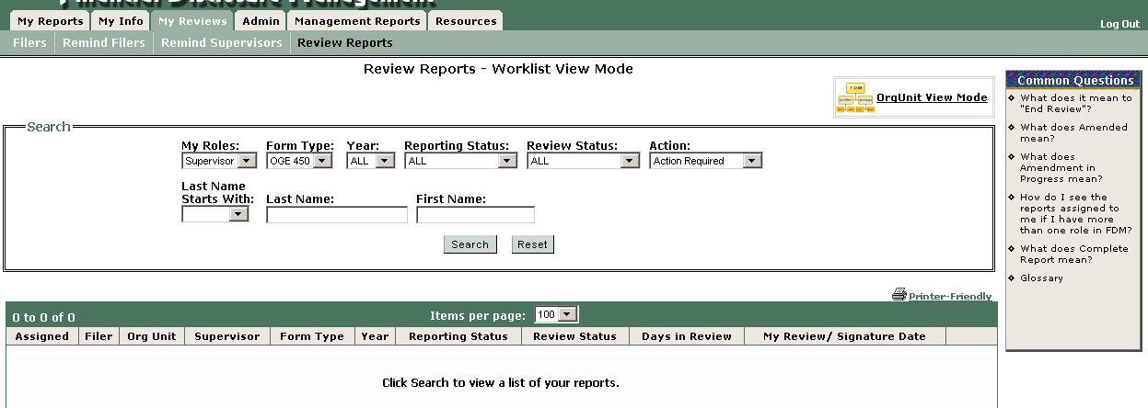

Using the Search filter settings shown above, a Supervisor clicks Search to display reports ready for the Supervisor’s action.

The table below the green title bar will contain those reports ready for the Supervisor’s review.

FDM offers two ways to review a report: Report Wizard View or View/Print View. Start by selecting View at the far right of the row with the report you want to review.

The report will open in the Report Wizard view and the Supervisor may proceed through the report using the report progress bar or Continue at the bottom of each page. This view enables the user to add comments to a particular report entry during the review.

Alternatively, once inside a particular report, Supervisors may select the Compare tab (when Filer has at least two reports in FDM) or the View/Print tab and see the OGE 450 report in a single, scrollable web page with an eSign button at the bottom.

Reports with a Compare tab indicates the Filer has the current and at least one earlier OGE 450 in FDM. Compare shows the reviewer all changes the Filer made between the earlier report and the current one (when the Filer chose to prepopulate the current report from an earlier one). When finished scrolling down the Compare, click on eSign to record your review.

6.4.1 Report Wizard View
The Report Wizard view provides the same view the Filer uses when creating the report. The same FDM Report Data progress bar navigation buttons allow the Supervisor to move section by section (e.g., Assets, Liabilities). Common Questions are also displayed.


The Report Wizard view allows the Supervisor to add comments tied to a specific item by using the Add Comment feature (in the far right column of each reported item). Comments are a way of clarifying reported information, alerting the Filer to missing information, over reporting, or other information that the agency report certifying official may need.

In addition, Supervisors may use the My Reviews | Review Reports – Report Data tab Comments, Flags, and Audit Trail items.
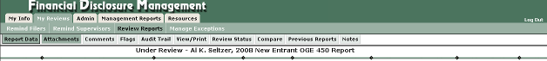

6.4.2 View/Print Review
On the My Reviews | Review Reports – Report Data tab, select the Report you want to View to open the report, then select View/Print to open the OGE 450 in a single, scrollable web page.
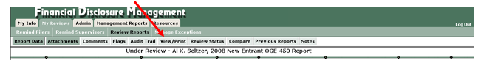
The Filer’s OGE 450 will open in a separate window so be sure pop up blockers are disabled to see the report. When finished the Supervisor proceeds to Wrap Up to eSign the report.

6.5 Electronically signing (eSigning) a reviewed report
The Supervisor may View, eSign, or End Review by selecting the appropriate choice in the far right column in the table listing reports for action on the My Reviews | Review Reports – Worklist view.
(Inside a report, click on the eSign tab in the report progress bar.) The eSign choice starts the FDM eSign process:
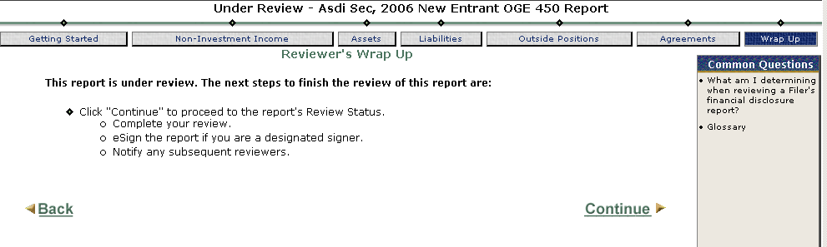

After selecting Continue, the Review Status screen displays the Under Review Filer Name, Type Report page.
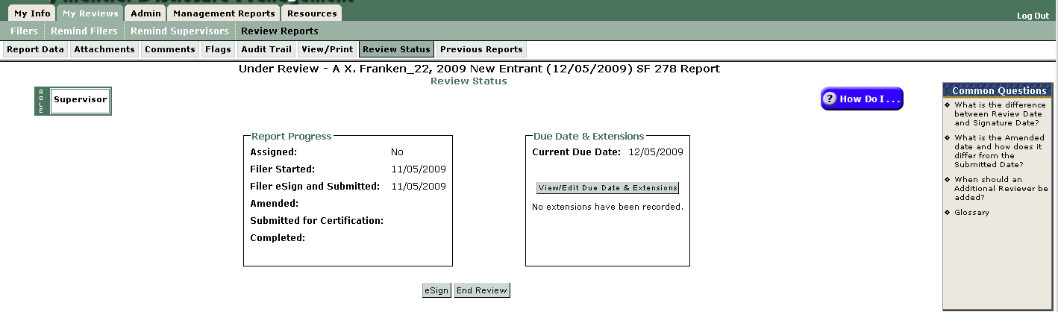

Most Supervisors click on the Flags, Comments, and Audit Trail Tabs before returning to the Review Status page and selecting eSign & Complete (at the bottom).

Some reports will have a “Compare” tab. For those, Compare indicates the Filer has the current and at least one earlier OGE 450 in FDM. Compare shows the reviewer all changes the Filer made between the earlier report and the current one (when the Filer chose to prepopulate the current report with an earlier one). When finished scrolling down the Compare, click on eSign to record your review.

Click OK to confirm and proceed to the eSign Report page. Supervisors have another opportunity to View the report using the link to display the report in a single scrollable web page (see Appendix A for a sample) or click on eSign.
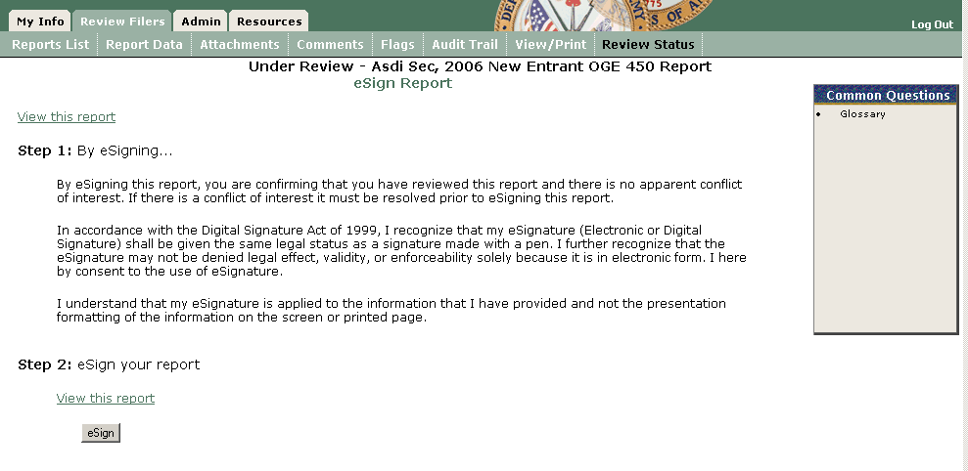

FDM returns the Supervisor to the My Reviews | Review Reports – Worklist View page to show any other reports that fit the search criteria awaiting Supervisor review.

6.7 eSigning an amended report
A Supervisor must eSign again if a Filer amends a report after the Supervisor eSigned it. The eSign process for an amended report is the same as eSigning a report described earlier. The Supervisor may want to use the Audit Trail tab for that report to quickly see what the Filer changed or amended.

6.8 Log Out
Use the Reports List tab to move to other reports or Log Out of FDM (upper right corner).

Return to Table of Contents
Appendix A
Sample Email Content
Electronically Filing Your Annual OGE 450

Use FDM’s “Remind Filers” tool (on the My Reviews | Remind Filers tab) to identify OGE 450 Filers to send an initial notice to file. Reuse this feature during the year for those filers who haven’t started, started but didn’t finish, or who are late. A quick reference, Remind Filers, that explains the feature is online: https://www.fdm.army.mil/documents/QRC_Remind_Filers.pdf.

Some optional suggested content for an email notice to your OGE 450 Filers:

Subject: eFiling Your Annual OGE 450, Confidential Financial Disclosure Report

The Annual OGE 450 Report filing season has begun. You are registered in Financial Disclosure Management (FDM), https://www.fdm.army.mil, as an OGE 450, Confidential Financial Disclosure Report, Filer. Your Annual OGE 450 Report is due xx February 20xx unless you obtain an extension.

The basic purpose of the OGE 450 is to assist employees and their agency avoid conflicts between official duties and private financial interests or affiliations. The OGE 450 is a confidential report protected under the Federal Privacy Act.

FDM is the Army’s secure, online tool similar to electronic filing income tax software. FDM uses a Report Wizard to guide you through preparing your report as it presents information screens and answers to common questions. View a short, narrated video on filing an OGE 450 in FDM: https://www.fdm.army.mil/documents/Filing_OGE_450_For_Website/Filing_an_OGE_450_Report.html. See a Filer Quick Start, https://www.fdm.army.mil/documents/450FilerQuickStart.doc, for reporting hints and a summary chart of what to report.

1. Log in to FDM, https://www.fdm.army.mil. (The first time you enter you will see a Contact Information screen to review, update, and complete. Click Save when finished.)

2. Next you land on the My Reports | Reports Not Started page if a report has been assigned (otherwise as a Filer you will be on the My Reports | Report List page).

3. Click the Start this Report button beside the Annual OGE 450 Report. FDM's report wizard will guide you through the report.

4. Once you start your report, FDM will again show you the Contact Info page, this time including who has been registered as your rater/Supervisor to review your report. Be sure to check that the names shown are correct.

5. When your finish providing your reportable information, go to Wrap Up and click the e-Sign button to sign and submit your report to your Supervisor.

Please consult your legal advisor or me, [sender’s role/name inserted], if you have questions about this requirement to file a Financial Disclosure Report, or need an extension. Also, consult your legal advisor or me if you do not think you should file such a report.

For further assistance, contact the FDM Service Center at 732-532-5566 or DSN 992-5566. Additional information can be found on the Help & Support page at: /helpSupport/helpSupport.htm. E-mail: mailto:MONM-SECFDMSpt@conus.army.mil."

Helpful reporting hints:

In the Assets section:
a. Only list assets with values of more than $1000.00, or if it earned more than $200.00 during the year.
b. Only list Sector Mutual funds. (DO NOT list diversified mutual funds.) Be sure to list the full name of the sector fund (e.g., Fidelity Magellan Select Health), not just the general family name of the fund.
c. Underlying holdings: some assets, e.g., IRAs, 401(k)s, managed brokerage accounts, are really collections of other assets. You may report the collection (or parent asset) name. You must report each of the individual reportable holdings (i.e., those valued over $1,000 or earned over $200 in income). You might do so by beginning the asset name with IRA-Asset name 1; IRA-Asset name 2 to show that asset 1 and 2 are held in a particular IRA. Remember, you do not need to report diversified mutual funds (even if in an IRA).
d. List your pension if it is held in stocks, or is administered by your spouse’s or your former employer.
e. Don’t list savings or checking, CDs, or money market accounts or US Government Bonds or notes.
f. Report any rental property that you own.
g. If you list a pension in the asset section and it is your pension (not your spouses), you will also need to remember to list the pension as an agreement in the Agreements section.

In the Liabilities section DO NOT LIST:
a. ANY mortgage you received from a financial institution on terms generally available to the public.
b. Loans from family members
c. Secured loans unless the loan exceeds the value of the item secured.
d. Student Loans

Browse the FDM Resources page, OGE 450 area, https://www.fdm.army.mil/helpSupport/resources.htm, for additional information.

FDM 450 report examples: https://www.fdm.army.mil/documents/FDM450Examples.doc

Return to Table of Contents
Appendix B
Certifying an OGE 450, Confidential Financial Disclosure Report

B.1 General:
The purpose of the OGE Form 450, Confidential Financial Disclosure Report, is to help employees avoid conflicts between their official government duties and their private financial interests or affiliations. It also helps them avoid conflicts that result from the financial interests and affiliations of their spouses and dependent children.

Agency review of the OGE Form 450 helps employees avoid conflicts of interests. It also protects the agency by giving the agency a chance to deal with conflicts of interest internally instead of publicly. The review also provides an in-depth, methodical review process to identify conflicts (or potential ones) that employees may overlook and to take appropriate preventive or corrective action (see Remedies below).

As an OGE 450 Certifier you have an important role in the review process. This appendix is intended to compile references and tools to assist you review and certify assigned OGE Form 450s.

B.2 References:
OGE Course Materials, Certifying 450 Reports, Participant Guide, FY08
OGE 450 FAQs, http://www.oge.gov/Financial-Disclosure/Confidential-Financial-Disclosure-450/Helpful-Resources/Helpful-Resources-for-Confidential-Financial-Disclosure/.
FDM Resources, https://www.fdm.army.mil/helpSupport/resources.htm, including the FDM 450 SOP, the Quick Reference, Reviewing an OGE 450 (visit the FDM Learning Center | Documentation, https://www.fdm.army.mil/learningCenter/documentation.htm), and the FDM Learning Center tutorials (https://www.fdm.army.mil/learningCenter/tutorials.htm).
FDM 450 examples: https://www.fdm.army.mil/documents/FDM450Examples.doc.

B.3 Certification:
Reviewers are checking the reported financial interests for completeness and to identify those financial interests that may conflict with the Filer’s official duties and that the report is administratively accurate and complete. Before signing off on the report the reviewer must take appropriate steps to resolve any apparent conflicts of interest. The in-depth, systematic agency review of financial disclosure reports is the certification process. It entails:
- A technical review (e.g., is the report completed accurately)
- A conflict of interest analysis (focal point of the certification process; your analysis whether a filer is/is not complying with the conflict of interest statutes, standards of conduct, and any agency-specific laws and regulations)
- Recommending remedies to resolve a conflict, if one is found on the report, and
- A certifying signature by the responsible approving authority (in FDM, a “450 Certifier” or “450 Certifier EC”).

B.3.1 Technical Review:
The first step in the certification process. The purpose of the technical review is to ensure that filers complete the form accurately. FDM’s flagging system is an important tool in the technical review. Filers must remove all red flags (those signifying missing or incomplete information) before they may submit their report. Certifying officials look to see that the information provided is appropriate. One of the best sources on how to complete the OGE 450 is the instructions. Another good source is 5 CPR Part 2634, Subpart I which identifies the contents of 450 reports.

- Use FDM’s “End Initial Review” feature (see 4.7.1 End Initial Review) to record completion of the Technical review on those reports that you will not certify within 60 days of the Filer’s eSign.

In most cases, do not continue the certification process until the report has all the required information. Sometimes you may need additional information from a Filer. When you obtain additional information, regardless of the source, include a comment for the item(s) using FDM’s comment tool (either a line item comment or the Comment tab).

B.3.2 Conflict of interest analysis:
To conduct a conflict of interest analysis, you evaluate each entry on the 450 in light of the:
- Conflict of interest statutes
- 18 USC § 208 implementing regulation (5 CFR 2640)
- Standards of conduct regulation (5 CFR Part 2635), and,
- DoD’s Joint Ethics Regulation (on the DoD SOCO site)

B.3.3 Remedies:
When you identify a conflict of interest on a 450 report, the next step in the certification process is to recommend a remedy to resolve the conflict.

B.3.4 Completing Certification:
The last step in the certification process is to sign the report (eSign in FDM). Your eSignature means that, in your professional opinion, the filer is complying with the conflict of interest statutes, standards of conduct, and any agency-specific laws and regulations.

You have 60 days to review and certify each report. The 60 days begin as soon as the filer eSigns his/her report in FDM. Final certification may occur later than 60 days if you need additional information from Filers or when remedies are needed. See 5 CFR § 2634.605(a).

B.4. Useful Resources to assist in your review and analysis of the confidential financial disclosure report include:
- OGE Form 450 instructions;
The Filer’s Reporting Status (i.e., New Entrant or Annual) affects the reporting period and what parts of the OGE 450 are required. Here is a comparison chart for each part that includes what a filer reports and what a filer does not report:
Report Part | New Entrant | Annual
Part I: Assets and Income: Report for yourself, your spouse, and dependent child those assets held for investment with a value over $1,000 at the end of the reporting period OR assets held for investment if produced over $200 income during the reporting period. Examples: stocks, bonds, annuities, trust holdings partnership interests, life insurance, investment real estate, or a privately-held trade or business; sector mutual funds (those funds invested in a particular industry, business, or location such as ABC Electronics Fund or XYZ Canada Fund (report the full name of the fund, not just the general family fund name)); holdings of retirement plans (e.g., 401(k)s or IRAs (list each holding except diversified mutual funds)); defined benefit pension plans provided by a former employer (include the name of the employer)  Also filer reports for filer all sources of salary, fees, commissions, and other earned income greater than $200, honoraria greater than $200, and other non-investment income such as scholarships, prizes, and gambling income greater than $200.  Filer reports for spouse all sources of salary, fees, commissions, and other earned income greater than $1000 and honoraria greater than $200.  Do not report: Federal Government retirement benefits, Thrift Savings Plan, certificates of deposit, savings or checking accounts, term life insurance, money market mutual funds and money market accounts, personal residence (unless rented), diversified mutual funds (e.g., ABC Equity Value Fund), US Government Treasury bonds, bills, notes, and savings bonds, money owed to you, your spouse, or dependent child by a spouse, parent, sibling, or child, dependent child’s earned income, Veterans’ benefits, Federal Government salary, Social Security benefits. | Preceding 12 months | Preceding Calendar Year
Part II: Liabilities: Report for yourself, your spouse, and dependent child a liability over $10,000 owed at anytime during the reporting period other than a loan from a financial institution or business entity granted on terms made available to the general public; report a loan over $10,000 from an individual such as a friend or business associate.  Do not report: any liability, such as a mortgage, student loan, or a credit card account, from a financial institution or business entity granted on terms available to the general public; loans secured by automobiles, household furniture, or appliances, unless the loan exceeds the purchase price of the item it secures; or liabilities that you owe to your spouse or to the parent, sibling, or child of you, your spouse, or your dependent child. | Preceding 12 months | Preceding Calendar Year
Part III: Outside Positions: Report for yourself all positions outside the US Government held at any time during the reporting period, whether or not you were compensated and whether or not you currently hold that position. Examples: officer, director, employee, trustee, general partner, proprietor, representative, executor, or consultant of a corporation, partnership, trust, or other business entity, non-profit or volunteer organization or educational institution.  Do not report: any position with a religious, social, fraternal, or political entity; any position held by your spouse or dependent child, or any position you hold as part of your official duties. | Preceding 12 months | Preceding Calendar Year
Part IV: Agreements and Arrangements: Report continuing participation in an employee pension or benefit plan maintained by a former employer; a leave of absence; future employment, including date you accepted employment offer; continuation of payment by a former employer (including severance payments).  Do not report: any agreement or arrangement related to your employment by the Federal Government or spouse’s/dependent child’s agreements or arrangements. | Preceding 12 months | Preceding Calendar Year
Part V: Gifts and Travel Reimbursements: Report for yourself, your spouse, and dependent child travel-related reimbursements (e.g., lodging, transportation, and food) totaling more than $335* from any one source during the reporting period; include where you traveled, the purpose, and date(s) of the trip; any other gifts totaling more than $335* from any one source during the reporting period.  *If you received more than one gift from one source determine the value of each item you received from that source but ignore each item valued at $134 or less. Add the value of those items above $134. If the total exceeds $335 then you must report those items.  Do not report: anything received from relatives, the US Government, DC, state, or local governments; bequests and other forms of inheritance; gifts and travel reimbursements given to your agency in connection with your official travel; gifts of hospitality (e.g., food, lodging, entertainment) at the donor’s residence or personal premises; anything received by your spouse or dependent child totally independent of their relationship to you. | Not applicable for New Entrants & SGEs | Preceding Calendar Year

Spouses & Dependent Children Summary:
In addition to reporting their own information, OGE Form 450 Filers must report certain information about their spouses* and dependent children. Filers report information about their spouses and dependent children on parts I, II, and V only.

OGE Form 450 | Filer | Spouse* | Dependent Child(ren)
Part I: Assets & Income | X | X | X
Part II: Liabilities | X | X | X
Part III: Outside Positions | X
Part IV: Agreements or Arrangements | X
Part V: Gifts & Travel Reimbursements | X | X | X
*A Filer living apart from his/her spouse with the intent to divorce or separate permanently, does not need to report the spouse's assets, income or liabilities. Otherwise, the Filer must disclose a spouse's interests as required.

Note: FDM’s Report Wizard separates Part I into Non-Investment Income and Assets for ease of data capture. FDM’s e450 view of the report displays those items together.

Use these citations for a complete description of reporting requirements for the items shown:

5 CFR § 2634.907, Report Contents. | Filer | Spouse & Dependent Child(ren)
Assets & Investment Income 5 CFR § | 2637.907(c) | 2637.907(b)
Noninvestment Income 5 CFR § | 2637.907(h)(2) | 2637.907(h)(1)
Liabilities 5 CFR § | 2637.907(d) | 2637.907(h)(3)
Outside Positions 5 CFR § | 2637.907(e) | NA
Agreements/Arrangements 5 CFR § | 2637.907(f) | NA
Gifts & Travel Reimbursements 5 CFR § | 2637.907(g) | 2637.907(h)(4)

- Conflict of interest statutes 18 U.S.C. §.§ 201-209;

Applicable Conflict of Interest Statutes – A Quick Reference Guide*
Statute | Title
18 USC § 201 Bribery & Gratuities | Prohibits a public official from accepting bribes or gratuities to influence his government actions. (Only Department of Justice interprets this statute.)
18 USC § 202  Definitions | Defines a special government employee who is a temporary or intermittent employee subject to special provisions of the conflict of interest statutes.
18 USC § 203  Representation of Others for Compensation | Prohibits an employee from accepting compensation for certain representations before the government.
18 USC § 205  Representation of Others with/without Compensation | Prohibits an employee from prosecuting a claim against the US or representing another before the government in matters where the US is a party or has an interest.
18 USC § 207  Post-employment Restrictions | Places certain restrictions on an employee’s activity before the government after he leaves federal service.
18 USC § 208 Conflicting Financial Interests | Prohibits an employee from participating in government matters that affect his own financial interests or those of certain other individuals with whom the employee has ties outside the government.
18 USC § 209 Supplementation of Salary | Prohibits an employee from being paid by someone other than the US for doing his government job.
*Source: OGE Course Materials, Certifying 450 Reports, Participant Guide, FY08

- Implementing regulation for 18 U.S.C. § 208 at 5 CFR Part 2640;

Brief Summary* – 5 CFR 2640 (Implementing regulation for 18 U.S.C. § 208)
Subpart | Brief Summary
A – General Provisions | Describes the statutory prohibition of 18 USC § 208(a), its purpose, scope, and interpretation, and defines the key terms used throughout part 2640.
B – Exemptions | Describes the financial interests that OGE considers too remote or too inconsequential to affect the integrity of the services of the employees to which the prohibition applies. Includes mutual funds, unit investment trusts, employee benefit plans, securities, and a variety of miscellaneous exemptions, and specific conditions that must be met for these exemptions to apply.
C – Waivers | Provides guidance to agencies on the factors to consider when issuing individual waivers under § 208(b)(1) or (b)(3).
*Source: OGE Course Materials, Certifying 450 Reports, Participant Guide, FY08

- Financial disclosure regulation at 5 CFR Part 2634;
- Standards of conduct regulation at 5 CFR Part 2635 and, in DoD, the Joint Ethics Regulation;

Standards of Conduct – An Overview
Subpart | An employee must not . . .
A – General Provisions | Place private gain above loyalty to the Constitution, laws, and ethical principles. Nor, violate the 14 general principles of ethical conduct.
B – Gifts from Outside Sources | Solicit or accept any gift given by a prohibited source or given because of his official position, unless the item is excluded from the definition of a gift or falls within one of the exceptions in this subpart.
C – Gifts between Employees | Give, donate to, or solicit contributions for a gift to an official superior nor accept a gift from an employee who receives less pay, unless the item is excluded from the definition of a gift or falls within one of the exceptions in this subpart.
D- Conflicting Financial Interests | Participate personally and substantially in any particular government matter that will affect his own financial interest or those of certain other persons. Or, acquire or continue to hold financial interests specifically prohibited by his agency.
E – Impartiality in Performing Official Duties | Act on a matter if a reasonable person who knew the circumstances of the situation could legitimately question impartiality.
F – Seeking Other Employment | Participate personally and substantially in any particular government matter that will affect the financial interests of a person with whom he is seeking, negotiating for, or has any arrangement concerning prospective employment.
G – Misuse of Position | Use his government time, authority, information, and resources for: his own private gain; the endorsement of any product, service or enterprise; or the personal benefit of others. Nor may a supervisor use a subordinate’s time in this manner.
H – Outside Activities | Engage in outside employment or any outside activity that conflicts with his government job. Or, fail to adhere to restrictions: on outside earned income; service as an expert witness; compensation for teaching, speaking, or writing; and fundraising.

- Agency lists of contractors, grantees, licensees, etc. (check the DoD SOCO library, http://www.dod.mil/dodgc/defense_ethics/resource_library/index.html)
- The filer's position description (if available)
- The filer's prior report (if an annual filer) [Check FDM’s Compare view for changes]
- The Internet (for use in researching financial assets, terms; see Enclosure 1, Financial Interest Websites, in the FDM OGE 450 SOP)

Report Area | Conducting a technical review:
General | The technical review is an initial determination to see if the filer provided complete information and properly completed the report. See 5 CFR § 2634.907, Report Contents. Often, a skilled Army paralegal will conduct the technical review using FDM’s flag system and checking the e450 display to ensure the information reported makes sense. Use this checklist as a guide when viewing the e450. Per 5 CFR § 2634.909, Procedures, penalties, and ethics agreements,(a) The provisions of subpart F govern the review of confidential disclosure reports. See 5 CFR § 2634.605.
Assets & Income | - Has the filer provided complete information?  - Has the filer reported underlying holdings (except diversified mutual funds) for investment clubs, private pension interests, investment life insurance, and retirement plans?  - If the filer reported a defined benefit plan, did the filer report the name of the employer providing the plan and identify it as a defined benefit plan?  - If the filer reported a defined contribution plan, did the filer report the reportable underlying assets of the plan (not diversified mutual funds)?  - Did the filer over-report items that should not be reported (e.g., diversified mutual funds)?  - When a previously reported asset no longer appears you may presume that it fell below the reportable threshold.  - Reference: 5 CFR § 2634.907(c)
Liabilities | - Did the filer report any liability that exceeded $10,000?  - Did the filer report the creditor’s name, city, and state?  - Did the filer over-report items that should not be reported (e.g., loans for automobiles, household furniture, or appliances (as long as the loan does not exceed the purchase price); loans from banks or other financial institutions on terms generally available to the public (e.g., mortgages); revolving charge accounts, student loans, loans from a spouse or to a parent, sibling, or child of filer, spouse, or dependent child(ren)? (Note: The new regulation does not require filers to report student loans, credit card debt, or loans from a financial institution or business entity that are granted on terms made available to the public.)  - When a previously reported liability/debt no longer appears you may presume that it was paid off or dropped below the $10,000 reportable threshold.  - Reference: 5 CFR § 2634.907(d)
Outside Positions | - Evaluate the completeness of each position reported (e.g., name, location of the organization, type or purpose of the organization, and specific position held)  - Verify that pertinent income-producing activities are also reported in the assets/income section of the report.  - Confirm that the filer is not over-reporting (e.g., did not report positions held by spouse or dependent child(ren); compensated or uncompensated positions held in any religious, social, fraternal, or political entity; positions solely of an honorary nature, positions filers hold as part of official duties, mere membership in an organization.  - Consider outside activity approval forms (if available)  - Reference: 5 CFR § 2634.907(e)
Agreements & Arrangements | - Evaluate the completeness of each entry (e.g., the name of the parties, the location, terms, and, if there is an arrangement for future employment, the date when the arrangement was made  - Confirm that pension plans and leaves of absence also appear in Part I and III, respectively.  - Confirm that the filer is not over reporting.  - Reference: 5 CFR § 2634.907(f)
Gifts & Travel Reimbursements | - Assess the completeness of each reported item (e.g., donor’s name, gift description, itinerary (i.e., purpose, date(s), and kinds of expenses when a travel-related gift).  - Assess the relationship between donor and filer  - Confirm the filer is not over-reporting (e.g., filer does not report anything less than $134, received from relatives, the US Government, DC, state, or local governments; bequests and other forms of inheritance; gifts and travel reimbursements given to filer’s agency in connection with filer’s official travel; gifts of hospitality (e.g., food, lodging, entertainment) at the donor’s residence or personal premises; anything received by filer’s spouse or dependent child totally independent of their relationship to filer.)  - Reference: 5 CFR § 2634.907(g)

Use these citations for a complete description of reporting requirements for the items shown:

5 CFR § 2634.907, Report Contents. | Filer | Spouse & Dependent Child(ren)
Assets & Investment Income 5 CFR § | 2637.907(c) | 2637.907(b)
Noninvestment Income 5 CFR § | 2637.907(h)(2) | 2637.907(h)(1)
Liabilities 5 CFR § | 2637.907(d) | 2637.907(h)(3)
Outside Positions 5 CFR § | 2637.907(e) | NA
Agreements/Arrangements 5 CFR § | 2637.907(f) | NA
Gifts & Travel Reimbursements 5 CFR § | 2637.907(g) | 2637.907(h)(4)

Here is a checklist* to use to review an OGE 450 for possible conflict of interests.
Report Area | Considerations to conduct a conflict of interest analysis:
Admin – Filer’s position, grade | - What official duties does the filer perform?  - Does the filer deal with non-federal entities?
Assets & Income | Purpose of reviewing assets & income is to ensure that filers are not using their government jobs to affect the sources of their assets and income, and ultimately, their own financial interests.  - Are any of the reported interests in DoD contractors or are they on a DoD/Army prohibited holdings list?  - Do any of the reported financial interests raise a potential conflict with the filer’s official duties:  - Determine if the filer might take an official action that would result in a monetary gain or loss to himself or those whose financial interests are imputed to him  - Consider whether the filer’s official action may create an appearance of a conflict of interest  - Decide if the filer has a covered relationship that creates an appearance of a conflict of interest  - Reference: 5 CFR § 2634.907(c)
Liabilities | Purpose of reviewing liabilities is to ensure that filers do not receive gifts or special favors under the guise of a loan.  - Does filer have a loan with a prohibited source? If yes: ask about  - loan terms (e.g., same as available to general public or more favorable (if more favorable, inquire why) (Note: Special terms may not always raise ethical concerns. For example, there are instances where special terms reflect normal economic motives on the part of the lender, e.g., offering a lower rate to a customer with very large deposits or exceptional credit-worthiness.)) &  - filer relationship to creditor  - Reference: 5 CFR § 2634.907(d)
Outside Positions | Purpose of reviewing reported outside positions is to ensure that filers do not experience any conflicts of interest through such paid or unpaid positions with non-Federal organizations.  - Do any of filer’s official duties impact any of the organizations listed?  - What does filer do for the listed organization?  - Watch for situation where filer may attempt to represent the organization before the Government (18 USC §§ 203, & 205)  - Is filer an employee of the organization and does filer take Government action that affects the organization (18 USC § 208)  - Reference: 5 CFR § 2634.907(e)
Agreements & Arrangements | Agreements or arrangements with nongovernmental organizations create a financial tie between the employee and that organization. This may influence the way an employee performs his government job.  - Assess the terms of the agreement/arrangement – do they indicate any special treatment because of filer’s federal job?  - Could filer take an official action that could result in a monetary gain or loss to himself or the entity with which he has an agreement/ arrangement?  - Consider whether filer’s official action may create an appearance of a conflict of interest.  - Decide if filer has a covered relationship that creates an appearance of a conflict of interest.  - Reference: 5 CFR § 2634.907(f)
Gifts & Travel Reimbursements | Purpose of reviewing this section is to determine whether gifts are being given to influence the performance or non-performance of an official action and to ensure that filers are not using their public office for private gain.  - Consider the relationship between donor and filer  - What could donor and its affiliates gain from filer’s official performance of duties?  - Is the donor a prohibited source?  - How frequently does donor give gifts? Does a gift exception or exemption apply?  - Consider the gifts from outside sources subpart of the standards of conduct (5 CFR part 2635, subpart B (and in DoD, the Joint Ethics Regulation)) and any exceptions/exemptions. Some common outside source exceptions that meet the reporting threshold are awards and honorary degrees; gifts based on outside business or employment relationships, free attendance at certain widely attended gatherings.  - Reference: 5 CFR § 2634.907(g)
*Developed from OGE training, Certifying Confidential Financial Disclosure Reports

Applicable Statutes & Regulations*
OGE Form 450 Part | Conflict of Interest Statute at 18 USC §§ | Applicable Regulations
OGE Form 450 Part | Conflict of Interest Statute at 18 USC §§ | 5 CFR Part 2635 | 5 CFR Part 2640
I | 201, 203, 205, 208, 209 | B, D, E, G, H | A, B, C
II | 201, 208, 209 | B, C, D, E, G, H | A, B, C
III | 201, 203, 205, 208, 209 | D, E, H | A, B, C
IV | 203, 205, 207, 208, 209 | D, E, F | A, B, C
V | 201, 209 | B, C, E, G, H | Not applicable
*Source: OGE Course Materials, Certifying 450 Reports, Participant Guide, FY08

Remedies:
When you discover real or potential conflicts of interests on an OGE 450 report, you need to counsel the filer (and maybe consult the supervisor) on what remedies would resolve the conflicts depending on the situation. This chart describes possible remedies.

Possible Remedy | The employee . . .
Recusal | Does not participate in the matter.
§ 208 Waiver | Is permitted to participate in governmental matters that would otherwise conflict with his financial interests, when certain conditions are met:  - (b)(1) waiver for circumstances where the employee’s interests are not so substantial as to be deemed likely to affect the integrity of the employee’s services to the government. See 5 CFR § 2640.301  - (b)(3) waiver for circumstances where the need for the Federal advisory committee member’s services outweighs the potential for a conflict of interest created by the financial interest involved. See 5 CFR § 2640.302
Divestiture | Sells the financial interest.
Reassignment | Avoids particular assignments, such as working on a particular contract, or transfers to a different section or subject area.
Resignation | Gives up his position in an outside organization or leaves his government position.
Gift resolution | May choose one of the following options:  - Return the gift;  - Pay the market value;  - Give the gift to an appropriate charity, share it within the office, or destroy it, if it is not practical to return the gift because it is perishable and the employee’s supervisor or ethics official approves. See 5 CFR § 2635.205(a)(2)

Financial Assets, Property Interests, and Income
Disclosed on OGE Form 450 Reports*
*Source: OGE Course Materials, Certifying 450 Reports, Participant Guide, FY08

Notes:
1. FDM includes a Glossary defining many of these terms and FDM-specific terms.
2. This document serves as a quick reference guide only. As such, the “definitions” are abbreviated. Further, the confidential financial disclosure regulation, 5 CFR part 2634, subpart I, serves as the ultimate authority for disclosure requirements.

Term | Definition/Description
401(k) Plans | An arrangement in which an employee places pre-tax earnings into a tax-deferred retirement account that a private industry employer creates and maintains. Employer holds funds in trust until employee reaches a specified age or leaves employer. Plans are self-directed. Filer must disclose the plan’s reportable underlying assets on Part I, and disclose the plan on Part IV. See Non-reportable Underlying Assets.
403(b) Plans | An arrangement in which an employee places pre-tax earnings into a tax-deferred retirement account that a state or local government employer or tax-exempt organizations (such as schools and charities) create and maintain. Plans generally offer limited choices of funds. Filer must disclose the plan’s reportable underlying assets on Part I, and disclose the plan on Part IV. See Non-reportable Underlying Assets.
Annuities | Contract with a life insurance company. Investor pays a premium to an insurance company per the contract and the insurance company makes payments to the investor at a specified age. See also Deferred Annuities, Fixed Annuities, Immediate Annuities, and Variable Annuities.
Collectibles | For OGE Form 450 reporting purposes, OGE is only concerned about items of personal property that are held for investment or for production of income. This may include antiques, works of art, vintage automobiles, stamps, rare coins, etc. Filer needs to describe the nature of the collectibles on Part I.
Corporate Bonds | A debt owed by a corporate issuer to a bondholder – usually a promise to pay a specified rate of interest over a fixed rate of time. Filer must disclose the name of the asset on Part I.
Deferred Annuities | Postpones payments to investor until he/she reaches a certain age or retirement. Deferred annuities may be either fixed or variable. See also Annuities, Fixed Annuities, Immediate Annuities, and Variable Annuities.
Defined Benefit Plans | Type of pension interest. Employer makes a contribution to a pool that is held and invested for all participating employees. Employee will receive a fixed amount of benefits when he or she retires. Employee may know in advance the amount of his future benefits or, at a minimum, know the formula that determines the amount. Filer must disclose the name of the employer providing the plan and the type of pension interest on Part I, e.g., defined benefit plan, and the plan’s terms on Part IV.
Defined Contribution Plans | Type of pension interest. 401(k) and 403(b) plans are examples of this type of interest. Employee makes contributions to an employer who maintains a separate account for each employee. Either the employee or an independent manager chooses how the contributions will be invested. The benefits upon retirement depend on the performance of the plan’s assets. Filer must disclose the reportable underlying assets of the plan on Part I, and the plan on Part IV. See Non-reportable Underlying Assets.
Diversified Mutual Funds | Diversified means that the fund does not have a stated policy of concentrating its investments in any industry, business, single country other than the U.S., or bonds of a single state within the U.S. Filer does not disclose diversified mutual funds on OGE Form 450 reports. Reviewers may have the filer check the fund’s prospectus or call a broker or the manager of the fund to determine whether a mutual fund meets this standard. See also Mutual Fund and Sector Mutual Fund.
Education Savings Accounts (529 plans) | An education savings plan operated by a state designed to help families set aside funds for future college costs. (Educational institutions may also offer 529 pre-paid tuition plans). Every state now has at least one 529 plan. 529 plans are tax-deferred. There are two types of plans – Prepaid Tuition Plans and Prepaid Savings Plans. Contributors decide the state plan in which they want to invest. Once invested in the plan, the plan’s assets are professionally managed. Disclosure requirements vary according to the type of plan. See Prepaid Tuition Plans and Prepaid Savings Plans.
Excepted Investment  Funds (EIF) | A pooled investment vehicle that is: 1) widely held (100 or more participants); 2) publicly traded (or available) or widely diversified (no more than 5% of the value of the portfolio is invested in one issuer [other than the U.S. government] and holds no more than 20% in any particular economic or geographic sector); and 3) independently managed. Investors do not exercise or have the ability to exercise control over interests held in the fund. The investment vehicle may be a mutual fund, regulated investment company, common trust fund maintained by a bank or similar financial institution, pension or deferred compensation plan, or any other investment fund. For investments that qualify as EIFs, the filer must identify the fund itself as an interest in property and/or a source of income. The filer does not have to disclose the fund’s underlying assets. Note: The definition of an EIF is used for financial disclosure purposes only.
Fixed Annuities | Income from an annuity at a specified rate of return guaranteed by the insurance company. The insured has no direct interest in how premiums are invested. Filer needs to disclose the name of the insurance company and specify that the asset is a fixed annuity on Part I. See also Annuities, Deferred Annuities, Immediate Annuities, and Variable Annuities.
Funds Receivable | Filers, spouses or dependent children may be lenders for a loan or have other receivable accounts, such as compensation owed by former employers or money owed for goods and services. Filer must disclose notes and accounts receivable unless it is a loan to a close relative. On Part I filer must identify the borrower (helpful if it includes relationship to filer and reason for loan). Watch for loans between government employees – if the loan is to a superior, a low interest rate could be a gift to a superior.
Futures | An agreement to buy or sell a commodity or a financial interest at a stipulated price, quantity, and time. Filer must report the asset on Part I if it is valued over $1,000 or if the income exceeds $200 during reporting period (even if it is unrealized gain).
General Obligations | A type of municipal security. A debt obligation for general expenditures and backed by taxing and borrowing power. Filer must disclose general obligations on Part I. See also Municipal Securities and Revenue Bonds.
Government Agency Securities | Debt obligations issued by federal agencies and Government corporations and Government-sponsored corporations to help finance operations such as GINNIE MAE, FANNIE MAE, FREDDIE MAC, SBA and TVA. Filer does not report these securities on the OGE Form 450. See also Treasury Securities.
Hedge Funds | Funds that seek to profit in all kinds of markets by pursuing leveraging and other speculative investment that may increase the risk of investment loss. Filer must disclose the name of the hedge fund. Hedge funds may qualify as excepted investment funds. If so, the filer must identify the fund itself as an interest in property and/or a source of income and does not have to disclose the fund’s underlying assets. If the hedge fund does not qualify as an excepted investment fund, the filer must disclose the hedge funds' reportable underlying holdings. See Excepted Investment Funds and Reportable Underlying Assets.
Honoraria | Payment for an appearance, speech, or article. Most federal employees may accept honoraria for activities that do not relate to their official duties (see exceptions at 5 CFR part 2636, subpart C). Filer must report honoraria and their sources on Part I. If the honorarium is received as compensation for an outside position, filer has to report the position on Part III. Reviewers may want to check if filers followed the requirements for participating in an outside activity and consider whether the honorarium is compensation for teaching, speaking, or writing that relates to their official duties (with an exception for teaching certain courses).
Immediate Annuities | Income from an annuity that pays out immediately. Immediate annuities may be either fixed or variable. The income may be interest or dividends. See also Annuities, Deferred Annuities, Fixed Annuities, and Variable Annuities
Individual Retirement Accounts (IRAs) | Generally a bank, brokerage, or mutual fund account that the employee designated as a tax-deferred retirement account. Reportable income is generated even though the income is reinvested. All IRAs are self-directed. Filer must disclose all reportable underlying assets on Part I. See Non-reportable Underlying Assets.
Intellectual Property | Filer may hold investments in intellectual property and related rights (patents, copyright, computer software, etc.). Intellectual property may produce both earned income (compensation for services and paid when item is sold) and investment income (i.e., royalties). The intellectual property must be described by indicating the nature of the item and the contractual arrangements in Part I. Income consists of advances, contract payments, royalties, etc.
Investment Clubs | Most investment clubs are set up as general partnerships. Each member or partner in the group owns a proportionate share of the assets in the club. The threshold for reporting the investment club itself is the overall amount that the filer invested in the club. The threshold for reporting the underlying assets of the club is based on the filer’s interest in each asset. If the filer’s interest in a particular underlying asset is not valued over $1,000 or if the filer’s share of income generated by that asset does not exceed $200, then the filer does not need to disclose that particular underlying asset. The filer must report the investment club and those underlying assets that meet the reporting thresholds on Part I (stocks, bonds, sector mutual funds, etc.). A position such as general partner should generally be reported on Part III.
Keogh Plans (HR-10 plans) | Tax-deferred pension account for self-employed persons and employees of unincorporated businesses. These plans have essentially the same financial disclosure and conflict of interest analysis as IRAs because employers have no continuing connection with the Keogh after their contributions have been made. Filer must disclose the reportable underlying assets on Part I. See Non-reportable Underlying Assets.
Life Insurance Policies | Policies issued in either term or cash value. Filer generally does not have to report term life insurance. However, filer must report cash value life insurance because it is part insurance and part investment. See also Universal Life Insurance, Variable Life Insurance, and Whole Life Insurance.
Limited Partnerships (LP) | Formed when a group of individuals join together for the purpose of investing in a trade or business. The other investors are limited partners. Usually has one general partner who organizes and manages the operations and the partnership. Individuals are offered reduced liability exposure, investment income, and tax advantages. LPs often invest in real estate, hedge funds, oil/gas, futures, equipment for leasing, or finance new product development, etc. Filer reports the name of the partnership on Part I and possibly the reportable underlying assets. Filer reports an outside position on Part III, if he is a general partner or if he receives fees for services performed for the LP. See also Public Limited Partnerships and Private Limited Partnerships.
Livestock and Farm Interests | Filers may have interests in livestock or other farm interests either as owners, employees, or investors– disclosure is the same for each. On Part I, filer must disclose his type of interest (limited partner, general partner, sole owner, corporate shareholder, etc.). If the asset is a farm, filer must also report the name under which the farm does business, the business of the farm (such as livestock) and the location of farm (city and state). Filers need to disclose their positions, such as general partner, sole owner of proprietorship, etc., if appropriate, on Part III.
Municipal Securities | Debt obligations of cities, counties, etc. Filer must report on Part I. See also General Obligations and Revenue Bonds.
Mutual Funds | An entity which is registered as a management company under the Investment Company Act of 1940, as amended (15 U.S.C. 80a-1 et seq.). Includes open-end and closed-end mutual funds and registered money market funds. Filer does not report money market or diversified mutual funds on the OGE Form 450. However, filer must disclose the full name of sector mutual funds on Part I. See also Diversified Mutual Funds and Sector Mutual Funds.
Non-Public Businesses | Filer must disclose on Part I, the full name of the entity, the location (city and state), the nature of the business (such as full-service restaurant, computer software, retail store, candle-making business, etc.), and any portfolio investments or attributions that are not solely incidental to the business. Filer needs to disclose any position held with the business on Part III.
Non-Public Stocks | Stocks not available to public. Usually issued directly to those who formed the company or provided capital to the company. Filer must provide a description of the nature of the company’s business and the location (city and state) of the business on Part I.
Non-Reportable Underlying Assets | Money market mutual funds; cash deposit accounts (such as certificates of deposit and money market accounts); U.S. government obligations, including Treasury bonds, bills, notes, and savings bonds; government securities issued by U.S. government agencies; and diversified mutual funds.
Options | Grants investors the right but not the obligation to buy or sell a commodity or a financial interest at a stipulated price, quantity, and time on specified terms. Filer must report asset on Part I if it is valued over $1,000 or if income exceeds $200 during reporting period.
Personal Bank Accounts | Personal savings accounts, money market accounts, CDs, NOW accounts, and checking accounts. Cash deposit accounts held in financial institutions such as banks, credit unions, etc. Filer does not disclose on the OGE Form 450.
Precious Metals | Metals such as gold, silver, and platinum are held by some investors as a hedge against inflation or foreign exchange fluctuations. Investors may take physical possession of the metals, hold certificates issued by an investment entity, or hold shares of metals in metals mutual funds or futures.
Prepaid Savings Plans | A 529 plan where the plan’s growth is based on the performance of investments chosen by the filer. Filer must disclose the name of the plan, e.g., GIFT College Investing Plan (Arkansas) and the reportable assets in that portfolio if the list is not available from public sources such as the internet, e.g., Vanguard Aggressive Growth Portfolio. See Education Savings Accounts (529 plans) and Prepaid Tuition Plans.
Prepaid Tuition Plans | A 529 plan that allows a contributor to lock in today’s tuition rates. The plan represents a contract between the state and the contributor. Filer reports the name of the plan and the sponsor of the plan, e.g., Maryland Prepaid College Trust. See Education Savings Accounts (529 plans) and Prepaid Savings Plans.
Private Limited Partnerships (LP) | For a private non-investment LP, the filer must disclose on Part I the name of the LP, location (city and state), and a brief description of its purpose or operation. If the private LP is an investment LP, but does not qualify as an excepted investment fund, the reportable underlying assets must also be disclosed on Part I. See Non-reportable Underlying Assets. See also Excepted Investment Fund, Limited Partnerships, and Public Limited Partnerships.
Public Limited Partnerships (LP) | These are generally publicly traded and are usually excepted investment funds. Filer needs only report the full name of the LP on Part I. See also Excepted Investment Funds, Limited Partnerships and Private Limited Partnerships.
Publicly Traded Stocks | Stocks available to the public and traded on an exchange. Reviewers can locate information about publicly traded stocks in the newspaper, on the internet, or in other financial services documents. These must be disclosed on Part I.
Real Estate | Typically includes residential property (homes, apartment buildings, hotels), commercial property (office buildings, business sites, shopping malls), and land held for agricultural use or mineral exploration (vacant lots are included if held for the production of income such as appreciation in value). Filer must report the name of the asset and the location (city and state) of the real estate on Part I except for personal residence unless rented out.
Real Estate Investment Trusts (REITs) | Managed diversified portfolios of real estate and mortgages. Usually publicly traded like mutual funds and qualify as excepted investment funds. Filer must disclose the name of the asset on Part I. If the investment is not publicly traded, filer must disclose the reportable underlying assets when the REIT does not qualify as an excepted investment fund. See Non-reportable Underlying Assets. See also Excepted Investment Fund.
Revenue Bonds | A type of municipal security. A debt obligation used to finance specific public service projects and backed by cash flow from those projects. Filer must disclose revenue bonds on Part I. See also Municipal Securities and General Obligations.
Salaries | Earned income that may be referred to as fees, commissions, salaries, or honoraria. Filer must report on Part I earned income in excess of $200 that is acquired during the reporting period from any one source. However, filer does not report Federal salaries or Federal retirement benefits – common over-reporting examples, especially military retirement benefits. The threshold for spouse’s earned income is $1,000 (not $200 like the filer). Filer does not need to disclose any earned income of dependent children. Filer needs to report outside positions from which he/she receives earned income on Part III.
Sector Mutual Funds | A mutual fund that concentrates its investments in an industry, business, single country other than the U.S., or bonds of a single state within the U.S. Filer must disclose these on Part I. See also Diversified Mutual Fund and Mutual Funds.
Simplified Employee Pensions (SEPs) | Tax-deferred plan for small employers with 25 employees or fewer. Not a continuing obligation of employer once contributions are made. SEPs are self-directed, so the filer must disclose reportable underlying assets on Part I. See Non-reportable Underlying Assets.
Stocks | Equity interest (ownership) in a corporation – usually pays a portion of its earnings to shareholders as dividends. Shareholders may also receive capital gains when they sell their stock. Filer reports the full name of the asset on Part I. In addition to the full name, the filer may also report the ticker symbol. See also Publicly Traded Stocks, Non-public Stocks, and Stock Options.
Stock Options | Rights to buy or sell stocks at specified quantities and prices within a certain time period. Some options are a form of employee benefits. These types of options are not purchased or sold over an exchange. They are granted by a company to its employees as part of an incentive and compensation plans. Filer reports stock options on Part I.
Tax Shelters | Methods used by investors to legally avoid or reduce tax liabilities. Some popular tax shelters include limited partnerships, individual retirement accounts, and Keogh plans.
Treasury Securities | A type of government security to include T-bills, treasury notes, treasury bonds, or U.S. savings bonds. Filer does not disclose on the OGE Form 450. See also Government Agency Securities.
Trusts | A formal legal arrangement, under which assets are managed and controlled by one party (trustee) for the benefit of another (beneficiary). If the filer, spouse, or dependent child has a reportable vested beneficial interest in the principal or income of the trust, the filer must disclose on Part I the name of the trust and any reportable underlying assets. If the filer is a trustee and receives a fee over $200, the fee received for the trustee position must be reported in Part I. The trustee position also must be reported on Part III (compensated or not).
Universal Life Insurance | Insured person can vary premiums by paying them with some of the accumulated cash value of the policy, and she normally receives a minimum guaranteed rate of return at money market rates. Investor has no control over investments. Filer must report the name of the insurance company on Part I and specify that the asset is universal life insurance. See Life Insurance Policies, Variable Life Insurance, and Whole Life Insurance.
Variable Annuities | Annuities that offer investors options in which they can invest (usually mutual funds). Return is based on the performance of the chosen investments. Filer must disclose on Part I the name of the company and the reportable underlying assets. See Non-reportable Underlying Assets. See also Annuities, Deferred Annuities, Fixed Annuities, and Immediate Annuities.
Variable Life Insurance | Insured person chooses investments from among several company options – performance of the chosen investments dictates its value. Filer must disclose on Part I the name of company, the type of insurance, and the reportable underlying assets. The policy itself is not an excepted investment fund, but the underlying assets may be. See Non-reportable Underlying Assets. See also Life Insurance Policies, Universal Life Insurance, and Whole Life Insurance.
Whole Life Insurance | Insured person pays fixed premiums and has no control over investments. Filer must report on Part I the name of the insurance company and indicate that the asset is whole life insurance. It is not an excepted investment fund as it represents an obligation by the sponsoring company and not an interest in an investment fund. See Life Insurance Policies, Universal Life Insurance, and Variable Life Insurance.

Return to Table of Contents
Appendix C
Summary Chart: OGE 450 Contents & Report Type*
(effective 1 January 2007)

As indicated below, a Filer must complete different parts of the report covering different time periods depending upon the type of report filed. For Annual reports due February 15, 2012 the period covered is all of calendar year 2011.

Report Part | New Entrant | Annual
Part I: Assets and Income: Report for yourself, your spouse, and dependent child those held for investment with a value over $1,000 at the end of the reporting period OR if produced over $200 income during the reporting period. Examples: stocks, bonds, annuities, trust holdings partnership interests, life insurance, investment real estate, or a privately-held trade or business; sector mutual funds; holdings of retirement plans (e.g., 401(k)s or IRAs (list each holding except diversified mutual funds)); defined benefit pension plans provided by a former employer (include the name of the employer)  Also filer reports for filer all sources of salary, fees, commissions, and other earned income greater than $200, honoraria greater than $200, and other non-investment income such as scholarships, prizes, and gambling income greater than $200.  Filer reports for spouse all sources of salary, fees, commissions, and other earned income greater than $1000 and honoraria greater than $200.  Do not report: Federal Government retirement benefits, Thrift Savings Plan, certificates of deposit, savings or checking accounts, term life insurance, money market mutual funds and money market accounts, personal residence (unless rented), diversified mutual funds (e.g., ABC Equity Value Fund), US Government Treasury bonds, bills, notes, and savings bonds, money owed to you, your spouse, or dependent child by a spouse, parent, sibling, or child. | Preceding 12 months | Preceding Calendar Year
Part II: Liabilities: Report for yourself, your spouse, and dependent child a liability over $10,000 owed at anytime during the reporting period other than a loan from a financial institution or business entity granted on terms made available to the general public; a loan over $10,000 from an individual such as a friend or business associate.  Do not report: any liability, such as a mortgage, student loan, or a credit card account, from a financial institution or business entity granted on terms made available to the general public; loans secured by automobiles, household furniture, or appliances, unless the loan exceeds the purchase price of the item it secures; or liabilities that you owe to your spouse or to the parent, sibling, or child of you, your spouse, or your dependent child. | Preceding 12 months | Preceding Calendar Year

Part III: Outside Positions: Report for yourself all positions outside the US Government held at any time during the reporting period, whether or not you were compensated and whether or not you currently hold that position. Examples: officer, director, employee, trustee, general partner, proprietor, representative, executor, or consultant of a corporation, partnership, trust, or other business entity, non-profit or volunteer organization or educational institution.  Do not report: any position with a religious, social, fraternal, or political entity; any position held by your spouse or dependent child, or any position you hold as part of your official duties. | Preceding 12 months | Preceding Calendar Year
Part IV: Agreements and Arrangements: Report continuing participation in an employee pension or benefit plan maintained by a former employer; a leave of absence; future employment, including date you accepted employment offer; continuation of payment by a former employer (including severance payments).  Do not report: any agreement or arrangement related to your employment by the Federal Government or spouse’s and dependent child’s agreements or arrangements. | Preceding 12 months | Preceding Calendar Year
Part V: Gifts and Travel Reimbursements: Report for yourself, your spouse, and dependent child travel-related reimbursements (e.g., lodging, transportation, and food) totaling more than $335* from any one source during the reporting period; include where you traveled, the purpose, and date(s) of the trip; any other gifts totaling more than $335* from any one source during the reporting period.  *If you received more than one gift from one source determine the value of each item you received from that source but ignore each item values at $134 or less. Add the value of those items above $134. If the total exceeds $335 then you must report those items.  Do not report: anything received from relatives, the US Government, DC, state, or local governments; bequests and other forms of inheritance; gifts and travel reimbursements given to your agency in connection with your official travel; gifts of hospitality (e.g., food, lodging, entertainment) at the donor’s residence or personal premises; anything received by your spouse or dependent child totally independent of their relationship to you. | Not applicable for New Entrants & SGEs | Preceding Calendar Year

*Adapted from OGE Form 450

Return to Table of Contents
Appendix D
450 Certifier Quick Start

Obtain the latest 450 Certifier Quick Start from the FDM web site, Resources page: https://www.fdm.army.mil/helpSupport/resources.htm (scroll to the OGE 450 Area).

Appendix E
Point of Contact Quick Start

Obtain the latest FDM 450 Point of Contact resources from the FDM web site, Resources page: https://www.fdm.army.mil/helpSupport/resources.htm (scroll to the OGE 450 Area).

Appendix F
How To Report Select Assets, Liabilities, and More in FDM 450

Obtain the latest FDM 450: How To Report Select Assets, Liabilities, and More in FDM 450, https://www.fdm.army.mil/documents/FDM450Examples.doc.

Appendix G
OGE Job Aid: Confidential Financial Disclosure
OGE released a job aid to help ethics officials determine if career employees should file a Confidential Financial Disclosure Report (OGE Form 450). View it at: http://www.oge.gov/Education/Education-Resources-for-Ethics-Officials/Resources/Determining-Which-Positions-Should-File-A-Confidential-Financial-Disclosure-Report--A-Worksheet/. See an Army-specific one in the FDM 450 SOP on the FDM Resources page, https://www.fdm.army.mil/helpSupport/resources.htm.

Return to Table of Contents

