How to Report Selected Assets, Income, Liabilities, & More in FDM 450



December 2009

Office of General Counsel
FDM Program Director
FDMWebmaster2@conus.army.mil

Table of Contents

Introduction 3
Summary Chart: OGE 450 Contents & Report Type 5
Helpful Hints 7
Filer Quick Start 8
Filer’s 401(k) 10
401(k) Plan—Spouse’s 13
529 Plans 15
Annuities 18
Asset Management Account 20
Defined Benefit Pension Plan 22
Defined Contribution Pension Plan 23
Non-Government Employment 24
Employer—Your Spouse’s 26
Exchange-Traded Fund (ETF) 27
Government-Sponsored Corporation—Stock 28
Honoraria 29
Individual Retirement Account 30
Liabilities 33
Life Insurance 34
Limited Partnership (LP) 36
Managed Account 37
Municipal Securities (Bonds) 38
Real Estate 39
Real Estate Investment Trust 40
Sector Mutual Fund 41
Stock—Privately Held Company 42
Stocks—Publicly Traded Company 43
TIAA-CREF 44
Trusts 45
Financial Assets, Property Interests, & Income Definitions 47

Introduction
The purpose of the OGE Form 450, Confidential Financial Disclosure Report, is to assist employees and their agencies in avoiding conflicts between official duties and private financial interests or affiliations.

This guide is for Ethics Counselors to assist their OGE Form 450 Filers. It includes a summary chart of reportable items, Helpful Hints, a suggested email notice to OGE Form 450 Filers, a Filer Quick Start, and provides a definition, the general rule regarding reporting the item, and shows how to report them in the Army’s Financial Disclosure Management (FDM) electronic filing program, https://www.fdm.army.mil. It uses examples from the Office of Government Ethics (OGE) publication, Examples of How to Report Assets, Liabilities, and More on the OGE Form 450 (Sep 2008). At the end of this guide is a general listing of selected financial assets, property interests, and income disclosed on the OGE 450. The FDM Glossary, https://www.fdm.army.mil/learningCenter/glossary.htm, defines these and other terms used in FDM.

The examples are based on these assumptions:
1. Unless otherwise noted, the directions about what to report apply to the Filer, the Filer’s spouse, and the Filer’s dependent child(ren).
2. The assets and liabilities in the examples meet the reporting thresholds:
a. Asset of Filer, spouse, or dependent child: value at end of reporting period was greater than $1,000 or income produced (dividends, capital gains, rent) during the reporting period was greater than $200.
b. Honoraria received by Filer or spouse: amount received by filer or spouse during the reporting period was greater than $200.
c. Earned income of Filer: amount from any one source during the reporting period was greater than $200.
d. Earned income of spouse: amount from any one source during the reporting period was greater than $1,000.
e. Liability of Filer, spouse, or dependent child: amount owed to any one person or entity was greater than $10,000 at any time during the reporting period.
Excepted Investment Fund (EIF): In completing the OGE Form 450, it is helpful to understand the concept of an excepted investment fund (EIF). An EIF is a pooled investment vehicle with these characteristics:
a. it is widely held;
b. it is independently managed (the filer neither exercises control over nor has the ability to exercise control over the financial interests held by the investment vehicle); and
c. it is publicly traded or available OR it is widely diversified. (It is widely diversified if it holds no more than 5% of the value of its portfolio in the securities of any one issuer (other than the U.S. Government) and no more than 20% in any particular economic or geographic sector.)

If an investment vehicle satisfies the EIF requirements, Filers are not required to report each of the underlying assets or holdings in that investment vehicle. Instead, report the investment vehicle itself. For example, a sector mutual fund meets the definition of an EIF. If you own shares of a sector mutual fund, report the name of the sector mutual fund, but not the companies that the sector mutual fund holds.
Some investment vehicles (e.g., IRA, 401(k), separately managed account, asset management account) never meet the requirements of an EIF, and Filers will always report their underlying assets.
Mutual Funds
Since 2007, there is no requirement to report diversified mutual funds on the OGE Form 450. A diversified mutual fund is a mutual fund that does not have a stated policy of concentrating its investments in any industry, business, single country other than the United States, or bonds of a single state within the United States.

Filers are still required to report sector mutual funds. Despite the change in this requirement, some Filers have chosen to continue reporting their interests in diversified mutual funds. If you choose to do so, report the full names of the funds so that your ethics official can properly identify the investment.

Reporting Sold Assets
Filers must report assets that produced more than $200 in income during the reporting period. This means that you must report assets that you sold during the reporting period if the sale produced income (even though you no longer own the asset at the end of the period covered by the OGE 450 report).

For a new entrant, the reporting period is the 12 months preceding the filing of the form.

For an annual filer, the reporting period is the calendar year.

As you are filing your OGE 450, remember to check your records for assets that you sold within the time period for the report. Do not rely on financial statements that show only what you own at the end of the reporting period. Report the sold asset (in the FDM Asset section) and check the box in the “no longer held” area.

Summary Chart
On the next two pages is a summary chart showing examples of what to report and what need not be reported. An OGE regulation, 5 CFR Part 2634.907, http://edocket.access.gpo.gov/cfr_2008/janqtr/5cfr2634.907.htm, sets forth the reporting requirements for the OG Form 450.

Disclaimer: The use of names of actual companies and funds as examples is not an endorsement of these entities.

Send suggestions or comments about this guide to the FDM Webmaster, FDMWebmaster2@conus.army.mil.

Summary Chart: OGE 450 Contents & Report Type*
(effective 1 January 2007)

A Filer must complete different parts of the OGE 450 report covering different time periods depending upon the type of report filed. For Annual reports due February 17, 2009 the period covered is all of calendar year 2008.

Report Part | New Entrant | Annual
Part I: Assets and Income: Report for yourself, your spouse, and dependent child those held for investment with a value over $1,000 at the end of the reporting period OR if produced over $200 income during the reporting period. Examples: stocks, bonds, annuities, trust holdings partnership interests, life insurance, investment real estate, or a privately-held trade or business; sector mutual funds; holdings of retirement plans (e.g., 401(k)s or IRAs (list each holding except diversified mutual funds)); defined benefit pension plans provided by a former employer (include the name of the employer)  Also filer reports for filer all sources of salary, fees, commissions, and other earned income greater than $200, honoraria greater than $200, and other non-investment income such as scholarships, prizes, and gambling income greater than $200.  Filer reports for spouse all sources of salary, fees, commissions, and other earned income greater than $1000 and honoraria greater than $200.  Do not report: Federal Government retirement benefits, Thrift Savings Plan, certificates of deposit, savings or checking accounts, term life insurance, money market mutual funds and money market accounts, personal residence (unless rented), diversified mutual funds (e.g., ABC Equity Value Fund), US Government Treasury bonds, bills, notes, and savings bonds, money owed to you, your spouse, or dependent child by a spouse, parent, sibling, or child. | Preceding 12 months | Preceding Calendar Year
Part II: Liabilities: Report for yourself, your spouse, and dependent child a liability over $10,000 owed at anytime during the reporting period other than a loan from a financial institution or business entity granted on terms made available to the general public; a loan over $10,000 from an individual such as a friend or business associate.  Do not report: any liability, such as a mortgage, student loan, or a credit card account, from a financial institution or business entity granted on terms made available to the general public; loans secured by automobiles, household furniture, or appliances, unless the loan exceeds the purchase price of the item it secures; or liabilities that you owe to your spouse or to the parent, sibling, or child of you, your spouse, or your dependent child. | Preceding 12 months | Preceding Calendar Year

Part III: Outside Positions: Report for yourself all positions outside the US Government held at any time during the reporting period, whether or not you were compensated and whether or not you currently hold that position. Examples: officer, director, employee, trustee, general partner, proprietor, representative, executor, or consultant of a corporation, partnership, trust, or other business entity, non-profit or volunteer organization or educational institution.  Do not report: any position with a religious, social, fraternal, or political entity; any position held by your spouse or dependent child, or any position you hold as part of your official duties. | Preceding 12 months | Preceding Calendar Year
Part IV: Agreements and Arrangements: Report continuing participation in an employee pension or benefit plan maintained by a former employer; a leave of absence; future employment, including date you accepted employment offer; continuation of payment by a former employer (including severance payments).  Do not report: any agreement or arrangement related to your employment by the Federal Government or spouse’s and dependent child’s agreements or arrangements. | Preceding 12 months | Preceding Calendar Year
Part V: Gifts and Travel Reimbursements: Report for yourself, your spouse, and dependent child travel-related reimbursements (e.g., lodging, transportation, and food) totaling more than $335* from any one source during the reporting period; include where you traveled, the purpose, and date(s) of the trip; any other gifts totaling more than $335* from any one source during the reporting period.  *If you received more than one gift from one source determine the value of each item you received from that source but ignore each item values at $134 or less. Add the value of those items above $134. If the total exceeds $335 then you must report those items.  Do not report: anything received from relatives, the US Government, DC, state, or local governments; bequests and other forms of inheritance; gifts and travel reimbursements given to your agency in connection with your official travel; gifts of hospitality (e.g., food, lodging, entertainment) at the donor’s residence or personal premises; anything received by your spouse or dependent child totally independent of their relationship to you. | Not applicable for New Entrants & SGEs | Preceding Calendar Year

*Adapted from OGE Form 450

Helpful Hints

- Report sector mutual funds; not diversified mutual funds. A sector fund concentrates investments in an industry, business, single country, or bonds in a single state.

- Report the underlying assets in IRAs, 401(k), Keogh, and similar accounts. For example, “Prudential IRA” is insufficient; the individual mutual fund (e.g., Prudential Equity Income), stocks, and/or bonds, etc., in these accounts must be reported separately. For those accounts that have multiple holdings, you do not report any diversified mutual funds. Do not list just the name of a brokerage account, cash management account, IRA, 401(k), Keogh, or similar accounts.

- Report the complete name of the asset. Do not merely list a mutual fund family, (e.g., Fidelity). You must list the name of the specific sector fund, for example, Fidelity Magellan Select Health.

- Report the assets contained in variable annuities, except diversified mutual funds. Diversified mutual funds are not required to be reported.

- Do not report assets or income related to cash accounts in depository institutions (banks, savings and loans, credit unions), money market mutual funds/accounts, or U.S. Government obligations/securities.

- Remember to list all positions that you hold or held within the last year.

Reportable assets include the following:
- Stocks/futures/options
- Bonds
- Sector mutual funds
- Tax shelters
- Pensions/annuities
- Trust holdings
- Investment life insurance
- Investment real estate
- Trades or businesses
- Partnership interests
- Collectibles held for investment

Reportable income includes:
- Spouse’s earned income if more than $1000 and honoraria if more than $200
- Dividends
- Interest
- Capital gains
- Distributions from partnerships
- Rents Royalties
- Commissions
- Fees
- Retirement benefits
- Honorarium

Filer Quick Start
https://www.fdm.army.mil/documents/450FilerQuickStart.doc

You may adapt this and “Remind” your OGE 450 Filers to file (My Reviews | Remind Filers tab).

Electronically Filing Your OGE 450

Introduction: Our agency is now using FDM, https://www.fdm.army.mil, to electronically file the OGE 450, Confidential Financial Disclosure Report. FDM is similar to TurboTax and has a report wizard to guide you.

Login: click this link, https://www.fdm.army.mil, then click on “Login to FDM” on the FDM home page. Click Ok on the use notice popup. On the next screen (on the right side) choose to login with your CAC/PIN (DoD users) or User Name/Password.

Contact Info: The first time you login you will land on a partially completed “Contact Info” screen. Review and update the information, then Save. Update this information whenever you need to record a change.

Start an OGE 450: FDM may automatically move you to the My Reports tab.
- My Reports | Reports Not Started tab – shows any assigned, not started reports. Is the default if an OGE 450 is assigned.

- My Reports | Reports List tab – shows all reports you have started or filed in FDM and their status (e.g., Draft, Under Review, Complete).

The annual report covers the previous calendar year. For example, the 2010 annual report covers calendar year 2009, 1 January 2009 – 31 December 2009.

FDM will indicate who is assigned as your current supervisor in the Getting Started portion of your report. Please ensure the listed supervisor is correct and if not follow the instructions provided to alert someone to update FDM.

Note: if you have other user roles (e.g., Supervisor) in FDM you may land on the My Reviews tab instead of the My Reports tab. Click the My Reports tab to move there and start your report.

Once you finish your report and click the eSign button, FDM will automatically email your supervisor informing him/her that your report is ready for review. Your supervisor will access FDM to review your report electronically. Once your supervisor reviews and eSigns FDM automatically notifies the responsible ethics attorney to complete the review process.

Resources:
- Watch a short narrated demonstration on filing an OGE 450 in FDM: https://www.fdm.army.mil/documents/Filing_OGE_450_For_Website/Filing_an_OGE_450_Report.html

- Start an OGE 450: https://www.fdm.army.mil/documents/QRC_Filing_An_OGE450.pdf

- See "how to report" examples - OGE 450: https://www.fdm.army.mil/PM_Reference_Docs/FDM450Examples.doc

- eSign OGE 450 – middle of page 3, https://www.fdm.army.mil/documents/QRC_Filing_An_OGE450.pdf

- Amend OGE 450 – bottom of page 4, https://www.fdm.army.mil/documents/QRC_Filing_An_OGE450.pdf

- FDM Security & Privacy information: https://www.fdm.army.mil/documents/privacy.htm.

Get Help
- FDM access or assistance: FDM Help Desk (732) 532-5566, DSN 992-5566; available 7:00 AM to 5:00 PM Eastern Time, Monday – Friday. Email: MONM-SECFDMSpt@conus.army.mil.

- Find my Ethics Counselor – login to FDM, https://www.fdm.army.mil, and click on the My Reports tab.
- If you land on the My Reports | Reports Not Started tab then you have an Assigned Report. Start it and go to the Review Status tab to see the assigned 450 Certifier for the report. Click the name shown to open a popup window with that Ethics Counselor’s email address.
- If you land on the My Reports | Reports List tab click View for your most recent OGE 450. Click on the Review Status tab to see the assigned 450 Certifier for that report. Click the name shown to open a popup window with that Ethics Counselor’s email address.

Filer’s 401(k)
Definition: An arrangement in which an employee places pre-tax earnings, and sometimes matching employer contributions, into a tax deferred retirement account that the employer creates and maintains. The employer holds funds in trust until the employee reaches a specified age or leaves the company and rolls the account into another tax-deferred plan.

General rule: Report the assets in all 401(k) plans if those assets meet the reporting requirements (e.g., valued over $1,000 or earned income over $200 during the reporting period). For example, if Filer’s 401(k) plan contains stocks, sector mutual funds, and diversified mutual funds, report the stocks and the sector mutual funds because the confidential financial disclosure regulation requires reporting those assets. Do not report the diversified mutual funds because the regulation exempts diversified mutual funds from disclosure.

Example: Filer has a 401(k) with O’Melveny & Myers LLP, Washington, DC. In it Filer owns BlackRock Utilities and Telecommunications Fund (MDGUX), Cohen & Steers Realty Income Fund (CSEIX), General Electric Co. (GE), & Vanguard 500 Index.

In FDM, on the Assets tab, select Add Asset then on the Assets – Add Assets and Investment Income” screen, report the O’Melveny & Myers LLP 401(k):
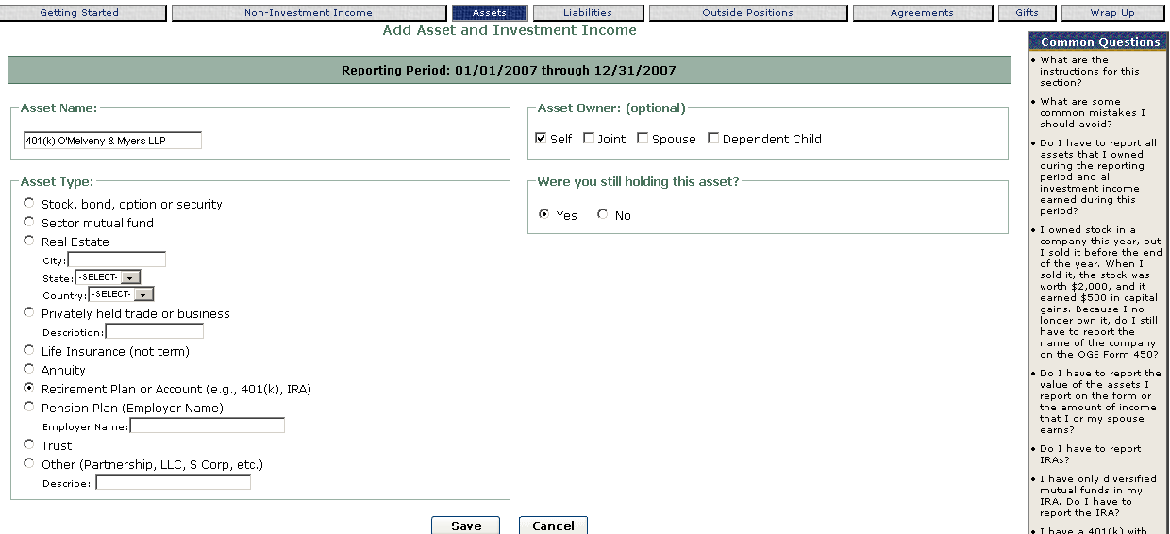
Click Save then Add Asset, BlackRock Utilities and Telecommunications Fund (MDGUX):
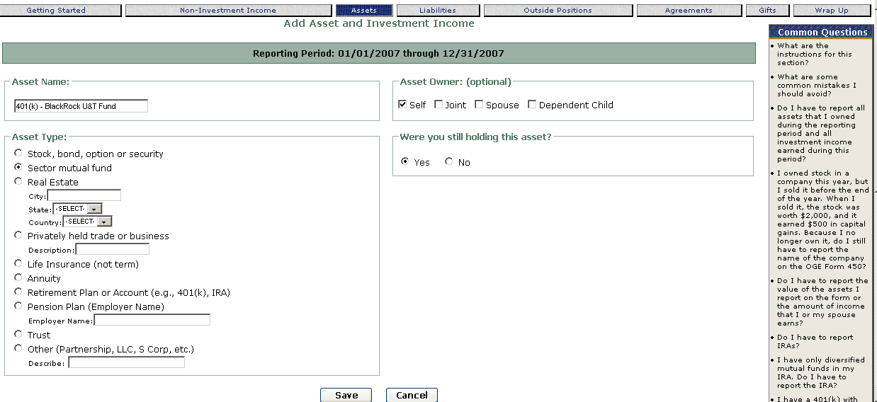

Click Save then Add Asset to report the Cohen & Steers Realty Income Fund (CSEIX):
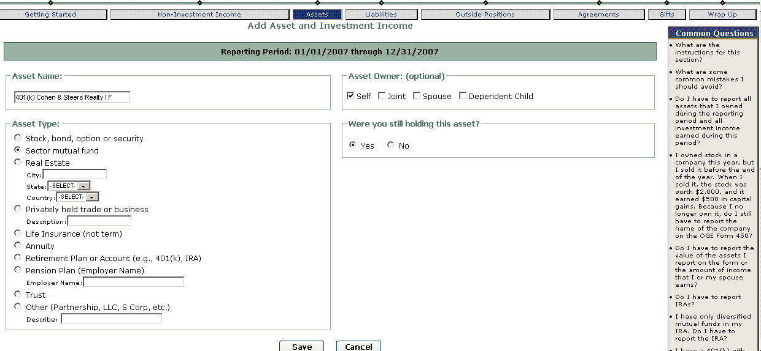

Click Save then Add Asset to report the General Electric Co. (GE) stock:
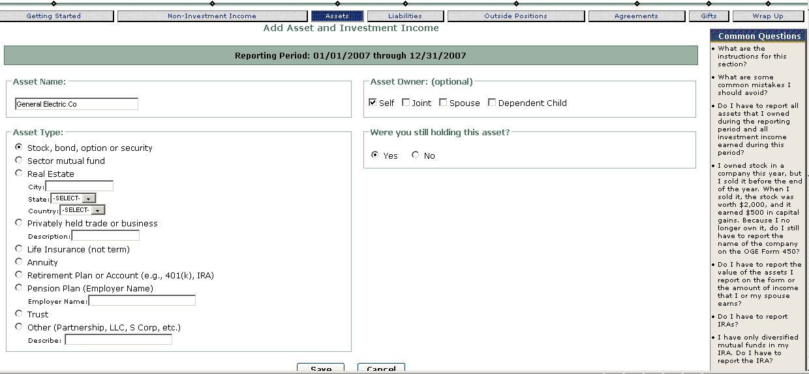

The Vanguard 500 Index fund is a diversified mutual fund and is not reported.

Report the 401(k) with O’Melveny & Myers LLP, Washington, DC, as an Agreement even if all of the underlying assets are diversified mutual funds and not reported:
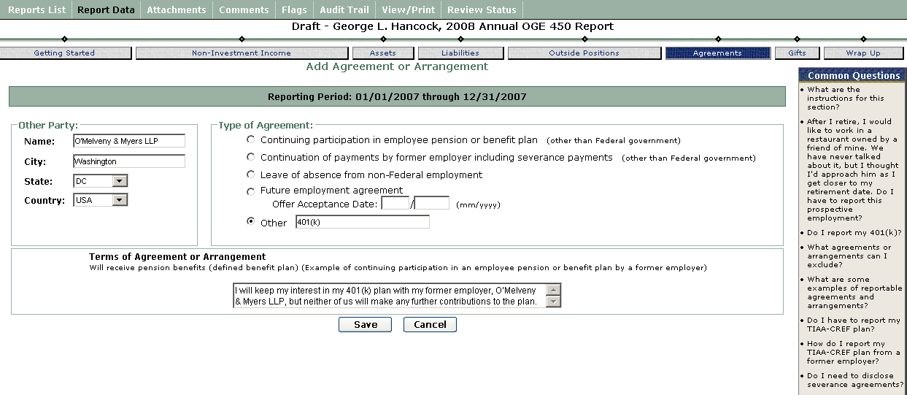

401(k) Plan—Spouse’s
General rule: Filer reports the assets in all 401(k) plans that the spouse has if those assets meet the reporting requirements (e.g., over $1,000 or over $200 income).

For example, if a spouse’s 401(k) plan with K Accounting contains stocks, sector mutual funds, and diversified mutual funds, report the stocks and the sector mutual funds because the confidential financial disclosure regulation requires it. Do not report the diversified mutual funds because the regulation exempts diversified mutual funds from disclosure.

Example: K Accounting 401(k): DWS Japan Equity Fund (FJEAX), Eaton Vance Kansas Municipals Fund (ETKSX), Microsoft Corp. (MSFT), Vanguard 500 Index Fund

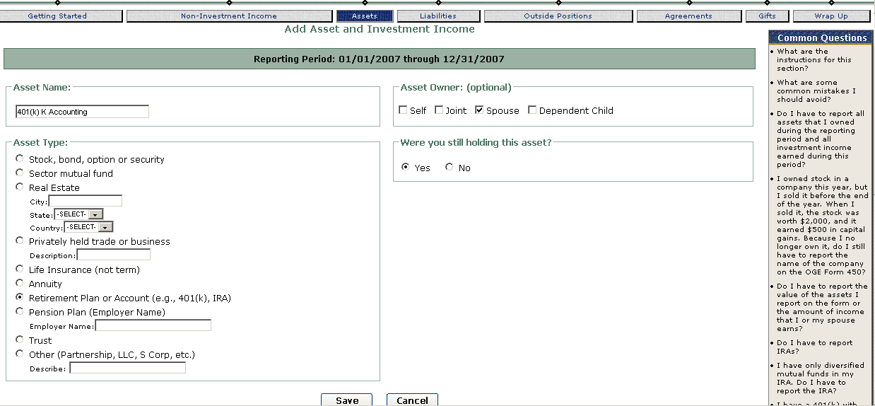
Click Save then Add Asset to report DWS Japan Equity Fund (FJEAX):
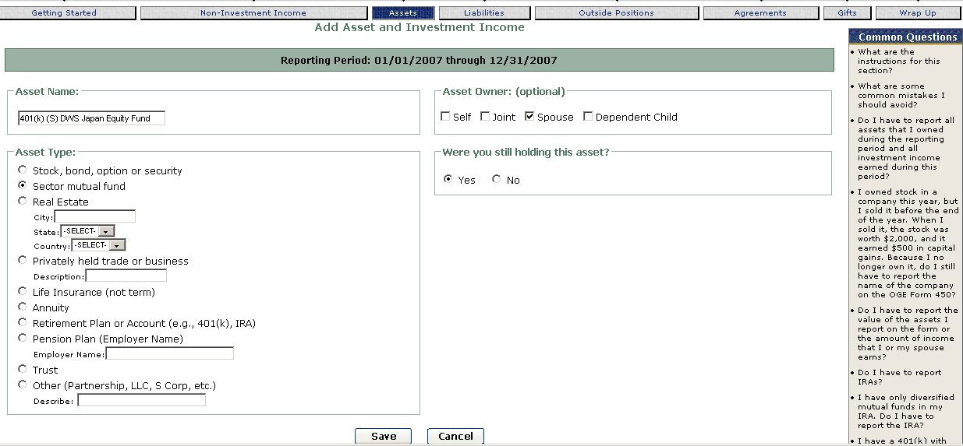
Click Save then Add Asset to report the Eaton Vance Kansas Municipals Fund (ETKSX):
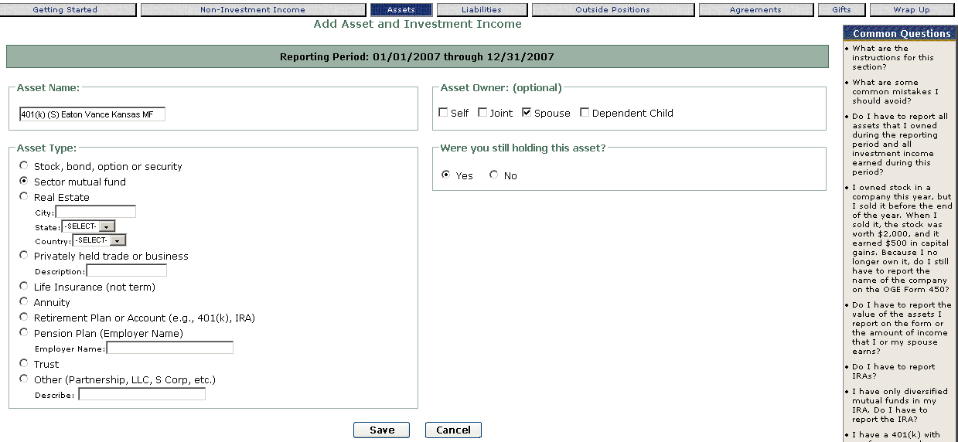
Click Save then Add Asset to report the Microsoft Corp. (MSFT):

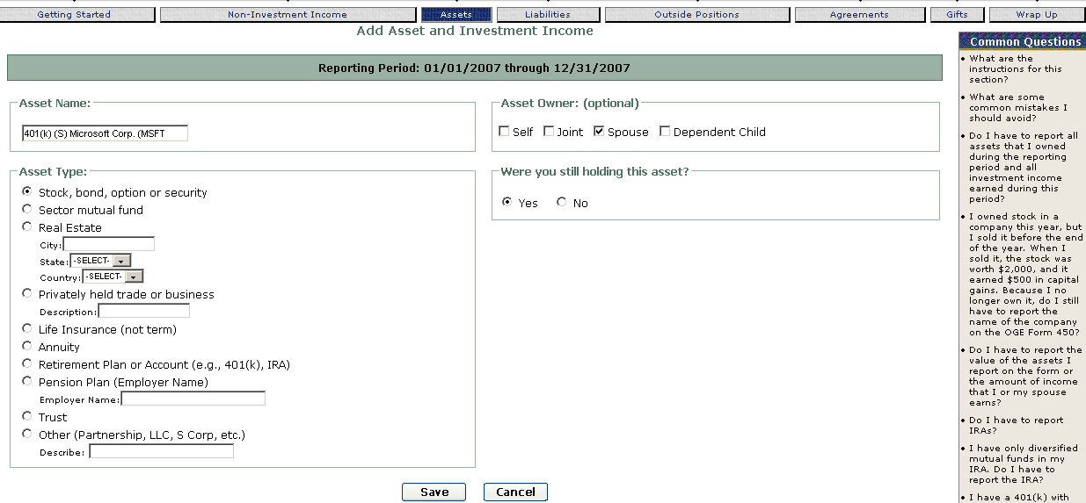
Do not report the Vanguard 500 Index fund (diversified fund).
Do not report the Spouse’s 401(k) as an agreement or arrangement.

529 Plans
Definition: An education savings account or plan operated by a state or educational institution designed to help families accrue funds for future college costs often locking in tuition rates. There are two types of plans – Prepaid Tuition Plans and Prepaid Savings Plans.

- Prepaid College Tuition Plan is an education savings account or plan operated by a state or educational institution designed to help families accrue funds for future college costs. Filer must disclose the name and sponsor of the plan (e.g. Maryland Prepaid College Trust).

- Prepaid College Savings Plan is an investment account in which an individual chooses among offered investment options, usually mutual funds. The participant relies on the growth of these funds to pay for education expenses in the future.
Filer must disclose the name and sponsor of the plan (e.g., GIFT College Investing Plan (Arkansas)), the name of the portfolio (e.g., Vanguard Aggressive Growth Portfolio), and the reportable underlying assets in that portfolio. Note: OGE 450 Filers do not need to report underlying assets that are diversified mutual funds.

General rule: Report 529 plans. Describing the asset as a “529 plan” is not adequate.

Report a prepaid tuition plan: Enter the full name and sponsor of the plan and describe it as a prepaid tuition plan.
Example: Texas Guaranteed Tuition Fund (prepaid tuition plan)
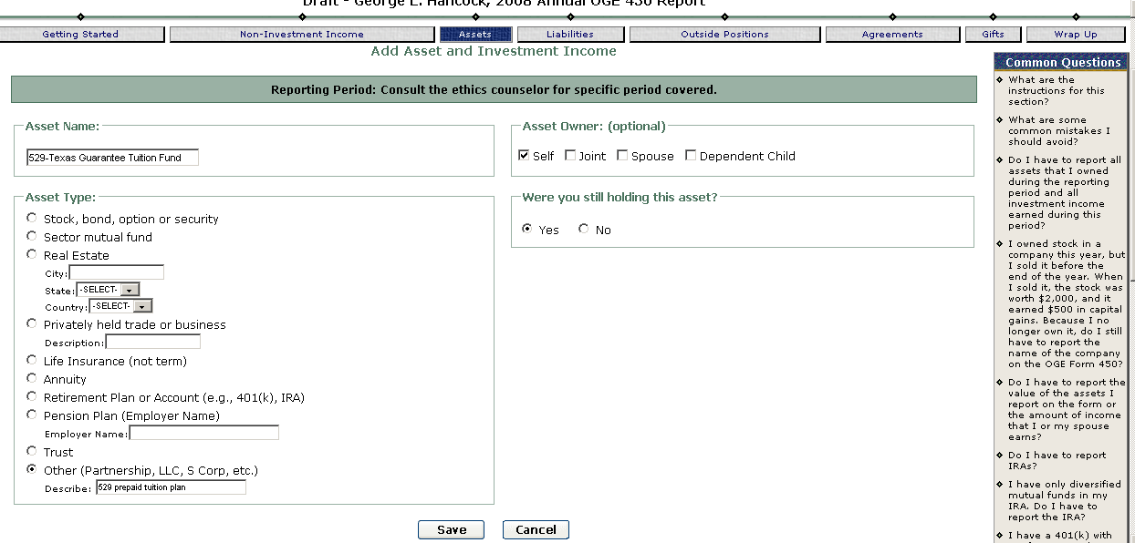

Report a college savings plan: Enter the full name and sponsor of the plan and the name of the portfolio or portfolios that you have under the plan. Most of these portfolios will hold a combination of money market funds, diversified mutual funds, and sector mutual funds. If the holdings of the portfolio are described in a prospectus or brochure on the plan’s web site, you are not required to list the reportable holdings on the OGE 450. It will be helpful if you provide your ethics official with the web site address when you submit your OGE 450. She can print the description of the portfolio from the web site and include it with your form.
Example: Texas Tomorrow’s College Investment Plan – Index Age-Based 12-14 Years Portfolio (underlying assets can be found on the plan’s web page (this plan is provided by the state of Texas))
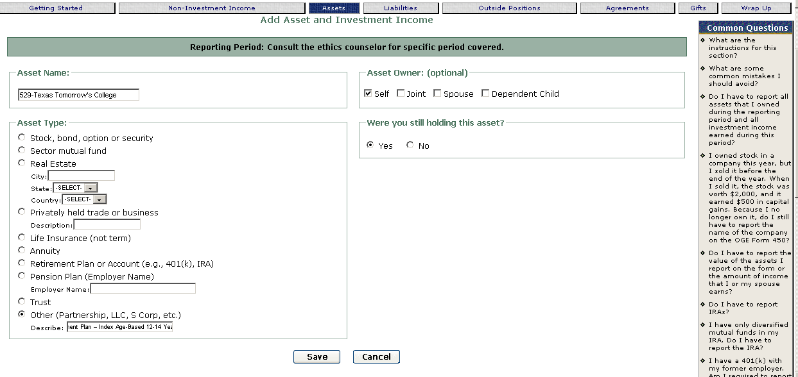
If the portfolio holding of the college savings plan is not available on a website, then report the plan as follows:
Texas Tomorrow’s College Investment Plan – Index Age-Based 12-14 Years Portfolio holds Oppenheimer Real Estate Fund
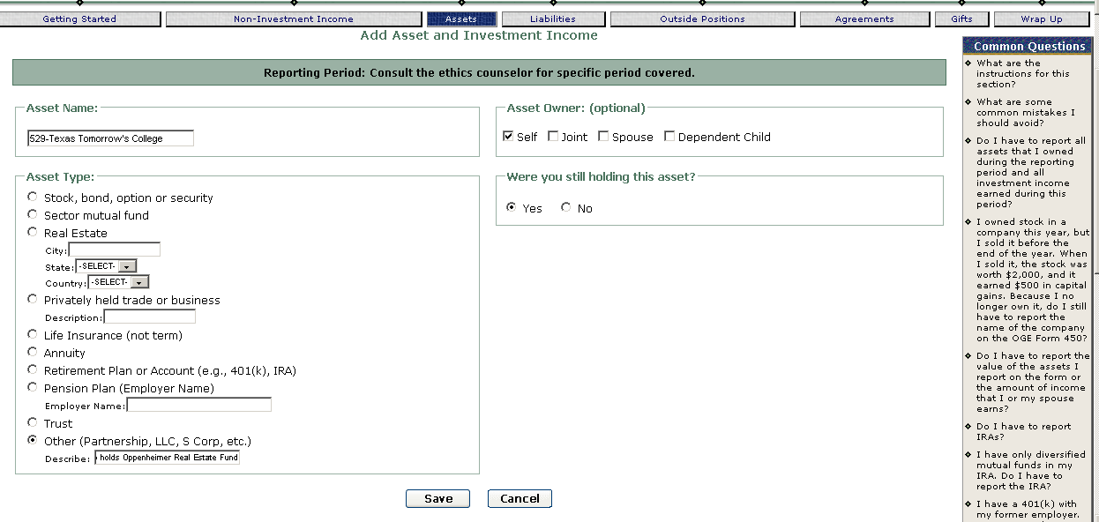

Asset list screen result:
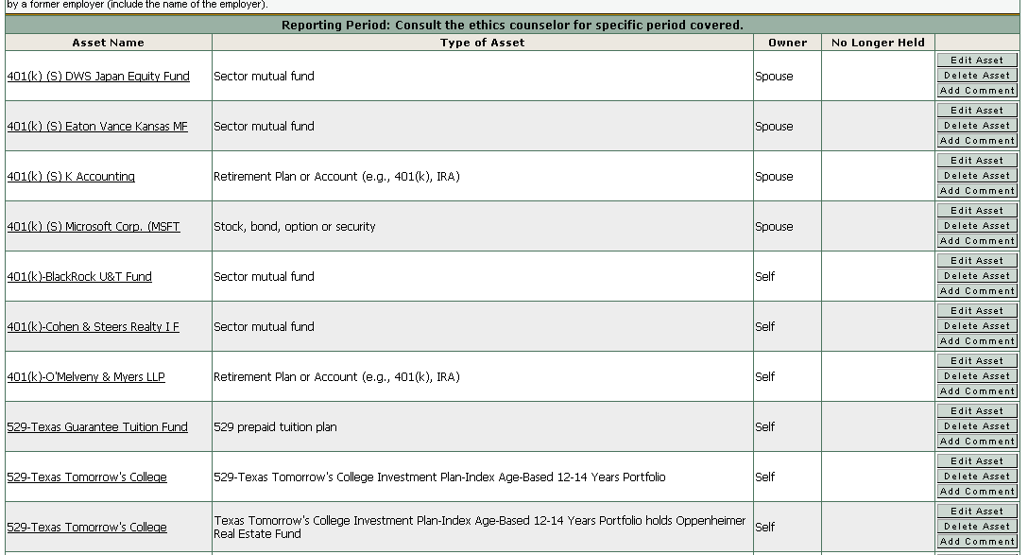
Annuities
Definition: An annuity is a contract with a life insurance company, though sometimes marketed through banks and financial planners. The investor (annuitant) pays a premium to the insurance company in either a single payment or a series of payments. In return, the insurance company makes payments to the investor, beginning at some future time, such as retirement or at a specified age. Tax-deferred investment income accumulates in the annuity. The two basic types of annuities are a fixed annuity and a variable annuity [see definitions of fixed annuity and variable annuity].
Fixed annuities: These annuities offer a specified rate of return that the issuing company guarantees. Individual investors have no direct financial interest in how the insurance company invests the premiums. Investors do have an interest in the insurance company in that if it becomes insolvent, they can lose their money. Filer must disclose the name of the insurance company issuing the annuity and state that the asset is a fixed annuity (e.g., John Hancock – Fixed Annuity).
Variable annuities: These annuities offer investors a limited series of options in which they can invest, typically mutual funds. Investors choose how their money is invested and receive a return based on the performance of the investments they choose. Filer must disclose the name of the company issuing the annuity, the type of annuity (variable), and the reportable underlying assets in the annuity, if any.

Report a fixed annuity: report the name of the company issuing the annuity and describe it as a fixed annuity.

Example: John Hancock Life Insurance Co (fixed annuity)
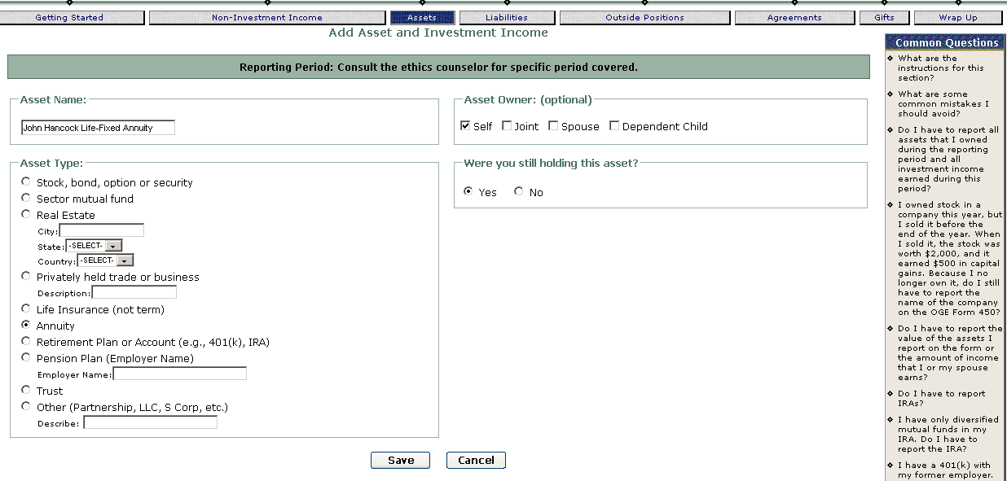

Report a variable annuity: report the name of the company issuing the annuity, the type of annuity (variable), and the reportable underlying assets in the annuity. A variable annuity may contain stocks, diversified mutual funds, and sector mutual funds. Do not report diversified mutual funds because the regulation exempts them. Do report the stocks, sector mutual funds, and any other assets that are not exempt from disclosure.

Example: New York Life Insurance (variable annuity) holding Fidelity Advisor Biotechnology (FBTAX) and MFS Utilities Series (MMUFX).
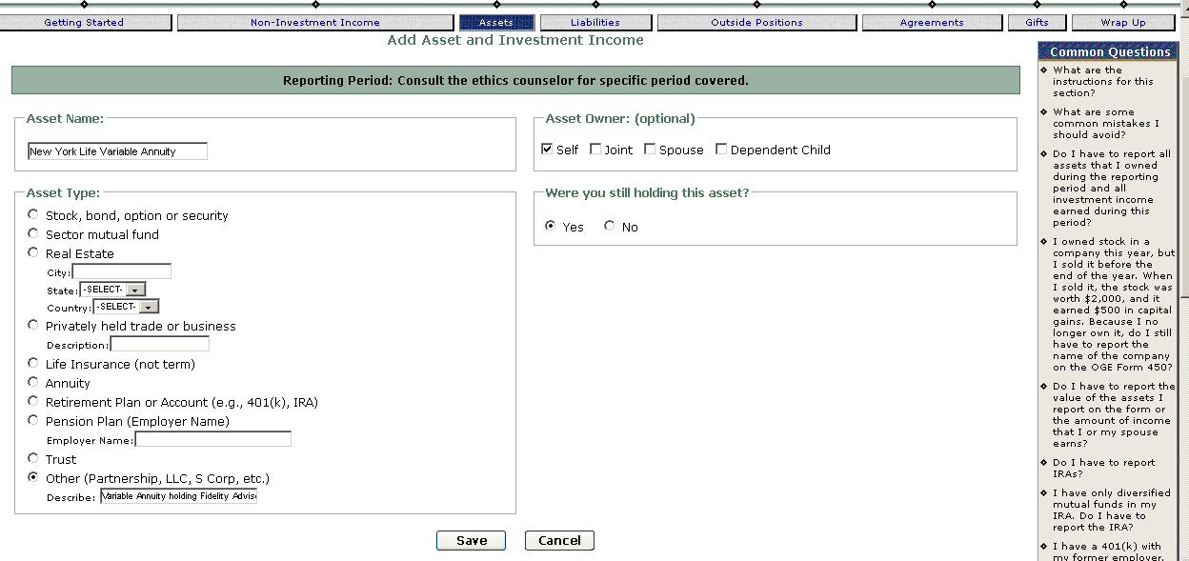

Resulting list asset screen for this asset:

Example: New York Life Insurance (variable annuity) – all of the underlying assets are diversified mutual funds
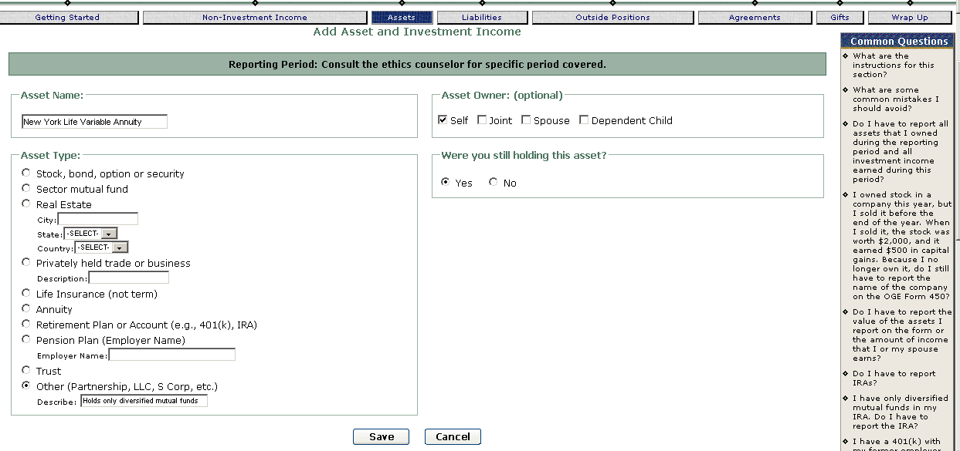
The last example shows how to report a variable annuity that holds only diversified mutual funds. If your variable annuity holds only diversified mutual funds, it is very helpful to your ethics official to include a statement on the form that “all of the underlying assets are diversified mutual funds.” Otherwise, your ethics official may contact you to ask what the underlying assets are.

Asset Management Account
Definition: An asset management account, offered by a brokerage house, bank, or savings and loan, combines a number of financial services, such as checking, money market, brokerage, and margin accounts, or a revolving line of credit. These accounts allow a person to receive one statement that covers all of their finances. Customers sometimes use these accounts to shift assets and income automatically or as needed. For example, a person might have excess funds in a checking account automatically transferred to a money market account. Several variants of this account exist, with brand names like Cash Management Account, Active Assets Account, and Financial Management Account. Such accounts are known by such proprietary names as the Cash Management Account (Merrill Lynch), Active Assets Account (Morgan Stanley Dean Witter), or Schwab One Account (Charles Schwab) (from www.allbusiness.com). Filer must disclose the reportable underlying assets in the account. FDM users may use the Underlying Asset feature to first report the account name and then list each reportable underlying asset in the account.

General rule: Report the holdings in an asset management account if those assets meet the reporting requirements. This type of account may contain a variety of investment products, such as stocks, municipal bonds, diversified mutual funds, sector mutual funds, and cash accounts. You do not have to report diversified mutual funds or cash accounts because the regulation exempts these assets from disclosure. You are required to report stocks, municipal bonds, sector mutual funds, and any other assets that are not exempt from disclosure. You are not required to report the name of the financial institution at which the account is located, but you may do so.

Example: Filer’s Merrill Lynch Cash Management Account has these assets: Petroleo Brasileiro SA (PBR), The Blackstone Group LP (BX), Lowe’s Companies Inc. (LOW)
In FDM, Assets, Add Asset enter name as “ML Cash Mgmt- Petroleo Brasileiro”; asset type: Stock, Asset Owner: Self; and Yes, still holding the asset. Click Save at the bottom of the screen.
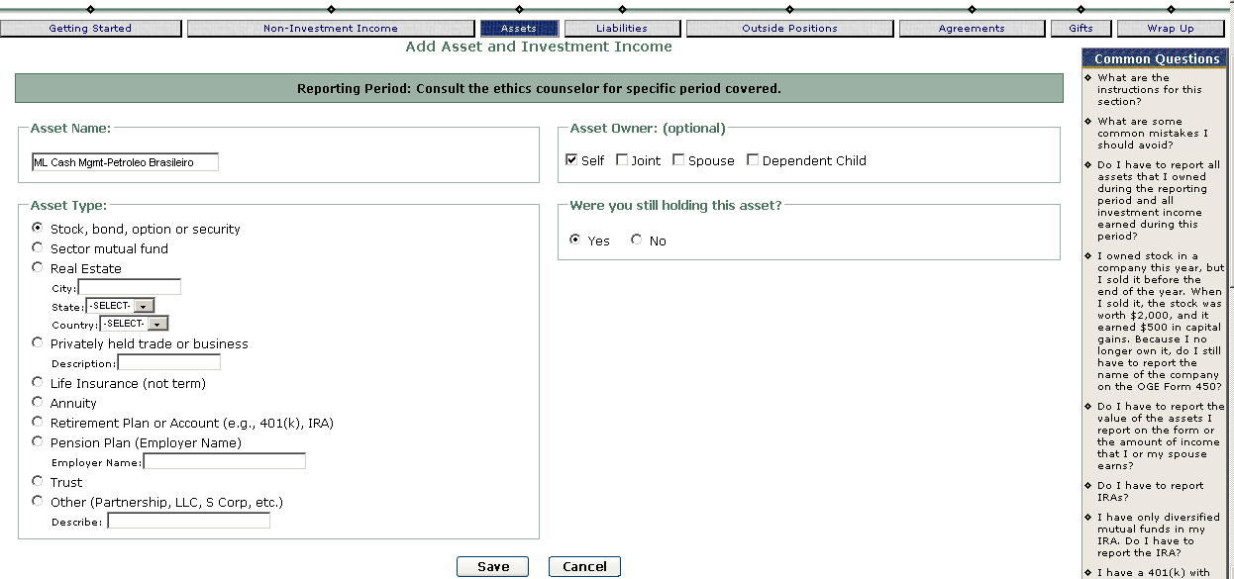
Repeat for the other assets: “ML Cash Mgmt-Blackstone Group LP (BX)”, “ML Cash Mgmt-Lowe’s Companies Inc. (LOW)”

Filer’s spouse’s Schwab One Account has these holdings: China Mobile Ltd (CHL), Walt Disney Co. (DIS), & Home Depot, Inc. (HD)
In FDM, in Assets, Add Asset enter name as “Schwab One-China Mobile Ltd (CHL)” asset type: Stock, Asset Owner: Spouse; and Yes, still holding the asset. Click Save at the bottom of the screen.

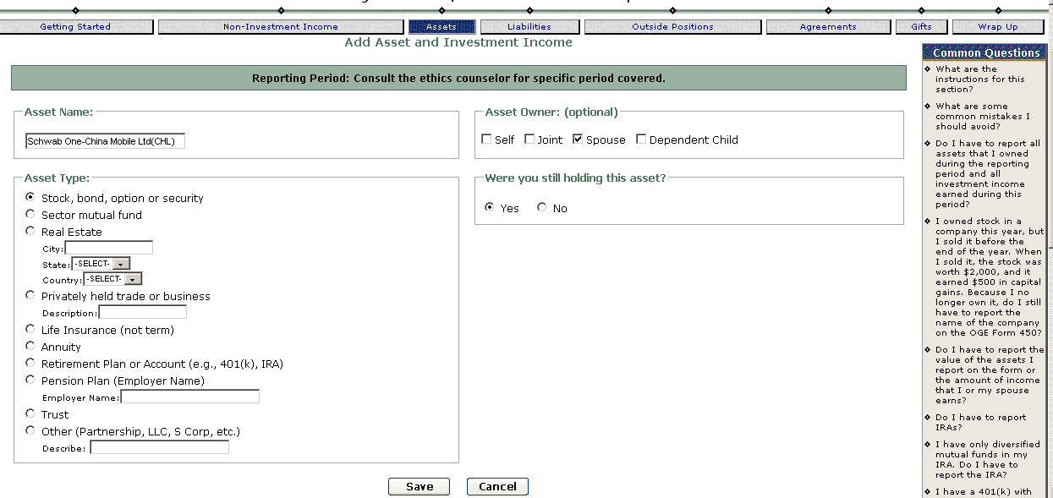

Repeat for the other assets: “Schwab One-Walt Disney Co. (DIS),” & “Schwab One-Home Depot, Inc. (HD)”

Defined Benefit Pension Plan
Definition: A pension plan in which an employer holds and invests pooled funds for participating employees together. The employer guarantees a fixed amount of benefits to employees after retirement.

General rule: Report defined benefit plans. To report a defined benefit plan, you must disclose in the Assets & Investment Income section and as an Agreement or Arrangement.

Example: Filer has a defined benefit plan from prior employment at General Electric, Fairfield, CT.

In FDM, in Assets, Add Asset enter name as “General Electric” type is Pension Plan, General Electric as employer name, Owner: Self; still holding Yes. You must disclose on Part IV the terms of the defined benefit plan.
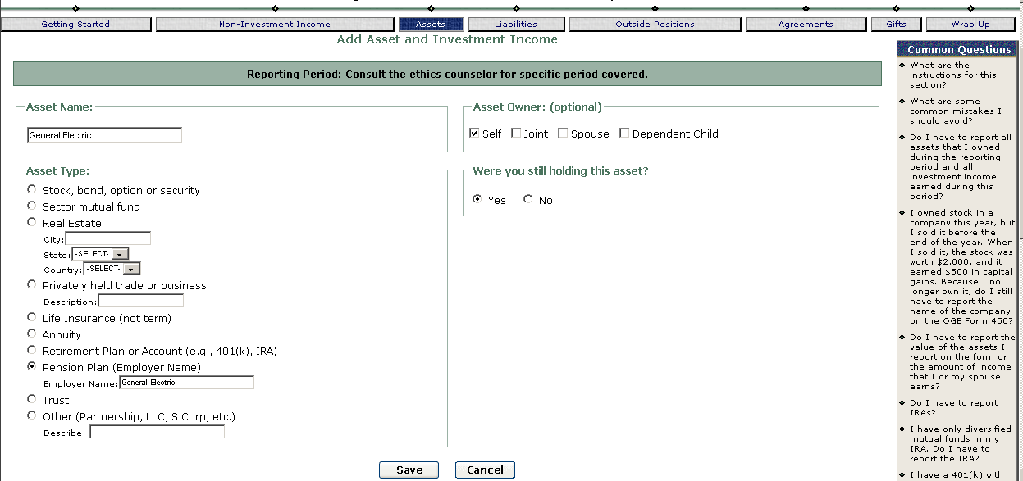
Click Save to save the information in FDM and return to the Assets list screen.

To report the terms as an Agreement or Arrangement, click the “Agreements” tab of the report progress bar to advance to that section.
Click Add Agreement and enter the information:
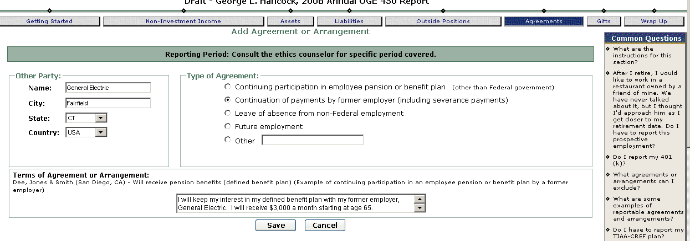
Click Save to save the information and return to the Agreements list screen.

Defined Contribution Pension Plan
Definition: A pension plan by which an employer or its agent maintains a separate account for each participating employee. Benefits at retirement depend upon the amount contributed and the investment performance of the plan's assets, which are selected by the employee or an independent manager.

General rule: Report defined contribution plans. Disclose in the Assets & Investment Income section and as an Agreement or Arrangement.

Example: Filer has a defined contribution plan from prior employment at General Dynamics, Arlington, VA.
In FDM, in Assets, Add Asset enter name as “General Dynamics” type is Pension Plan, General Dynamics as employer name, Owner: Self; still holding Yes. You must disclose on Part IV the terms of the defined benefit plan.
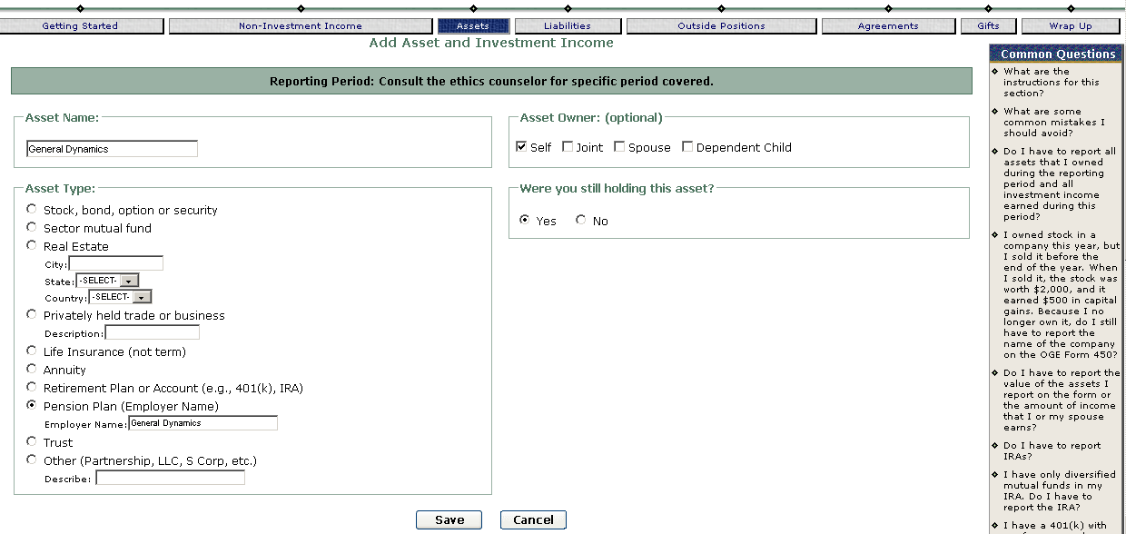
Click Save to return to the list screen.

To report the terms as an Agreement or Arrangement, click the “Agreements” tab of the report progress bar to advance to that section.
Click Add Agreement and enter the information:

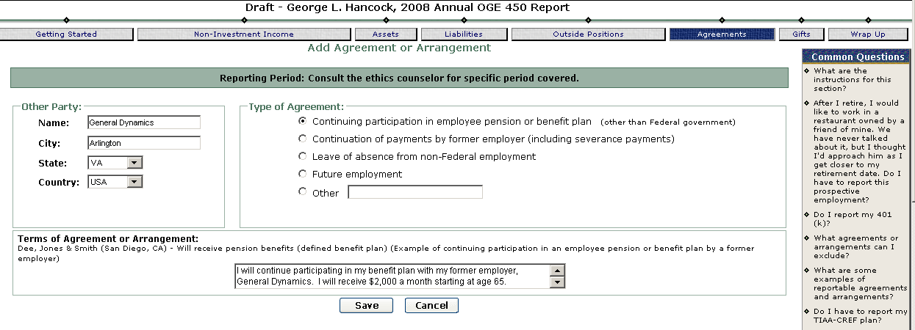

Non-Government Employment
Definition: employment with a non-executive branch employer.

General rule: report the name of your non-executive branch employer, whether a full-time or part-time employer. If you are a new executive branch employee, you will report your former, non-executive branch employer on your new entrant OGE 450 report. If you are a current executive branch employee, you may have part-time employment or you may be self-employed in your own business. Both types of employment must be reported. Remember to report your position (for example, employee, consultant, proprietor, general partner) in the Agreements section.

Example: New Government employee Filer is coming into the agency having worked at Lockheed Martin Corp., a research and development (aerospace & defense industry) company, in the last 12 months will report that employment.
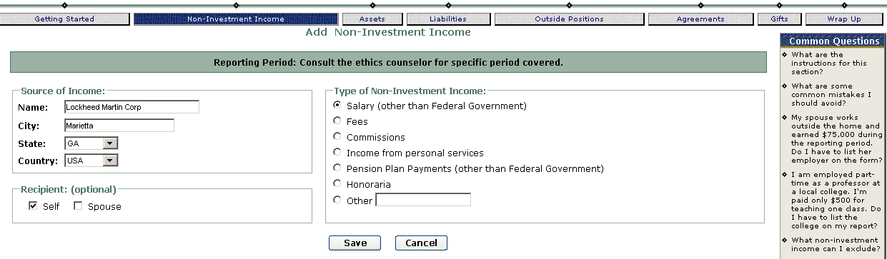

Current employee, a full-time government employee has her own business, Delta Star Solutions, where she works part-time.
In FDM, on the Non-Investment Income screen, click Add to open the “Add Non-Investment Income” screen shown below:
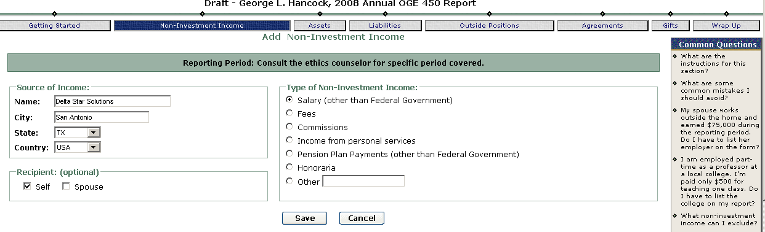
In FDM, click on the “Outside Positions” tab of the report progress bar to report the outside Positions Delta Star Solutions, San Antonio, TX, Video game development Owner/Proprietor
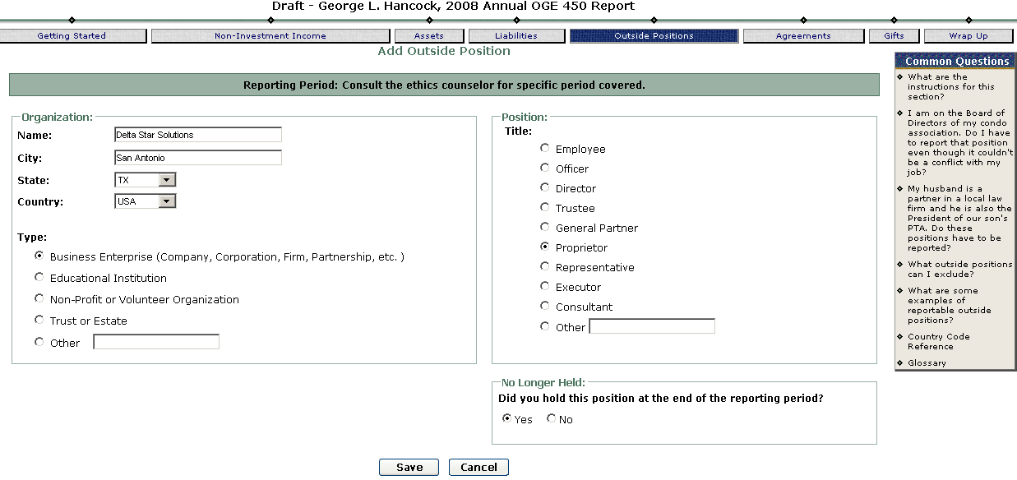

Employer—Your Spouse’s
General rule: Report the name of your spouse’s non-executive branch employer, whether your spouse works full-time or part-time. If your spouse is self-employed, report that employment. It is helpful to your ethics official if you indicate on the form that the company is your spouse’s employer. Otherwise, the ethics official may think the entry indicates that you or your spouse owns stock in the company listed. If your spouse works for an executive branch agency, you are not required to report that employment. Listing your spouse’s executive branch employer will, however, eliminate a call from your ethics official. When the ethics official does not see any reference to an employer for your spouse, the official will ask you if your spouse is employed outside the home. The information provided will go into the reviewer’s comments with your OGE 450.

Example: spouse works at Northrop Grumman.
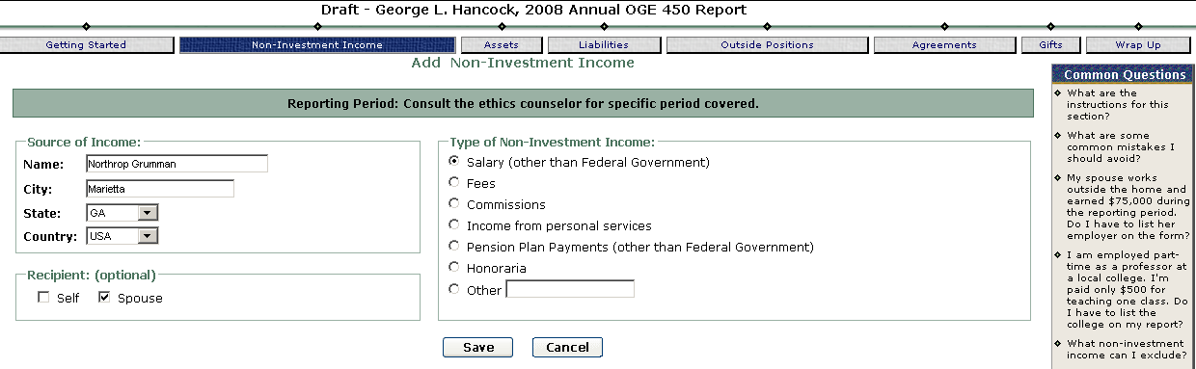
Do not report your spouse’s employment in Outside Positions.

Exchange-Traded Fund (ETF)
Definition: An investment vehicle that holds numerous companies under one umbrella unified by a particular investing theme, such as companies that comprise the Dow Jones Industrial Average. Like mutual funds, ETFs may be diversified or may concentrate on a particular sector. Unlike mutual funds, ETFs are traded like stocks on the major stock exchanges. The following are the most common ETF types: DIAMONDs (track the Dow Jones Industrial Average), iShares (ETFs marketed by Barclays Global Investors), QUBEs (track the Nasdaq-100 index), Spiders or SPDRS (track a variety of Standard & Poors’ indices), and VIPERs (ETFs marketed by Vanguard). Filer must disclose the full name of an ETF that concentrates on a sector.

General rule: You must report an exchange-traded fund (ETF) if it concentrates on a sector (for example, telecommunications, utilities, real estate, financial services). Do not report diversified ETFs. To report a sector ETF, list the full name of the fund. Although you are not required to provide the ticker symbol, the ticker symbol is helpful to your ethics official in identifying the asset and may reduce the number of questions that your ethics official will have for you. Most sector ETFs qualify as excepted investment funds; therefore, you are usually not required to report the underlying assets that sector ETFs hold. The following are the most common ETF types: DIAMONDs (track the Dow Jones Industrial Average), iShares (ETFs marketed by Barclays Global Investors), QUBEs (track the Nasdaq-100 index), Spiders or SPDRs (track a variety of Standard & Poors’ indices), and VIPERs (ETFs marketed by Vanguard).

Example: Filer owns iShares S&P Global Telecommunications Sector Index Fund (IXP)
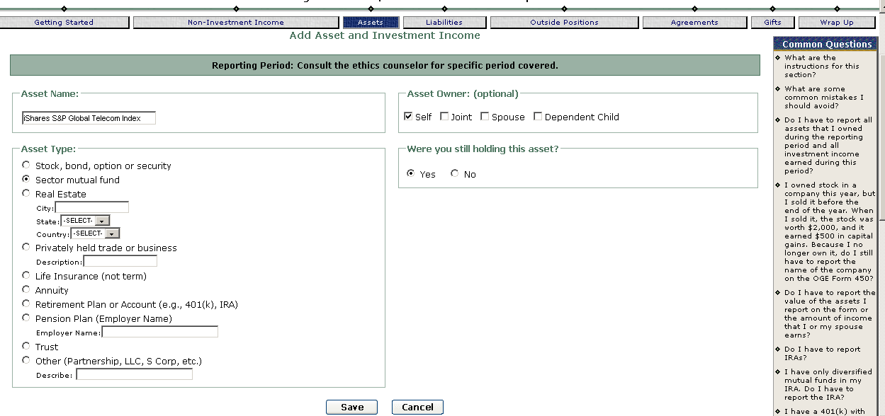

Government-Sponsored Corporation—Stock
Definition: stock issued by government-sponsored corporations, e.g., Federal National Mortgage Association (Fannie Mae) and the Federal Home Loan Mortgage Corporation (Freddie Mac), Ginnie Mae (Government National Mortgage Association (GNMA)), Tennessee Valley Authority (TVA)

General rule: report stock that you own in government-sponsored corporations. Do not report bonds issued by government-sponsored corporations.

Example: Filer owns $10,000 worth of stock in Federal National Mortgage Association.
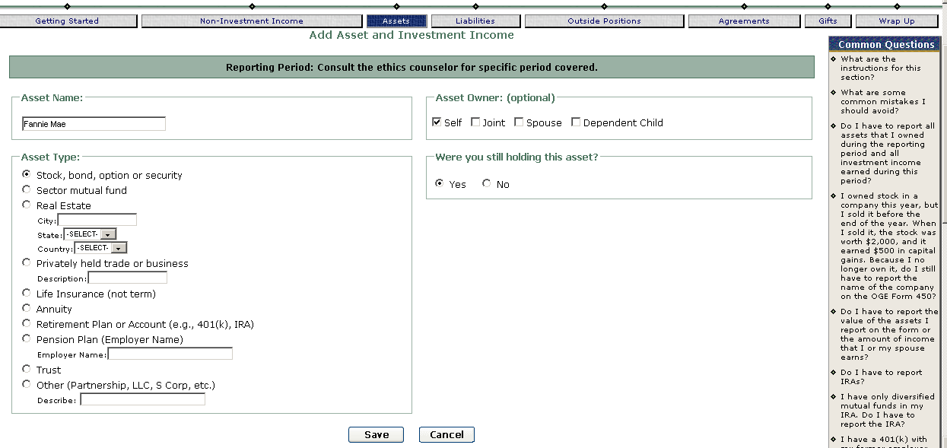

Honoraria
Definition: A payment of money or anything of value for an appearance, speech, or article, less any necessary travel expenses. Most federal employees may accept honoraria for activities that do not relate to their official duties (see exceptions at 5 CFR part 2636, subpart C).

General rule:
Report honoraria that you or your spouse receives. An honorarium is a payment for an appearance, a speech, or an article, less any necessary travel expenses. Report the source of each honorarium as Non-Investment Income. If the honorarium is received as compensation for an outside position, you must report the outside position. Reviewers will want to verify that filer followed the requirements for participating in an outside activity and consider whether the honorarium is compensation for teaching, speaking, or writing that relates to their official duties (with an exception for teaching certain courses).

Example: Filer receive an honorarium from the University of Southern California Marshall School of Business

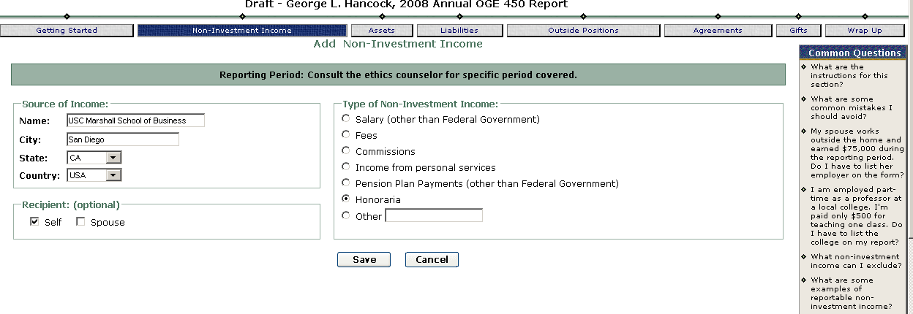

Individual Retirement Account
Definition: Generally a bank, brokerage, or mutual fund account that a person designated as a tax-deferred retirement account. All IRAs are "self-directed" because investors choose where to invest their retirement funds. IRAs may hold cash accounts, stocks, mutual funds, and other securities.

General rule: report the assets in an individual retirement account (IRA) if those assets meet the reporting requirements (e.g., are valued at over $1,000 or earned over $200 income in the reporting period). For example, if the IRA contains stocks, sector mutual funds, and diversified mutual funds, report the stocks and the sector mutual funds because the confidential financial disclosure regulation requires that you report those assets. OGE 450 Filers do not report the diversified mutual funds because the regulation exempts diversified mutual funds from disclosure. OGE 450 Filers who have an IRA with only diversified mutual funds in the IRA are not required to report the IRA.

Note: Although you are not required to indicate that the assets you list are in an IRA, you will eliminate a call from your ethics official if you do so. When the ethics official does not see any reference to an IRA on the form, the official will ask you if you or your spouse has an IRA. She will then add a comment in FDM to indicate which assets are in the IRA.

Example: Filer has an IRA that has these holdings: Alcoa, Inc. (AA) and Merck & Co. Inc. (MRK).
On the Asset list filer clicks “Add” to open the “Add Asset and Investment Income” screen below, and enters the information for the first IRA holding, Alcoa, Inc. (AA):
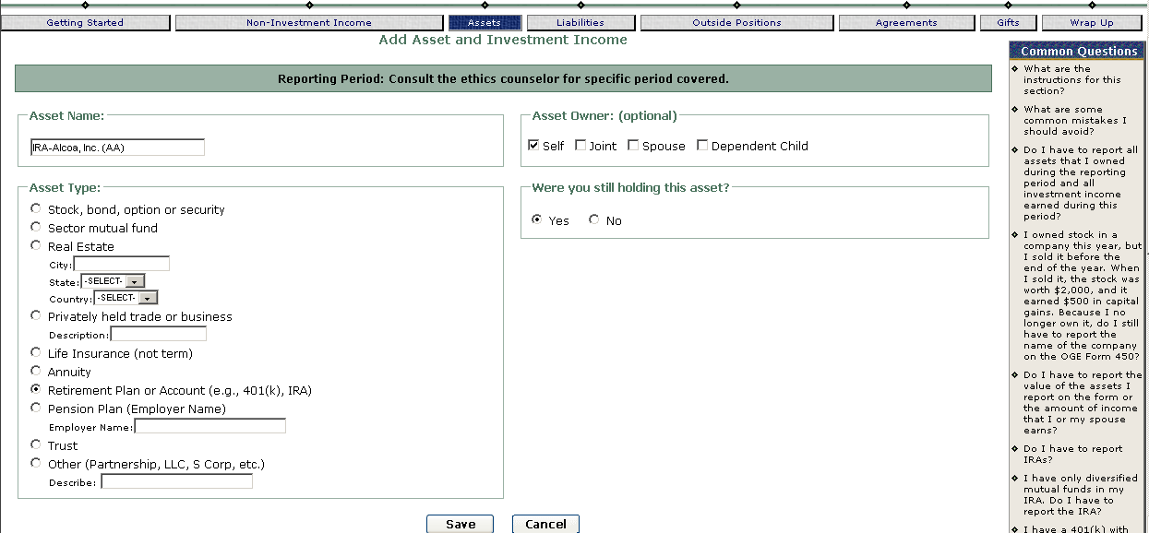

Clicking “Save” produces a popup information screen in FDM:
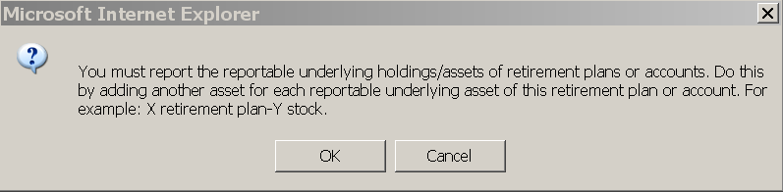
as a reminder to report underlying holdings/assets of retirement plans. Filer clicks OK, then proceeds to click “Add” to open another “Add Asset and Investment Income” to report the Merck holding.
Merck & Co. Inc. (MRK):
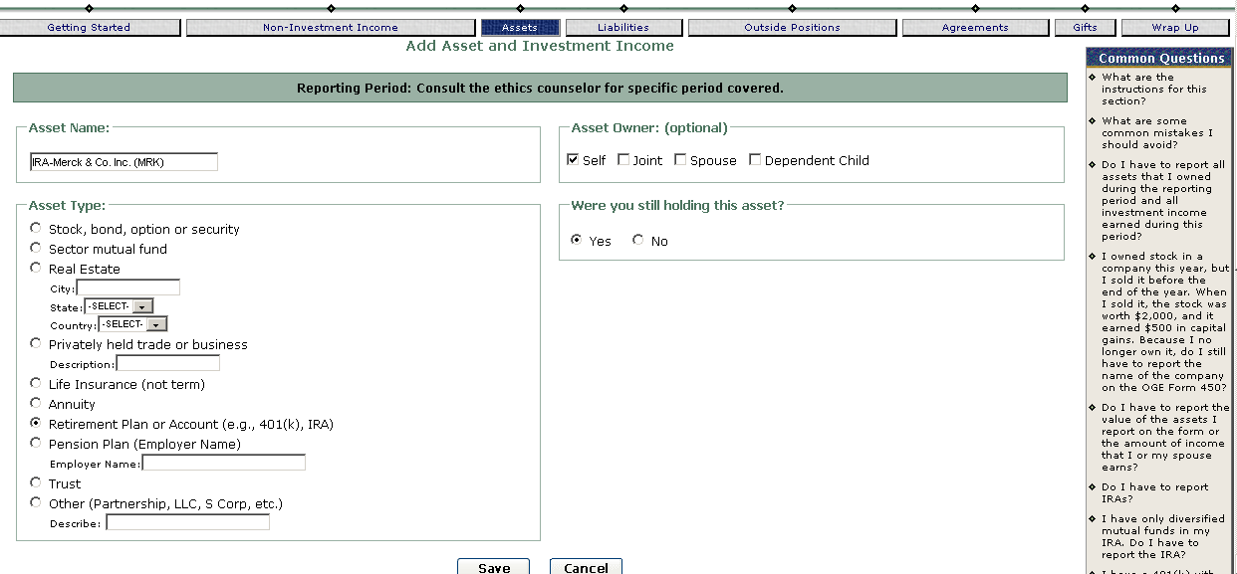

Filer’s spouse has an IRA with these holdings: iShares MSCI Japan Index Fund (EWJ) and Fidelity Select Defense & Aerospace Fund (FSDAX)
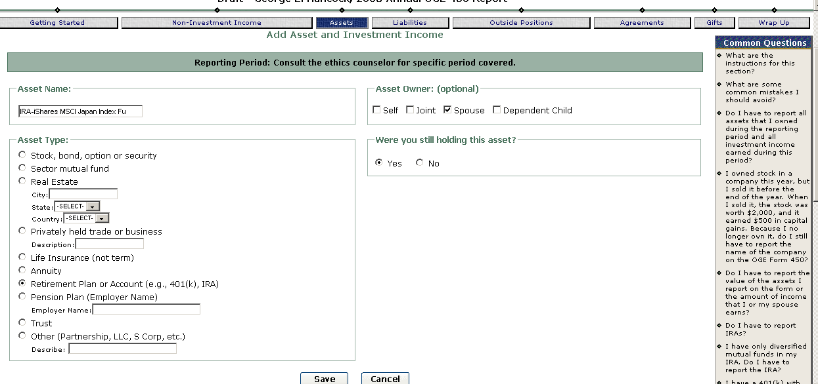

Fidelity Select Defense & Aerospace Fund (FSDAX):
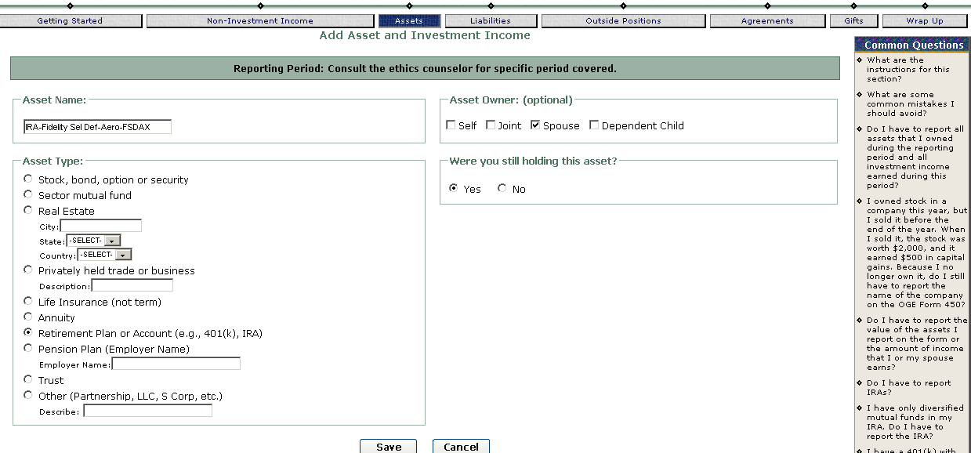

Liabilities
Definition: indebtedness owed by the Filer during the period covered by the report.

General rule: report a liability if the amount owed to the person or entity was greater than $10,000 at any time during the reporting period. Always disclose a loan over $10,000 from an individual. Report the name of the individual and the city and state where the individual is located. Report a loan over $10,000 from a financial institution or business entity if the loan was granted on terms that are not made available to the general public. To report this type of liability, disclose the name of the financial institution or business entity and the city and state where it is located.

Exceptions to the reporting of liabilities: Do not report a liability from a financial institution or business entity if the loan was granted on terms available to the general public. As a result, most mortgages, student loans, and credit card debt are not reportable. For example, if you have a mortgage on a house that you rent to someone and that mortgage is at a rate that is available to the general public, you are not required to report the mortgage. You are required, however, to report the property because you receive income from the rental (in FDM, use the Non-Investment Income tab to report the rental income).

Example: Filers owes a personal loan ($15,000) to Jeff Gardner Boulder, CO
On the Liabilities tab, Filer clicked “Add Liability” to open the “Add Liability”
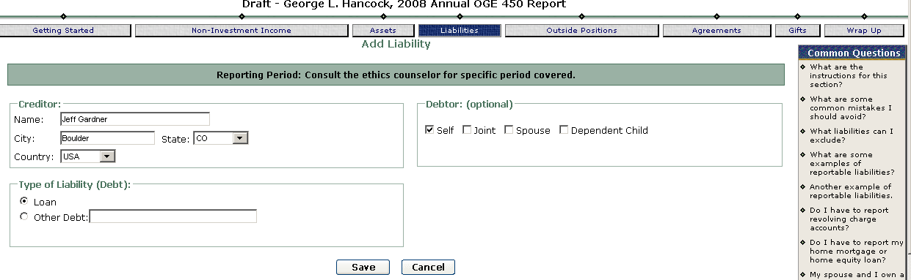

Reporting rental income from rental property even though there is a mortgage that is not reported:

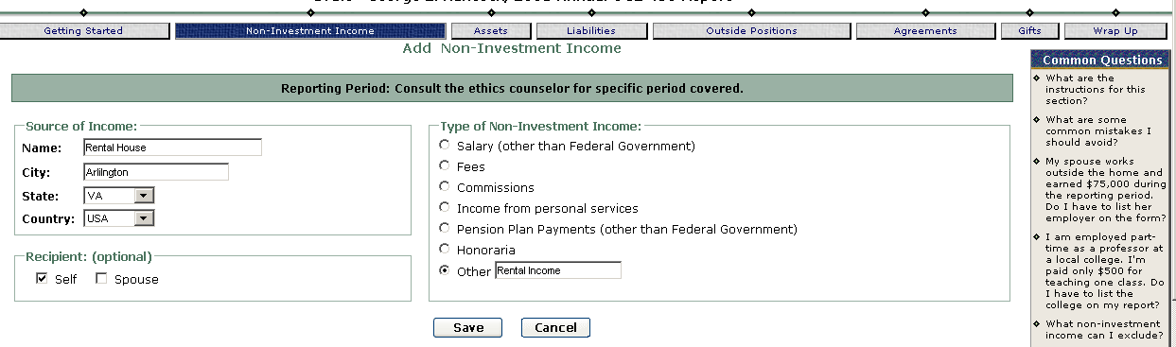

Life Insurance
Definition: Cash value insurance is part insurance and part investment. Such policies require premiums during the life of the insured person in exchange for a sum of money to a beneficiary when the insured person dies. While part of these premiums pay for expenses and the insurance part of the policy, the remainder goes into a tax-deferred cash reserve which is invested and builds the policy's cash value. There are three general types of cash value policies:

Universal | Life insurance in which the insured person can vary the premiums by paying them with some of the accumulated cash value under the policy; person normally receives a minimum guaranteed rate of return at money market rates. Filer must disclose the name of the insurance company and the type of insurance (universal).
Variable | Life insurance in which the insured person chooses investments from among several company options, such as stock, bond, or money market portfolios. Filer must disclose I the name of the insurance company, the type of insurance (variable), and all reportable underlying assets.
Whole | Life insurance in which the insured person pays fixed premiums and has no control over the investments, which is left to the insuring company. Filer must disclose the name of the insurance company and the type of insurance (whole).

General rule: report cash value insurance policies—whole, universal, and variable. Do not report term life insurance. To report a whole or universal life insurance policy, report the name of the company issuing the policy and the type of policy. To report a variable life insurance policy, report the name of the company issuing the policy, the type of policy (variable), and the underlying assets in the policy.
Example: Filer has a whole life insurance policy with Mutual of Omaha
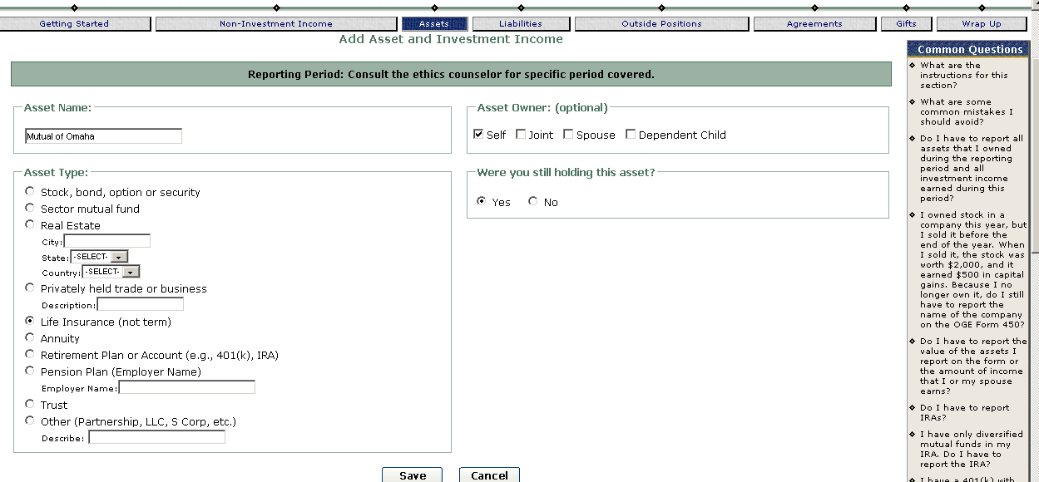

Filer has a Home Life (universal life) insurance policy (underlying assets: Dreyfus Premier California AMT-Free Bond Fund (DRCAX) and Janus Global Life Sciences Fund (JAGLX)).
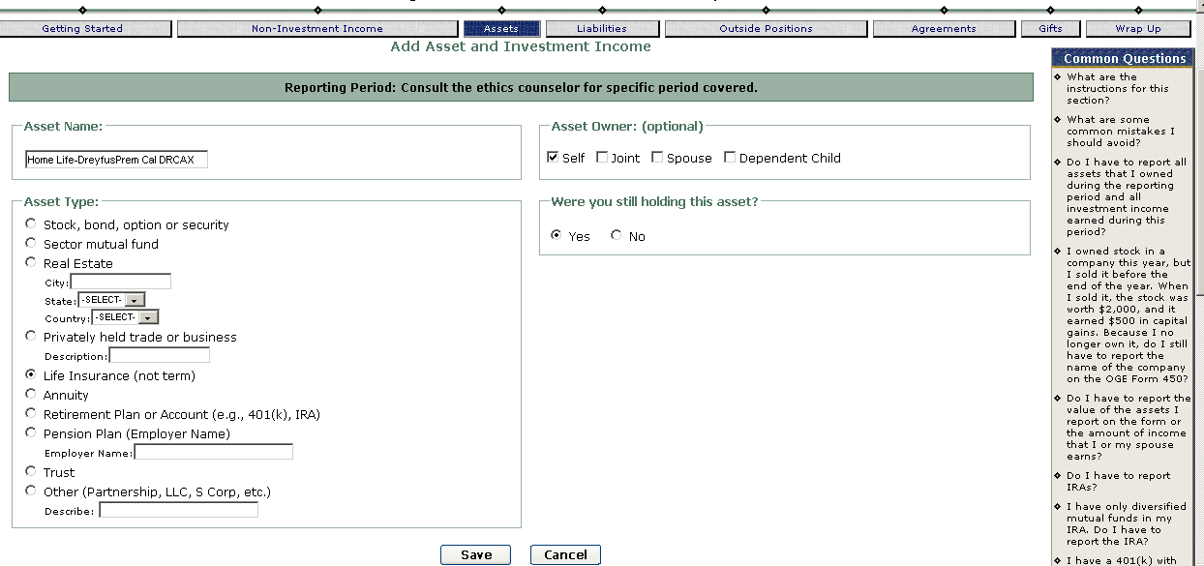
Janus Global Life Sciences Fund (JAGLX):
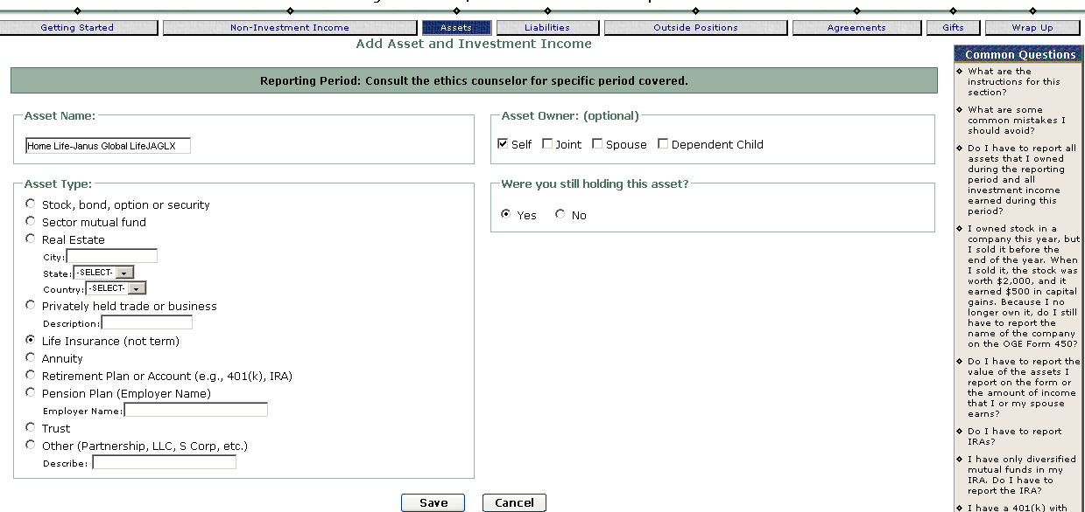

Limited Partnership (LP)
Definition: Entity formed when a group of individuals join together for the purpose of conducting or investing in a trade or business. It usually has one general partner who organizes and manages the operations and the partnership. The other investors are limited partners. Typically, LPs invest in real estate, hedge funds, oil and gas, and equipment for leasing. Filer must disclose the name of the partnership. If the LP is a private LP, filer must disclose additional information.
Private Limited Partnership | An LP that has private investors and does not sell shares to the public. Filer must report the full name of the LP, the location (city and state) of the LP, and a brief description of its line of business or its purpose. If an investment LP does not meet the definition of an excepted investment fund, the underlying assets must be disclosed.
Public Limited Partnership | An LP that sells shares to the public. Filer must report the full name of the LP. Public LPs will usually meet the definition of an excepted investment fund. In the case of such an LP, filer is not required to disclose the reportable underlying assets.

General rule: report your interest in a limited partnership (LP) that sells its shares to the public. Like private LPs, public LPs may be formed for the purpose of conducting or investing in a trade or business, such as equipment leasing or oil and gas exploration. To disclose your interest in this type of public LP, report the full name of the LP. Although you are not required to provide the ticker symbol, the ticker symbol is helpful to your ethics official in identifying the LP as being publicly traded and may reduce the number of questions that your ethics official will have for you.

Example: Kinder Morgan Energy Partners, LP (KMP)
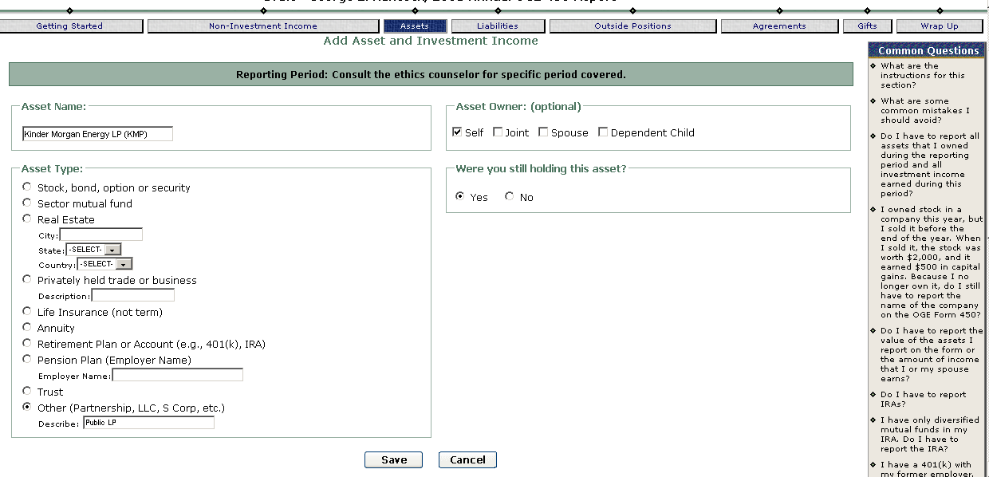
Report the private LP holdings similar to how reportable IRA underlying holdings are reported.

Managed Account
Definition: Also called a separately managed account/fund, a customized portfolio of stocks and/or bonds and cash that is guided by a professional investment manager. The manager buys and sells stock and/or bonds for [the] portfolio on [the investor’s] behalf. From the "Individual Investors" page of the Morgan Stanley web site. These accounts may have names that are similar to mutual funds, but they are not mutual funds. They also do not qualify as excepted investment funds.

General rule: report the assets in a separately managed account that meet the reporting requirements. If the separately managed account contains stocks, sector mutual funds, and diversified mutual funds, report the stocks and the sector mutual funds because the confidential financial disclosure regulation requires that you report those assets. Do not report the diversified mutual funds because the regulation exempts these funds from disclosure. You are not required to indicate that the assets you list are held in a separately managed account or fund, but you may want to do so if you have several of these accounts. Including the name of the account or fund will help you keep the form organized.

Example: Smith-Barney International Growth (separately managed fund) holdings: Dassault Systemes S.A. and Deutsch Bank
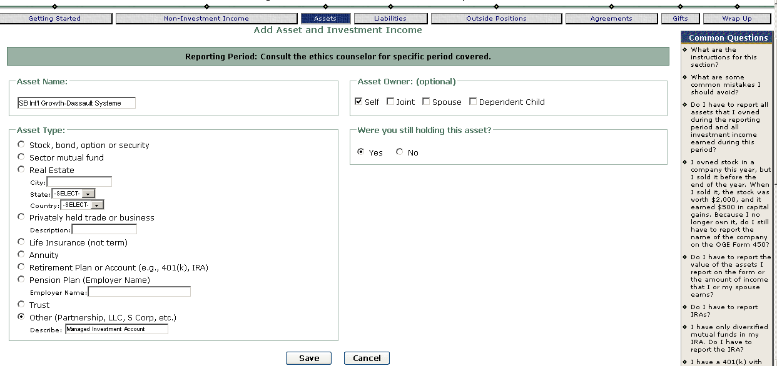
Deutsch Bank:
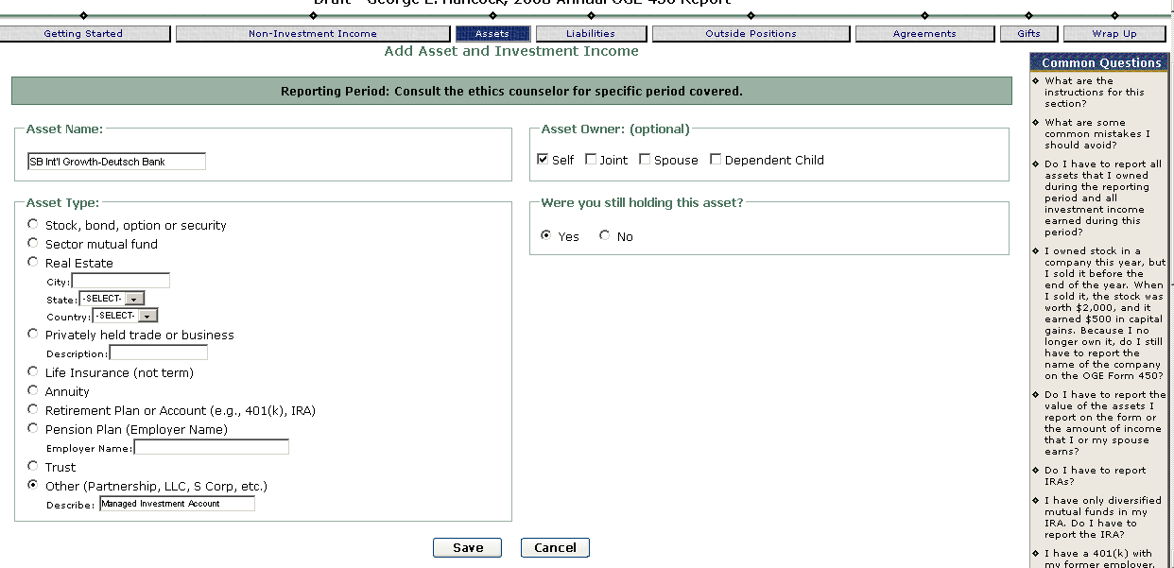

Municipal Securities (Bonds)
Definition: Debt obligation issued by a government municipality (e.g., county, city, township)

General rule: report municipal securities or bonds. To report a general obligation bond, you must disclose the issuing municipality and describe the bond as a general obligation bond. To report a revenue bond, you must disclose the issuing municipality and describe the type of bond.

Example: Filer has a Palm Beach County, FL Solid Waste Disposal Authority bond

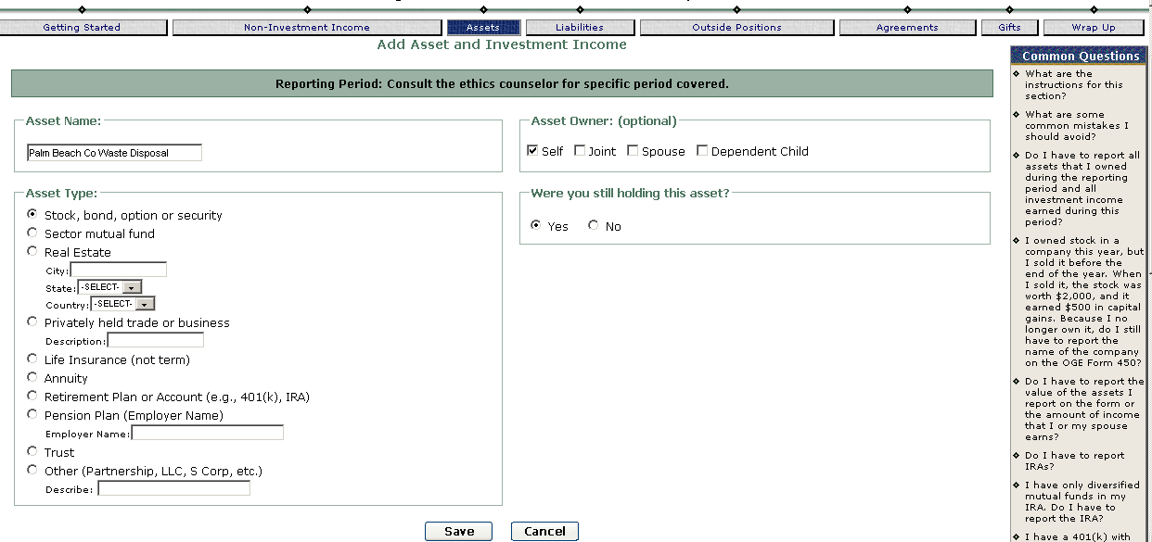

Real Estate
Definition: Typically includes residential property (e.g., homes, apartment buildings, hotels), commercial property (e.g., office buildings, business sites, shopping malls), and land held for agricultural use or mineral exploration (e.g., vacant lots are included if held for the production of income such as appreciation in value).
General rule: Report as an Asset real estate (residential, commercial, and undeveloped) from which you receive income over $200 in a reporting period. Do not report the home in which you reside unless you rent it and receive rental income. To report real estate, describe the type of property and the city and the state where it is located. If you have a mortgage on that property, read “Liabilities” to determine if you must report the mortgage on Part II.

Example: Filer owns a rental house in Denver, CO
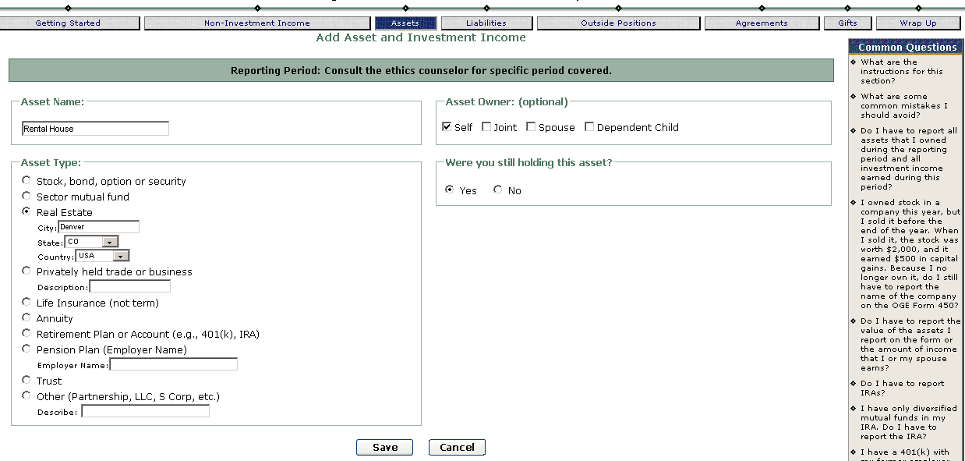

Real Estate Investment Trust
Definition: Managed diversified portfolios of real estate and mortgages. REITs are usually publicly traded like mutual funds and qualify as excepted investment funds (EIF).

General rule: report the full name of the REIT. A publicly traded REIT will usually qualify as an excepted investment trust, and you will not be required to list the underlying assets in the REIT. Although you are not required to provide the ticker symbol, the ticker symbol is helpful to your ethics official in identifying the REIT as being publicly traded and may reduce the number of questions that your ethics official will have for you.

Example: Filer owns an interest in Washington Real Estate Investment Trust (WRE)
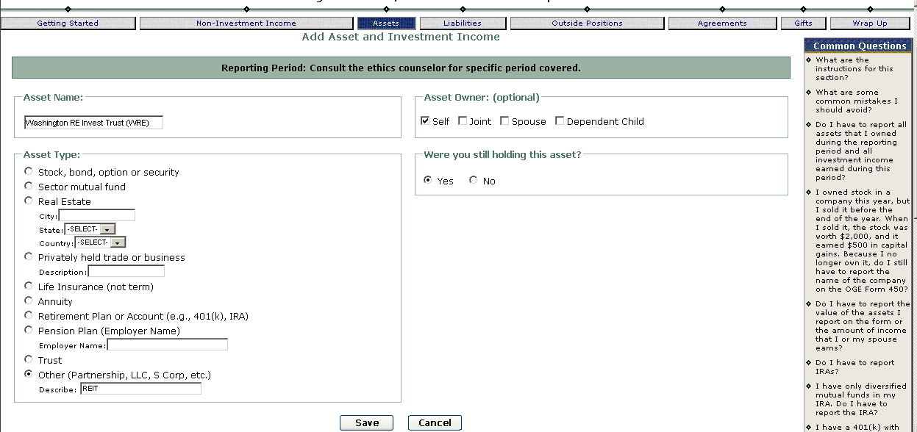

Sector Mutual Fund
Definition: A mutual fund that concentrates its investments in an industry, business, single country other than the United States, or bonds of a single state within the United States. Filer must disclose the name of the sector fund, including the fund family name. A portfolio of stocks, bonds, futures, options, money market instruments, or other securities, that is created and managed as an investment company and registered with the Securities and Exchange Commission. The mutual fund sells shares to investors and pools their money to purchase its investments.

General rule: Report the full name of the sector fund, including the fund family name. Most sector mutual funds qualify as excepted investment funds; therefore, you are usually not required to report the underlying stocks that the funds hold. Although you are not required to provide the ticker symbol, the ticker symbol is helpful to your ethics official in identifying the asset and may reduce the number of questions that your ethics official will have for you.
Example: ING DIRECT Financial Services Fund (IDFOX)
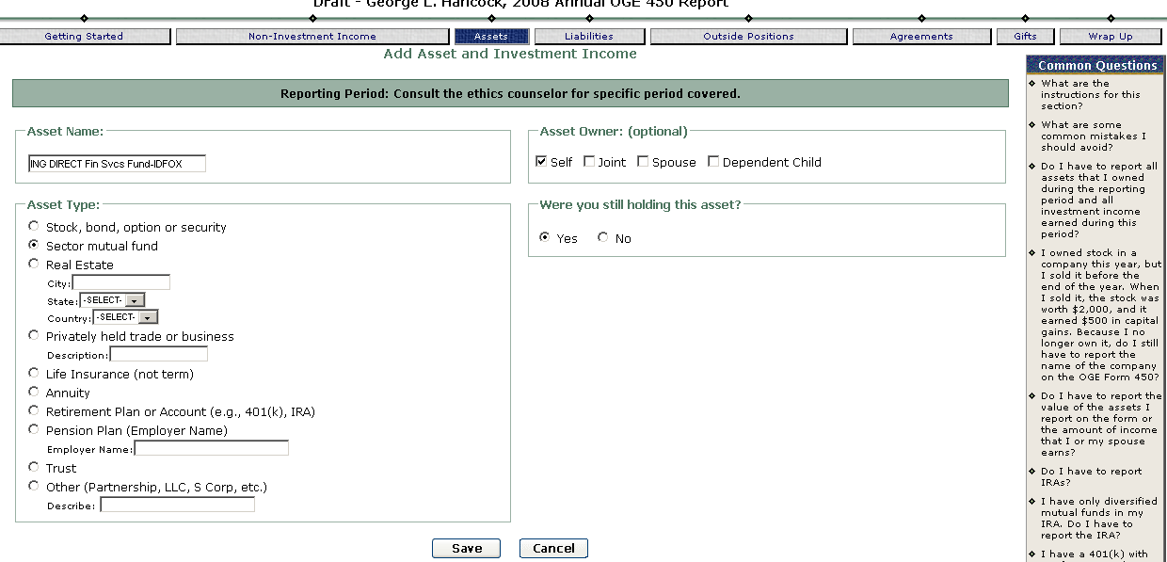

Stock—Privately Held Company
Definition: Equity interest in a corporation. This type of interest is usually issued directly to those who formed the company or provided capital to the company.

General rule: report the full name of the company, the location (city and state) of the company, and a brief description of the nature of the company’s business.

Example: Knight, Inc. - Houston, TX Owns and operates natural gas pipelines and terminals
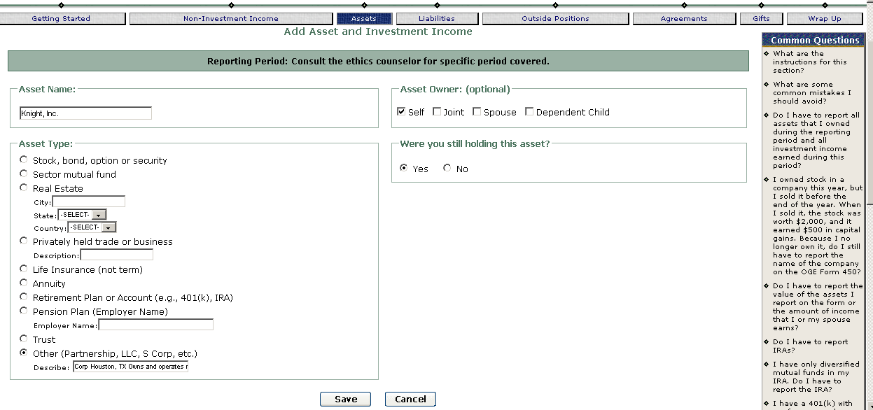

Stocks—Publicly Traded Company
Definition: Equity interest in a corporation. This type of interest is usually is available to the public and traded on an exchange. Reviewers can locate information about publicly traded stocks in the newspaper, on the internet, or in other financial services publications.
General rule: report the full name of the company. Filer may provide the ticker symbol. It helps ethics official in identifying the stock as publicly traded and may reduce the number of questions that your ethics official will have for you.

Example: McDonald’s Corporation (MCD)

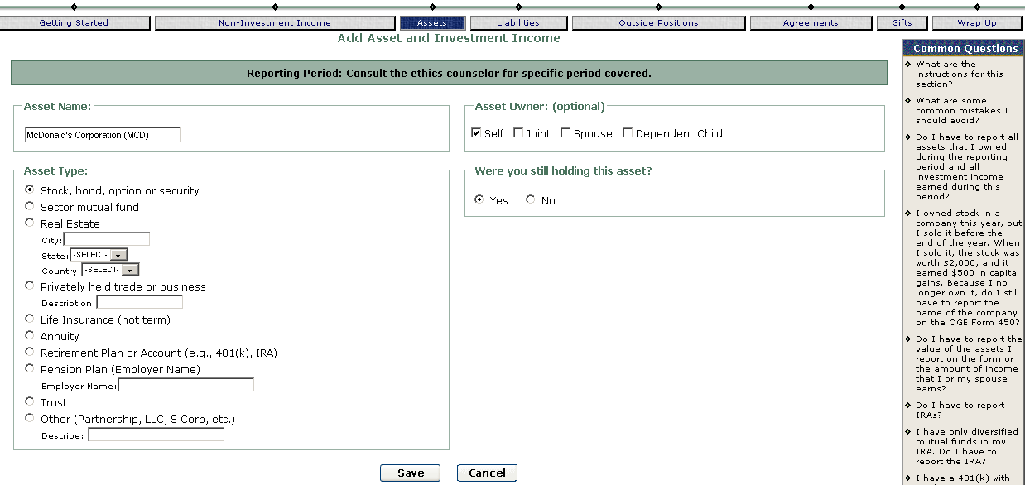

TIAA-CREF
Definition: The Teachers’ Insurance and Annuity Association—College Retirement Equities Fund (TIAA-CREF) is one of the largest private pension funds in the United States. In addition to operating a pension system for people employed in academic and research fields, it offers to the general public a variety of investment products, such as annuities, diversified mutual funds, and sector mutual funds.

General Rule: report your reportable investments in the Teachers’ Insurance and Annuity Association—College Retirement Equities Fund (TIAA-CREF). Describing your investment as “TIAA-CREF” is not sufficient. TIAA-CREF currently offers a variety of investment products, such as annuities, diversified mutual funds, and sector mutual funds. You must report the specific investment product. You are not required to report the diversified mutual funds because the regulation exempts these funds from disclosure. You must report the annuities and the sector mutual funds.

Example: TIAA Traditional Fixed Annuity
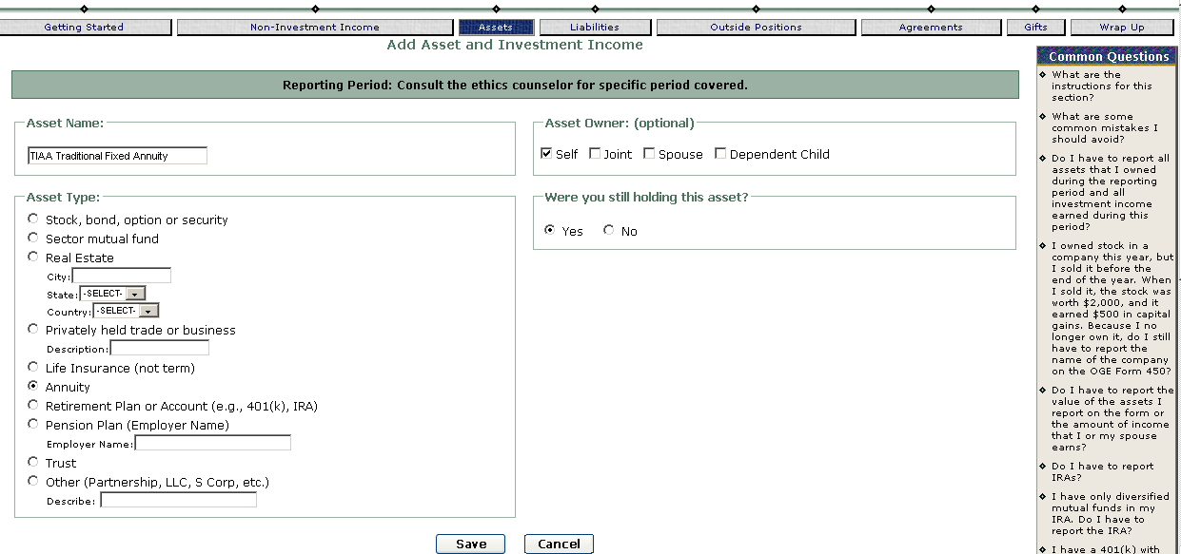

Trusts
Definition: A trust is a formal, legal arrangement by which legal title and management responsibility for a person's property is given to a fiduciary, known as the trustee. The person who creates the trust is known as the grantor, settlor or donor. The property put into the trust is called the corpus (the body, literally), trust res (the thing in trust, literally), trust fund, or trust estate. Those who are designated to receive income from or ultimately the corpus of the trust are known as beneficiaries. Generally, filers need to report holdings and income from any trust or estate in which they, their spouse or dependent children hold a vested beneficial interest in principal or income. Income received in the form of a distribution from a trust is required to be reported by the filer in actual amount if a filer does not have a beneficial interest and the trust holdings have not been individually reported. Distributions to spouses and dependent children are not required to be reported. Consult your Ethics Official for assistance in reporting trusts.
If the filer, spouse, or dependent child has a reportable vested beneficial interest in the principal or income of the trust, the filer must disclose the name of the trust and all reportable underlying assets. If the filer is a trustee and receives a fee over $200, filer must make a separate entry for her service as trustee to indicate that she received earned income for this work. Filer must always report a trustee position, whether it is compensated or uncompensated.

General rule: report each asset in a trust if you have a vested beneficial interest in the trust. Because the assets in a trust will probably fall into one of the categories of assets described in this guide, refer to the directions for that particular asset to learn how to report it.

Example: Stonecipher Family Trust underlying assets are listed below: Whole Foods Market Inc. (WFMI) & Intel Corp (INTC)
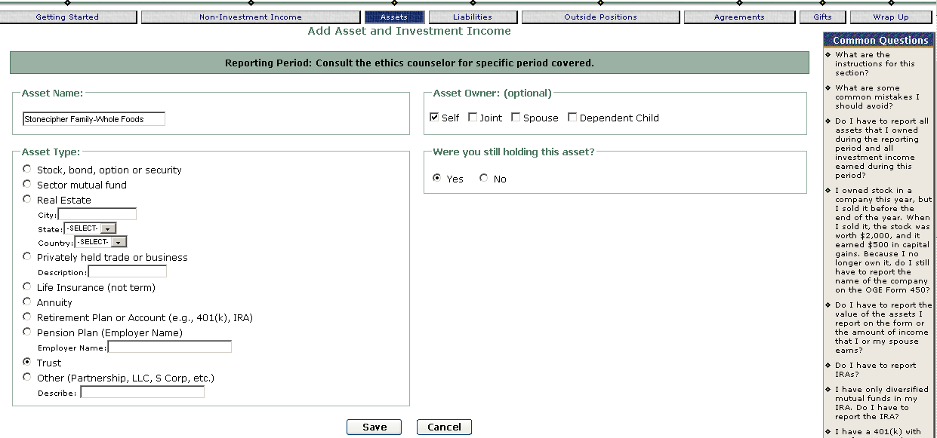
Intel Corp (INTC)
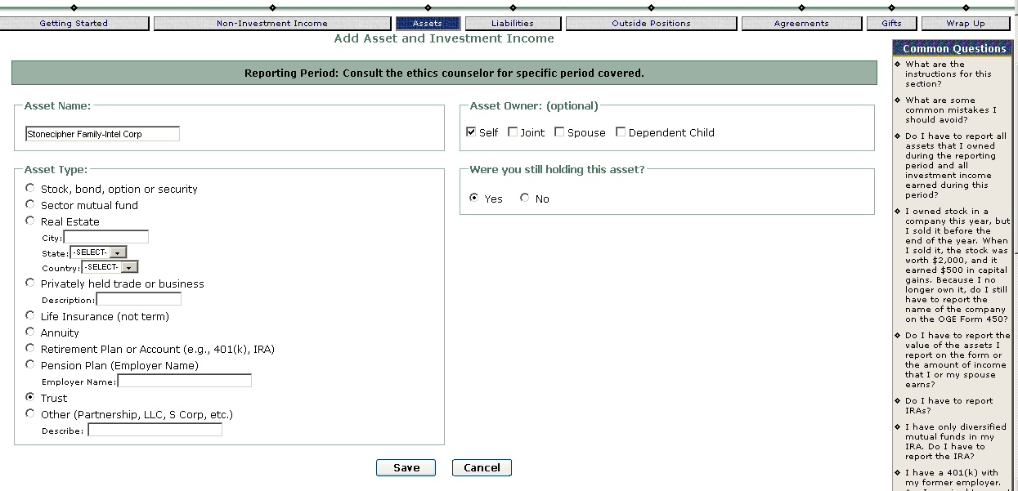
Note: If you are a trustee, you must report the outside position. If the position is uncompensated, please indicate that. Otherwise, when your ethics official reviews the form and does not see the trustee service listed as Non-Investment Income, she will have to contact you to find out whether or not the position is compensated.
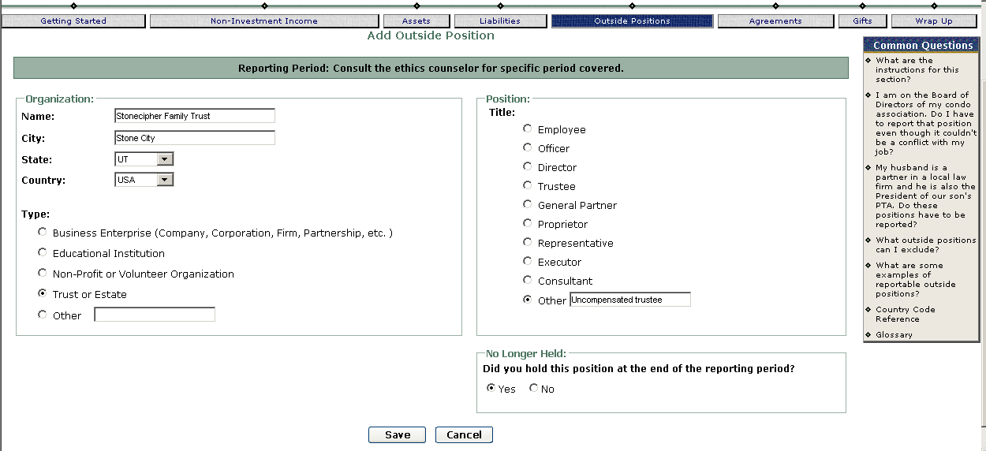

Financial Assets, Property Interests, and Income
Disclosed on OGE Form 450 Reports*
*Source: OGE Course Materials, Certifying 450 Reports, Participant Guide, FY08

Notes:
1. FDM includes a Glossary defining many of these terms and FDM-specific terms.
2. This document serves as a quick reference guide only. As such, the “definitions” are abbreviated. Further, the confidential financial disclosure regulation, 5 CFR part 2634, subpart I, http://edocket.access.gpo.gov/cfr_2008/janqtr/5cfr2634.907.htm, serves as the ultimate authority for disclosure requirements.

Term | Definition/Description
401(k) Plans | An arrangement in which an employee places pre-tax earnings into a tax-deferred retirement account that a private industry employer creates and maintains. Employer holds funds in trust until employee reaches a specified age or leaves employer. Plans are self-directed. Filer must disclose the plan’s reportable underlying assets (Assets section), and disclose the plan (Agreements section). See Non-reportable Underlying Assets.
403(b) Plans | An arrangement in which an employee places pre-tax earnings into a tax-deferred retirement account that a state or local government employer or tax-exempt organizations (such as schools and charities) create and maintain. Plans generally offer limited choices of funds. Filer must disclose the plan’s reportable underlying assets (Assets section), and disclose the plan on Part IV. See Non-reportable Underlying Assets.
Annuities | Contract with a life insurance company. Investor pays a premium to an insurance company per the contract and the insurance company makes payments to the investor at a specified age. See also Deferred Annuities, Fixed Annuities, Immediate Annuities, and Variable Annuities.
Collectibles | For OGE Form 450 reporting purposes, OGE is only concerned about items of personal property that are held for investment or for production of income. This may include antiques, works of art, vintage automobiles, stamps, rare coins, etc. Filer needs to describe the nature of the collectibles (Assets section).
Corporate Bonds | A debt owed by a corporate issuer to a bondholder – usually a promise to pay a specified rate of interest over a fixed rate of time. Filer must disclose the name of the asset (Assets section).
Deferred Annuities | Postpones payments to investor until he/she reaches a certain age or retirement. Deferred annuities may be either fixed or variable. See also Annuities, Fixed Annuities, Immediate Annuities, and Variable Annuities.
Defined Benefit Plans | Type of pension interest. Employer makes a contribution to a pool that is held and invested for all participating employees. Employee will receive a fixed amount of benefits when he or she retires. Employee may know in advance the amount of his future benefits or, at a minimum, know the formula that determines the amount. Filer must disclose the name of the employer providing the plan and the type of pension interest (Assets section), e.g., defined benefit plan, and the plan’s terms (Agreements section).
Defined Contribution Plans | Type of pension interest. 401(k) and 403(b) plans are examples of this type of interest. Employee makes contributions to an employer who maintains a separate account for each employee. Either the employee or an independent manager chooses how the contributions will be invested. The benefits upon retirement depend on the performance of the plan’s assets. Filer must disclose the reportable underlying assets of the plan on (Assets section), and the plan (Agreements section). See Non-reportable Underlying Assets.
Diversified Mutual Funds | Diversified means that the fund does not have a stated policy of concentrating its investments in any industry, business, single country other than the U.S., or bonds of a single state within the U.S. Filer does not disclose diversified mutual funds on OGE Form 450 reports. Reviewers may have the filer check the fund’s prospectus or call a broker or the manager of the fund to determine whether a mutual fund meets this standard. See also Mutual Fund and Sector Mutual Fund.
Education Savings Accounts (529 plans) | An education savings plan operated by a state designed to help families set aside funds for future college costs. (Educational institutions may also offer 529 pre-paid tuition plans). Every state now has at least one 529 plan. 529 plans are tax-deferred. There are two types of plans – Prepaid Tuition Plans and Prepaid Savings Plans. Contributors decide the state plan in which they want to invest. Once invested in the plan, the plan’s assets are professionally managed. Disclosure requirements vary according to the type of plan. See Prepaid Tuition Plans and Prepaid Savings Plans.
Excepted Investment  Funds (EIF) | A pooled investment vehicle that is: 1) widely held (100 or more participants); 2) publicly traded (or available) or widely diversified (no more than 5% of the value of the portfolio is invested in one issuer [other than the U.S. government] and holds no more than 20% in any particular economic or geographic sector); and 3) independently managed. Investors do not exercise or have the ability to exercise control over interests held in the fund. The investment vehicle may be a mutual fund, regulated investment company, common trust fund maintained by a bank or similar financial institution, pension or deferred compensation plan, or any other investment fund. For investments that qualify as EIFs, the filer must identify the fund itself as an interest in property and/or a source of income. The filer does not have to disclose the fund’s underlying assets. Note: The definition of an EIF is used for financial disclosure purposes only.
Fixed Annuities | Income from an annuity at a specified rate of return guaranteed by the insurance company. The insured has no direct interest in how premiums are invested. Filer needs to disclose the name of the insurance company and specify that the asset is a fixed annuity (Assets section). See also Annuities, Deferred Annuities, Immediate Annuities, and Variable Annuities.
Funds Receivable | Filers, spouses or dependent children may be lenders for a loan or have other receivable accounts, such as compensation owed by former employers or money owed for goods and services. Filer must disclose notes and accounts receivable unless it is a loan to a close relative. In the Non-Investment Income section Filer must identify the borrower (helpful if it includes relationship to filer and reason for loan). Watch for loans between government employees – if the loan is to a superior, a low interest rate could be a gift to a superior.
Futures | An agreement to buy or sell a commodity or a financial interest at a stipulated price, quantity, and time. Filer must report the asset (Assets section) if it is valued over $1,000 or if the income exceeds $200 during reporting period (even if it is unrealized gain).
General Obligations | A type of municipal security. A debt obligation for general expenditures and backed by taxing and borrowing power. Filer must disclose general obligations (Assets section). See also Municipal Securities and Revenue Bonds.
Government Agency Securities | Debt obligations issued by federal agencies and Government corporations and Government-sponsored corporations to help finance operations such as GINNIE MAE, FANNIE MAE, FREDDIE MAC, SBA and TVA. Filer does not report these bonds on the OGE Form 450, but does report stock issued by GINNIE MAE, FANNIE MAE, etc. See also Treasury Securities.
Hedge Funds | Funds that seek to profit in all kinds of markets by pursuing leveraging and other speculative investment that may increase the risk of investment loss. Filer must disclose the name of the hedge fund. Hedge funds may qualify as excepted investment funds. If so, the filer must identify the fund itself as an interest in property and/or a source of income and does not have to disclose the fund’s underlying assets. If the hedge fund does not qualify as an excepted investment fund, the filer must disclose the hedge funds' reportable underlying holdings. See Excepted Investment Funds and Reportable Underlying Assets.
Honoraria | Payment for an appearance, speech, or article. Most federal employees may accept honoraria for activities that do not relate to their official duties (see exceptions at 5 CFR part 2636, subpart C). Filer must report honoraria and their sources (Assets section). If the honorarium is received as compensation for an outside position, filer has to report the position (Outside Positions section). Reviewers may want to check if filers followed the requirements for participating in an outside activity and consider whether the honorarium is compensation for teaching, speaking, or writing that relates to their official duties (with an exception for teaching certain courses).
Immediate Annuities | Income from an annuity that pays out immediately. Immediate annuities may be either fixed or variable. The income may be interest or dividends. See also Annuities, Deferred Annuities, Fixed Annuities, and Variable Annuities
Individual Retirement Accounts (IRAs) | Generally a bank, brokerage, or mutual fund account that the employee designated as a tax-deferred retirement account. Reportable income is generated even though the income is reinvested. All IRAs are self-directed. Filer must disclose all reportable underlying assets on (Assets section). See Non-reportable Underlying Assets.
Intellectual Property | Filer may hold investments in intellectual property and related rights (patents, copyright, computer software, etc.). Intellectual property may produce both earned income (compensation for services and paid when item is sold) and investment income (i.e., royalties). The intellectual property must be described by indicating the nature of the item and the contractual arrangements (Assets section). Income consists of advances, contract payments, royalties, etc.
Investment Clubs | Most investment clubs are set up as general partnerships. Each member or partner in the group owns a proportionate share of the assets in the club. The threshold for reporting the investment club itself is the overall amount that the filer invested in the club. The threshold for reporting the underlying assets of the club is based on the filer’s interest in each asset. If the filer’s interest in a particular underlying asset is not valued over $1,000 or if the filer’s share of income generated by that asset does not exceed $200, then the filer does not need to disclose that particular underlying asset. The filer must report the investment club and those underlying assets that meet the reporting thresholds (Assets section) (stocks, bonds, sector mutual funds, etc.). A position such as general partner should generally be reported (Outside Positions).
Keogh Plans (HR-10 plans) | Tax-deferred pension account for self-employed persons and employees of unincorporated businesses. These plans have essentially the same financial disclosure and conflict of interest analysis as IRAs because employers have no continuing connection with the Keogh after their contributions have been made. Filer must disclose the reportable underlying assets (Assets section). See Non-reportable Underlying Assets.
Life Insurance Policies | Policies issued in either term or cash value. Filer generally does not have to report term life insurance. However, filer must report cash value life insurance because it is part insurance and part investment. See also Universal Life Insurance, Variable Life Insurance, and Whole Life Insurance.
Limited Partnerships (LP) | Formed when a group of individuals join together for the purpose of investing in a trade or business. The other investors are limited partners. Usually has one general partner who organizes and manages the operations and the partnership. Individuals are offered reduced liability exposure, investment income, and tax advantages. LPs often invest in real estate, hedge funds, oil/gas, futures, equipment for leasing, or finance new product development, etc. Filer reports the name of the partnership (Assets section) and possibly the reportable underlying assets. Filer reports an outside position (Outside Positions section), if he is a general partner or if he receives fees for services performed for the LP. See also Public Limited Partnerships and Private Limited Partnerships.
Livestock and Farm Interests | Filers may have interests in livestock or other farm interests either as owners, employees, or investors– disclosure is the same for each. Filer must disclose his type of interest (limited partner, general partner, sole owner, corporate shareholder, etc.) (Assets section). If the asset is a farm, filer must also report the name under which the farm does business, the business of the farm (such as livestock) and the location of farm (city and state). Filers need to disclose their positions, such as general partner, sole owner of proprietorship, etc., if appropriate (Outside Positions section).
Municipal Securities | Debt obligations of cities, counties, etc. Filer must report (Assets section). See also General Obligations and Revenue Bonds.
Mutual Funds | An entity which is registered as a management company under the Investment Company Act of 1940, as amended (15 U.S.C. 80a-1 et seq.). Includes open-end and closed-end mutual funds and registered money market funds. Filer does not report money market or diversified mutual funds on the OGE Form 450. However, filer must disclose the full name of sector mutual funds (Assets section). See also Diversified Mutual Funds and Sector Mutual Funds.
Non-Public Businesses | Filer must disclose (Assets section), the full name of the entity, the location (city and state), the nature of the business (such as full-service restaurant, computer software, retail store, candle-making business, etc.), and any portfolio investments or attributions that are not solely incidental to the business. Filer needs to disclose any position held with the business (Outside Positions section).
Non-Public Stocks | Stocks not available to public. Usually issued directly to those who formed the company or provided capital to the company. Filer must provide a description of the nature of the company’s business and the location (city and state) of the business (Assets section).
Non-Reportable Underlying Assets | Money market mutual funds; cash deposit accounts (such as certificatesof deposit and money market accounts); U.S. government obligations, including Treasury bonds, bills, notes, and savings bonds; government securities issued by U.S. government agencies; and diversified mutual funds.
Options | Grants investors the right but not the obligation to buy or sell a commodity or a financial interest at a stipulated price, quantity, and time on specified terms. Filer must report asset (Assets section) if it is valued over $1,000 or if income exceeds $200 during reporting period.
Personal Bank Accounts | Personal savings accounts, money market accounts, CDs, NOW accounts, and checking accounts. Cash deposit accounts held in financial institutions such as banks, credit unions, etc. Filer does not disclose on the OGE Form 450.
Precious Metals | Metals such as gold, silver, and platinum are held by some investors as a hedge against inflation or foreign exchange fluctuations. Investors may take physical possession of the metals, hold certificates issued by an investment entity, or hold shares of metals in metals mutual funds or futures.
Prepaid Savings Plans | A 529 plan where the plan’s growth is based on the performance of investments chosen by the filer. Filer must disclose the name of the plan, e.g., GIFT College Investing Plan (Arkansas) and the reportable assets in that portfolio if the list is not available from public sources such as the internet, e.g., Vanguard Aggressive Growth Portfolio. See Education Savings Accounts (529 plans) and Prepaid Tuition Plans.
Prepaid Tuition Plans | A 529 plan that allows a contributor to lock in today’s tuition rates. The plan represents a contract between the state and the contributor. Filer reports the name of the plan and the sponsor of the plan, e.g., Maryland Prepaid College Trust. See Education Savings Accounts (529 plans) and Prepaid Savings Plans.
Private Limited Partnerships (LP) | For a private non-investment LP, the filer must disclose (Assets section) the name of the LP, location (city and state), and a brief description of its purpose or operation. If the private LP is an investment LP, but does not qualify as an excepted investment fund, the reportable underlying assets must also be disclosed (Assets section). See Non-reportable Underlying Assets. See also Excepted Investment Fund, Limited Partnerships, and Public Limited Partnerships.
Public Limited Partnerships (LP) | These are generally publicly traded and are usually excepted investment funds. Filer needs only report the full name of the LP (Assets section). See also Excepted Investment Funds, Limited Partnerships and Private Limited Partnerships.
Publicly Traded Stocks | Stocks available to the public and traded on an exchange. Reviewers can locate information about publicly traded stocks in the newspaper, on the internet, or in other financial services documents. These must be disclosed (Assets section).
Real Estate | Typically includes residential property (homes, apartment buildings, hotels), commercial property (office buildings, business sites, shopping malls), and land held for agricultural use or mineral exploration (vacant lots are included if held for the production of income such as appreciation in value). Filer must report the name of the asset and the location (city and state) of the real estate on Part I except for personal residence unless rented out.
Real Estate Investment Trusts (REITs) | Managed diversified portfolios of real estate and mortgages. Usually publicly traded like mutual funds and qualify as excepted investment funds. Filer must disclose the name of the asset (Asset section). If the investment is not publicly traded, filer must disclose the reportable underlying assets when the REIT does not qualify as an excepted investment fund. See Non-reportable Underlying Assets. See also Excepted Investment Fund.
Revenue Bonds | A type of municipal security. A debt obligation used to finance specific public service projects and backed by cash flow from those projects. Filer must disclose revenue bonds (Assets section). See also Municipal Securities and General Obligations.
Salaries | Earned income that may be referred to as fees, commissions, salaries, or honoraria. Filer must report (Non-Investment Income section) earned income in excess of $200 that is acquired during the reporting period from any one source. However, filer does not report Federal salaries or Federal retirement benefits – common over-reporting examples, especially military retirement benefits. The threshold for spouse’s earned income is $1,000 (not $200 like the filer). Filer does not need to disclose any earned income of dependent children. Filer needs to report outside positions from which he/she receives earned income (Outside Positions section).
Sector Mutual Funds | A mutual fund that concentrates its investments in an industry, business, single country other than the U.S., or bonds of a single state within the U.S. Filer must disclose these (Assets section). See also Diversified Mutual Fund and Mutual Funds.
Simplified Employee Pensions (SEPs) | Tax-deferred plan for small employers with 25 employees or fewer. Not a continuing obligation of employer once contributions are made. SEPs are self-directed, so the filer must disclose reportable underlying assets (Assets section). See Non-reportable Underlying Assets.
Stocks | Equity interest (ownership) in a corporation – usually pays a portion of its earnings to shareholders as dividends. Shareholders may also receive capital gains when they sell their stock. Filer reports the full name of the asset (Assets section). In addition to the full name, the filer may also report the ticker symbol. See also Publicly Traded Stocks, Non-public Stocks, and Stock Options.
Stock Options | Rights to buy or sell stocks at specified quantities and prices within a certain time period. Some options are a form of employee benefits. These types of options are not purchased or sold over an exchange. They are granted by a company to its employees as part of an incentive and compensation plans. Filer reports stock options (Assets section)I.
Tax Shelters | Methods used by investors to legally avoid or reduce tax liabilities. Some popular tax shelters include limited partnerships, individual retirement accounts, and Keogh plans.
Treasury Securities | A type of government security to include T-bills, treasury notes, treasury bonds, or U.S. savings bonds. Filer does not disclose on the OGE Form 450. See also Government Agency Securities.
Trusts | A formal legal arrangement, under which assets are managed and controlled by one party (trustee) for the benefit of another (beneficiary). If the filer, spouse, or dependent child has a reportable vested beneficial interest in the principal or income of the trust, the filer must disclose (Assets section) the name of the trust and any reportable underlying assets. If the filer is a trustee and receives a fee over $200, the fee received for the trustee position must be reported (Assets section). The trustee position also must be reported on (Outside Positions section) (compensated or not).
Universal Life Insurance | Insured person can vary premiums by paying them with some of the accumulated cash value of the policy, and she normally receives a minimum guaranteed rate of return at money market rates. Investor has no control over investments. Filer must report the name of the insurance company (Assets section) and specify that the asset is universal life insurance. See Life Insurance Policies, Variable Life Insurance, and Whole Life Insurance.
Variable Annuities | Annuities that offer investors options in which they can invest (usually mutual funds). Return is based on the performance of the chosen investments. Filer must disclose (Assets section) the name of the company and the reportable underlying assets. See Non-reportable Underlying Assets. See also Annuities, Deferred Annuities, Fixed Annuities, and Immediate Annuities.
Variable Life Insurance | Insured person chooses investments from among several company options – performance of the chosen investments dictates its value. Filer must disclose (Assets section) the name of company, the type of insurance, and the reportable underlying assets. The policy itself is not an excepted investment fund, but the underlying assets may be. See Non-reportable Underlying Assets. See also Life Insurance Policies, Universal Life Insurance, and Whole Life Insurance.
Whole Life Insurance | Insured person pays fixed premiums and has no control over investments. Filer must report (Assets section) the name of the insurance company and indicate that the asset is whole life insurance. It is not an excepted investment fund as it represents an obligation by the sponsoring company and not an interest in an investment fund. See Life Insurance Policies, Universal Life Insurance, and Variable Life Insurance.

